
2013 CASNR  ADVISORY E-NEWSLETTER  VOLUME 1, ISSUE 1 |  | 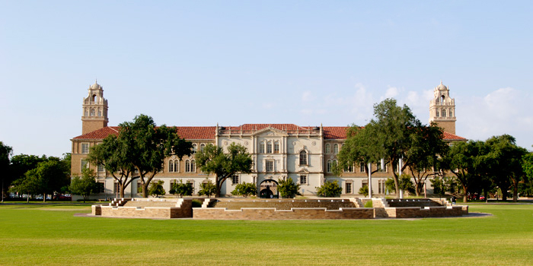
FORUM WITH PRESIDENT DUANE NELLIS

As part of his effort to learn more about Texas Tech University, Dr. Duane Nellis, the President of Texas Tech University, has been touring each of the university’s 11 colleges and meeting with administrators and faculty members in a half-day forum. Dr. Nellis began his tenure as President in June, and he has certainly hit the ground running. Our forum was on October 21st, and the President was accompanied by Interim Provost and Senior Vice President Lawrence Schovanec and two members of his staff (Grace Hernandez and Suzanne Taylor).

The format was a very casual, round-table setting, in which the associate deans and department chairs provided the President with a one-page fact sheet and took 2 to 3 minutes to share key points about their area of responsibility. We then had a brief tour of all the CASNR facilities, starting at the Animal and Food Sciences Building and ending at the CASNR Annex. Finally, in an open forum with CASNR faculty members, the President shared some remarks about his vision for Texas Tech, followed by a brief question-and-answer session.

A geographer by training who worked with remote sensing and GIS earlier in his career, Dr. Nellis has a good appreciation for agricultural sciences and natural resources. He often notes that part of his research while on the faculty at Kansas State dealt with mapping of the Ogallala Aquifer in Western Kansas. We believe he will be a strong supporter of the college and look for good things to come in the future under his leadership.

FACULTY SEARCHES & REQUESTS FOR NEW FACULTY POSITIONS

We continue to fill positions in several of our departments. In most cases, these are positions that have been vacant because of retirements or faculty members taking positions elsewhere during the past couple of years.

- At the Dean’s Office, we are still working on identifying candidates for the Associate Dean for Research position. During the first round of the process, we interviewed some very strong candidates, but we were not able to get anyone hired. The search committee for this position, chaired by Dr. Steve Fraze, is currently reviewing additional applications, and we anticipate scheduling interviews in the near future.

- Animal and Food Sciences is currently advertising an Assistant Professor position in food science, and they also will be seeking to fill three additional replacement positions (two most likely in the swine and beef areas plus one equine position) by August 2014. The department has an open new position funded by the university administration that will be targeted in the area of animal health, with a preference for someone with a D.V.M. and a Ph.D. in an area of animal science.

- Agricultural and Applied Economics currently is advertising to replace Dr. Jeff Johnson, who accepted an administrative position with Mississippi State University. Jeff’s last day was November 15th.

- Natural Resources Management has interviewed candidates for the Bricker Chair (formerly held by Dr. Warren Ballard, who passed away in 2012), with an offer pending to one candidate. They also will be filling two positions this spring – one to replace a departure and one to replace Dr. Ernest Fish, who will retire in January 2014.

Earlier this fall, President Nellis requested proposals from across the university for “cluster hires.” These proposals were designed to stimulate multi-disciplinary, cross-college research efforts. A proposal by our food safety faculty members was accepted, and we anticipate two or three new positions (likely in Animal and Food Sciences and Agricultural Education and Communications) will be added to the college as a result of this effort. One additional position in biostatistics should be added in Animal and Food Sciences through a proposal by the Center for Biotechnology and Genomics that also was funded.

Dean’s Message

Welcome to the inaugural issue of the CASNR Advisory Board Newsletter. When we met as a group before our faculty retreat this summer, I promised that we would develop a format to share information about the college with members of the Advisory Board. This is our first attempt at fulfilling that promise. I would certainly appreciate your feedback on this newsletter, particularly suggestions of information you would like to see in future editions.

We appreciate your service to the college. Please feel free to contact me or any of the associate deans and department chairs anytime you have comments to share and suggestions for ways to reach our goal of making CASNR the best college of its kind in the nation. -- Michael Galyean

Student & Academic Programs Update

We’re excited to report that Texas Tech University’s Fall 2013 enrollment is at an all-time high of 33,111 students. CASNR’s Fall 2013 enrollment is also at an all-time high of 1,928 students. The undergraduate enrollment is 1,577, and graduate is 351 – a 4.2 percent increase from last year. When enrollment increases, like we’ve seen in CASNR, retention becomes more of a challenge to maintain, let alone increase. That’s why now, more than ever, we should be focusing on retention and graduation initiatives alongside recruitment efforts. Texas Tech reports a retention percentage of 81 percent, with CASNR at 85 percent for new full-time freshmen for Fall 2011-2012. The college consistently retains students above the university average. If we continue to grow, it is important that we develop new practices to maintain and improve retention rates. As a result, the Bill Bennett Student Success Center is implementing new activities to help keep our students engaged. On January 22, 2014, CASNR will host “Winter Welcome,” an event that will provide food, games, and university services information tables for students. The new event will assist with re-engaging students as they return from winter break and welcoming new students starting in the spring semester. For the spring semester, CASNR will also provide tutoring referrals for students struggling in these courses. CASNR faculty will recommend graduate and upper-classmen that are willing to assist their peers in these courses. This will allow the Student Success Center staff to immediately give the student contact information for a tutor.

Although we need to focus on retention in the future, it’s important not to lose sight of the fact that the vast majority of CASNR students continue to excel and to be recognized for their outstanding efforts. Among those honored recently are:
- Texas Tech earned the school’s 11th national championship in meat judging on Nov. 17 at the American Meat Science Association’s International Meat Judging Contest held in Dakota City, Neb. It’s the third consecutive year that Texas Tech has won the title, making it only the second university in the history of intercollegiate meat judging to accomplish the feat.
- Texas Tech’s Livestock Judging Team was edged out by 18 points at the North American International Livestock Exposition on Nov. 19 in Louisville, and finished their season as Reserve National Champions. The national contest tested the contestants’ knowledge of cattle, sheep, and swine, as well as their oral reasons.
- As a commitment to increasing agricultural literacy about the nation’s food and fiber, the Block and Bridle Club celebrated National Food Day in October at Lubbock’s United Supermarket’s Market Street. Members handed out brochures, free food samples, and recipe ideas. One of their goals was to represent facets of the beef, swine and, sheep industries.
- Texas Tech senior food science major, Graysen Ortega, was named the winner of the biomedical and biological sciences category at the Minority Access National Role Models Conference’s Undergraduate Research Competition in September in Washington, DC. The title of the Lubbock native’s work was, “Prevalence of Shiga Toxin producing Escherichia coli non-O157:H7 in beef in Mexico.”
- Department of Animal and Food Sciences graduate student, Jerilyn Hergenreder, earned third place honors for her research poster at the Innovate, Innovations in Animal Growth and Health: The Next Generation of Cell Biology Conference in September in Braselton, GA. Her poster was titled, “Effects of supplemental lysine and methionine in combination with zilpaterol hydrochloride on muscle fiber type, size, and beta-adrenergic receptors in finishing feedlot cattle.”
- Department of Landscape Architecture student, DeMera Ollinger, was named an Integrated Scholar by Texas Tech’s Provost Office. The Dumas native is president of the Student American Society of Landscape Architects and has served as a member of Agri-Techsans, promoting the departments within CASNR at events both on and off campus.
- Three CASNR students are spending the fall semester working as interns in the nation’s capital. They include Allison Cameron, a sophomore environmental crop and soil sciences (crop biotechnology) from El Centro, CA; Katherine Setterbo, a senior horticulture and turfgrass science major from Fredericksburg; and Shawna Newsome, an agricultural communications graduate student from Riverview, FL.
- Texas Tech’s Agricultural Communicators of Tomorrow chapter had a strong showing this summer at the national ‘Ag Media Summit’ in Buffalo, NY. Tech students brought home several top awards, in addition to taking on a standout leadership position. AEC graduate student Faith Jurek was elected as the National Agricultural Communicators of Tomorrow President for 2013-2014.

Research Facts & Figures

Research activities continue to be central to CASNR’s mission and a vital part of our future in terms of the ability to grow in faculty numbers and facilities. As you will note in the bulleted list below, CASNR continues to be a major player in TTU’s quest for Tier 1 or AAU-like status, despite being a relatively small college in terms of faculty and student numbers. This is a message that we need to keep repeating to campus administrators, as well as federal and state legislators.
- $8.4 million in Restricted Research Expenditures (REE) in FY13 – represents about 22 percent of the university’s total RRE for FY13 with only about 5 percent of the university’s FTE (full-time equivalent faculty count).
- $9.3 million in research grants in FY13.
- National prominence in several areas: Food Safety, Animal and Meat Science, Sustainable Agriculture, Biopolymer, Biotechnology, Natural Resources Management, Agricultural Trade and Policy Analysis, and Technology Transfer.
- Good progress in new areas of research excellence identified in 2011: (1) Sustainable Land and Water Use; (2) Animal Health, Nutrition, and Welfare; and (3) International Agricultural Development
- Our research priorities are interdisciplinary and inter-institutional in nature, linking disciplines of CASNR, other colleges and schools of TTU, Texas A&M AgriLife Research and AgriLife Extension, USDA-ARS, various corporations, and other universities and research entities.
- The focus is on discovery of reliable and relevant research and dissemination of our research findings to all our constituencies, including the regulatory agencies and commodity groups.

Development Report

For the first time in history, the total endowment for the College of Agricultural Sciences and Natural Resources has exceeded $46 million dollars. We have raised the funds and will be announcing the establishment of two new professorships in the college before the end of the year; Dr. Cynthia McKenney will be the Rockwell Professorship in Horticulture, and Dr. Brad Dabbert will be named the Burnett Foundation Professor in Quail Ecology. Also, the current BayerCrop Science Regent’s Professorship will be elevated to a Chair level. Our college will then have thirteen endowed Chairs and six endowed Professorships.

The largest research gift to Texas Tech University will be announced in the very near future. Our Department of Plant and Soil Sciences will be the recipient.

The Texas Tech Equestrian Program Advisory Board continues to assist with raising money and building capacity. Two major gifts for the programs are expected to be announced before the end of 2014.

We awarded approximately 612 students approximately 986 scholarships, totaling approximately $1.4 million, with 32 percent of our students are on scholarship. Once again, we had an outstanding group of students who interviewed for the Washington, DC internships for the Spring and Summer of 2014. Thanks to a group of very generous donors, we are able to provide the students housing at no cost and scholarships for their tuition while serving in the internship roles.

The new wing for our Plant and Soil Sciences (PSS) building is scheduled to be on the Board of Regent’s agenda for December, with construction likely to begin in late spring of next year. This is a project that has been in planning and fundraising stages for well over six years, and we are very excited to see it come to fruition. A few renderings of the exterior of the new addition from 15th Street (A) and the interior view of the courtyard that will be enclosed by the new addition, the existing Plant Sciences Building, and Goddard Hall (B) are shown below. The PSS departmental offices will be moved into the new addition, which also will contain several laboratories and graduate student office spaces. Renovations of space in the existing Plant Sciences Building will allow for most of the PSS faculty members to be “under one roof,” rather than in multiple locations as they are now. We have asked for an estimate of the cost for building a new entry to Goddard Hall (perhaps similar to the entry on the new wing shown below), and we hope to include that effort in the overall project by raising additional funds if necessary.

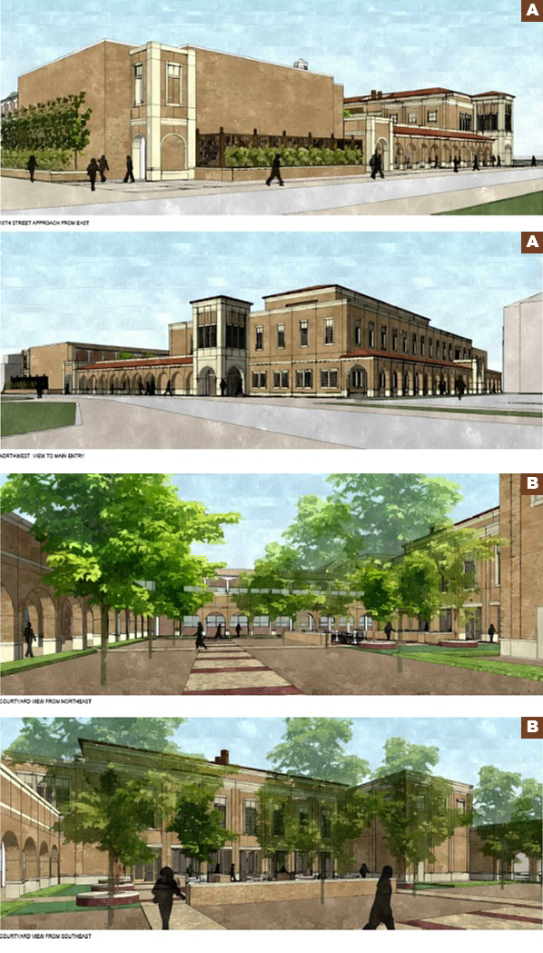

College of Agricultural
Sciences & Natural Resources
PO Box 42123
Lubbock, Texas 79409-2123
(806) 742-2808 phone
(806) 742-2836 fax

