Performance Reference Compounds Calculator for PDMS in Passive Sampling – User Guide
Introduction
This performance reference compounds (PRCs) correction calculator is designed to calculate the fraction steady state (f_{ss}) of PRCs the in passive sampling using Polydimethylsiloxane (PDMS). The loss of PRCs reflect the degree of approach to equilibrium of target compounds assuming linear, reversible sorption in the sediment surrounding the passive sampler. At equilibrium the PRCs, which are generally chosen as compounds that are not present in the sediment matrix and preloaded on the passive sampler, will decline toward 0 and the quantity 1-C/C₀ represents the fraction of equilibrium obtained, f_{ss} . The same extent of equilibration describes the uptake of the contaminant from the sediment and the concentration on the passive sampler that would be observed at equilibrium is C(measured)/f_{ss}.
The assumption of equal extent of equilibration between target compounds and PRCs assumes linear reversible sorption of both PRC and target compounds. If the sorption of the target and PRC compounds is nonlinear, i.e. a function of concentration, this assumption is not strictly valid. Common situations where this might occur is if the media contains black carbon or activated carbon. In general desorption of PRCs such as a deuterated PAH would not be at the same rate of sorption of the parent PAH in such a situation. It is often assumed, however, that a deuterated or C-13 labeled PRCs still provide a reasonable approximation to uptake of the parent compound, particularly if the concentration ranges of the compounds are similar.
Assuming the rates of PRC release and target compound uptake are the sample, the fractional approach to steady state and concentration for the PRC and the target compound can be written.
$$fss,prc=\frac{Cdeployment-Cretrieval}{Cdeployment}$$
$$Cpw, target=\frac{Cpw, measured}{fss}$$
It is often necessary to extrapolate from a small number of PRC compounds to a large number of target contaminants. In such cases, it is normally assumed that the rate of PRC release or target compound is a function of the hydrophobicity of the compound. One option would be to correlate f_{ss} with a measure of hydrophobicity such as the octanol-water partition coefficient, K_{ow}. This direct approach, however, is sensitive to experimental errors and may lead to extrapolations outside of the range of PRCs to physically unrealistic values of f_{ss}.
For PDMS passive samplers, the fractional approach to steady state is almost always controlled by external mass transfer resistances (Lampert, Thomas et al. 2015). A model of the fractional approach to steady state of a PRC assuming one-dimensional release of PRCs (typically valid for all organic passive samplers because they are typically very thin) and external mass transfer resistances control can be written
Where L represents the volume to area ratio of the passive sampler, K_{PDMS-w}, is the equilibrium partition coefficient between the passive sampler and water, t is time and RD is the product of a retardation factor (related to sorption) and effective diffusivity of the PRC external to the passive sampler. Due to motion in the surrounding media and uncertainties in sorption, these values may not be known but can be correlated with the hydrophobicity of the PRCs (e.g., a relationship between RD and K_{ow}). This model ensures that RD and f_{ss} are positive definite and the relationship can be easily used to extrapolate to estimate f_{ss} for target compounds as
The excel spreadsheet is designed to help with the calculations necessary to determine f_{ss} of target compounds. It uses measured values of f_{ss} for PRCs (C/C₀) to develop a relationship for RD as a function of K_{ow} and then calculates f_{ss} for target PAHs or PCBs.
Software Requirement
This file was developed in Microsoft Excel and macros must be enabled. Changes to the spreadsheet must be done with care to avoid conflicts with the macros. . The remaining worksheets provide supporting information that should not be changed.
The file contains five worksheets. The first two worksheets are designed for PAHs and PCBs calculations separately. Changes can only be made to these worksheets. Items that can be modified for particular conditions are highlighted in yellow on the spreadsheet. The last two sheets are lists of LogK_{ow} (octanol-water partition coefficient) for polycyclic aromatic hydrocarbons (PAHs) (SPARC estimates) and polychlorinated biphenyls (PCBs) (Hawker and Connell, 1988). LogK_{f} (octanol-water partition coefficient) used here are calculated based on their relationships with LogK_{ow} (Ghosh, et al 2014).
For PAHs,
For PCBs,

In each calculation spreadsheet, there are four parts that require inputs or provide results.
Calculation Steps
- Select PRCs
The PRCs employed must be entered in this section. Information for 11 commonly used PRCs, including 4 dPAH (d10-fluoranthene, d12-chrysene, d12-benzo[b]fluoranthene, d14-dibenz[a]anthracene) and 7 C¹³ labeled PCBs (PCB 28*, PCB 52*, PCB 101*, PCB 153*, PCB 180*), are provided and can be selected from a drop down list by clicking on one of the compound cells. After you have selected the PRCs from the list, the logK_{ow} and logK_{f} values will be filled out automatically. If you have PRCs other than these 11 compounds, please input their names and logK_{ow} values manually.
- Input parameters
The dimensions of the PDMS fibers that are being used need to entered in this section as well as analytical details of the extraction procedure. It is assumed that the PDMS is a cylindrical annulus with an outside and inside dimension that is supplied along with the time period of the passive sampler deployment. In the section below, the length of PDMS fiber (with the dimensions just entered) and the volume of solvent used to extract the target contaminants and PRCs from the fiber should be entered. This information is used to calculate the pore-water concentration (C_{pw}) of PRCs and target compounds from the measured extract concentrations. The measured extract concentrations in fibers at time of incoculation of the PRCs (C₀) should be entered in row 32 while the final post-deployment PRC measurements should be placed row 39. When entering values, make sure you employ the units requested. Please note that if you already have pore-water concentrations instead of extraction concentrations, you may skip part 2 and directly input the C_{pw} data in part 3.
- Calculations
Based on the parameters you input in part 2, part 3 will provide you calculation results, including C_{pw}, f_{ss}, RD and logRD. RD is the product of the effective compound retardation factor and effective medium diffusivity which is used to characterize the mixing rates external to the fiber. This parameter is the single parameter needed to extrapolate the extent of equilibration for a other compounds from the PRCs. The methodology is described in (Lampert, Thomas et al. 2015). Please note that if you have more than 4 PAH PRCs or 7 PCB PRCs, you need to extend the sheets here as well.
- Results
Part 4 provides the PRCs corrected concentration results for the target compounds. First, figures of logRD vs. logK_{ow} for PRCs are given (Figure 1). This plot allows you to see whether the extent of equilibration is adequately described by a simple model of log RD vs. logK_{ow}. You can remove individual PRCs as a result of analytical problems or discrepancies if needed. You can plot for both individual samples and averaged data. In each figure, a trend line will appear with a linear equation. The slope and intercept of the best fit line are required to continue the calculation. You need to choose the appropriate model (typically the average linear model unless there are differences in mixing and therefore equilibration across your site). You can also enter your target compounds and their logK_{ow} values in the table at the bottom of either the PAH or PRC worksheet. Sample target compounds are shown but additional compounds can be added by copying these entries for additional target compounds. Once all required data are input, a figure of f_{ss} vs. logK_{ow} for both target compounds and PRCs will be given (Figure 2). Values from the model will automatically be updated for the chosen target compounds and measured porewater concentrations can be corrected for deviation from steady state by dividing by the estimated f_{ss} for the respective compounds.
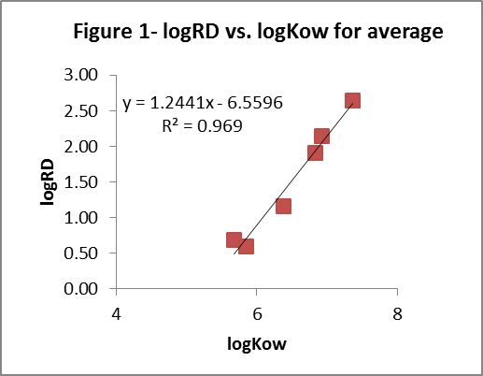
Figure 1. logRD vs. logK_{ow} for PRCs
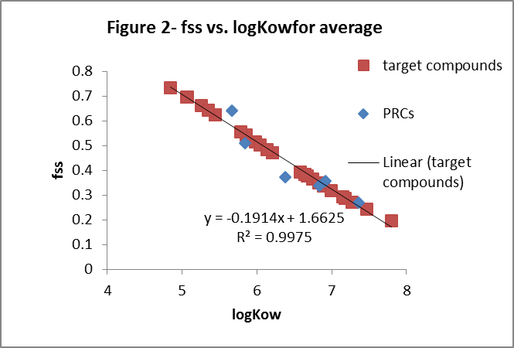
Figure 2. f_{ss} vs. logK_{ow} for PRCs and target compounds

References
- Hawker D W, Connell D W. Octanol-water partition coefficients of polychlorinated biphenyl congeners [J]. Environmental science & technology, 1988, 22(4): 382-387.
- Ghosh U, Kane Driscoll S, Burgess R M, et al. Passive sampling methods for contaminated sediments: Practical guidance for selection, calibration, and implementation [J]. Integrated environmental assessment and management, 2014, 10(2): 210-223.
Lampert, D., C. Thomas and D. Reible (2015). "Internal and external transport significance for predicting contaminant uptake rates in passive samplers." Chemosphere 119: 910-916.

