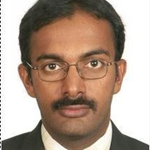
Department of Chemical Engineering
Seminar Schedule

Development and Modification of Epoxy Resins for High Performance Composites
Prashanth Badrinarayanan
Technical Services Manager, Olin Epoxy
Abstract
Fiber reinforced composites are increasingly considered as metal replacements due to their high strength to weight ratio, lightweight, and durability. As a consequence, there is a growing need for polymer matrices that enable a balance of processing ease while delivering specific performance characteristics such as higher service temperatures and enhanced damage tolerance. This presentation will discuss the development and modification of epoxy resins for demanding composite applications ranging from aerospace to compressed gas storage.
Bio

Seminar
Friday, October 20, 2017
3:00 pm
Livermore 101

