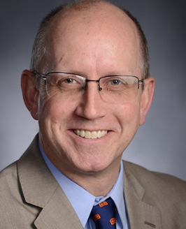
Department of Chemical Engineering
Seminar Schedule

Wrinkled Polymeric Coatings via Shape Memory Activation: A Cell Alignment Study
Patrick T. Mather
Chemical Engineering, Bucknell University
Abstract
Approaches to the creation and study of materials for tissue engineering utilize natural or synthetic scaffolds intended to mimic the natural biological environment for seeding with cells and eventual achievement of the targeted tissue. Achievement of fundamental understanding of cell-material interactions in this complex system has been difficult, so some researchers have turned to model environments, most notably biologically functionalize flat-surfaces. Recognizing the geometric limitations of such studies, we have adopted an approach of studying cell behavior on wrinkled and actively wrinkling substrates (somewhere between 2D and 3D materials) and that will be the topic of my presentation. We prepared such materials by applying a thin, rigid coating to a strained shape memory polymer. When the shape memory polymer is thermally triggered to shrink, the thin coating is compressed and responds by wrinkling. Interestingly, we have been able to identify parameters for this system that yield wrinkles who spatial characteristics (wavelength, amplitude) match the dimensions of adherent biological cells. Consequently, cells respond quite dramatically in their dynamics and geometric configuration when plated on wrinkled substrates. The talk reveals trends that we observe in cell behavior for variations in coating composition and wrinkle characteristics. The work is in collaboration with Prof. James H. Henderson and Dr. Ariel Ash-Shakoor of Syracuse University and is funded by NSF under DMR-1609523.

Bio
Patrick T. Mather holds his doctorate in materials engineering from the University of California, Santa Barbara. He came to Bucknell from Syracuse University, where he led the creation of and served as the founding director of the Syracuse Biomaterials Institute, an interdisciplinary center with more than 20 faculty spanning three institutions and eight departments, including Syracuse's L.C. Smith College of Engineering & Computer Science and its College of Arts & Sciences. He was also the Milton & Ann Stevenson Professor of Biomedical & Chemical Engineering and previously held the position of faculty chair of Syracuse's engineering college.

Seminar
Friday, Feb 9, 2018
3:00 pm
Livermore 101

