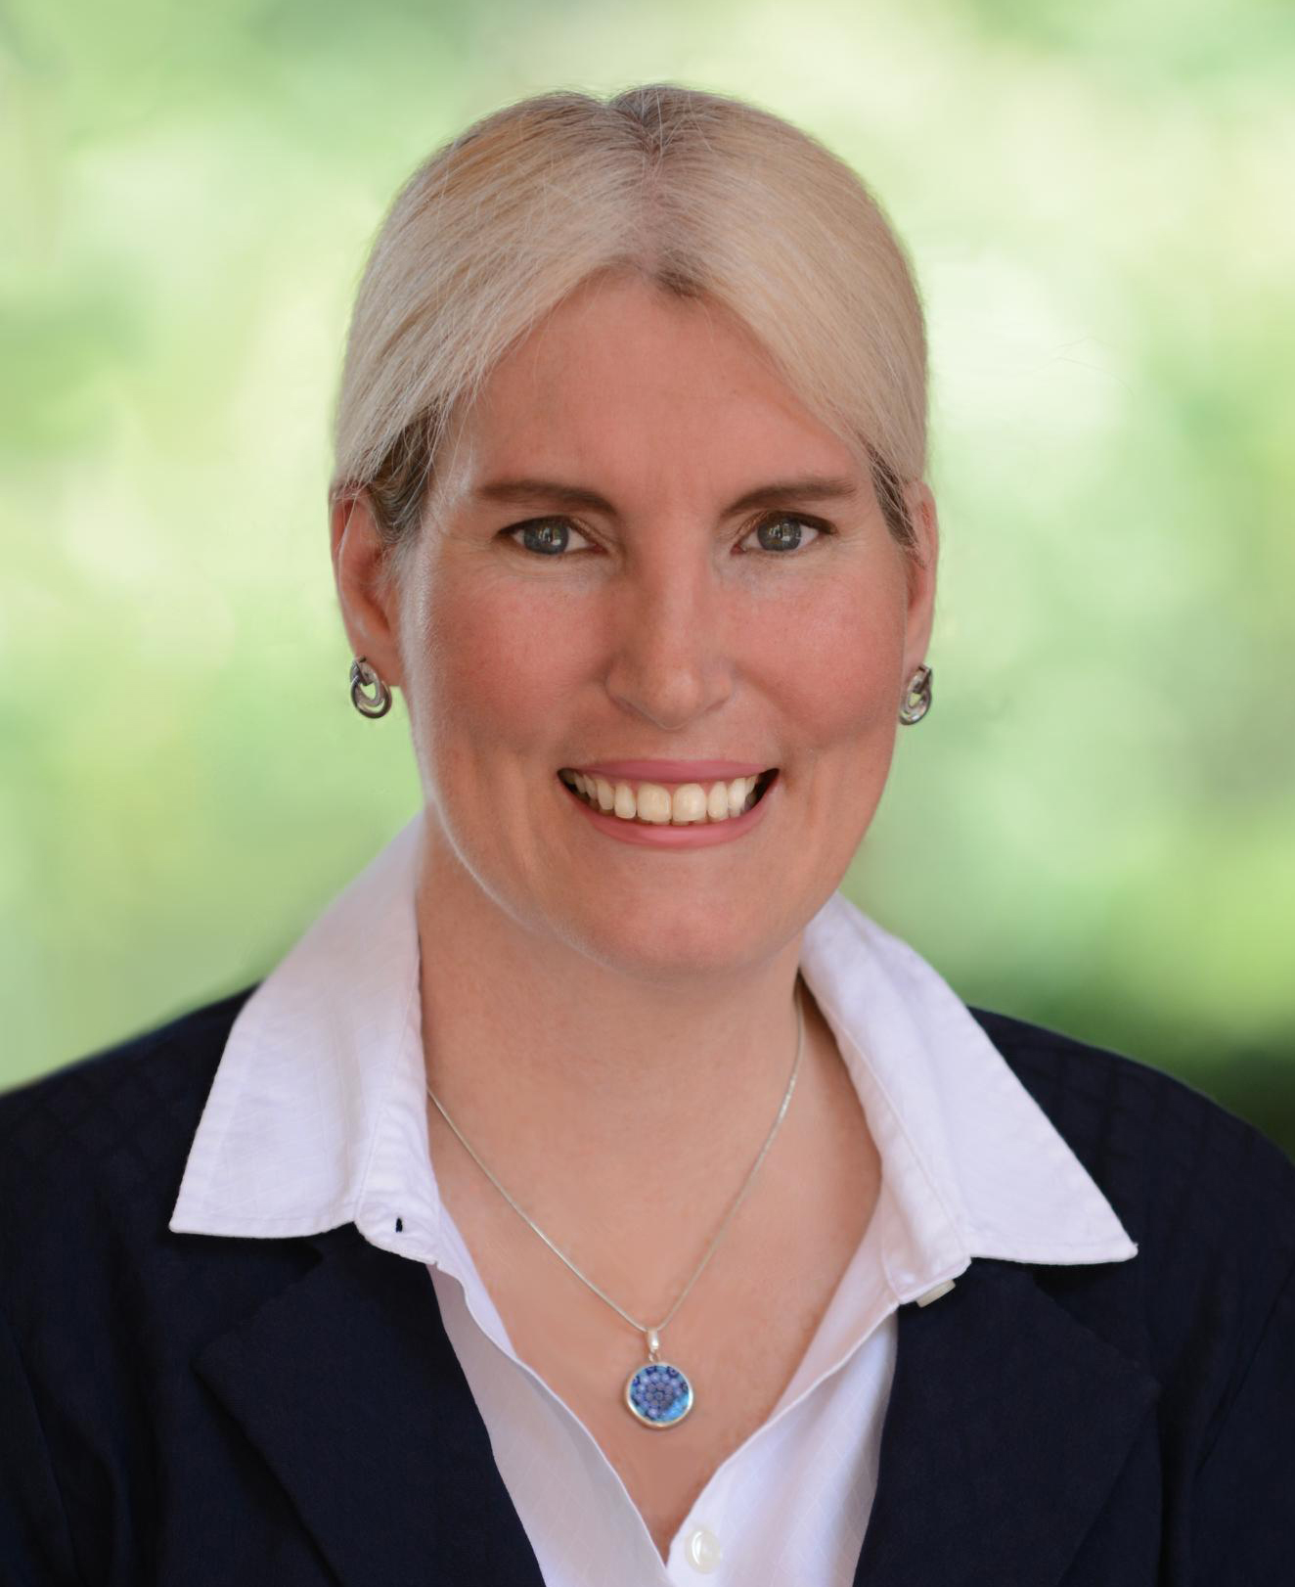
Department of Chemical Engineering
Seminar Schedule

Understanding Heterogeneous Water Oxidation Catalysis
Laser Technologist
California Institute of Technology
Astrid M. Müller
Abstract
Conversion of solar energy into storable fuels is essential to meet future global energy demands. Efficient, robust materials that are exclusively made of non-precious elements are imperative for a sustainable energy economy. I rationally designed first-row transition metal (hydr)oxide water oxidation nanocatalysts and realized them by pulsed-laser in liquids synthesis. I advanced this method into a reactive technique and prepared multimetal nanomaterials with tailored compositions by adding metal ions into the aqueous liquid. My method is game changing because of its rapidity, control of size and composition, unnecessity of surfactants, and ease of preparation of multimetal nanostructures. My approach enabled atomistic level understanding and concomitant optimization of highly active, robust nickel–iron layered double hydroxide nanocatalysts for water oxidation in base.
Structural analysis of these mixed-metal nanocatalysts provided evidence that water oxidation occurred at edge-site iron centers. We discovered that interlayer anions played key roles during turnover, as incorporating anions with different basicities tuned the catalytic performance of these materials. Our nanocatalysts were regenerated and most active in alkaline electrolyte in ambient air, where ubiquitous carbonate rapidly replaced other interlayer anions. And we gained structural and mechanistic insights from in-situ spectroscopy data: we identified a cis-dioxo iron(VI) reactive intermediate as the lowest-energy species before O–O bond formation during water oxidation catalysis.
Bio
Astrid M. Müller is a Staff Scientist at the California Institute of Technology, where she has developed pulsed-laser ablation in liquids into a reactive chemistry-under-extreme-condition technique to synthesize controlled mixed-metal nanomaterials for solar energy solutions. She has extensive experience in the research of ultrafast light-matter interactions, laser spectroscopy of organic solar cell materials, and heterogeneous catalysts and photoelectrodes for sustainable energy applications. She double-majored in Chemistry and Chemical Engineering at the Master's level at the Technical University Munich, and obtained her Ph.D. in Physical Chemistry (magna cum laude) from the Ludwig-Maximilians-Universität München in Germany for her work at the Max-Planck-Institute of Quantum Optics in Prof. Karl-Ludwig Kompa's group. Through a Fellowship by the German Research Foundation, she moved to the U.S. for postdoctoral work with Prof. Stephen R. Leone at CU Boulder and UC Berkeley, and with Prof. Christopher J. Bardeen at UC Riverside, before she joined the Beckman Institute at Caltech. Her current research interests focus on the discovery and atomistic understanding of laser-synthesized inorganic nanomaterials that serve as electrocatalysts or light absorbers for solar water-splitting devices.

Seminar
Wednesday, Feb 28
3:00 pm
Livermore 101

