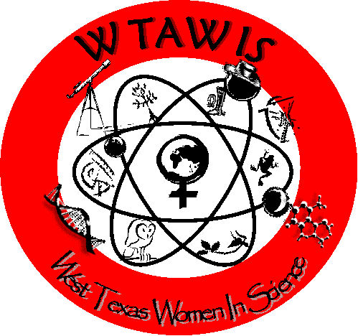 WT-AWIS
C.O.W and O.W.L Awards
Nomination Instructions
C.O.W - Champion of Women in Science
O.W.L - Outstanding Woman Leader in Science
www.ciser.ttu.edu/wis/awards

- Champion of Women (C.O.W.) Award
- Outstanding Woman Leader (O.W.L.) Award

These awards are given by WT-AWIS members only, during the spring semester of each year, and are for the purpose of recognizing men (Champion of Women Award/C.O.W.) and women (Outstanding Woman Leader Award/O.W.L.) who are active supporters of women in science, and who have demonstrated their commitment to the education, training and mentoring of women, as well as to overall gender equity in science. Male TTU or TTUHSC faculty and staff are eligible for C.O.W. nominations; female TTU or TTUHSC faculty and staff personnel are eligible for O.W.L. nominations; and members of the community are also eligible for nomination. Students are not eligible for nomination for this award.

Nominator and Nominee Information (1 page maximum)

In the first page of the nomination document, include the following:
1. Name(s) and contact information (phone, email, affiliation, position/title) of those submitting the nomination (At least one person must be a WT-AWIS/AWIS member –i.e., having paid dues to submit a nomination. Student dues are $15 to the local organization. Join now!)
2. Name and contact information (phone, email, affiliation, position/title, department/campus) of the COW or OWL nominee, and indicate which award.

Nomination Narrative (1 page maximum)

On the second page of the nomination document, discuss the following:
1. Why does this person deserve to be a C.O.W. or O.W.L.?
2. How has this person supported or promoted women in science?
(Specific examples will help the committee in the selection process.)

Nominations are due via email as a 2 page PDF document in the spring semester of each year to WT-AWIS Records Chair julie.isom@ttu.edu

