Editor's Column
Editors:
Bret Hendricks, EdD
Annette Tommerdahl, PhD
Tanner Hargrove
Hannah Wilhite
In This Issue:
Editor’s Column
Welcome & COVID Updates
Advising Updates
Master’s Comprehensive Examinations: Spring 2022
Internship: Spring 2022
Practicum Reservations for Summer 2022
2022 Conference Information
Updated Program Objectives
Chi Sigma Iota
Student Dispositions
Program Evaluation
CACREP Accreditation
Social Media
Advisory Board
Admissions Procedures
Important Numbers & Information
EPCE & Adjunct Faculty
Links for Students

Hello everyone, we hope you enjoy the new version of the Texas Tech Counselor Education Newsletter! Dr. Tommerdahl and I are pleased to present this newsletter in its new format. In this issue, we have provided CACREP updates, advising and clinical information, and the latest news about our chapter of Chi Sigma Iota, amongst other topics. We also included information about the upcoming Counselor Education Growth Conference, February 18, 2022, featuring our former student, now a bestselling author, Dr. John Delony. Also, thanks to our associate editor Tanner Hargrove, we have included a special section of music and creative pieces that we hope you enjoy!

Dr. Tommerdahl and I want to thank our wonderful associate editors, Hannah Wilhite and Tanner Hargrove, for their contributions! Hannah is now the official technology and layout editor, and Tanner is our creative contributor, and they have provided indispensable assistance in creating this newsletter! We also want to thank the advisors and EPCE faculty for their timely and thoughtful contributions to the newsletter. Finally, thanks to each of you for being a part of our wonderful program. We wish you and your family happy, safe, and restful holidays as we look forward to a new year.

Dr. Bret Hendricks

Winter Break and COVID Updates
The Counselor Education Faculty extends our best wishes for a restful Winter Break, and we will see you back in the Spring semester. As a reminder, due to the COVID-19 emergency, we continue to structure the classes to primarily include a hybrid of synchronous (live online meetings) and asynchronous (work at your own pace assignments) instruction. The Counselor Education Faculty hopes to resume classes in person when possible; however, we will continue to monitor the situation and maintain student safety and health. We ask that you remain flexible throughout this time as Texas Tech University may adopt new policies to address world health concerns. Further, please continue to check your Texas Tech University emails as you will receive updated information from the university regarding changes in policies. As per university policies, please note that Counselor Education faculty can only contact you through your @ttu.edu university email (not @gmail or another email service).

ACA Elections
I wanted to take a moment to remind and encourage all ACA members to vote for the 2022-2023 ACA president-elect. Two candidates are running: Dr. Judy Daniels and Dr. Edil Torres Rivera. Information on these candidates is in the current issue of Counseling Today.

Many of you heard Dr. Judy Daniels as she spoke to Drs. Bradley and Hendrick’s classes this semester and last spring. This past November, Dr. Judy Daniels flew in from Honolulu, Hawaii, to spend time with many of her friends and professional colleges, and made new connections in Galveston, Texas, at the TCA Professional Growth Conference.

Members of ACA should have received an email from Noreply@eballot.com on or about November 30.

Advising Updates
To watch our video regarding advising updates, please visit our website.

Master's Comprehensive Exam: March 11, 2022
Students must apply to Graduate School to be eligible to take the master's comprehensive examination, and deadlines are enforced. After the beginning of the Spring semester, you may apply by first completing the Master's Comprehensive Exam Application and returning it to gradforms.educ@ttu.edu. To register for the Comprehensive Examination, students must be enrolled in EPCE 5094 (Internship 2) and have completed all other coursework required for the master's degree. The form will be sent at the beginning of the Spring 2022 semester.

To register for the national Counselor Preparation Comprehensive Examination (CPCE), the following two steps are required:
- Register with CPCE for approval to test.
- Register with Pearson V.U.E. after receiving approval for the test itself. Students will create an account and pay a $75 test fee.
To complete these registrations, you will receive information from Dr. Gould in the Spring. We anticipate that the Testing Center will be available for the Comprehensive Exam in the Spring; students will be informed of any changes. If the Testing Center is open, on the date of the test, students will go to the TTU Testing Center in West Hall where the test will be administered. There is an additional $20 charge at the Testing Center. At the end of the examination, students can request copies of their raw scores; the final scores are computed and given to students in letter format.

Internship: Spring 2022
Students enrolling in EPCE 5094 (Internship 2) or EPCE 6094 (Doctoral Internship 2) in Spring 2022 must complete the forms in Appendix B of the Field Handbooks no later than November 1, 2021. All students must complete and turn in new contracts each semester in which they are enrolled in practicum and internship, even if staying at the same site. In addition, all students entering practicum and internship must complete training for conducting distance counseling (online counseling) before beginning practicum or internship. They must submit evidence of the training to Dr. Gould. If you have questions about paperwork, please contact Dr. Gould at lj.gould@ttu.edu or by phone at 806-834-4224.

Practicum Reservations for Summer 2022
Students planning to enroll in Practicum (EPCE 5360 or EPCE 6360) during Summer 2022 must submit a reservation form to Dr. L.J. Gould, Counselor Education Business Manager, room 216 COE, by March 1, 2022. An Internship/Practicum meeting will be held during the Spring semester, and attendance will be mandatory. The reservation form does not enroll a student in practicum; instead, Dr. Gould must put in a permit that allows the student to register. Thus, students should contact Dr. Gould at 806-834-4224 or at lj.gould@ttu.edu to ensure that she has your information for enrollment.

Before enrolling in practicum, students must complete all prerequisite and co-requisite requirements except for a maximum of two co-requisite courses that may be taken during the semester in which the student is enrolled in practicum (NOT internship). For more information, please consult the website and review the Admitted MEd Student Handbook and the Field Experiences Handbook (Clinical Mental Health or School). Please note practicum and internship sites and site supervisors must be approved. If you plan to complete a practicum at a new site, please contact Dr. Annette Tommerdahl at atommerd@ttu.edu to ask for a site visit to be conducted to determine if the site meets approved criteria. For site approval, the student must contact Dr. Tommerdahl at least three months before enrolling in practicum or internship.

Clinical Site Information
Here is some information for students who are planning to do the Practicum in Summer 2022 and the Internship during the 2022/2023 academic year.

List of Approved Clinical Sites:
- The Ranch at Dove Tree
- Family Counseling Services
- Lubbock County Detention Center
- Roosevelt ISD (Internship only)
- TTU Career Center
- Center for Adolescent Resiliency (Internship only)
- South Plains College
- Lubbock-Crosby County Community Supervision
- Moody Neurorehabilitation Institute
- Texas Tech Equine Assisted Counseling and Wellness Lab
- Slaton ISD (Internship only)
- Lubbock ISD (Internship only)
- Lubbock State Supported Living Center

Assignments for Practicum/Internship:
During both the Practicum and Internship, students are to attend the scheduled classes and complete all assignments to successfully complete the Practicum or Internship. Students who miss class or do not complete the required assignments will not successfully complete the Practicum or Internship class. Here are the required assignments for Practicum/Internship:
- ePortfolio
- Weekly Journals
- Tapescripts
- Time Logs
Other Practicum/Internship Information:
- Professional and ethical behavior is expected at the clinical site.
- Students who are fired from the clinical site MAY NOT transfer to another clinical site and will receive a failing grade in the Practicum/Internship course.
- Attendance at all class sessions is mandatory.
- Students MAY NOT do a distance counseling Practicum/Internship unless approved by the Counselor Education faculty. If approved, the Practicum/Internship may not be more than 30% distance counseling.
- Students MAY NOT see clients during official TTU breaks. Student also MAY NOT see clients during finals week. Students are to let clients know ahead of time that they will have a break between Practicum and Internship as well as between the two semesters of Internship.
- The Practicum/Internship must be completed within a 60-mile radius of Lubbock.
- Students will be required to complete distance counseling training as part of either the Practicum or Internship.
Please direct any questions regarding the Practicum/Internship to Dr. Annette Tommerdahl at atommerd@ttu.edu.

Musical Musings
Because sometimes we find ourselves thinking about losses and gains in impactful ways…
Taylor Swift: I Bet You Think About Me

Because she’s legendary in her tone, grace, and influence… Adele: Easy on Me

Because sometimes we need a little remix! Holiday Remix

Because emotion can be influential and fluid… Nutcracker Ballet Reboot

Because the impact of our movement allows us to incite change… Seas of Crimson: Synesthesia

2022 Schedule: Upcoming Professional Conference Information
American Counseling Association Conference | April 7-10, 2022 @ Atlanta, GA  www.counseling.org
American Educational Research Conference | April 22-25, 2022 @ San Diego, CA  www.AERA.net
American School Counselor Association Conference | July 9-12, 2022 @ Austin, TX  www.schoolcounselor.org
Counselor Education Growth Conference | February 18, 2022 @ Virtual  depts.ttu.edu/education/webinars/counselor-education-growth-conference/index.php
International Association of Marriage and Family Counselors Conference | January 27-29, 2022 @ New Orleans, LA  http://www.iamfconline.org/
National Career Development Association Conference | June 27-29, 2022 @ Anaheim, CA  www.ncda.org
Texas Counseling Association Conference | November 10-11, 2022 @ Dallas, TX  www.txca.org
Texas Professional School Counselor Conference | February 13-15, 2022 @ Round Rock, TX  http://txca.org/tsca/

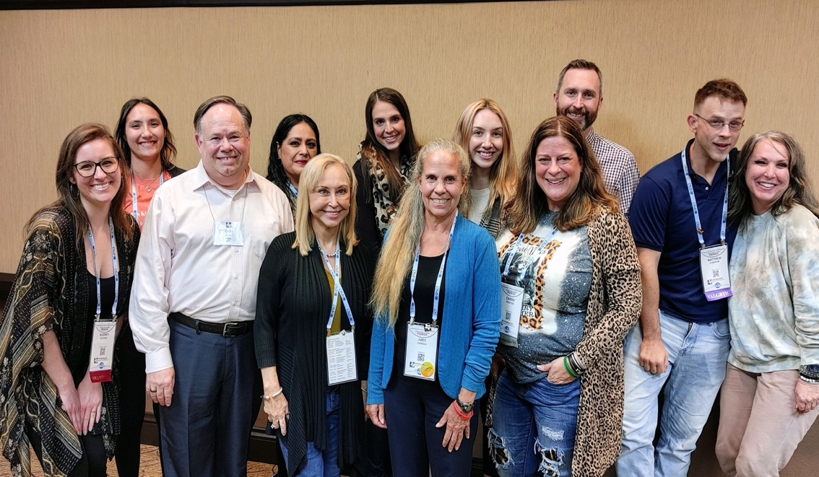

Pictured: Members of the 2021 TTU Doctoral Cohort at the Texas Counseling Association (TCA) Professional Conference in November alongside Dr. Thelma Duffey (left) and Dr. Judy Daniels (right).

TTU Counselor Education 2021 Updated Program Objectives
There are updated Counselor Education Program Objectives based on feedback from students, graduates, employers, site supervisors, and advisory board members from the Fall 2016-Summer 2021 Program Evaluation. These changes were unanimously approved by the Counselor Education Program core faculty and by the Counselor Education Advisory Board. Below is more information concerning the program objectives

Program objectives represent a map or plan for meeting learning outcomes of a program. Specifically, the Counselor Education Program's Objectives were developed to communicate the desired learning activities of the program. Further, the objectives were developed based on feedback about the program from students, graduates, site supervisors, advisory board members, and employers. Using themes from the data, the faculty developed the program objectives and agreed upon them. The objectives are required by the program's national accreditation agency CACREP (Council for the Accreditation for Counseling and Related Educational Programs).
- To support students in establishing a firm professional counseling/counselor education identity
- To foster professional and personal growth in counseling students
- To create ethically responsible counselors
- To encourage counselors-in-training to contribute to the profession in a unique and specialized manner
- To embody advocacy and social justice approaches and develop counselors-in-training who advocate for their clients and communities

The following table, titled Program Objectives Systematic Evaluation, provides an overview of the program objectives and specific measures that evaluate the objectives. Specifically, the five program objectives are listed in the left column and the measures to evaluate the objectives are listed in the columns adjacent to the objectives. For details, open the file: program-objectives-systematic-evaluation-table.xlsx

If students are interested in other program changes recently made, the link to the program changes made since Fall 2016-Fall 2021 is here.

The Program Evaluation for the Fall 2016-Summer 2021 is now available here:

In 2022, the TTU Counselor Education program will submit their CACREP Self-Study report based on the CACREP 2016 Standards. If you have any questions concerning the CACREP Self-Study, please contact Dr. Loretta Bradley and Dr. Nicole Noble.

Chi Sigma Iota National Counseling Honorary Society
Chi Sigma Iota is a great organization to get involved with to increase the development of your counselor identity. Membership in Chi Sigma Iota, as specified in the C.S.I. Bylaws, is by chapter invitation to both students and graduates of the chapter's counselor education program who meet the membership eligibility criteria specified in the Society's bylaws.

Students must have completed at least one semester of full-time graduate coursework in a counselor education degree program, have earned a grade point average of 3.5 or better on a 4.0 system, and be recommended for membership by the chapter, including promise for a capacity to represent the best about professional counseling through appropriate professional behavior, ethical judgment, emotional maturity, and attitudes conducive to working to advocate for wellness and human dignity for all. Faculty and alumni of the program shall have met the overall G.P.A. requirement as graduates of a counselor education program and be recommended to C.S.I. by the chapter. The primary identity of these persons shall be as professional counselors, including evidence of a state or national credential as a professional counselor.
While C.S.I. Headquarters will acknowledge receipt of the application and payment with a welcoming notice, full-fledged membership into the Society takes place at a formal oath-taking initiation ceremony that is arranged by the chapter. Certificates of membership and recognition pins are sent to Chapter Faculty Advisors (C.F.A.s) to be distributed during the formal initiation ceremony.
The next meeting of Chi Sigma Iota will be announced. Current and prospective members are encouraged to attend this meeting. The faculty advisors are Dr. Ian Lertora and Dr. Charles Crews. For additional information, please contact the faculty advisors Dr. Lertora at ian.lertora@ttu.edu and Dr. Crews at charles.crews@ttu.edu.

In Memorial of Dr. Sam Gladding
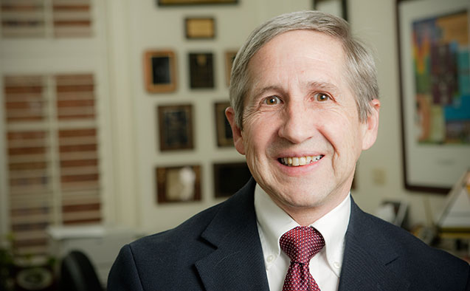
Dr. Sam Gladding, who was a counseling scholar, mentor, advocate, poet, and friend, died Monday, December 6, 2021, in Winston-Salem, NC. Many of you will remember him as the presenter at the 2019 EPCE Counselor Education Growth Conference where he, as always, presented pertinent and valuable information to his audience. Dr. Gladding truly lived his life as a consummate counseling professional and impacted the counseling profession in profound ways. Please take a moment to read more about him on his website. He was a wonderful person who will be truly missed.

Student Dispositions
Dispositions have been defined by Spurgeon, et al. (2012) as the core values, attitudes, behaviors, and beliefs needed to become a competent counselor. Essentially, these authors are positing that it takes more than knowledge and skills to become an effective counselor. The Counselor Education faculty agree with the importance of dispositions. Accordingly, the faculty endorse and promote the dispositions listed below. Please note the list is exemplary not comprehensive. Further, in instances where students do not practice and subscribe to the dispositions, the faculty may recommend to the Texas Tech University Graduate School that the student be dismissed from the Counselor Education program.

Examples of Dispositions include:
- Respect for human dignity, human rights, and social justice;
- Adherence to Multicultural Acceptance and Advocacy practice;
- Display of emotional stability inside/outside of Texas Tech University;
- Display of good professional behaviors inside/outside of Texas Tech University (e.g., in the classroom, at conferences);
- Display of strong personal characteristics including but not limited to commitment, dependability, flexibility, honesty, integrity, openness to self and others, respect, tolerance for ambiguity, trustworthiness, and the ability to shift from sympathy to empathy;
- Practices good boundaries with others (e.g., at TTU, at meetings, at professional conferences);
- Exhibits a strong understanding of and implementation of ethical codes, ethical practices, and ethical decision-making
- Understands legal issues and laws;
- Exhibits self-awareness;
- Exhibits critical thinking skills;
- Exhibits academic honesty.

NOTE: Any documented use of illegal drugs, excessive drinking to the point of danger to self and others, or any violation of the Texas Tech Student Code of Conduct will result in disciplinary action which may include recommendation to the Texas Tech Graduate School for dismissal from the program.

Students must understand that dispositions are an integral part of the student's training in both the M.E.D. and PhD programs. The Counselor Education faculty will endorse, enforce, and sanction the dispositions. There is a disposition rubric that faculty will use to rate students' dispositions. If you would like a copy of the rubric, please contact Dr. Gould at lj.gould@ttu.edu.

Source: Spurgeon, S. L., Gibbons, M. M., & Cochran, J. (2012). Creating personal dispositions for the counseling program. Counseling and Values, 57, 96-107.

Program Evaluation
The Counselor Education program at Texas Tech University is the only CACREP accredited program within a 325-mile radius of Lubbock. The program was reaccredited by CACREP in 2015, and this accreditation will remain valid until October 2023. In 2023, the program will apply for reaccreditation. An important aspect of the CACREP accreditation procedures is their attention to assessment (program assessment) and program evaluation.

The Counselor Education Faculty employ a wide array of data collection methods. In addition to data collected from examinations and classroom assignments, additional data are collected to provide broader, more intense data sources. For example, data are collected from current students, graduates, and employers. Data are used to inform Counselor Education program decisions, which in turn have resulted in the addition of a new course, revision to an existing course, and change to the course scope and sequence. We hope that you will review our program evaluations/assessments. The program evaluation is conducted every five years, and the program assessments are conducted annually; both are located here:

CACREP Accreditation
Why is CACREP Accreditation important? Below are a few of the many benefits of CACREP Accreditation.

- Employment Opportunities Students graduating from a CACREP program have increased employment opportunities. The Department of Veterans Affairs (V.A.), the Department of Defense, and the U.S. Army have specific qualification standards for positions that require that the student must have graduated from a CACREP accredited master's program. Additionally, some insurance companies only accept providers from CACREP programs.
- Recruitment of Students CACREP accreditation enhances the recruitment of students into the Counselor Education Program at TTU. Currently, the Counselor Education Program has 76 PhD-level and 97 MEd-level students. Students constantly report that they attend the TTU Counselor Education Program because it is nationally accredited by CACREP. Students are aware of the importance of CACREP in that CACREP enhances their employability.
- Recruitment of Faculty Within the counseling profession, CACREP accreditation is not only recognized by faculty but in addition, it is highly respected and sought. In fact, CACREP accreditation is like the "Good Housekeeping Seal of Approval." Because of the recognition of the importance of CACREP and because CACREP is associated with a quality program, it is easier to recruit the "best" faculty to teach in a CACREP accredited program.
- Competition CACREP accreditation enhances opportunities for the TTU Counselor Education program to compete for well-qualified students. Since the Counselor Education program is the only program west of Dallas and east of Albuquerque that has achieved CACREP accreditation, the program can successfully compete for the "best" students.
- Standards CACREP programs are reviewed against rigorous, professionally accepted standards. The standards are both difficult to achieve and difficult to maintain. The CACREP standards provide confidence to prospective students, employers, and the public to signify that the program is a "quality" program. CACREP accreditation provides recognition that the content and the quality of the program have been evaluated to meet the standards of the counseling profession.
- Licensure Students graduating from a CACREP program have an increased chance at licensure. The CACREP office reported that CACREP graduates perform better on the National Counselor Exam (N.C.E.), an exam required for licensure in Texas and 47 other states.
- Accountability CACREP accreditation provides a system for accountability. CACREP programs must undergo peer evaluation that ensures that the program meets and maintains the CACREP Standards (The EPCE programs at TTU were accredited for the maximum time of 8 years; our next accreditation will occur in October 2023). Once accreditation has been achieved, annual reports, data collection, and program analysis/evaluation are required annually to ensure that standards are continuing to be met.
- Improvement Accreditation stimulates program self-evaluation, program development, and program improvement. As prescribed by CACREP, the program must experience a full review every eight years in which a CACREP Team visits the CACREP program. The collegial consultation that occurs through an on-site CACREP review is important because both the verbal and written information from the site team can be incorporated into the program's curriculum and future plans.
- Recognition CACREP accreditation is not only recognized by students and professional counselors but additionally, it is recognized by professional groups. For example, CACREP is recognized by such accrediting groups as CAEP and CORE. Further, CACREP has a reciprocal agreement with CAEP.
- College of Education Reform CACREP standards correlate with the reform movement in the College of Education. The eight core areas of CACREP link to the Trademark Outcome involving the development and implementation of an advocacy, social justice leadership plan. Embedded in the eight core areas is the expectation of a sequence of courses which correlates with the P1, P2, and P3 sequence. CACREP requires that data be collected and maintained in a manner like the data maintained on the database required in the college.

Counselor Education and Social Media
Counselor Education is on Social Media (Facebook). The purpose of the Facebook page is to inform alumni, current students, prospective students, and the community about the Texas Tech University Counselor Education program. Through Facebook, readers will have the opportunity to become aware of the CACREP accredited program that is a nationally recognized program. For example, we hope the readers will go to our webpage and review information on program evaluation as well as our other assessments. Readers may join our Facebook page today by following this link.
As the counseling profession incorporates and adopts more technology, the growth in social media is continually becoming more common. The program would like to increase its presence on Instagram and Twitter.

Counselor Education Advisory Board
The Counselor Education Advisory Board meets annually. The purpose of the Advisory Board is to make recommendations to the faculty regarding curricula, accreditation, recruitment, assessment, and program evaluation. The next Advisory Board meeting will likely be held in October next year. The Advisory Board meeting will be held virtually via Zoom. The board has been invaluable in our program evaluation and assessment. The members of the Advisory Board are:

Capt. Ryan C. Brown | Director of Programs & Accreditations, Lubbock Sheriff's Office
Pam Brown | Director of Counseling & Assessment, Lubbock-Cooper I.S.D.
Sofia Chapman | Associate Dean, Texas Tech University School of Law
Tammy Edmonson | School Counselor, All Saints
Julia Finch | Counseling Department Supervisor, Lubbock County Community Supervision and Corrections Department
Gordon Jones | L.P.C., Gordon Jones Counseling Services
Jay Killough, PhD | Director, Texas Tech Career Center
Don McCormick | School Counselor (Retired)
Gloria Moore | Director of Special Education, SELCO
Eddie Owens | Exec. Director, Integrated Marketing, Wayland Baptist University
Glenna Payne | School Counselor, O.L. Slaton Junior High School
Charlotte Sessom | Director, Counseling & College/Career Readiness
Leon Williams | Counseling Specialist, Project Intercept LISD
Marion O. Williams | MD, Montford Psychiatric Unit

Admissions Procedures
Admission to the Counselor Education Programs requires that an application be submitted through the Graduate School portal located here. Please note that the Counselor Education programs admit only in the Fall semester. The applicant will be required to create an account through which application materials may be submitted. Materials required at the time of application for both the master's programs and the PhD program are: all post-secondary transcripts, a personal statement, resume, and three professional recommendations. School Counseling master's applicants will also be required to provide a valid Texas Teaching Certificate and a Service Record showing a minimum of two years credible classroom experience. Application deadlines are as follows: master's programs deadline – June 1st; PhD program deadline is scheduled for January 15th. If you have questions about the admissions process, contact Dr. Gould at lj.gould@ttu.edu or 806-834-4224.

EPCE Faculty
Full Time (Alphabetical Order):
Loretta J. Bradley, PhD | Horn Distinguished Professor, Coordinator of Counselor Education, & Director, PhD Program
Charles Crews, PhD | Associate Professor & Director, School Counseling Program
Ian Lertora, PhD | Assistant Professor
Bret Hendricks, EdD | Professor, Counselor Education, & Associate Dean, College of Education
aretha marbley, PhD | Professor & Director, Clinical Mental Health Counseling Program
Nicole Noble, PhD | Assistant Professor
Annette Tommerdahl, PhD | Instructor

Adjunct Faculty (Alphabetical Order)
D. Brown, PhD | Adjunct Professor, Counselor Education
D. Kabell, PhD | Adjunct Professor, Counselor Education
S. Jennings, PhD | Adjunct Professor, Counselor Education

Important Numbers & Emergency Information
Texas Tech University has implemented an Emergency Alert Notification system to communicate important alerts and emergency response information to students, faculty, and staff. To receive alerts, update your contact information here.

Emergency 911: Ambulance, Fire, Police

Texas Tech Police (Non-emergency): 806-742-3931

Physical Plant (Maintenance Emergencies): 806-742-3301 or 806-742-3328 (after 5pm)

Information Technology: 806-742-HELP. or for Server-related issues, 806-742-3649

Texas Department of Public Safety: 806-747-4491

Texas State Board of Examiners of Professional Counselors

Texas Tech University Graduate Writing Center

Counselor Education Program Handbook

