Editors:
Bret Hendricks, EdD
Annette Tommerdahl, PhD
Tanner Hargrove
Hannah Wilhite
In This Issue:
Editor’s Column
CACREP & Vital Statistics Report
Texas Counseling Association Conference Proposals
Advising Updates
New Student Orientations
Course Rotations & Class Offerings 2022-2023
Master’s Comprehensive Examinations: Spring 2023
Internship: Spring 2023
Practicum Reservations: Summer 2023
Creative Musings
2022-2023 Conference Information
Updated Program Objectives
Chi Sigma Iota
Student Dispositions
Program Evaluation
CACREP Accreditation
Social Media
Advisory Board
Admissions Procedures
Important Numbers & Information
EPCE & Adjunct Faculty
Links for Students

Editor's Column
Hello everyone, we hope you enjoy this latest version of the Texas Tech Counselor Education Newsletter for Spring/Summer, 2022! We are pleased to present this newsletter in its new format. In this issue, we have provided CACREP updates, advising and clinical information, and the latest news about our chapter of Chi Sigma Iota, amongst other topics. We also included information about the upcoming Counselor Education Growth Conference, which will be happening in early spring of 2023 and we will keep you informed about any new information about the conference. Also, thanks to our associate editor Tanner Hargrove, we have included a special section of music and creative pieces that we hope you enjoy!
Dr. Tommerdahl and I want to thank our wonderful associate editors, Hannah Wilhite and Tanner Hargrove, for their contributions! Hannah is now the official technology and layout editor, and Tanner is our creative contributor, and they have provided indispensable assistance in creating this newsletter! We also want to thank the advisors and EPCE faculty for their timely and thoughtful contributions to the newsletter. Finally, thanks to each of you for being a part of our wonderful program. We wish you and your family a happy, safe, and restful summer as we look forward to a new year.
Dr. Bret Hendricks

CACREP & Vital Statistics Report

The Counselor Education Faculty wants to extend information about our updated CACREP and Vital Statistics Report. This information is found on our website located here.

Texas Counseling Association Conference Proposals

The 66th Annual TCA Professional Growth Conference will be held on November 9 - 11, 2022 in Dallas, TX. Students may submit a conference proposal here.

Advising Updates
Advising Update

There are several sites/forms that you may need to access regarding information that you will need as you go through the Counseling programs. First, on Raiderlink, you need to know about the MyTech tab. This is the page that you will use when enrolling in classes each semester. Additionally, when you are in your final semester, this is the page where you will find and file your Intent to Graduate (Please note: if a problem occurs, and you do not graduate, another form will be required as the Intent does not roll over). It is also the page where you will find the link to your Student Dashboard where you can change your graduation date if needed. Another page that you will find helpful is your DegreeWorks. In DegreeWorks, you will find a listing of courses you have completed and a listing of other requirements (Comprehensive or Qualifying Examination, Responsible Scholarship Training, and major requirements) that are required prior to graduation. Reviewing this page periodically allows you to make any changes to information on DegreeWorks that may be incorrect.

You should review the Graduate School homepage (https://www.depts.ttu.edu/gradschool/), especially the Academic Progress tab which provides links that you may need regarding deadlines, commencement information, and forms that you may need if you are defending your PhD dissertation. The College of Education homepage (https://www.depts.ttu.edu/education/) has information about the College , and the Resources tab has links to student resources such as the Change of Degree Plan form and the Master’s Comprehensive Exam Application form, as well as student travel, scholarships and financial aid, and other information that you may need.

If you have advising questions, please contact your faculty advisor. All students, both master’s and PhD, should have received information from Dr. Gould about fall registration. If you have not registered for fall classes, we ask that you please do so as soon as possible.

New Student Orientations
The Master of Education in Clinical Mental Health Counseling (MEd in CMHC) 2022 Cohort student orientation will be held during a regular class time of EPCE 5353, Introduction to Clinical Mental Health Counseling. If you have questions concerning this orientation, please contact Dr. aretha marbley at aretha.marbley@ttu.edu.

Course Rotations & Class Offerings 2022-2023

Clinical Mental Health Counseling (60 hour program)

Fall (Year 1) | Spring (Year 1) | Summer I (Year 1) | Summer II (Year 1)
EPCE 5353, Introduction to Clinical Mental Health Counseling  EPCE 5364, Theories of Counseling  EPCE 5370, Ethical and Legal Issues in Counseling | EPCE 5362, Pharmacologics for LPCs (Currently offered as EPCE 5369)  EPCE 5371, Counseling Diverse Populations for LPC  EPCE 5377, Crisis Counseling | EPCE 5376, Assessment for Professional Counselors  EPSY 5331, Human Development | EPCE 5355, Introduction to Career Counseling  EPCE 5367, Couples and Family Counseling
Fall (Year 2) | Spring (Year 2) | Summer I (Year 2) | Summer II (Year 2)
EPCE 5357, Techniques of Counseling I  EPCE 5366, Dysfunctional Behavior  EPCE 5372, Addictions: An Overview | EPCE 5354, Group Counseling  EPCE 5374, Techniques of Counseling II  EPCE 5369, Ethics II | EPCE 5360, Practicum in Counseling  EPSY 5379, Introduction to Educational Research
Fall (Year 3) | Spring (Year 3)
EPCE 5094, Internship in  Counseling I | EPCE 5094, Internship in  Counseling II

School Counseling (48-hour program)

Spring (Year 1) | Summer I (Year 1) | Summer II (Year 1) | Fall (Year 1)
EPCE 5358, Introduction to School Counseling  EPCE 5370, Ethical and Legal Issues in Counseling | EPCE 5371, Counseling Diverse Populations for LPC  EPCE 5364, Theories of Counseling |  | EPCE 5357, Techniques of Counseling I  EPCE 5358, Child & Adolescent Counseling
Spring (Year 2) | Summer I (Year 2) | Summer II (Year 2) | Fall (Year 2)
EPCE 5354, Group Counseling  EPSY 5331, Human Development | EPCE 5367, Couples and Family Counseling  EPCE 5355, Introduction to Career Counseling |  | EPCE 5376, Assessment for Professional Counselors  EPCE 5377, Crisis Counseling
Spring (Year 3) | Summer I (Year 3) | Summer II (Year 3) | Fall (Year 3)
EPCE 5360, Practicum in Counseling  EPSY 5379, Introduction to Educational Research | EPCE 5094, Internship in  Counseling I |  | EPCE 5094, Internship in  Counseling II

PhD in Counselor Education

Fall (Year 1) | Spring (Year 1) | Summer I (Year 1) | Summer II (Year 1)
EPCE 6335, Advanced Theory and Techniques  EPCE 6337, Advanced Ethics and Legal Issues in Counseling  EPCE 6350, Doctoral Seminar in Counseling: Scholastic Writing I | EPCE 6354, Advanced Theory and Practice of Group Leadership  EPCE 6336, Advanced Consultation, Diversity, Social Justice, and Advocacy  EPSY 5380, Introduction to Statistics | EPCE 6360, Advanced Practicum in Counseling  EPSY 5382, Qualitative Research in Education  {Specialization/Research Course}
Fall (Year 2) | Spring (Year 2) | Summer I (Year 2) | Summer II (Year 2)
EPCE 6094, Doctoral Internship in Counseling I  EPSY 5381, Intermediate Educational Statistics  EPSY 6379, Foundations of Educational Research | EPCE 6094, Doctoral Internship in Counseling  EPCE 6355, Scholastic Writing and Teaching  EPSY 6320, Mixed Methods Research | EPCE 6366, Advanced Supervision in Counselor Education  {Specialization/Research Course}
Fall (Year 3)
EPCE 8000, Dissertation Qualifying Examination

Counseling Core: 27 hours (9 courses)
Research Core: 15 hours (5 courses: EPSY 5381, 5382, 6320, and two additional courses)
Foundations: 9 hours (3 courses: EPCE 6350, EPSY 5380, EPSY 6379)
Specialization/Minor: 15-21 hours (5-7 courses)
Counseling Issues: 9-15 hours (3-5 courses)
Qualifying Exam: 1 hour (EPCE 8000)
Dissertation: 12 hours (including Qualifying Examination)

TOTAL: 93 hours. Please note: We have no control over when the EPSY courses will be offered.

Master's Comprehensive Exam: Spring 2023
Students must apply to the Graduate School to be eligible to take the master's comprehensive examination, and deadlines are enforced. After the beginning of the Spring semester, you may apply by first completing the Master's Comprehensive Exam Application and returning it to gradforms.educ@ttu.edu. To register for the Comprehensive Examination, students must be enrolled in EPCE 5094 (Internship 2) and have completed all other coursework required for the master's degree. The form will be sent at the beginning of the Spring 2023 semester.

To register for the national Counselor Preparation Comprehensive Examination (CPCE), the following two steps are required:
- Register with CPCE for approval to test.
- Register with Pearson V.U.E. after receiving approval for the test itself. Students will create an account and pay a $75 test fee.
To complete these registrations, you will receive information from Dr. Gould in the Spring. We anticipate that the Testing Center will be available for the Comprehensive Exam in the Spring; students will be informed of any changes. If the Testing Center is open, on the date of the test, students will go to the T.T.U. Testing Center in West Hall where the test will be administered. There is an additional $20 charge at the Testing Center. At the end of the examination, students can request copies of their raw scores; the final scores are computed and given to students in letter format.

Internship: Fall 2022
Students enrolling in EPCE 5094 (Internship I) or EPCE 6094 (Doctoral Internship I) in Fall 2022 must complete the forms in Appendix B of the Field Handbooks. All students must complete and turn in new contracts each semester in which they are enrolled in practicum and internship, even if staying at the same site. In addition, all students entering practicum and internship must complete training for conducting distance counseling (online counseling) before beginning practicum or internship. They must submit evidence of the training to Dr. Gould. If you have questions about paperwork, please contact Dr. Gould at lj.gould@ttu.edu or by phone at 806-834-4224.

Practicum Reservations for Summer 2023
Students planning to enroll in Practicum (EPCE 5360 or EPCE 6360) during Summer 2023 must submit a reservation form to Dr. L.J. Gould, Counselor Education Business Manager, room 216 COE, by March 1, 2023. An Internship/Practicum meeting will be held during the Spring semester, and attendance will be mandatory. The reservation form does not enroll a student in practicum; instead, Dr. Gould must put in a permit that allows the student to register. Thus, students should contact Dr. Gould at 806-834-4224 or at lj.gould@ttu.edu to ensure that she has your information for enrollment.

Before enrolling in practicum, students must complete all prerequisite and co-requisite requirements except for a maximum of two co-requisite courses that may be taken during the semester in which the student is enrolled in practicum (NOT internship). For more information, please consult the website and review the Admitted MEd Student Handbook and the Field Experiences Handbook (Clinical Mental Health or School). Please note practicum and internship sites and site supervisors must be approved. If you plan to complete a practicum at a new site, please contact Dr. Annette Tommerdahl at atommerd@ttu.edu to ask for a site visit to be conducted to determine if the site meets approved criteria. For site approval, the student must contact Dr. Tommerdahl at least three months before enrolling in practicum or internship. Also, if your site requires a contract for practicum or internship, you must allow an extra month for the contract to be approved by the university.

Clinical Site Information
Here is some information for students who are planning to do the Practicum in Summer 2023 and the Internship during the 2022/2023 academic year.

List of Approved Clinical Sites:
- The Ranch at Dove Tree
- Family Counseling Services
- Lubbock County Detention Center
- Roosevelt ISD (Internship only)
- TTU Career Center
- Center for Adolescent Resiliency
- South Plains College
- Lubbock-Crosby County Community Supervision
- Moody Neurorehabilitation Institute
- Texas Tech Equine Assisted Counseling and Wellness Lab
- Slaton ISD (Internship only)
- Lubbock ISD (Internship only)
- Lubbock State Supported Living Center

Assignments for Practicum/Internship:
During both the Practicum and Internship, students are required to attend all the scheduled classes and complete all assignments to successfully complete the Practicum or Internship. Students who miss class or do not complete the required assignments will not successfully complete the Practicum or Internship class. Here are the required assignments for Practicum/Internship:
- ePortfolio
- Weekly Journals
- Tapescripts
- Time Logs
Other Practicum/Internship Information:
- Professional and ethical behavior is expected at the clinical site.
- Students who are fired from the clinical site MAY NOT transfer to another clinical site and will receive a failing grade in the Practicum/Internship course.
- Attendance at all class sessions is mandatory.
- Students MAY NOT do a distance counseling Practicum/Internship unless approved by the Counselor Education faculty. If approved, the Practicum/Internship may not be more than 30% distance counseling.
- The Practicum/Internship must be completed within a 60-mile radius of Lubbock.
- Students will be required to complete distance counseling training as part of either the Practicum or Internship.
Please direct any questions regarding the Practicum/Internship to Dr. Annette Tommerdahl at atommerd@ttu.edu.

Creative Musings

Music
When we need to be reminded that we are not alone…
  - Brandi Carlile: Party of One feat. Sam Smith
  - https://www.youtube.com/watch?v=Ll_QeA-1LZM

When some inanimate companionship is welcomed…
  - Little Big Town: Wine, Beer, Whiskey
  - https://www.youtube.com/watch?v=FDF0Y9KOloY

Poetry
When we need a little permission to LIVE life…
  - “Direct Orders,” Slam Poetry by Anis Mojgani

You have been given a direct order to rock the f*** out.
Rock out like you were just given the last rock and roll record on earth and the minutes are counting down to flames. Rock out like you just won both showcase showdowns.
Rock out like the streets are empty except for you, your bicycle and your headphones.
Rock out like your lips were just placed onto a breakdancing muse with legs that go all the way up.
Rock out like you’ll never have to open a textbook again.
Rock out like you get paid to disturb the peace.
Rock out like music is all that you got.
Rock out like you’re standing on a rooftop and the city’s as loud and glowing as a river below you.
Rock out like the plane is going down, there are 120 people on board, and 121 parachutes.
Rock out like the streets and the books are all on fire and the only way it can be extinguished is by doin’ the Electric Slide.
Rock out like it’s Saturday afternoon and Monday is a national holiday.
Rock out like somebody’s got a barrel pointed at your temple saying ‘Rock out like your life depended on it, fool, because it does.
Rock out like your eyes are fading but you still got your ears. But you don’t know for how long so rock out like 5 o’clock time, meant pop-and-lock time.
Rock out like you got a pants full of tokens and nothing to do but everything.
Rock out like you are the international ski-ball champion of the entire universe.
Rock out like you just escaped an evil orphanage to join a Russian circus.
Rock out like your hero is fallen and you are spinning your limbs until they burst into a burning fire of remembrance.
Rock out like you are enslaved in the south and dancing is all that you have to know who you are.
Rock out like your dead grandfather just came back to take a drive with you in your brand-new car. Rock out like the table is full.
Rock out like the neighbors are away.
Rock out like the walls won’t fall but, damn it, you’re going to die trying to make them.
Rock out like the stereo’s volume knob is the figure 8 of infinity instead of merely numbers.
Rock out like it’s raining outside, and you’ve got a girl to run through it with.
Rock out like you’re playing football in the mud and your washing machine is not broken.
Rock out like you’re throwing your window open on your honeymoon because you want the whole world to know what love is. Rock out like you just got a book published.
Rock out like you just went to your high school reunion to find everyone, even the women, are all ugly and bald, except for the former homecoming queen, who you just found out, got divorced from her impotent husband and only has eyes for…YOU!
Rock out like a shadow man passes behind you, drops you to your knees. You’re buckling in sweat, cold metal is pushed to your forehead, the trigger’s pulled and the gun jams.
Rock out like you got an empty appointment book, and a full tank of gas.
Rock out like Jimi has returned carrying brand new guitar strings.
Rock out like the mangoes are in season. Rock out like the record player won’t skip.
Rock out like this was the last weekend, like these were the last words, like you don’t ever want to forget how.

When inspiration is subtle, yet powerful…
  - “Coherence in Consequence,” by Claudia Rankine

Imagine them in black, the morning heat losing within this day that floats. And always there is the being, and the not-seeing on their way to—

The days they approach and their sharpest aches will wrap experience until knowledge is translucent, the frost on which they find themselves slipping. Never mind the loose mindless grip of their forms reflected in the eye-watering hues of the surface, these two will survive in their capacity to meet, to hold the other beneath the plummeting, in the depths below each step full of avoidance. What they create will be held up, will resume: the appetite is bigger than joy. indestructible. for never was it independent from who they are. who will be.

Art
When life feels like it is an amalgamation of all the things…
  - The Family, by Paula Figueiroa Rego, 1982

When strength needs to be felt in our souls…
  - Untitled, Normal Lewis, 1965

2022-2023 Schedule: Upcoming Professional Conference Information
American Counseling Association Conference | March 30 - April 2, 2023 @ Toronto, Canada  www.counseling.org
American Educational Research Conference | April 2023 (TBD) @ Chicago, IL  www.AERA.net
American School Counselor Association Conference | July 9-12, 2022 @ Austin, TX  www.schoolcounselor.org
International Association of Marriage and Family Counselors Conference | February 2-4, 2023 @ St. Petersburg, FL  http://www.iamfconline.org/
National Career Development Association Conference | June 27-29, 2022 @ Anaheim, CA  www.ncda.org
Texas Counseling Association Conference | November 10-11, 2022 @ Dallas, TX  www.txca.org
Texas Professional School Counselor Conference | February 12-14, 2023 @ Round Rock, TX  http://txca.org/tsca/

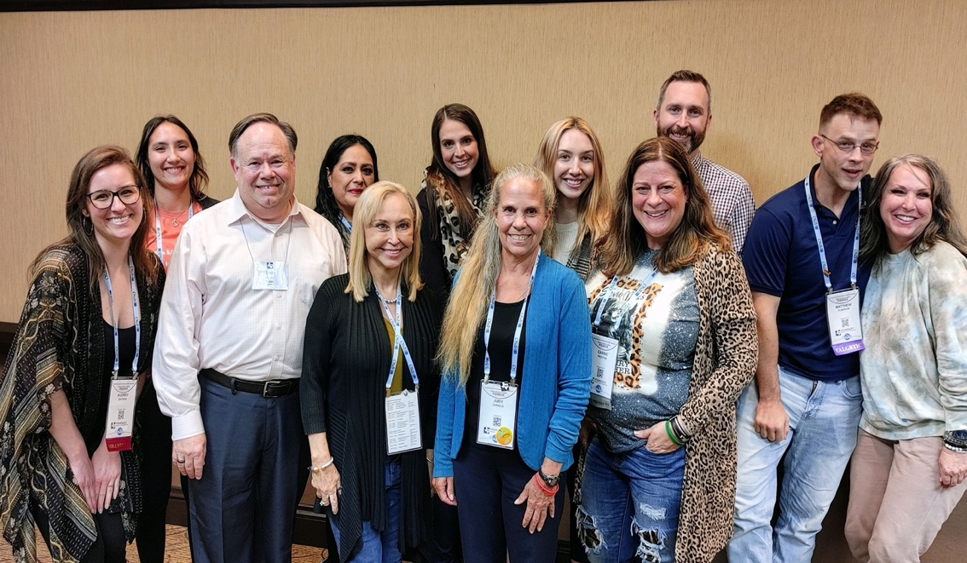

Pictured:

Top: Members of the 2021 TTU Doctoral Cohort at the Texas Counseling Association (TCA) Professional Conference in November alongside Dr. Thelma Duffey (left) and Dr. Judy Daniels (right).

Bottom: Members of the 2021 TTU Doctoral Cohort at the American Counseling Association (ACA) Professional Conference in April 2022 in Atlanta, GA.

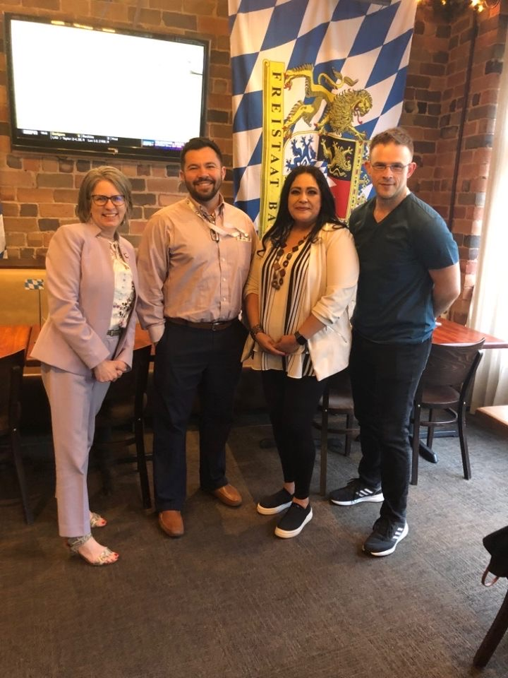

TTU Counselor Education 2021 Updated Program Objectives
There are updated Counselor Education Program Objectives based on feedback from students, graduates, employers, site supervisors, and advisory board members from the Fall 2016-Summer 2021 Program Evaluation. These changes were unanimously approved by the Counselor Education Program core faculty and by the Counselor Education Advisory Board. Below is more information concerning the program objectives.

Program objectives represent a map or plan for meeting learning outcomes of a program. Specifically, the Counselor Education Program's Objectives were developed to communicate the desired learning activities of the program. Further, the objectives were developed based on feedback about the program from students, graduates, site supervisors, advisory board members, and employers. Using themes from the data, the faculty developed the program objectives and agreed upon them. The objectives are required by the program's national accreditation agency CACREP (Council for the Accreditation for Counseling and Related Educational Programs).
- To support students in establishing a firm professional counseling/counselor education identity
- To foster professional and personal growth in counseling students
- To create ethically responsible counselors
- To encourage counselors-in-training to contribute to the profession in a unique and specialized manner
- To embody advocacy and social justice approaches and develop counselors-in-training who advocate for their clients and communities

The following table, titled Program Objectives Systematic Evaluation, provides an overview of the program objectives and specific measures that evaluate the objectives. Specifically, the five program objectives are listed in the left column and the measures to evaluate the objectives are listed in the columns adjacent to the objectives. For details, open the file: program-objectives-systematic-evaluation-table.xlsx

If students are interested in other program changes recently made, the link to the program changes made since Fall 2016-Fall 2021 is here.

The Program Evaluation for the Fall 2016-Summer 2021 is now available here:

In 2022, the TTU Counselor Education program submitted their CACREP Self-Study report based on the CACREP 2016 Standards. Information about the Counselor Program Evaluation and Accreditation is linked here. If you have any questions concerning the CACREP Self-Study, please contact Dr. Loretta Bradley or Dr. Nicole Noble.

Chi Sigma Iota National Counseling Honorary Society
Chi Sigma Iota is a great organization to get involved with to increase the development of your counselor identity. Membership in Chi Sigma Iota, as specified in the C.S.I. Bylaws, is by chapter invitation to both students and graduates of the chapter's counselor education program who meet the membership eligibility criteria specified in the Society's bylaws.

Students must have completed at least one semester of full-time graduate coursework in a counselor education degree program, have earned a grade point average of 3.5 or better on a 4.0 system, and be recommended for membership by the chapter, including promise for a capacity to represent the best about professional counseling through appropriate professional behavior, ethical judgment, emotional maturity, and attitudes conducive to working to advocate for wellness and human dignity for all. Faculty and alumni of the program shall have met the overall G.P.A. requirement as graduates of a counselor education program and be recommended to C.S.I. by the chapter. The primary identity of these persons shall be as professional counselors, including evidence of a state or national credential as a professional counselor.
While C.S.I. Headquarters will acknowledge receipt of the application and payment with a welcoming notice, full-fledged membership into the Society takes place at a formal oath-taking initiation ceremony that is arranged by the chapter. Certificates of membership and recognition pins are sent to Chapter Faculty Advisors (C.F.A.s) to be distributed during the formal initiation ceremony.
The next meeting of Chi Sigma Iota will be announced. Current and prospective members are encouraged to attend this meeting. The faculty advisors are Dr. Ian Lertora and Dr. Charles Crews. For additional information, please contact the faculty advisors Dr. Lertora at ian.lertora@ttu.edu and Dr. Crews at charles.crews@ttu.edu.

Student Dispositions
Dispositions have been defined by Spurgeon, et al. (2012) as the core values, attitudes, behaviors, and beliefs needed to become a competent counselor. Essentially, these authors are positing that it takes more than knowledge and skills to become an effective counselor. The Counselor Education faculty agree with the importance of dispositions. Accordingly, the faculty endorse and promote the dispositions listed below. Please note the list is exemplary not comprehensive. Further, in instances where students do not practice and subscribe to the dispositions, the faculty may recommend to the Texas Tech University Graduate School that the student be dismissed from the Counselor Education program.

Examples of Dispositions include:
- Respect for human dignity, human rights, and social justice;
- Adherence to Multicultural Acceptance and Advocacy practice;
- Display of emotional stability inside/outside of Texas Tech University;
- Display of good professional behaviors inside/outside of Texas Tech University (e.g., in the classroom, at conferences);
- Display of strong personal characteristics including but not limited to commitment, dependability, flexibility, honesty, integrity, openness to self and others, respect, tolerance for ambiguity, trustworthiness, and the ability to shift from sympathy to empathy;
- Practices good boundaries with others (e.g., at T.T.U., at meetings, at professional conferences);
- Exhibits a strong understanding of and implementation of ethical codes, ethical practices, and ethical decision-making
- Understands legal issues and laws;
- Exhibits self-awareness;
- Exhibits critical thinking skills;
- Exhibits academic honesty.

NOTE: Any documented use of illegal drugs, excessive drinking to the point of danger to self and others, or any violation of the Texas Tech Student Code of Conduct will result in disciplinary action which may include recommendation to the Texas Tech Graduate School for dismissal from the program.

Students must understand that dispositions are an integral part of the student's training in both the M.E.D. and PhD programs. The Counselor Education faculty will endorse, enforce, and sanction the dispositions. Students are evaluated according to the dispositions in the rubric below:

Rubric to Rate Dispositions

Student: Class: Date: Instructor:

Subskill | Unacceptable  1 | Poor  2 | Fair/Adequate  3 | Good  4 | Excellent  5 | Score
Attendance and Punctuality | Often misses class and is usually late | Occasionally misses class and/or is often late to class | Attends almost all classes and/or is sometimes late to class | Rarely misses class and is rarely late to class | Never misses class and is never late to class
Preparedness | Usually ill- prepared for class, (e.g., failure to read text) | Often is ill- prepared for class, (e.g., failure to read text) | Usually comes to class prepared | Almost always comes to class well prepared | Always comes to class very well prepared
Engagement | Rarely contributes to class discussions | Often fails to contribute to class discussions | Usually contributes to class discussions | Almost always makes valuable contributions to class discussions | Always makes very valuable contributions to class discussions
Attentiveness | Usually distracted by emails, texts, Facebook, calls, etc. | Often distracted by emails, texts, Facebook, calls, etc. | Usually focused and free of distractions from emails, texts, Facebook, calls, etc. | Almost always focused and free of distractions from emails, texts, Facebook, calls, etc. | Always focused and free of distractions from emails, texts, Facebook, calls, etc.
Respectful | Usually ignores or disrupts speaker | Often ignores or disrupts speaker | Usually listens to speaker | Almost always listens responsively to speaker | Always listens very responsively to speaker
Teamwork | Usually avoids or manipulates to find ways to escape working on the team | Often avoids or manipulates to find ways to escape accepting duties on the team | Usually accepts duties and responsibilities and participates in the team effort | Almost always assumes responsibility and displays initiative in completing team tasks. | Always assumes a leadership role on a team by not only contributing to the team’s mutual tasks but also by exceeding assigned responsibilities
Non-defensiveness | Usually responds to feedback defensively | Often responds to feedback somewhat defensively | Usually responds to feedback non-defensively | Almost always responds to feedback productively | Always utilizes feedback in productive and positive ways
Morale | Usually creates negative morale by being negative and recalcitrant | Often creates negative moral by being negative and recalcitrant | Usually achieves a balance of being cooperative while being proactive and having the courage of one’s convictions | Almost always achieves a balance of being cooperative while expressing proactivity in ways that enhance the class | Always conveys cooperation while also asserting proactive leadership that enhances the class
Decorum/ Presentation/ Presence/Attire | Usually inappropriate for class context | Often inappropriate for class context | Usually appropriate for class context | Almost always appropriate for class context | Always appropriate for class context
Professional Behaviors | Usually demonstrates inappropriate behaviors in and outside of TTU (e.g., excessive drinking to the point of danger to self or others; swearing) | Often demonstrates inappropriate behaviors in and outside of TTU  (e.g., excessive drinking to the point of danger to self or others; swearing) | Usually demonstrates appropriate behaviors in and outside of TTU | Almost always demonstrates appropriate behaviors in and outside of TTU | Always demonstrates appropriate behaviors in and outside of TTU
Boundary Issues | Usually both ignores and crosses boundaries | Often both ignores and crosses boundaries | Usually has appropriate boundaries | Almost always has appropriate boundaries | Always has appropriate boundaries
Professional Identity as a Counselor | Usually does not identify as a professional counselor, does not attend counseling conferences, is not a member of ACA, its divisions, or branches | Often does not identify as a professional counselor, does not attend counseling conferences, is a member of ACA, its divisions, or branches | Usually identifies as a professional counselor, attends some counseling conferences, and is a member of ACA, its divisions, or branches | Almost always identifies as a professional counselor, attends and presents at counseling conferences, and is a member of ACA and its divisions, and branches | Always identifies as a professional counselor, attends and presents at counseling conferences, and is a member of ACA, its divisions, and branches
Mean Rating
Total
Comments:

If you would like a copy of the rubric, please contact Dr. Gould at lj.gould@ttu.edu.

Source: Spurgeon, S. L., Gibbons, M. M., & Cochran, J. (2012). Creating personal dispositions for the counseling program. Counseling and Values, 57, 96-107.

Program Evaluation
The program was reaccredited by CACREP in 2015, and this accreditation will remain valid until October 2023. In 2023, the program will apply for reaccreditation. An important aspect of the CACREP accreditation procedures is their attention to assessment (program assessment) and program evaluation.

The Counselor Education Faculty employ a wide array of data collection methods. In addition to data collected from examinations and classroom assignments, additional data are collected to provide broader, more intense data sources. For example, data are collected from current students, graduates, and employers. Data are used to inform Counselor Education program decisions, which in turn have resulted in the addition of a new course, revision to an existing course, and change to the course scope and sequence. We hope that you will review our program evaluations/assessments. The program evaluation is conducted every five years, and the program assessments are conducted annually; both are located here:

CACREP Accreditation
Why is CACREP Accreditation important? Below are a few of the many benefits of CACREP Accreditation.

- Employment Opportunities Students graduating from a CACREP program have increased employment opportunities. The Department of Veterans Affairs (V.A.), the Department of Defense, and the U.S. Army have specific qualification standards for positions that require that the student must have graduated from a CACREP accredited master's program. Additionally, some insurance companies only accept providers from CACREP programs.
- Recruitment of Students CACREP accreditation enhances the recruitment of students into the Counselor Education Program at T.T.U. Currently, the Counselor Education Program has 76 PhD-level and 97 MEd-level students. Students constantly report that they attend the T.T.U. Counselor Education Program because it is nationally accredited by CACREP. Students are aware of the importance of CACREP in that CACREP enhances their employability.
- Recruitment of Faculty Within the counseling profession, CACREP accreditation is not only recognized by faculty but in addition, it is highly respected and sought. In fact, CACREP accreditation is like the "Good Housekeeping Seal of Approval." Because of the recognition of the importance of CACREP and because CACREP is associated with a quality program, it is easier to recruit the "best" faculty to teach in a CACREP accredited program.
- Competition CACREP accreditation enhances opportunities for the T.T.U. Counselor Education program to compete for well-qualified students.

- Standards CACREP programs are reviewed against rigorous, professionally accepted standards. The standards are both difficult to achieve and difficult to maintain. The CACREP standards provide confidence to prospective students, employers, and the public to signify that the program is a "quality" program. CACREP accreditation provides recognition that the content and the quality of the program have been evaluated to meet the standards of the counseling profession.
- Licensure Students graduating from a CACREP program have an increased chance at licensure. The CACREP office reported that CACREP graduates perform better on the National Counselor Exam (N.C.E.), an exam required for licensure in Texas and 47 other states.
- Accountability CACREP accreditation provides a system for accountability. CACREP programs must undergo peer evaluation that ensures that the program meets and maintains the CACREP Standards (The EPCE programs at T.T.U. were accredited for the maximum time of 8 years; our next accreditation will occur in October 2023). Once accreditation has been achieved, annual reports, data collection, and program analysis/evaluation are required annually to ensure that standards are continuing to be met.
- Improvement Accreditation stimulates program self-evaluation, program development, and program improvement. As prescribed by CACREP, the program must experience a full review every eight years in which a CACREP Team visits the CACREP program. The collegial consultation that occurs through an on-site CACREP review is important because both the verbal and written information from the site team can be incorporated into the program's curriculum and future plans.
- Recognition CACREP accreditation is not only recognized by students and professional counselors but additionally, it is recognized by professional groups. For example, CACREP is recognized by such accrediting groups as CAEP and CORE. Further, CACREP has a reciprocal agreement with CAEP.
- College of Education Reform CACREP standards correlate with the reform movement in the College of Education. The eight core areas of CACREP link to the Trademark Outcome involving the development and implementation of an advocacy, social justice leadership plan. Embedded in the eight core areas is the expectation of a sequence of courses which correlates with the P1, P2, and P3 sequence. CACREP requires that data be collected and maintained in a manner like the data maintained on the database required in the college.

Counselor Education and Social Media
Counselor Education is on Social Media (Facebook). The purpose of the Facebook page is to inform alumni, current students, prospective students, and the community about the Texas Tech University Counselor Education program. Through Facebook, readers will have the opportunity to become aware of the CACREP accredited program that is a nationally recognized program. For example, we hope the readers will go to our webpage and review information on program evaluation as well as our other assessments.
As the counseling profession incorporates and adopts more technology, the growth in social media is continually becoming more common. The program would like to increase its presence on Instagram and Twitter.

Counselor Education Advisory Board
The Counselor Education Advisory Board meets annually. The purpose of the Advisory Board is to make recommendations to the faculty regarding curricula, accreditation, recruitment, assessment, and program evaluation. The next Advisory Board meeting will likely be held in October 2022. The Advisory Board meeting will be held virtually via Zoom. The board has been invaluable in our program evaluation and assessment. The members of the Advisory Board are:

Capt. Ryan C. Brown | Director of Programs & Accreditations, Lubbock Sheriff's Office
Pam Brown | Director of Counseling & Assessment, Lubbock-Cooper I.S.D.
Sofia Chapman | Associate Dean, Texas Tech University School of Law
Tammy Edmonson | School Counselor, All Saints
Julia Finch | Counseling Department Supervisor, Lubbock County Community Supervision and Corrections Department
Gordon Jones | L.P.C., Gordon Jones Counseling Services
Jay Killough, PhD | Director, Texas Tech Career Center
Don McCormick | School Counselor (Retired)
Gloria Moore | Director of Special Education, SELCO
Eddie Owens | Exec. Director, Integrated Marketing, Wayland Baptist University
Glenna Payne | School Counselor, O.L. Slaton Junior High School
Charlotte Sessom | Director, Counseling & College/Career Readiness
Leon Williams | Counseling Specialist, Project Intercept LISD
Marion O. Williams | MD, Montford Psychiatric Unit

Admissions Procedures
Admission to the Counselor Education Programs requires that an application be submitted through the Graduate School portal located here. Please note that the Counselor Education programs admit only in the Fall semester. The applicant will be required to create an account through which application materials may be submitted. Materials required at the time of application for both the master's programs and the PhD program are: all post-secondary transcripts, a personal statement, resume, and three professional recommendations. School Counseling master's applicants will also be required to provide a valid Texas Teaching Certificate and a Service Record showing a minimum of two years credible classroom experience. Application deadlines are as follows: master's programs deadline – June 1st; PhD program deadline is scheduled for January 15th. If you have questions about the admissions process, contact Dr. Gould at lj.gould@ttu.edu or 806-834-4224.

EPCE Faculty
Full Time (Alphabetical Order):
Loretta J. Bradley, PhD | Horn Distinguished Professor, Coordinator of Counselor Education, & Director, PhD Program
Charles Crews, PhD | Associate Professor & Director, School Counseling Program
Bret Hendricks, EdD | Professor, Counselor Education, & Associate Dean, College of Education
Ian Lertora, PhD | Assistant Professor
aretha marbley, PhD | Professor & Director, Clinical Mental Health Counseling Program
Nicole Noble, PhD | Assistant Professor
Annette Tommerdahl, PhD | Instructor

Adjunct Faculty (Alphabetical Order)
D. Kabell, PhD | Adjunct Professor, Counselor Education
S. Jennings, PhD | Adjunct Professor, Counselor Education
S. Lilly, PhD | Adjunct Professor, Counselor Education
L. Pearson, PhD | Adjunct Professor, Counselor Education
S. Southern, EdD | Adjunct Professor, Counselor Education

Important Numbers & Emergency Information
Texas Tech University has implemented an Emergency Alert Notification system to communicate important alerts and emergency response information to students, faculty, and staff. To receive alerts, update your contact information here.

Emergency 911: Ambulance, Fire, Police

Texas Tech Police (Non-emergency): 806-742-3931

Physical Plant (Maintenance Emergencies): 806-742-3301 or 806-742-3328 (after 5pm)

Information Technology: 806-742-HELP. or for Server-related issues, 806-742-3649

Texas Department of Public Safety: 806-747-4491

Texas State Board of Examiners of Professional Counselors

Texas Tech University Graduate Writing Center

Counselor Education Program Handbook

