Retention/Graduation Rates

The following data from the Texas Education Agency (TEA) provide an overview of the Texas Tech educator preparation program in respect to admission and retention.

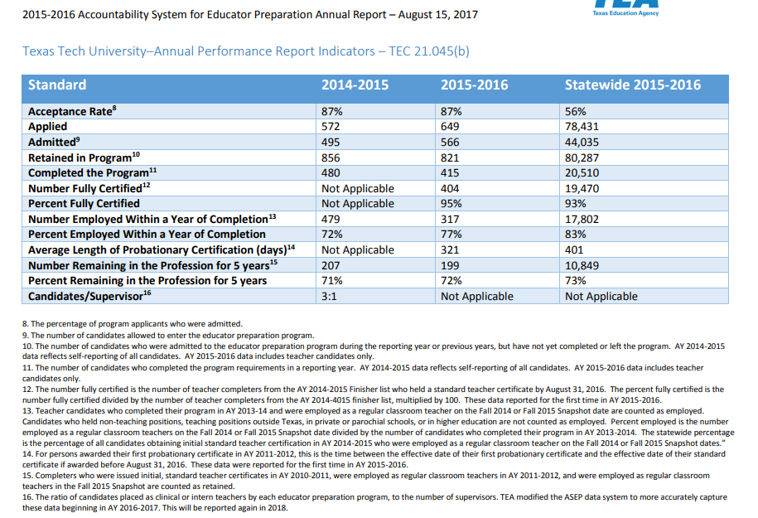

The traditional idea of a student graduating in a four-year period for an undergraduate degree is not as feasible as it used to be. Today, there are many outside demands on time, such as the need for outside employment and participation in curricular activities.

The following indicates a cohort of 85 new students entering the College of Education in fall 2012. Of the 85 students, 48 or 56.47% graduated in four years, with 14 still enrolled.

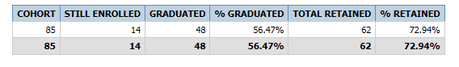

Over a five-year period, 55 or 64.71% graduated

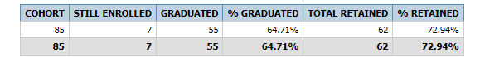

A graduation rate of 60% and higher tends to be usual and reasonable in a university setting.

However, the College of Education now has an accelerated 2+1 program through partnership arrangements with school districts and community colleges throughout Texas. During this Tech Teach across Texas program, candidates complete a two year community college associate’s degree and then conclude upper-level course work and student teaching in one calendar year.

