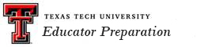

Impact on P-12 Learning and Development

A major focus of educator preparation assessment is to measure the impact candidates have on the clients and communities they serve. The growth of P-12 students’ knowledge, skills, and dispositions is a basic measure of the success of college candidates. As part of this process, school districts provide a variety of data concerning the performance of their students on district assessments, and on the State of Texas Assessments of Academic Readiness (STAAR) test. These data are used to determine the impact educator candidates have on the public school students, and becomes the bases for educator preparation program improvement.

Dashboard 1 indicates growth in STAAR performance in schools that have teacher candidates in classrooms serving as co-teachers (traditional student teachers). Such data allow school district and university collaboration to advance the education of both P-12 students and university candidates.

Dashboard 1
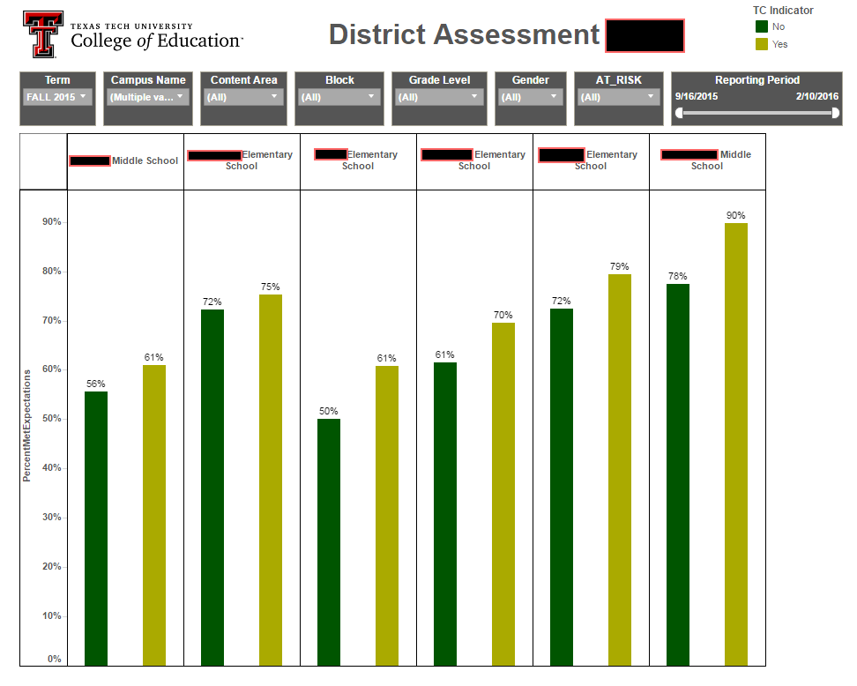

Another source of STAAR analysis data is from CREATE (The Center for Research, Evaluation and Advancement of Teacher Education). CREATE, a consortium of several university systems in Texas, provides an annual PACE (Performance Analysis for Colleges of Education) Report. One portion of the report considered information about school districts within a 75 mile radius of Texas Tech, which is called the Proximal Zone of Professional Influence (PZPI).

The following tables indicate how TTU candidates impact P-12 student learning.

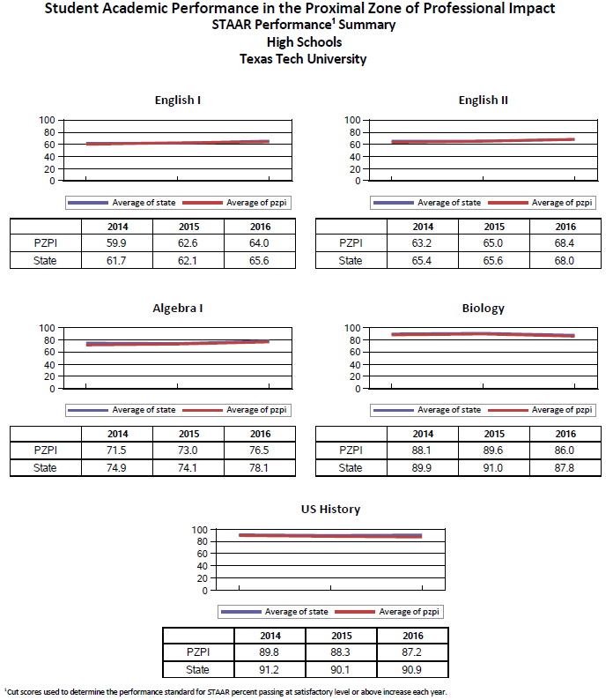

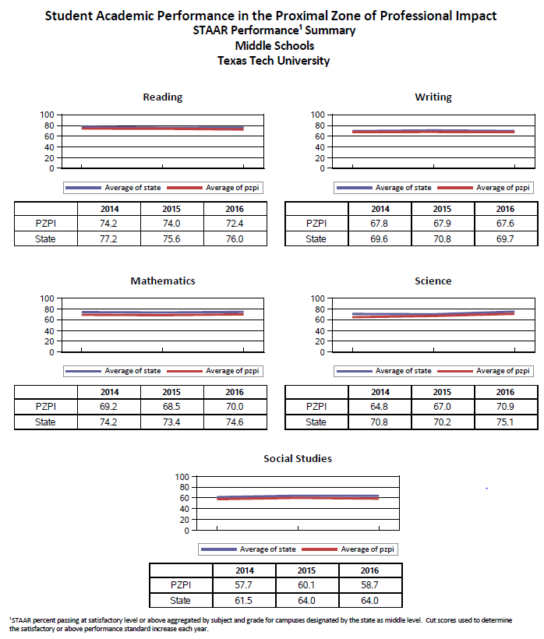

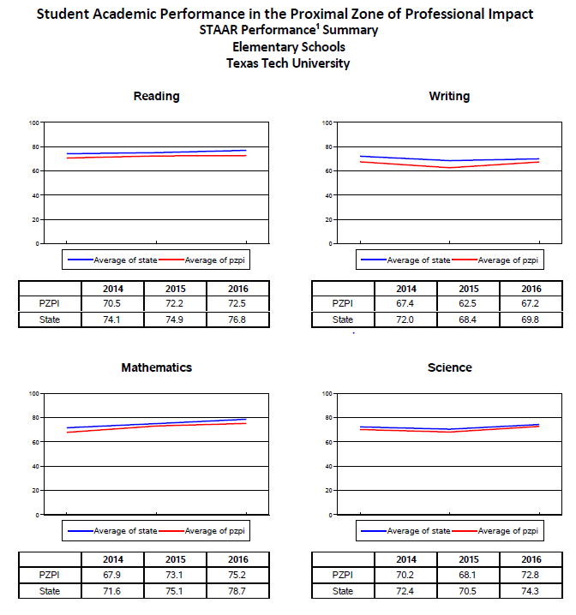

Another means of judging TTU candidates’ impact on P-12 student learning is to analyze impact that TTU College of Education Teacher Candidates (TC) have on the performance of students on standardized tests. Here are data as an example from one school district.

Because the sample is small, particularly when examined by campus, it is premature to draw a definitive conclusion on the impact that TTU TCs have on student performance. However, the data provides initial and promising evidence that students perform slightly higher in classes where a TC and Mentor Teacher (MT) operate as a team (MT-TC dyad).

Classification legend:

MT_TC: Refers to the Mentor Teacher/Teacher candidate dyad.
COMP: Refers a random sample of Teachers that do not have a Teacher Candidate in their classroom during the examination period.

Figure 2 shows a comparison of the MT_TC dyad with the COMP sample on the aggregate average of scale scores in all subjects tested.

Classification | N
COMP | 151
MT_TC | 34

Figure 3 shows a comparison of the MT_TC dyad with the COMP sample on the aggregate average of scale scores by Content Area tested.

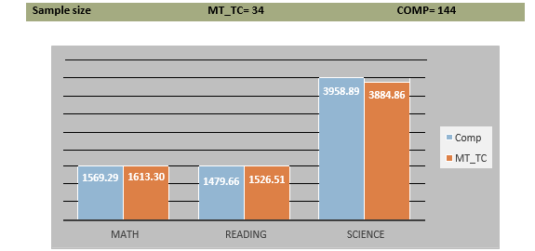

The Student Perception Survey (SPS) also provides insight into TTU candidates’ impact on P-12 student learning. The SPS is a research-based survey that is administered to students in grades 3-12. Each student completes two surveys, providing feedback to teachers and input for the teacher’s evaluation. The survey asks questions about the students’ perception about their teacher’s level of care, support, and expectations for their students, as well as their instructional methods and delivery.

This dashboard shows SPS data by different districts and can be used to compare between districts by using a variety of filters

