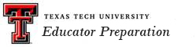
Consumer Information
A major consideration for students is to consider the general cost of attending Texas Tech University. The following table provides an overview.

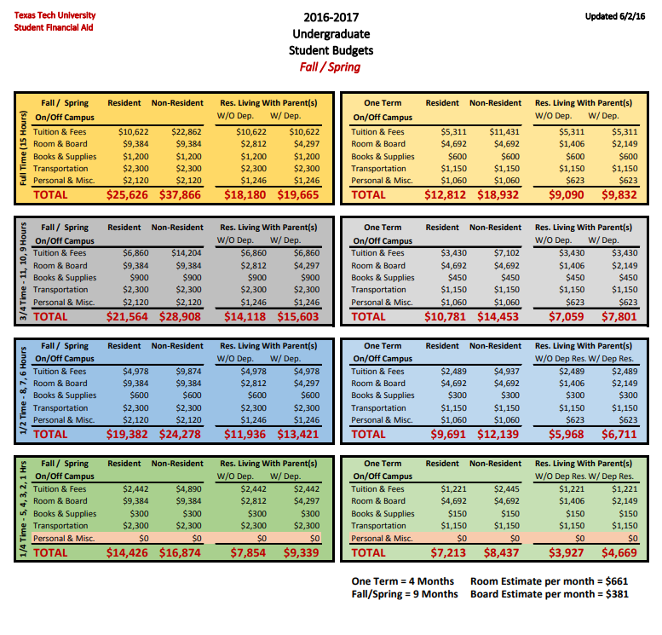
Additional details about cost at TTU is found on the Financial Aid Office webpage. Also, The Texas Education Agency (TEA) posts Consumer Information about Educator Preparation Programs to assist individuals interested in obtaining a teaching certificate.
Loan Default Rate: The official Texas Tech University cohort default rate for 2014 is 6.2% and the State of Texas average cohort default rate for 2014 was 10.4%. (2014 cohort data is the last complete data available.)

Texas Tech default rates are traditionally low when compared to the average state rate. Institutions face possible financial aid sanctions upon reaching the 30% default rate mark.

