Indicators of Candidate Teaching Effectiveness

Educator preparation at Texas Tech University has undergone major changes the past several years, resulting in Tech Teach, a reformed teacher education program. Tech Teach is a clinically-intensive, competency-based program, which prepares candidates and graduates to improve the achievement of the P-12 students with whom they work.

The TAP Rubric is used throughout Tech Teach to provide indicators of teaching effectiveness.
TAP is an instructional rubric designed by the National Institute for Excellence in Teaching as part of the Teacher Advancement Program (TAP). Texas Tech has adapted this rubric for supporting teacher candidates, using eight indicators as primary evaluation standards—instructional plans, standards and objectives, presenting instructional content, activities and materials, academic feedback, managing student behavior, questioning, and thinking.

Dashboard 1 provides an overview of TAP generated data. These dashboards are very interactive with numerous filters, such as year, semester, program, faculty, and TAP indicator. Such filters allow for varied and detailed analysis of data, all in support of program improvement, better trained candidates, and teaching effectiveness.

Dashboard 1

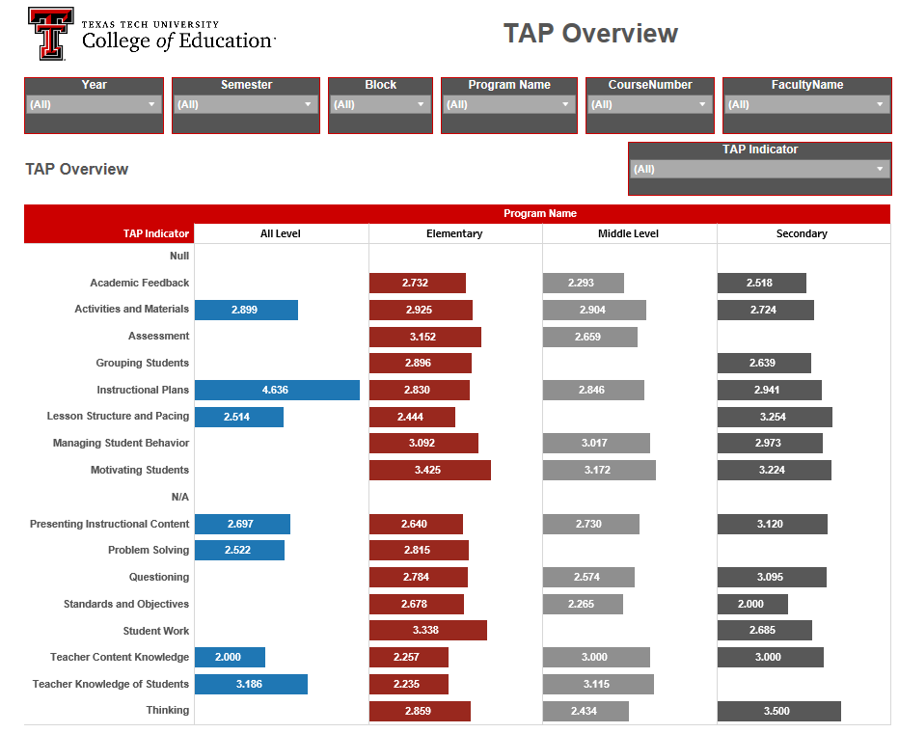

The TAP Rubric is the foundation for several assessments of teaching effectiveness: Apply and Evaluate Assignments (A&E); End of Phase Assessments (EOP), and Performance Assessments (PA).

1. Apply and Evaluate Assignments (A&E)

Each educator preparation course has an A&E assignment, which provides opportunities for candidates to practice and develop instructional skills. These skills are first taught and modeled in the college classroom, and then candidates practice in the college classroom to improve competency. Then, candidates apply the strategies in real-world, clinical settings to further refine and demonstrate competency. Candidates use a video-capture device to record their instruction, and then submit the video for self, peer, and instructor evaluations. These evaluations provide important feedback to candidates about their competency and teaching effectiveness.

2. End of Phase Assessments (EOP)

All educator programs and courses are hierarchically organized into three levels or phases, each reflecting increasing performance expectations. These expectations are reflected in corresponding end-of-phase performance assessments.
- Phase One (P1) assessments emphasize the foundational knowledge and reasoning required in the discipline.
- Phase Two (P2) assessments incorporate the knowledge, reasoning from P1 and assimilate them into practice, or skill, that takes place in guided and hypothetical settings, such as case studies and controlled clinical experiences.
- Phase Three (P3) assessments integrate the knowledge, reasoning and skills from Phase 1 with the simulated application from Phase 2, and then employ them in authentic real world settings.

The results from end-of-phase assessments are developed into dashboards, which are analyzed by faculty members to monitor candidate progress, teaching effectiveness, and program quality. If a candidate does not meet the proscribed level of competency, remediation is undertaken to advance individuals to the next Phase, or to guide them to consider other career options.

3. Performance Assessments (PA)

Performance Assessments are used to judge candidate instructional competency throughout the program. A PA cycle consists of (a) a pre-conference to review the lesson; (b) observation and scripting of lesson to gather evidence for evaluation; (c) post-lesson meeting with the candidate to review evidence, coach and assign ratings; and (d) ensuring the timely uploading of video capture and entry of ratings by the candidate and instructor into the TAP database.

The culminating Phase 3 evaluation for candidates takes place during the year-long student teaching practicum or graduate internship. During this year, candidates’ instructional competency is evaluated through four performance assessments (PA) of instructional competency. Dashboard 2, indicates an increasing tread of competency as candidates move through the four performance assessments. This dashboard also has multiple filters allowing for varied and detailed analysis of data.

Dashboard 2
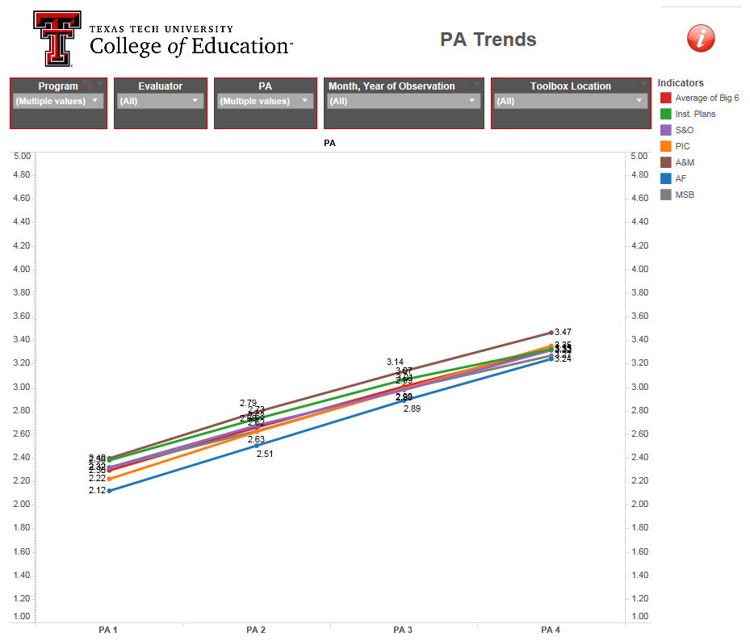

Throughout educator programs at Texas Tech, candidates are regularly and rigorously assessed to improve teaching effectiveness and program quality.

