Department of Educational Psychology and Leadership
Strategic Plan
(2015-2020)

Mission Statement

The Department of Educational Psychology and Leadership strives to provide education professionals with skills that make a distinct, measurable, and positive impact on the clients they serve through one of six programs: Counselor Education, Educational Leadership/Administration, Educational Psychology, Higher Education, Instructional Technology, and Special Education.

Vision Statement

The department’s vision is to build from a culture of excellent teaching, to advance the translation of research-based best practice into real world settings. The department will cultivate interchanges with partners, allowing candidates to convert newly learned skills into better outcomes for clients. The resulting community of engaged scholars will conduct world class research that makes a meaningful impact on the schools, agencies, and communities we serve. Our vision represents renaissance-type thought and action, where our diverse students’ ascendance is central to our curriculum and how we choose to deliver it.

Core Values Statement

Programs in the Department of Educational Psychology and Leadership are committed to the following core values:
- dignity and worth of all individuals;
- cultural diversity;
- collaboration and cooperation;
- creativity, individuality, and innovation;
- academic integrity and excellence;
- open communication and collaborative decision making;
- professional and community service;
- research into practice;
- developmentally-driven skills learning; and
- formative assessment and specific feedback.

Strategic Goals

The bolded descriptors with each objective, e.g. “Program Quality/Reputation/Student Success,” indicate an alignment with university strategic priorities. A more detailed EP&L alignment with university priorities and college goals is available at the end of this document.

Goal 1: Produce Measurably High Quality Educators
The Department of Educational Psychology and Leadership will produce graduates equipped with the knowledge, skill, and dispositional toolsets to effect positive, measurable change in any learning environment and across a range of student diversities.

Objectives:
Objective 1.1 – Program Quality/Reputation/Student Success: By 2020, the department will establish a reputation for superior programs and graduates based on trademark outcomes measured by how well our clients meet their goals.

Objective 1.2 – Enrollment: By fall 2020, contingent upon available resources, the department will grow enrollment from 842 (fall 2015) to 1,200.

Objective 1.3 – Enrollment: The department will maintain its number one ranking of graduate student enrollment (842, fall 2015) within the university. (Business Administration is second at 507.)

Objective 1.3 - Student Diversity: By 2020, EP&L students will become increasingly diverse, better aligning with ethnic demographics of statewide K-12 students.

Goal 2: Add value to the profession by collaborating with partner schools, agencies, and communities to maximize college preparedness, career readiness, and success of students at all levels (elementary through university).
The Department of Educational Psychology and Leadership will engage with school, agency, and community partners to maximize college preparedness, career readiness, and success of students at all levels; and will maximize the measured impact of graduates on the fields they serve.

Objectives:
Objective 2.1 – Program Quality/Reputation/Student Success: By 2020, 100% of department faculty and students will contribute to partner school, agency, and community improvement through internship projects, academic programs, and related research.

Objective 2.2 - Expand and Enhance Research and Creative Scholarship: The department will become known for quality research focused on school, agency, and community partnerships and collaborations.
Objective 2.3 - Further Outreach and Engagement: By 2020, the department will develop collaborations with at least one department in each college on campus and 3 collaborations at HSC to extend engagements with schools, agencies, and communities.
Objective 2.4 - Increase and Maximize Resources: By 2020, personnel and operating resources in the department will increase by 30% over the 2015/16 level to meet growing needs of the department. Allocation of resources will meet faculty identified needs.

Goal 3: Conduct client-centered research that brings measurable improvement and innovation to the field. Prepare educators to use research as a tool to improve continuously and innovate distinctively.
The Department of Educational Psychology and Leadership will use client-centered research to maximize a measured impact of graduates on the fields they serve, including maximizing EC-20 students’ college preparedness, career readiness, and success.

Objectives:
Objective 3.1 - Expand and Enhance Research and Creative Scholarship: By 2020, the department will contribute to the college’s goal of consistently being one of the top three colleges in the university for annual external funding. This will be accomplished by securing 7 million annually in competitive research funding.

Objective 3.2 - Program Quality/Reputation/Student Success: Systematic program research and departmental self-study will result in measured program innovations, improvements, and student success.

Objective 3.3 - Expand and Enhance Research and Creative Scholarship: By 2020, the combined amount of scholarly productivity in the department will increase by at least 25% from 2015 levels. Client-centered research and graduate student and faculty combined research projects will also increase.

Following is a visual representation of the department’s strategic plan.

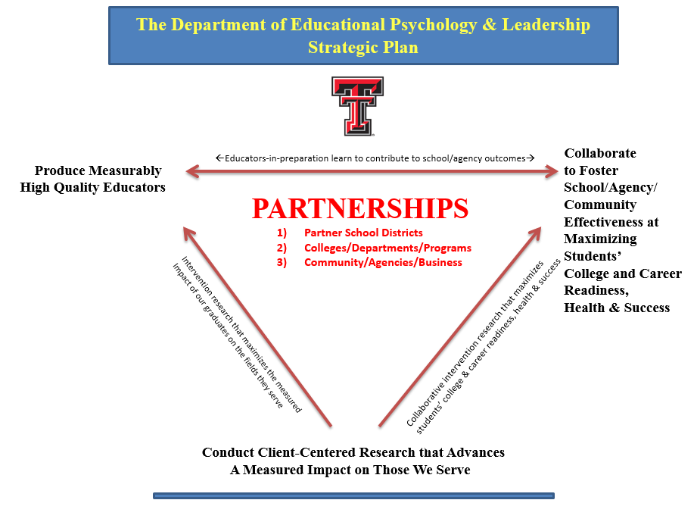

The alignment of EP&L strategic goals with those of the university and college is indicated following.

Alignment of Department, College and University
Strategic Goals and Priorities

Texas Tech University  Strategic Priorities  2010-2020 ¹ | College of Education  Strategic Goals  2015-2020 ² | Educational Psychology & Leadership  Strategic Goals  2015-2020
Strategic Priority 1, Increase Enrollment and Promote Student Success:  We will grow and diversify our student population in order to improve higher education participation and supply a well-equipped, educated workforce for the State of Texas. | Goal 1: Produce the Measurable Best Educators in the U.S.  The College will produce “trademark” graduates with distinctive skills and outcome-producing capacities that address stated market needs, thus increasing diversity and enrollments. | Goal 1: Produce Measurably High Quality Educators  The Department of Educational Psychology and Leadership will produce graduates equipped with the knowledge, skill, and dispositional toolsets to effect positive, measurable change in any learning environment and across a range of student diversities.
Strategic Priority 2 Strengthen Academic Quality and Reputation:  We will attract and retain the best faculty in the country in order to enhance our teaching excellence and grow our number of nationally recognized programs. | The attraction and retention of quality faculty are integrated throughout the COE goals. | The attraction and retention of quality faculty are integrated throughout the Department of Educational Psychology and Leadership goals.
Strategic Priority 4 Further Outreach and Engagement:  We will expand our community outreach, promote higher education and continue to engage in partnerships in order to improve our communities and enrich their quality of life. | Goal 2: Add value to the profession by collaborating with partner schools, agencies, and communities to maximize P-20 students’ college and career readiness, health, and success.  The College will engage with school, agency, and community partners to maximize college and career readiness, health, and success; and will maximize the measured impact of our graduates on the fields they serve. | Goal 2: Add value to the profession by collaborating with partner schools, agencies, and communities to maximize college preparedness, career readiness, and success of students at all levels (elementary through university).  The Department of Educational Psychology and Leadership will engage with school, agency, and community partners to maximize college preparedness, career readiness, and success of students at all levels; and will maximize the measured impact of graduates on the fields they serve.
Strategic Priority 3 Expand and Enhance Research and Creative Scholarship:  We will significantly increase the amount of public and private research dollars in order to advance knowledge, improve the quality of life in our state and nation, and enhance the state’s economy and global competitiveness. | Goal 3: Conduct research that brings measurable improvement and innovation to the field. Prepare educators to use research as a tool to continuously improve and innovate.  The College will use client-centered research to maximize a measured impact of our graduates on the fields they serve, including maximizing EC-20 students’ college and career readiness, health, and success. | Goal 3: Conduct research that brings measurable improvement and innovation to the field. Prepare educators to use research as a tool to continuously improve and innovate.  The Department of Educational Psychology and Leadership will use client-centered research to maximize a measured impact of graduates on the fields they serve, including maximizing EC-20 students’ college preparedness, career readiness, and success.
Strategic Priority 5 Increase and Maximize Resources:  We will increase funding for scholarships, professorships, and world-class facilities, and maximize those investments through more efficient operations in order to ensure affordability for students and accountability to the State of Texas. | Objective 2.6 - By 2020, personnel and operating resources in the College will have doubled from 2015 levels with funding from academic programming and fee-for-service assistance to schools, agencies, and communities. | Objective 2.4 - Personnel and operating resources in the department will increase to meet growing needs of the department.  Allocation of resources will meet faculty identified needs.
¹ The numbering of Strategic Goals and Priorities is for communication purposes and does not indicate order or importance.
² COE Strategic Goals are from the COE Strategic Plan 2015-2020.

