Does it Take Two to Tango in STEM?:
Interdisciplinary Course-Taking in Community Colleges

by

Jonathan Lyman McNaughtan*
Texas Tech University-School of Education

Grant Jackson
Center for the Study of Higher and Postsecondary Education

Peter Riley Bahr
Center for the Study of Higher and Postsecondary Education

Revised December 26, 2016

Recommended Citation: McNaughtan, J. L., Jackson, G., & Bahr, P. R. (2016). Does it take two to tango in STEM?: Interdisciplinary course-taking in community colleges. Lubbock, Texas: School of Education, Texas Tech University.

*Correspondence may be directed to the first author at Texas Tech University, Box 47071 Lubbock, TX 79409; email: jon.mcnaughtan@ttu.edu. The authors thank Patrick Perry and the Chancellor’s Office of the California Community Colleges for authorizing and providing the data used in this study. The authors also gratefully acknowledge feedback on this work provided by Leigh Arsenault, Brian Johnson, Meghan Oster, and Kimberly Truong.

Does it Take Two to Tango in STEM?:
Interdisciplinary course-taking in community colleges

Abstract
Scholars and policy makers alike have argued that the United States is faces a shortage of STEM professionals in the coming years, especially among individuals from historically disadvantaged backgrounds (e.g., black, Hispanic, and Native American heritage). As the country increases in diversity, and the STEM sector is left with a shortage of workers, many predict negative consequences on the economic competitiveness of the country in a continually globalized marketplace. Some researchers have focused on the role that community colleges can play in enhancing the STEM pipeline, due to their position in the higher education landscape as access points for historically disadvantaged groups. Research has demonstrated both the stark rates of attrition for all students, but especially for historically disadvantaged students, as well as the potential of these institutions to increase participation in STEM fields. This study continues this line of research by presenting the case for an interdisciplinary approach to both studying STEM student course-taking. We first present evidence of the inherently interdisciplinary curriculum and identify critical combinations of courses that serve as gatekeepers to STEM degrees. We then present foundational information on how students from the California community college system engage, or fail to engage, with the interdisciplinary STEM curriculum over a 14 year period. We also provide a descriptive analysis of how students’ course taking behaviors are associated with important outcomes such as course success, transfer, and credential completion. We conclude by offering implications for practitioners and a set of directions for future research.

KEYWORDS: Student, Pathway, STEM, Biology, Engineering, Computer Science, Interdisciplinary, Minority, Transcript
Does it Take Two to Tango in STEM?:
Interdisciplinary course-taking in community colleges

Introduction
Policy makers and scholars alike have argued that increasing the number of highly skilled STEM professionals is critical to the economic stability and growth of the United States (Carnevale, Smith & Melton, 2011; Palmer & Wood, 2013; U.S. Department of Commerce, 2012). The role of postsecondary institutions is a significant part of the discussion (Carnevale, Smith & Melton, 2011; U.S. Department of Commerce, 2012), which is not surprising in light of the high educational requirements of many STEM jobs. In recent years, scholars have begun to focus more attention on the role of community colleges as an educational stepping stone to STEM baccalaureate degrees both to help ameliorate inadequate production and to increase the equity of opportunity in STEM fields of employment (Bahr, Jackson, McNaughtan, Oster, & Gross, 2016).
In that regard, several scholars have undertaken significant lines of inquiry into student pathways through the STEM transfer curriculum in community colleges (Bahr et al., 2016; Wang, 2015). This work has provided irrefutable evidence of the potential role of community colleges to increase the number of STEM professionals. For example, Bahr and his colleagues (2016) found that a little over one-third of first-time students in community colleges take at least one college-level, transferrable STEM course. Among students who take such a course, the average number of college-level STEM courses taken is 3.5. This demonstrates that a large number of students utilize community colleges to begin their collegiate STEM education, and that, on average, these students engage in multiple STEM courses at the community college.
Research on community college student pathways in STEM has also provided much needed insight on the ways in which students enroll in coursework in each of the STEM disciplines. However, most of these analyses have addressed STEM subjects individually (e.g., math separately from chemistry, chemistry separately from physics), or have collapsed all STEM subjects into a single monolithic category of coursework. Neither of these approaches has been especially helpful to understanding core STEM majors like engineering and biology, which, at the lower-division level, are largely interdisciplinary in nature (Bahr et al., 2016; Wang, 2015).
The interdisciplinary nature of such STEM programs requires a shift in the way we have conceptualized the analysis of community college student pathways. This is especially evident in the field of engineering in which math and physics coursework, not engineering coursework, constitute the foundational, lower-division curriculum.
In this study, we use data from the California Community College system to analyze the interdisciplinary course-taking behaviors and outcomes of students who enroll in transferrable, college-level STEM coursework in math, physics, chemistry, biology, and computer science. We build on the methods employed by other scholars who have analyzed student transcript data (e.g., Bahr, 2012, 2013; Bahr et al., 2016; Hagedorn & Lester, 2006), by presenting our approach to accounting for the interdisciplinary nature of coursework in many STEM programs. Our study seeks to identify critical course pairs that act as gatekeepers to STEM programs of study and then analyze how student completion outcomes (e.g., credential completion, transfer) differ by race and gender when students have attempted both courses. Further, we will analyze how the order in which courses are taken is associated with course success and student completion outcomes.
Background
Shortage of STEM Graduates
Attention to the role of STEM education in producing a highly skilled and innovative workforce has increased over the last several decades, driven by globalization and technological advancement (Carnevale, Smith, & Melton, 2011; Lynn & Salzman, 2010; President’s Council, 2012). However, educational institutions have struggled to produce a sufficient number of STEM baccalaureate degree-holders with a projected shortfall of one million STEM professionals and over 100,000 STEM teachers in the near future (President’s Council, 2012).
Assessments of the shortfall in STEM production has come under criticism in recent years, with some citing the approximately eleven million STEM graduates that work outside of a STEM field as evidence that we have too many, not too few, STEM degree-holders (Charette, 2013; National Science Board, 2015; Salzman, 2013). Yet, even those who disagree with the dire projections acknowledge that there are a large number of unfilled STEM jobs (Charette, 2013) and that students who graduate in STEM fields have a lower probability of being unemployed than do their non-STEM colleagues (Salzman, 2013). Moreover, the need to increase the production of STEM graduates is critical to develop a more innovative workforce (Carnevale et al., 2011) and maintain our global economic competitiveness (National Science Foundation, 2012).
Role of Community Colleges
Building on the work of Bragg (2012), Terrenzini, et al. (2014), Wang (2015), and others, Bahr and his colleagues (2016) present a compelling case for the potentially sizable role of community colleges in resolving the STEM shortage. They cite the fact that community colleges account for about half of undergraduate enrollment in the U.S., and are a primary access point to higher education for students who are underrepresented in STEM fields, among whom the greatest potential for growth in STEM degree production is found as critical reasons for more intentional research to be conducted on community colleges (Bahr et al., 2016; Espinosa & Nellum, 2015; Landivar, 2013).
In their study, Bahr et al. (2016) found that over one-third of students in their sample of three million took at least one college-level STEM course with a large proportion (38%) of those students identifying as a member of a historically disadvantaged group (i.e., black, Hispanic, and native American) that are underrepresented in STEM professions. They also find that despite the large number of students who enroll in at least one college-level STEM course, many do not persist further than introductory STEM courses (e.g., college algebra, introductory physics). Further, there are stark differences by entry point for men and women in STEM courses, which is especially evident in math where women are overrepresented in introductory math courses like general education math, statistics and college algebra, but they are underrepresented among students whose first math course is trigonometry or above. Bahr et al. (2016) demonstrate the unrealized potential of community colleges to produce future STEM professionals, and present a strong case for the role of community colleges in addressing the STEM shortage.
Interdisciplinary Course-taking Pathways in Community Colleges
The growing availability of student transcript data has made it possible for scholars and policymakers to directly examine how students actually engage with a specific curriculum. Studies of this sort often seek to discern when and in what order students actually take courses and the outcome of students’ course-taking pathways (Bahr et al., 2016). Not surprisingly, community colleges students’ course-taking paths often differ from those prescribed by colleges and articulated in the curriculum (Wang, 2015). This is evident when reviewing the number of studies that have employed pathway analysis (e.g., Bahr et al., 2016; Bragg, 2012, Haggedorn et al., 2007). These studies have focused on advancement in STEM subjects and have identified attrition points (Bahr, 2016; Wang, 2015).
For example, Wang (2015) found that while starting at community college decreased a student’s likelihood of obtaining a STEM baccalaureate degree; for some students, taking certain STEM courses (e.g., math courses) in community colleges actually increased their likelihood of advancing to a STEM degree. Bahr et al. (2016) presented multiple pathway analyses by select demographic characteristics and found that attrition points and course-taking behavior differed substantially by sex and race, with women and historically disadvantaged groups starting at introductory courses (as opposed to more advanced courses, based on previous academic preparation) at much higher rates than their male and historically advantaged counterparts. In turn, starting in more introductory courses (college algebra and introductory physics) was associated with lower rates of progression to more advanced STEM coursework (e.g., calculus and physics for scientists and engineers).
While research that utilizes pathway analysis has advanced our understanding of the STEM pipeline, the majority of these studies are focused on specific isolated courses (e.g., calculus, general chemistry) or subjects (e.g., math, physics, chemistry). For example, Bahr and colleagues (2016) identified student course-taking sequences in specific subjects (i.e., math, physics, and chemistry). Similarly, Wang (2015) analyzed course-taking patterns in individual STEM courses and their relationship to transfer rates within STEM subjects, utilizing a theory of STEM momentum. In both cases, the researchers focused on STEM subjects and courses in isolation from one another, setting aside the interdisciplinary nature of STEM education.
In contrast, other scholars have taken a more interdisciplinary approach by focusing on STEM majors, but have not been able to provide an analysis of student course-taking pathways. For example, Riegle-Crumb and King (2010) focused on physical science and engineering majors and found significant gender and racial disparities. Further, Pejcinovic, et al. (2015) studied only the freshman year course performance in engineering courses as it relates to the students’ background in mathematics where they found that greater mathematics preparation was associated with higher levels of course success.
The closest approach to analyzing interdisciplinary course-taking was conducted by Nam, et al. (2014), who investigated engineering students’ profiles (e.g., SAT math or ACT math scores) and first semester course-taking patterns in order to understand factors that predict student success. However, this study did not take a pathway approach, as they focused on only one semester and did not seek to understand the relationship of starting point with completion.
Despite the significant advancements, we are still left with many important questions as to how community colleges students engage with and progress through (or fail to progress through) the STEM curriculum. Specifically, by isolating STEM courses or subjects from other STEM courses or subjects (i.e., not viewing these subjects as part of an interdisciplinary STEM program), researchers may be missing crucial information on how students engage with the inherently interdisciplinary curriculum of STEM fields.
Purpose of the Study
Although most research on STEM course-taking acknowledges the broad range of subjects within STEM, there is a remarkable dearth of research on how students’ course-taking pathways in STEM fields of study are influenced by the interrelationships between STEM curricula. STEM course-taking typically has been analyzed within a given discipline or subject, without consideration to the many STEM programs of study that require students to complete coursework in multiple STEM subjects (e.g., engineering requires coursework in math and physics). In this study, we move beyond an acknowledgement of the importance of individual STEM subjects to analyze STEM course-taking in an interdisciplinary context, focusing on pairs of STEM courses that are critical to student advancement in STEM.
We contribute to the growing body of work that analyzes community college student course-taking behavior in STEM subjects by addressing several unanswered questions about interdisciplinary STEM course-taking. First, how many students engage with multiple STEM disciplines at community colleges? This will provide baseline information on how students are engaging, or failing to engage with STEM courses. Second, what are the critical pairs of STEM courses that act as gatekeepers to STEM programs of study? This question will provide a conceptual framework of interdisciplinary course-taking for our subsequent analysis. Third, how do representation, course-success, and student credential and transfer outcomes differ by sex and race? Given the increasing rhetoric around the underrepresentation of women and students of color in STEM, this study will provide baseline information on the STEM pipeline from an interdisciplinary perspective. Finally, how does course-success differ by the order in which interdisciplinary course pairs are taken?
In order to answer these questions we present a descriptive analysis of lower-division interdisciplinary coursework, which accounts for how many students engage with multiple STEM subjects at community colleges. We then focus on a few combinations of courses (i.e., pairs of courses) that are critical to STEM degree completion and identify how engagement in interdisciplinary coursework is associated with important institutional outcomes, such as transfer, credential completion, and exit without a credential.
Our approach is strengths-based, in that we are seeking to understand the characteristics, course-taking behaviors, and outcomes associated with students who completed these critical course combinations in the STEM curriculum (Maton & Hrabowski III, 2004). Further, analyze how these outcomes differ by select demographic characteristics (i.e., sex and race/ethnicity). Finally, we examine how student course-taking behaviors may are associated with success in the course and other outcomes such as transfer and credential attainment. Our findings provide a much needed perspective to scholars and practitioners on how students not only engage with the STEM curriculum, but how their course-taking decisions affect the progress, or failure to progress, to STEM majors that require simultaneous interdisciplinary course-taking in community colleges.
Data and Methods
Data
The data used in this study are from the California Community College system database, which is comprised of 112 community colleges and one-fifth of all community college students in the United States (California Community College Chancellors Office, 2016). We focus our analysis on first-time college students who entered any of the 109 semester-based colleges of the system (excluding the three quarter-semester colleges) between Fall semester 2000 and Summer semester 2009, and who reported a valid social security number at entry (N=2,982,166). We track all course-taking by these students through the Spring semester of 2014 to allow for a minimum of five observed years of attendance, which accounts for the extended time to completion commonly observed in community colleges (Shapiro et al., 2015).
We then narrowed our focus to students who enrolled in least one transferrable course in one of six core STEM fields --- math, chemistry, physics, biology, computer science, or engineering --- which resulted in an analytical sample of just over one million students (N=1,003,987). We define transferrable STEM courses as did Bahr and his colleagues (2016) as lower-division courses offered by the CCC system colleges accepted by the institutions of the California State University (CSU) system for either general education credit or major credit in the field of study in which the course is located. For a detailed discussion of this definition, including its strengths and weaknesses, see Bahr, et al., (2016, p. 10).
Interdisciplinary Course Pairs
The primary goal of this study was to identify the gatekeeping combinations of lower-division STEM courses that regulate access to the greatest number of STEM programs. These course pairs, if not completed successfully by a student, foreclose opportunities to advance in multiple STEM degrees. By identifying these courses we will be able to focus our analysis on these critical combinations of courses and see how course-taking behaviors associated with these courses is related to course success and student outcomes.
In order to identify critical course combinations, we collected and analyzed three of the main resources community college students would have: 1) the 109 community college course catalogs from the California system, 2) the college catalogs for the 23 California State Universities, and 3) the recently adopted Transfer Model Curriculum (TMC). A careful review of these three resources helped us understand what STEM courses were needed in each STEM major, what courses were prerequisites to other STEM courses both in the same discipline and in other disciplines, and how students were intended to engage with the curriculum.
As a result of our process, we developed a set of decision rules that allowed us focus in on a few critical course combinations. Specifically, we identified six rules that our three combinations were required to meet:
- The course pair must be required in multiple STEM majors,
- The two courses must be from different disciplines,
- At least one of the courses is not an introductory course, meaning that at least one of the courses had college-level prerequisite course work to be completed before enrolling in the critical course pair,
- The courses are not terminal at the two year college-level. That is, they must be situated in the curriculum in such a way that they serve the purpose of preparing students for more advanced coursework in STEM fields (e.g., calculus I prepares students for calculus II),
- The courses are foundational, or are the only pathway, to at least one set of STEM majors (e.g., all biology majors require specific courses from multiple disciplines),
- The courses must be offered by all or nearly all of the colleges in the CCC system.
Using these criteria, we were able to reduce the number of interdisciplinary course combinations to a core set of three course pairs that exhibited the above criteria:
- Calculus I & Physics I: These courses are required for almost all STEM majors, serve as prerequisites for advanced coursework, and they are referenced frequently as co-requisites in CCC catalogs.
- Biology I & General Chemistry I: This course pair is required for biology majors, some chemistry majors and all medical fields.
- Calculus I & Computer Programming Concepts: This course pair is required in computer science programs and in most programs of study in engineering.
Although we identify and focus on three critical combinations of courses, in our analysis of college catalogs, we found that all STEM majors require introductory (and sometimes advanced) courses from two or more STEM disciplines beyond general education requirements. For example, most STEM majors require a minimum demonstration of math competency, like trigonometry, and a physical science course beyond introductory chemistry or physics. However, among STEM majors, students typically are required to take a more advanced math course (e.g., trigonometry or calculus I) at a minimum, in addition to their other discipline specific lower division coursework, thus providing evidence of previous claims that math “is the backbone of STEM” (Bahr et al., 2016, p.11). Surprisingly, we also found that physics beyond an introductory course was required for STEM majors at almost the same rate as math, thus demonstrating physics centrality to the STEM curriculum. For example, even biology majors were required to take a general physics course that was beyond the general education introductory physics course.
Analytical Approach
While we focus on critical combinations for this paper, we also seek to provide baseline information on how students engage, or fail to engage with multiple STEM disciplines. With that in mind, our analytical approach acts as flow chart of students on the STEM pathway. We first present our descriptive analysis which illuminates how many students actually attempt courses from multiple STEM disciplines. Second, we focus on the students who attempt at least one STEM course and track how many of those students attempt one of our three critical combinations. This helps to clarify how many students attempt one of these sets of courses. Finally, we present an analysis of course-taking behavior, specifically the order in which students take these courses to see how success differs by student behavior.
In each of our figures, we provide information for all students and then break up the population by historically advantaged students/ historically disadvantaged students, and males/females. In addition, we provide the proportion of students who attain outcomes of interest. Specifically, we include students who achieve a credential (cred), transferred (tran), transferred with a credential (cred+tran), or did not transfer or receive a credential (neither). In this study, receiving a credential is defined as attaining an associate degree or a certificate and transfer is defined as transferring to a four-year institution.
This descriptive approach allows us to provide important information about how students are engaging with interdisciplinary curriculum, how many students attempt critical course combinations, how the progression and outcomes of these students differ by race and sext, and how success in these courses differs by course taking behavior. Given that these courses are advanced in their respective disciplines, we believe that taking a flow-chart approach provides the reader with context for how outcomes of these students changes by increased STEM engagement.
Limitations
This study has several limitations. First, given that we focused on specific course pairs that often require prerequisite courses or, for many students, developmental education, our analysis cannot speak to the effect of earlier courses in a sequence on our outcomes of interest. However, others have focused on this work, and for a more comprehensive review see Bahr et al. (2016) and Wang (2015).
Second, we focus on students’ first enrollment in a course and subsequent grade because our primary concern is whether and how students engage with STEM coursework across disciplines. As a result, we do not direction attention to how many times a student took a particular STEM course. This limits our understanding of how many times students may have to take a specific course, which would be helpful in understanding which courses in interdisciplinary coursework are precluding students from progressing in STEM. For example, the failure rate in some of these courses was relatively high and many students take a course multiple times. In this study, we focus on the first attempt and it is possibly that a second attempt on a math course may yield a passing outcome at a higher rate that a second attempt at a physics course. This could we helpful information, but is not accounted for in this study.
Third, unlike other pathway studies that attempt to map all courses in a given discipline (e.g., Bahr et al., 2016), this study focuses on specific pairs of courses across disciplines, which is critical to understand how progress in one discipline influences progress in another. However, we do not account for how the course pathway leading up to the critical combination may be associated with student’s outcome. This limits the ability of this study to speak to how courses within a given discipline can hinder progress in that same discipline. For example, perhaps college algebra makes it difficult for students to progress in math. Other scholars have conducted work in this area and provided a robust descriptive work of where students depart the curriculum (e.g., Bahr et al., 2016).
Finally, this study is descriptive in nature, which precludes causal claims regarding how students’ course taking decisions impact their course outcomes. Yet, exploratory work, such as this study, is needed to provide a foundation for future work on student participation and progress in STEM that is sensitivity to the interdisciplinary nature of most STEM programs of study.
ANALYSIS
Descriptive Analysis
Table 1 presents the frequency distributions of selected characteristics of (1) all first-time college students in our sample, (2) students enrolled in at least one college-level STEM course, (3) students who enrolled in courses in only one of the six STEM disciplines, and (4) students who engaged in interdisciplinary course-taking in select STEM fields (e.g., math and physics; biology and chemistry; math and computer science). This table provides baseline information of interdisciplinary course-taking by students. For example, of the 1,003,987 students who took a college-level STEM course, a little under half (46.7%) took STEM courses in only one STEM discipline, which greatly limits their ability to progress in nearly all STEM disciplines.
[Insert Table 1 about here]
Further, there are noteworthy differences in course-taking by sex and race/ethnicity. Specifically, there are slightly more females among all full-time students (51% female) and among students who take at least one college-level STEM course (54% female). Among students who take college-level courses in both biology and chemistry, however, we find that females are overrepresented (64% female), while females are underrepresented among students who take courses in both math and physics (37% female). Females are underrepresented to an even greater degree among students who take college courses in both computer science and math (28% female). Thus, it is apparent that women are engaging in interdisciplinary course-taking at higher rates than men, but their participation is focused in chemistry/ biology and not in the other two critical combinations.
Furthermore, we find that students of historically disadvantaged racial/ethnic groups (i.e., black, Hispanic, and Native American) are slightly underrepresented among all STEM students where they make up 37% of students compared to their representation of all students (43.9%). In addition, they are underrepresented in all three of the interdisciplinary pairings, with only 25% engaging in interdisciplinary coursework math/physics and math/computer science, and 33% engaging in biology/chemistry. This demonstrates that for many of these students, they are demonstrating a basic competency in STEM coursework, but are not engaging in the interdisciplinary coursework required to progress in STEM.
Also of note, we find that students not of U.S. citizenship are highly overrepresented in all three interdisciplinary pairs. Non-citizens make up only 14% of our sample, yet their representation is double that among students who take both math and physics coursework (28%) and math and computer sciences coursework (27%).
Pathway Analysis
Our pathway analyses begins by presenting differences between students who enroll in at least one STEM course and students who enroll in the previously identified course pairs. Figure 1 includes the outcomes for students who have taken at least one college-level STEM course and the outcomes of students who enroll in each of the three critical course pairs. As mentioned previously, beginning at this point limits our focus to one-third of all community college students in our sample, which seems appropriate given the extensive work done on developmental education (Bahr, 2010, 2012; Haggedorn, 2006).
Of the over one-million students who took at least one college-level STEM course, a little less than 7% [68,1694/ 1,003,987) completed at least one of the course pairs. Further, no more than 3% of the one million students completed any two of the three course pairs. When comparing all students who have engaged with the STEM curriculum with students who enrolled in interdisciplinary course pairs, we identify a number of interesting findings. First, 12% of the students who take at least one STEM course receive a credential and do not transfer, while among the students who attempt the interdisciplinary course pairs, that proportion is almost cut in half. The highest proportion of students who enroll in these course pairs that seek a credential are those students who attempt general chemistry and general biology. This may be associated with the number of students pursuing associate degrees in health fields, but it represents a large number of students who may enter those fields and take critical gateway courses to some STEM fields and then do not pursue these fields after their community college education.
[Insert Figure 1 about here]
The second noteworthy finding is that among students who are historically disadvantaged, even among those who attempted any of the three interdisciplinary course pairs, 11% less transfer or transfer with a credential. Further, 7-18% more of the historically disadvantaged students who attempt these beyond introductory STEM course pairs neither complete a credential, nor transfer when compared to historically advantaged students. Both of these findings (historically disadvantaged students being less likely to transfer and more likely to stop out) are especially troubling because 37% of the students who take at least one STEM course are from historically disadvantaged racial groups, but only 25% [15,578/61,904] of students who enroll in at least one of our identified critical combinations are historically disadvantaged students.
Regarding enrollment differences between men and women, though women are significantly underrepresented in two of the three course pairs (e.g., calculus I/physics I and calculus I/computer programing), a greater proportion (2-10% more) of the women that enroll in those course pairs transfer than men. However, it is interesting to note that a higher proportion of men will transfer without a credential than women, whereas, of the women who transfer, a higher proportion of them also receive a credential. For example, in both the calculus I/physics I and calculus I/computer programing course pairs, the proportion of women who only transfer is 1-2% less than men, but around 10% more of the women who transfer do so with a credential.
Calculus I & PS&E I. Table 2 presents the course engagement in math and physics for students who complete calculus I and PS&E I course pair. This table demonstrates that eight out of ten of the students who even attempt this course pair take their first math course in trigonometry or higher, which means that the vast majority of the students who make it to the gateway courses required for many STEM degrees (calculus I and PS&E I) did not require any remediation and placed above college algebra. Despite starting in more advanced courses, many of these students take lower level math courses after their initial enrollment. For example, though only 5% of students that enroll in this interdisciplinary course pair begin college math in statistics, 23% of the students attempt this course before they leave the community college and, for 11% of students, that is their final enrollment in college-level math. A similar finding is apparent for physics. Around 74% of the students who take both calculus I and PS&E I begin their enrollment in PS&E I, skipping the introductory physics course. Thus, many of these students appear to be taking courses that are not required for STEM majors, despite taking the critical gateway courses and they are doing it after attempting the critical combination.
[Insert Table 2 about here]
Likely the most notable finding for these students is that, for 37% of them, PS&E I is there final enrollment in physics, while 67% move through the calculus series to calculus III. This is noteworthy, because for most engineering fields, PS&E II and PS&E III are required. Only 36% of these students even attempt PS&E III and barely half (54%) attempt PS&E II.
In Figure 2, one observes the course-taking behaviors and subsequent outcomes for students who attempt calculus I and PS&E I. Of note, 90% of the students who take this course pair attempt calculus I before they attempt PS&E I. We also find that attempting calculus I first has the results in the highest success rates in both calculus I (78%) and in PS&E I (69%), whereas, attempting physics I first has the lowest success rates in both physics I (41%) and calculus I (68%). The success rates of physics are especially volatile when considering the order in which students take these two interdisciplinary courses. The success rate for students in calculus I drops a small 6% if students take these two courses simultaneously, but the success rate in physics declines a full 10%, and declines an additional 18% when students opt to attempt physics before calculus I. Regardless of the order in which students take these two courses, the success rates for historically disadvantaged students are around 10% lower than their historically advantaged.
[Insert Figure 2 about here]
A similar result occurs when analyzing the outcomes of course-taking decisions. There is no substantial difference between student outcomes between the students who take calculus first and the students who take the two courses simultaneously. However, for the students who take physics before calculus, 13% more depart the community college with neither a credential nor transferring to a four-year institution.
General Biology I & General Chemistry I. Similar to calculus I and PS&E I, of the 33,534 students who attempt general biology I and general chemistry I, the first course of enrollment in chemistry is general chemistry I (42%) and the first course of enrollment in biology is general biology I for 64% of these students (see Table 3). In addition, we see a surprising number of students who start at an advanced course and still end up enrolling in lower level courses. For example, only 51% of these students first enrollment is introductory chemistry, a typical prerequisite to general chemistry I, but 72% of these students enroll in introductory chemistry.
[Insert Table 3 about here]
Unlike the calculus I/ PS&E I interdisciplinary course pair, fewer students’ progress in these two disciplines simultaneously. In fact, while 78% of these students final enrollment in chemistry is in a course more advanced than general chemistry I, only 28% of the final enrollments of these students is in the second core biology course. Further, only 41% of these students ever take the second core biology course.
Figure 3 presents the course-taking behaviors and subsequent outcomes for students who attempt the interdisciplinary course pair of general biology I and general chemistry I. Similar to the calculus I/ PS&E I pair, there is one dominant path with 89% of students enrolling in general chemistry I before general biology I. Of note, the overall results of students success in biology is similar regardless of the order these courses are taken in. However, success in chemistry is highest in the dominant path, where 74% of students are successful on their first attempt, compared to 68% when the courses are taken concurrently and 60% when students take general biology I first.
[Insert Figure 3 about here]
In this interdisciplinary pair, it is easy to spot the course with the highest variance in success across groups. Specifically, historically disadvantaged students have noticeably lower success rates in chemistry (10%) compared to their historically advantaged peers. Further, even the highest success rate in general chemistry I for historically disadvantaged students is 66%, providing evidence of chemistry as stumbling block and may be associated with students attempting lower level courses even after first enrolling in general chemistry I.
In reviewing the outcomes of these students by their course-taking behavior, we identify a few key findings. First, we note that women and historically disadvantaged students are more likely to receive a credential than their advantaged or male counterparts are. Specifically, women on average receive a credential 7-11% more than males, even when women who transfer tend to also get a credential at higher rates. Second, a higher proportion of men (2-4%) neither receive a credential nor transfer than women. As noted earlier, this means that even after reaching these advanced courses at the community college, no less than 17% of men leave without credential nor transferring. A similar finding is identified among historically disadvantaged groups. One final finding of note is that, even though the success rates for all groups is the highest for both groups when general chemistry I is taken before general biology I, the highest transfer rate for historically disadvantaged students occurs when students take these two courses simultaneously.
Calculus I & Computer Programming Basics. Table 4 presents the course-taking engagement with math and computer science for students who take both calculus I and the computer programming basics course. Calculus I is a common course between two of our identified course pairs, and it is important to note that of the 27,009 students who attempt calculus I and computer programming basics, 49% [13,154/27,009] also completed the calculus I/ PS&E I course pair. As such, the findings of course engagement will be fairly similar. For example, the first enrollment in math for 78% of these students is trigonometry is higher, which is similar to the calculus I/ PS&E I course pair.
[Insert Table 4 about here]
In contrast to the calculus I/ PS&E I course pair, only 70% of these students attempt calculus II compared to 93%, and only 45% attempt calculus III compared to 67%. Further, it would appear that the majority of students engaging in this course pair do not take computer science courses beyond the basic programming language courses. In fact, for 83% of the students enrolled in this interdisciplinary course pair, computer programming basics was their first and last computer science course at the community college-level. This could be due to inconsistencies in the computer science curriculum across community colleges.
In figure 4, we see the course-taking behaviors of the students who attempted both calculus I and the computer programming basics course. In contrast to the other two interdisciplinary course pairs discussed, we observe that there is not a particular dominant course-taking path, though 53% of students take calculus I before they take computer programming basics.
[Insert Figure 4 about here]
Success rates for computer programming basics is similar for these groups, regardless of order, with two noteworthy differences. The success rates for calculus I, on the other hand, are slightly different depending on course-taking behavior. For example, among historically disadvantaged students, 63% of students who attempt calculus I before computer programming basics successfully pass calculus I on their first attempt, whereas, among the same group of students who take computer programming basics first, we find that only 48% pass.
We also note that the most common course-taking path has the most promising outcomes, regardless of group. For example, the proportion of students who do not receive a certificate or transfer to a four-year institution is 10% lower when students attempt calculus before computer programming basics. Clearly, this is not causal, but it does lead to questions as to how the curriculum supports, or fails to support, the pairing of these two courses.
Similar to the previous interdisciplinary course pairs, we find that women have higher rates of getting a certificate, even when women transfer the proportion that also get a certificate is 10% higher than their male counterparts. Somewhat surprisingly, the proportion of women who take these two courses have between an 8-9% advantage in transferring over men though there are significantly less women overall.
Discussion
The potential for community colleges to increase the number of STEM professionals is well documented, however, much of the current work on STEM in community colleges focuses on single subjects or fields of study when most STEM degrees require interdisciplinary course-taking (Bahr et al., 2016, Wang, 2015). The purpose of this study is to provide baseline information for how students are engaging in the interdisciplinary curriculum of STEM, identify crucial interdisciplinary STEM course pairs, analyze how student’s success in these courses differs by race, sex and course-taking behaviors.
We first find that while over one-third of students attempt at least one college-level STEM course (N=1,003,987), barely half (53% [534,907/1,003,987]) even attempt courses in more than one STEM discipline. This demonstrates a lack of engagement in the interdisciplinary STEM curriculum and potential for increased involvement in STEM programs.
Second, using our conceptual decision rules we identified three interdisciplinary course pairs that are critical for advancement in STEM. Unfortunately, despite the necessity for interdisciplinary course-taking in the highest need STEM programs, less than 7% [68,794/1,003,987] attempt one of the three identified three critical combinations. This illustrated just how crucial it is for students to understand the interdisciplinary nature of these programs, and for the programs to be presented as such from a young age.
Regarding student representation and outcomes by sex, our analysis found that women are especially underrepresented in interdisciplinary course work among students who take calculus I/ PS&E I, and calculus I/ computer programing basics. This finding aligns with what others have found, i.e., that women are underrepresented in physics and computer science (Bahr et al., 2016), but it provides further evidence that it is not just one subject that is driving the lack of participation among women. For example, women make up 34% [33,526/ 96,118] of enrollments in calculus I, but they make up less than 23% [7,609/33,272] of the students who ever enroll in PS&E I. In addition, women are also more underrepresented in computer programming basics (31% [36,358/117,447] than they are in calculus I, thus, in addition to focusing on increased female participation in math, we must make even more headway in subjects like physics and computer science to increase representation in STEM professions.
In a similar vein, we find that historically disadvantaged students are likewise underrepresented in our critical course pairs. Though historically disadvantaged students are 37% [376,034/1,003,987] of the students attempt at least one STEM course and even represent 34%[183,869/534,907] of the students who attempt a STEM course in at least two disciplines, they only make up 25% [15,578/61,904] of the students who enroll in one of our identified interdisciplinary course pairs. This finding aligns with Bahr et al. (2016), which demonstrated that historically disadvantaged students left STEM pathways at higher rates than their historically advantaged counterparts. What is also staggering is that we find that, for these historically disadvantaged students, even engaging in these more advanced courses, they still have a higher proportion that neither receive a credential nor transfer by around 8% when compared to their advantaged peers.
Finally, our results of course order reveal that for at least two of the interdisciplinary course pairs (i.e., calculus I/ PS&E I and general biology I/ general chemistry I) there is a dominant order for how the courses are taken by students, likely associated with prerequisites at some colleges and advising. However, we still find variation in course-taking behaviors, and that course success is associated with the order in which these courses are taken. While we do not claim this relationship to be causal, this is an important resource for advisors and faculty to demonstrate the need for students to think about how interdisciplinary curriculum can influence success in multiple disciplines. For example, we found that for students who took calculus I before PS&E I, the proportion that are successful is between 6 and 10% higher than when they take the two courses inversed or simultaneously. Further, for those students who take calculus I first, the proportion successful in PS&E I is even more drastic, ranging between 10-28% higher than when the courses are taken in a different order.
Regarding differences between men and women, we find that women seek credentials more than men. This finding is not surprising, given that many of the jobs that require only an associate’s degree or credential (e.g., certified nurse assistant) historically have more women than men (Bureau of Labor Statistics, 2015), however, it is surprising that even when women transfer they are much more likely to do so with a credential when compared to males (7-10% higher). This is noteworthy because there is either something institutional happening at colleges that encourages women to seek credentials, or there is something about a credential that women find appealing when compared to men, like a sense of security or a back-up plan should their STEM aspirations not develop.
Along these lines, while men seem to not seek credentials, they either transfer or they leave the community college without credential. Sadly, men have much higher rates of departure without a credential or transferring than women in all three interdisciplinary course pairs (4-9% higher). Similar to the findings of Bahr et al. (2016), we also find that historically disadvantaged students are more likely to depart the community college than their advantaged peers (7-8%). This is troubling because while we also find that historically disadvantaged students and males have a higher proportions of departure early on, even among these advanced courses where students demonstrate competence in multiple disciplines, there is still a substantial number of students who leave without a credential or to continue their education.
Implications for Practice
There is no easy answer to solving the STEM shortage, but these findings demonstrate the role that community colleges currently play in advancing students toward STEM professions through an interdisciplinary perspective. Through this baseline data, we also are able to provide a few practical implications from our findings. First, it is clear by the number of students who enrolled in the interdisciplinary course pairs that there are dominant behaviors and course orders that are likely informed by faculty, staff, and the college catalog. However, this information provides data for how students fair as they engaged with the curriculum using alternative pathways, which typically result in lower success rates and higher departure. Further, it demonstrates the need for advisors and faculty to be explicit and intentional in how courses can build on each other so that students understand how coursework from one discipline informs another.
Second, while many institutions have taken a deficit approach through the use of early alert systems to identify students who are struggling, this study demonstrates evidence that we should also seek to identify potential STEM-seeking students who take advanced courses and may still fall through the cracks. For example, almost 80% of the students who took the course pairs in the calculus I/ PS&E I course pair, and the calculus I/ computer programing basics course pair first enrolled in trigonometry or higher. Of those students who took trigonometry, almost one in four (24% [3,931/16,436]) neither transfer, nor get a credential. Thus, there are many students who demonstrate high math ability by enrolling in high-level math courses, but are likely “weeded out” instead of encouraged to continue forward in STEM fields. In other words, in colleges, we are quick to support those who are struggling through institutionalized alert systems, but we are not as vigilant in identifying and encouraging high achieving students to pursue societal priorities like entering STEM fields.
Finally, this research provides an impetus for colleges to put greater emphasis on supporting all students through their coursework, where the current rhetoric has been focused on historically advantaged groups and women. We find that while it is true that we need to encourage and support more women in STEM fields, especially those that require calculus and physics, a higher proportion of men who attempt these courses are not advancing. In contrast, historically disadvantaged groups are both underrepresented in all STEM fields, and a higher proportion fail to advance, thus providing additional impetus to focus on these students. It is interesting to note that, while the proportion of students who depart the community college who don’t transfer and don’t receive a credential is a staggering 45% for men and 49% for historically disadvantaged students. After these students attempt at least one college-level STEM course, it is still between 18-23% for men and 22-26% for historically disadvantaged groups even when they engaged in higher-level coursework. There is clearly a need to devote resources to these students who have demonstrated capability and have worked their way through many of the introductory hurdles.
Implications for Future Research
In this study, we provide evidence for the use of an interdisciplinary approach to studying STEM course-taking. While a strong foundation, there are a number of additional questions that arise from the research done here.
Intersectionality. While we focus on the specific demographic groups based on historical advantage and sex, we are unable to identify how the intersection of identity may lead to further identifying groups that are in even more acute need. For example, we notice than men and historically disadvantaged students have higher rates of departure and lower rates of course success regardless of the interdisciplinary course pair. Future research should analyze how the intersection of identity may help us to understand which groups are in need of additional support and how those groups engaged with the curriculum in unique ways.
Repeating courses and other course behaviors. In this analysis, we do not account for repeated course attempts. This is one of many course-taking behaviors that may help us tease apart what can be done to better support students who engaged in STEM coursework. Future research in this area would also lead us to answer critical questions, like which courses or disciplines are most frequently repeated? What is the resiliency of students in these STEM pathways, and what are their common points of exit. In this study, we found that many students attempt lower level courses even after attempting the more advanced interdisciplinary course pairs, but we are unable to understand why and if those lower level courses may be points of exit.
Causal analysis. In this study we identify a number of important relationships between how students engage with the curriculum. However, our results are not causal. Future research on pathway analysis should engage in quasi-experimental methods such a difference in difference model or a post-hoc randomized selection of students to tease apart how different demographic groups are engaging in the curriculum in unique ways. Information like this could help inform advising and policy around how students potentially are diverted to specific fields of study, or, in the case of women, are more likely to seek a credential.
Interdisciplinary preparation. Utilizing the strength-based approach in this study helped us hone in on students that completed the course pairs, but it did not provide insight into what is happening to students who do not complete these course pairs. While it would be hard to identify what motivates students to progress through the curriculum, future quantitative and qualitative analysis should seek to understand how students are being prepared, or not prepared, to engage in the required interdisciplinary curricula for STEM majors. Our critical course pair decision rules and method are a starting point for future work in this area for researchers to use when teasing apart what is happening throughout the curriculum that hinders or enhances students’ ability to progress in the STEM pipeline.
Conclusion
There has been a great deal of conversation and research done on improving the STEM pipeline that focuses on single subjects or discusses STEM as a series of disconnected fields. In this study, we provide a conceptual approach and analysis of STEM as a set of interdisciplinary fields that build on each other. If we are to increase the number of STEM professionals in the U.S., we will need to do so from an interdisciplinary perspective that accounts for the multiple disciplinary proficiencies required to be successful and advance in the STEM pipeline. We find in this study that, while the number of students who complete advanced coursework in math and other STEM fields is low, the proportion that complete advanced coursework in multiple fields is miniscule. As the designated point of access, community colleges should be given the resources necessary to support and enhance the potential of society’s historically disadvantaged to enter the most promising and needed career fields, including STEM fields. Further, the decisions of institutions should be based on research that most closely represents the reality their students are facing in needing to progress.

References

Bahr, P. R. (2010). Preparing the underprepared: An analysis of racial disparities in postsecondary mathematics remediation. Journal of Higher Education, 81, 209-237.
Bahr, P. R. (2012). Deconstructing remediation in the community college: Exploring associations between course-taking patterns, course outcomes, and attrition from the remedial math and remedial writing sequences. Research in Higher Education, 53, 661-693.
Bahr, P. R. (2013). The deconstructive approach to understanding community college students’ pathways and outcomes. Community College Review, 41, 137-153.
Bahr, P. R., Jackson, G., McNaughtan, J., Oster, M., and Gross, J. (2015). Unrealized potential:
Community college pathways to STEM baccalaureate degrees. Ann Arbor, Michigan: Center for the Study of Higher and Postsecondary Education, School of Education, University of Michigan. Retrieved from http://www.soe.umich.edu/people/profile/peter_riley_bahr/
Bragg, D. D. (2012). Two-year college mathematics and student progression in STEM programs of study. In S. Olson and J.B. Labov (Rapporteurs), Community colleges in the evolving STEM education landscape: Summary of a summit (pp. 81-105). Washington, DC: The National Academies Press.
California Community Colleges Chancellor’s Office. (2016). California Community Colleges Key Facts. Retrieved from http://californiacommunitycolleges.cccco.edu/PolicyInAction/
KeyFacts.aspx
Carnevale, A.P., Smith, N., & Melton, M. (2011). STEM. Washington, DC: Center on Education and the Workforce. Georgetown University.

Charette, R. N. (2013). The STEM crisis is a myth. IEEE Spectrum, 50(9), 44-59.
Espinosa, L. L., & Nellum, C. J. (2015). Five Things Student Affairs Professionals Can Do to Support Diverse Students in STEM. Washington, D.C.: Student Affairs Professionals in Higher Education (NASPA).
Hagedorn, L.S. (2006). Traveling successfully on the community college pathway: The research and findings of the Transfer and Retention of Urban Community College Students Project. University of Southern California: Rossier School of Education.
Hagedorn, L. S., Chi, W. Y., Cepeda, R. M., & McLain, M. (2007). An investigation of critical
mass: The role of Latino representation in the success of urban community college students. Research in Higher Education, 48(1), 73-91.
Hagedorn, L. S., & Lester, J. (2006). Hispanic community college students and the transfer game: Strikes, misses, and grand slam experiences. Community College Journal of Research and Practice, 30, 827-853.
Landivar, L.C. (2013). Disparities in STEM employment by sex, race, and Hispanic origin. American Community Survey Reports, (24). Washington, DC: U.S. Department of Commerce, Economic and Statistics Administration, U.S. Census Bureau.
Lynn,L. & Salzman, H. (2010). Engineering and engineering skills: What’s really needed
for global competitiveness. Paper Presented at the Association for Public Policy Analysis and Management Annual Meeting, Boston, MA.
Maton, K. I., & Hrabowski III, F. A. (2004). Increasing the number of African American PhDs
in the sciences and engineering: A strengths-based approach. American Psychologist, 59(6), 547.
Nam, S., Lonn, S., Brown, T., Davis, C. S., & Koch, D. (2014). Customized course
advising: investigating engineering student success with incoming profiles and patterns of concurrent course enrollment. In Proceedings of the Fourth International Conference on Learning Analytics and Knowledge (pp. 16-25).
National Science Board. (2015). Revisiting the STEM workforce: A companion to Science and Engineering Indicators 2014 (NSB-2015-10). Arlington, VA: National Science Foundation.
Palmer, R. T., & Wood, J. L. (Eds.). (2013). Community colleges and STEM: Examining underrepresented racial and ethnic minorities. New York, NY: Routledge.
Pejcinovic, B., Duncan, D., Wong, P. K., Faust, M., & Recktenwald, G. (2014). Assessment of student preparedness for freshman engineering courses through assessment of math background. In 2014 IEEE Frontiers in Education Conference (FIE) Proceedings (pp. 1-5).
President’s Council of Advisors on Science and Technology. (2012). Engaging to Excel: Producing One Million Additional College Graduates with Degrees in Science, Technology, Engineering, and Mathematics. Washington, DC: Executive Office of the President, The White House.
Riegle-Crumb, C., & King, B. (2010). Questioning a white male advantage in STEM examining disparities in college major by gender and race/ethnicity. Educational Researcher, 39(9), 656-664.
Shapiro, D., Dundar, A., Wakhungu, P. K., Yuan, X., Nathan, A., & Hwang, Y. (2015).
Completing college: A national view of student attainment rates-Fall 2007 cohort. Signature Report, (10).

Terenzini, P. T., Lattuca, L. R., Ro, H. K, & Knight, D. B. (2014). America's Overlooked Engineers: Community Colleges and Diversity in Engineering Education. Ann Arbor, MI: Authors.
U.S. Department of Commerce. (2012). The competitiveness and innovative capacity of the United States. U.S. Department of Commerce, (No. 01-13). Washington, DC: Author.
Wang, X. (2015). Pathway to a baccalaureate in STEM fields: Are community colleges a viable route and does early STEM momentum matter? Educational Evaluation and Policy Analysis, 37, 376-393.

Table 1: Frequency distributions of selected characteristics for first-time college students, first-time college students who enrolled in at least one transferrable STEM course, first-time college students who enrolled in transferable course(s) in only one STEM discipline, and first-time college students who enrolled in course(s) in selected disciplinary combinations.

 | All First-Time Students | All STEM  Students | Only One STEM Discipline | Math and Phys | Bio and Chem | Math and Comp Sci
Sex Male | 0.486 | 0.457 | 0.468 | 0.628 | 0.358 | 0.712
Female | 0.507 | 0.540 | 0.528 | 0.369 | 0.639 | 0.284
missing | 0.006 | 0.003 | 0.003 | 0.002 | 0.002 | 0.003
Race White | 0.377 | 0.399 | 0.405 | 0.359 | 0.365 | 0.380
Black | 0.093 | 0.070 | 0.091 | 0.036 | 0.055 | 0.043
Hispanic | 0.335 | 0.294 | 0.308 | 0.212 | 0.269 | 0.205
Asian | 0.089 | 0.129 | 0.092 | 0.289 | 0.179 | 0.265
Pacific Isl. | 0.009 | 0.009 | 0.010 | 0.007 | 0.009 | 0.008
Filipino | 0.032 | 0.048 | 0.040 | 0.047 | 0.082 | 0.050
Native Amer. | 0.011 | 0.008 | 0.010 | 0.005 | 0.007 | 0.005
missing | 0.051 | 0.038 | 0.040 | 0.041 | 0.031 | 0.042
Citizenship U.S. | 0.843 | 0.848 | 0.873 | 0.712 | 0.801 | 0.723
Not U.S. | 0.141 | 0.144 | 0.116 | 0.282 | 0.193 | 0.271
missing | 0.014 | 0.007 | 0.009 | 0.004 | 0.004 | 0.004
Age at Entry < 17 | 0.013 | 0.019 | 0.017 | 0.029 | 0.023 | 0.022
17-19 | 0.482 | 0.717 | 0.655 | 0.766 | 0.734 | 0.748
20-22 | 0.108 | 0.089 | 0.098 | 0.106 | 0.087 | 0.104
23-25 | 0.057 | 0.041 | 0.047 | 0.038 | 0.041 | 0.042
26-30 | 0.066 | 0.039 | 0.049 | 0.026 | 0.039 | 0.032
31-40 | 0.116 | 0.053 | 0.071 | 0.022 | 0.049 | 0.031
41-50 | 0.093 | 0.029 | 0.042 | 0.008 | 0.019 | 0.014
>50 | 0.059 | 0.008 | 0.014 | 0.002 | 0.003 | 0.003
missing | 0.002 | 0.001 | 0.002 | 0.001 | 0.001 | 0.001
N | 2,982,166 | 1,003,987 | 469,080 | 92,433 | 204,582 | 71,300

TABLE 2: Course-taking of students who enroll in the calculus I and physics I interdisciplinary course pair (N=28,228)
Subject | Course | Start | Ever Enroll | Final Enroll
Math | Statistics | 0.053 | 0.230 | 0.116
 | College Algebra | 0.126 | 0.163 | 0.002
 | Trigonometry | 0.256 | 0.390 | 0.004
 | Pre-Calculus | 0.212 | 0.512 | 0.002
 | Calculus I | 0.328 | 1.000 | 0.047
 | Calculus II | 0.048 | 0.934 | 0.221
 | Calculus III | 0.008 | 0.672 | 0.600
Physics | Intro Physics | 0.157 | 0.167 | 0.005
 | Physics for S & E I | 0.743 | 1.000 | 0.376
 | Physics for S & E II | 0.013 | 0.548 | 0.293
 | Physics for S & E III | 0.006 | 0.363 | 0.301

TABLE 3: Course-taking of students who enroll in the Biology I and General Chemistry I interdisciplinary course pair (N=33,534)
Subject | Course | Start | Ever Enroll | Final Enroll
Chemistry | Applied Chemistry I | 0.060 | 0.082 | 0.012
 | Introductory Chemistry | 0.507 | 0.726 | 0.009
 | General Chemistry I | 0.422 | 1.000 | 0.263
 | General Chemistry II | 0.001 | 0.703 | 0.347
 | Organic Chemistry I | 0.001 | 0.343 | 0.108
 | Organic Chemistry II | 0.000 | 0.242 | 0.233
Biology | Introductory Biology | 0.194 | 0.288 | 0.060
 | Applied Biology I | 0.152 | 0.342 | 0.102
 | General Biology I | 0.636 | 1.000 | 0.429
 | General Biology II | 0.008 | 0.406 | 0.272

TABLE 4: Course-taking of students who enroll in the Calculus I and Introduction to Computer Science interdisciplinary course pair (N=27,009)
Subject | Course | Start | Ever Enroll | Final Enroll
Math | Statistics | 0.069 | 0.292 | 0.141
 | College Algebra | 0.132 | 0.178 | 0.004
 | Trigonometry | 0.235 | 0.375 | 0.005
 | Pre-Calculus | 0.236 | 0.535 | 0.006
 | Calculus I | 0.299 | 1.000 | 0.209
 | Calculus II | 0.004 | 0.701 | 0.211
 | Calculus III | 0.005 | 0.445 | 0.398
Computer | Computer Programming Basics* | 0.952 | 1.000 | 0.827
Science | Object Oriented Programming | 0.011 | 0.087 | 0.040
 | Discrete Structures | 0.001 | 0.098 | 0.054
 | Computer Architecture (Applications) | 0.003 | 0.087 | 0.046
 | Special Courses (e.g., video games) | 0.005 | 0.032 | 0.017
NOTE: Due to inconsistencies in curriculum we merged introduction to computer science with introductory computer language courses.

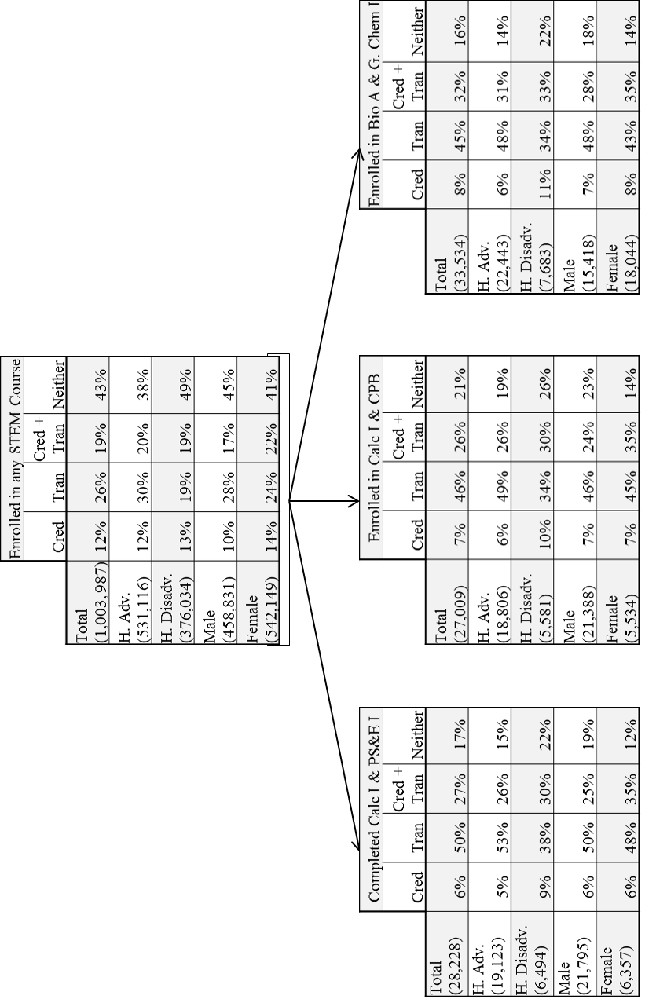
Figure 1: Comparison of student enrollment in any STEM with students who enrolled in each critical pair.
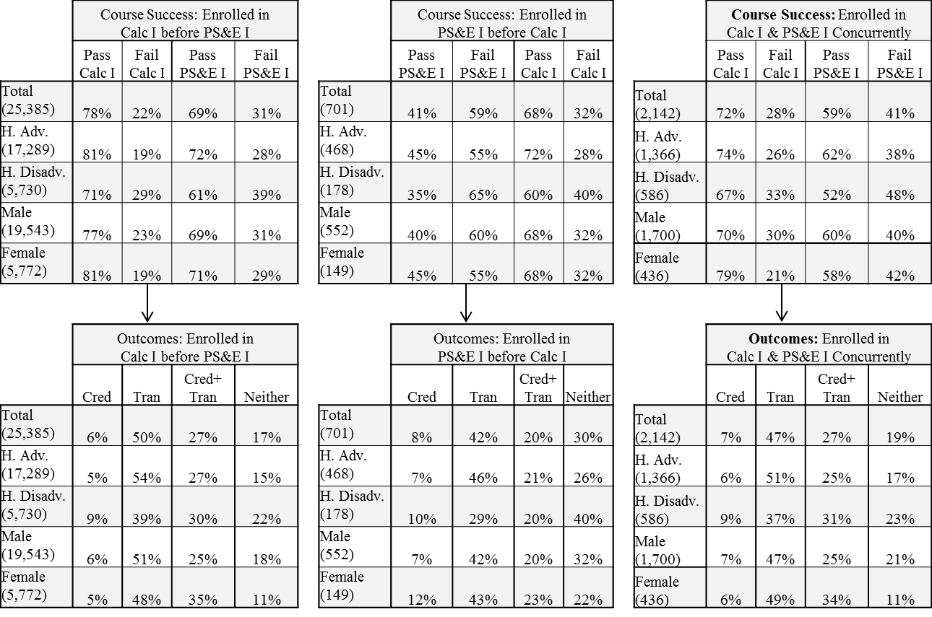
Figure 2: Comparison of student enrollment in the calculus I/PS&E I critical pair by sequence of course enrollment

Figure 3: Comparison of student enrollment in the general biology I/general chemistry I critical pair by sequence of course enrollment
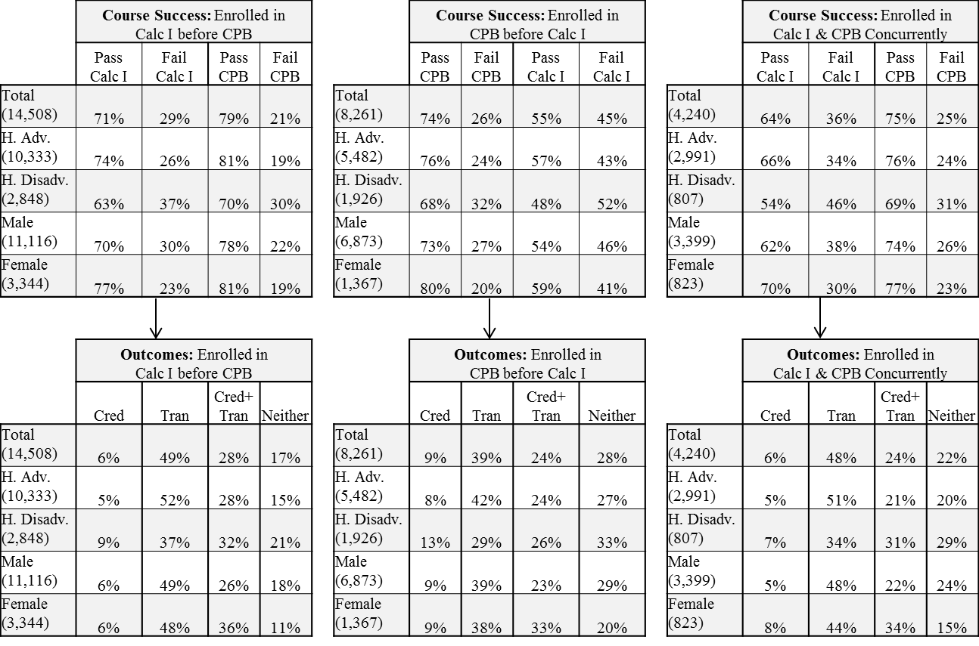
Figure 4: Comparison of student enrollment in the General Biology I/General Chemistry I critical pair by sequence of course enrollment
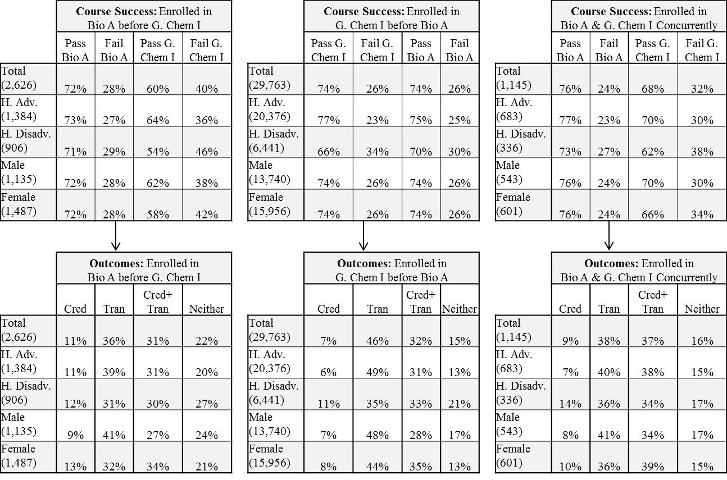

It is important to note that we count students who have attempted the course, not limiting our analysis to students who complete the course. Further, for the analysis by course outcome we present the outcome for the student’s first attempt.
Given that the curriculum in computer science was not standardized across colleges, we combined introductory computer programming courses with the first course in a specific computer language. This was a logical approach because for many of the basic computer programming courses there was still an identified computer language that students would become exposed to. This is important to note because some students could have taken two courses, introductory computer programming and a specific introductory programming language (e.g., java, c++) that would have been counted as one attempt in this model.

