How to Submit a Meeting Request for a Conference Room
How to Submit a Meeting Request via Microsoft Outlook 2
How to Submit a Meeting Request via Outlook Web Access 4
How to Submit a Meeting Request via Outlook 2011 for Mac 7

How to Submit a Meeting Request via Microsoft Outlook

- Within Outlook, click to open your Calendar.
- Click New Appointment. (Alternatively, if you’d like others to be able to join remotely via Lync, click New Skype Meeting.)
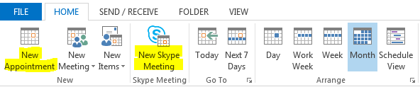
- Click Invite Attendees (if you didn’t click Skype Meeting in the previous step).
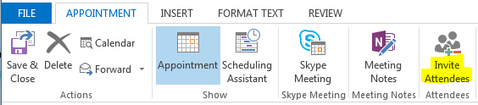
- Click the To… button.
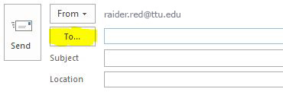

- A pop-up box for the Global Address List will appear. In the Search box, type the name of the room you’d like to add (e.g., Education Conference Room 152). Click the Required -> button, then click OK. (Note: Do not click the Delegates mailbox.)
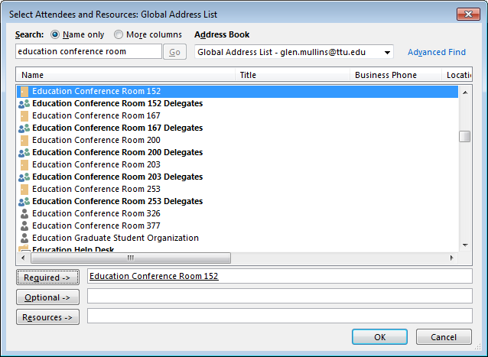
- Complete other details regarding your meeting, including other attendees, the meeting subject, and the date/time. Click Send.
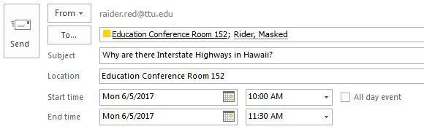
- If the room is available, you’ll receive a confirmation message like the one below.
(Note: If the room is already booked, you’ll automatically get a message that your request was declined.)
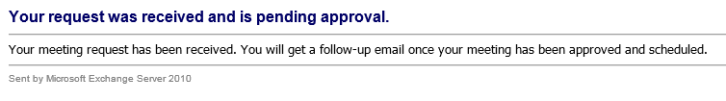
- Once your request is approved, you’ll get a confirmation email.

How to Submit a Meeting Request via Outlook Web Access

- Open a web browser and navigate to mail.ttu.edu.
- Log into your account, then click the Calendar link.
- Click New | Meeting Request.
- Click To….
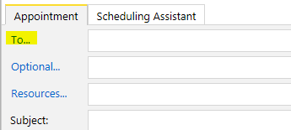

- In the Search box, type the name of the room you’d like to add (e.g., Education Conference Room 152). Click the To -> button, then click OK.
(Note: Don’t click the Delegates mailbox.)
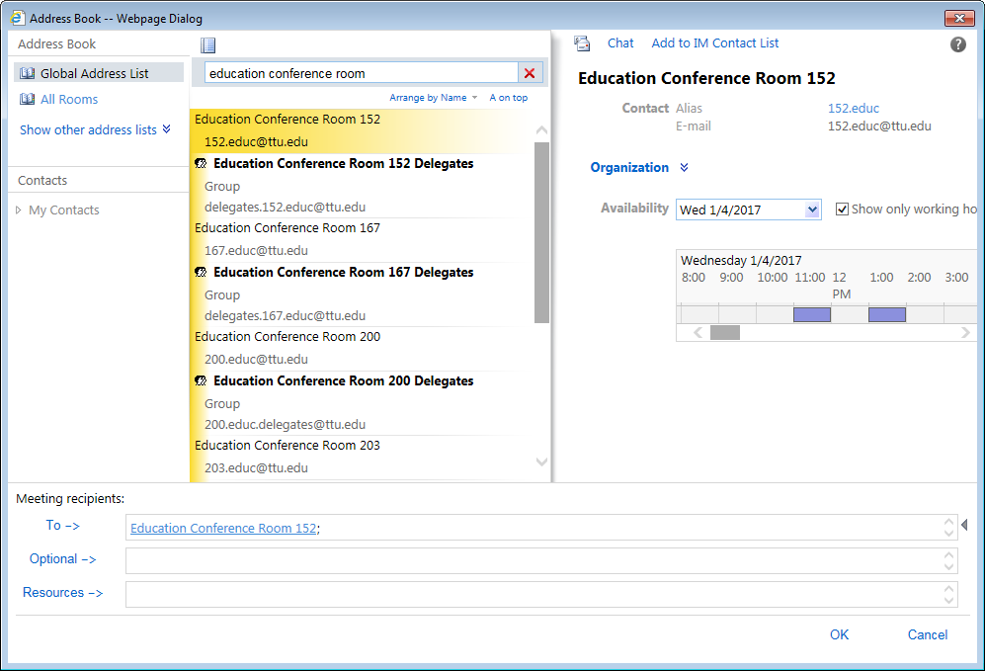
- Complete other details regarding your meeting, including other attendees, the meeting subject, and the date/time. Click Send.
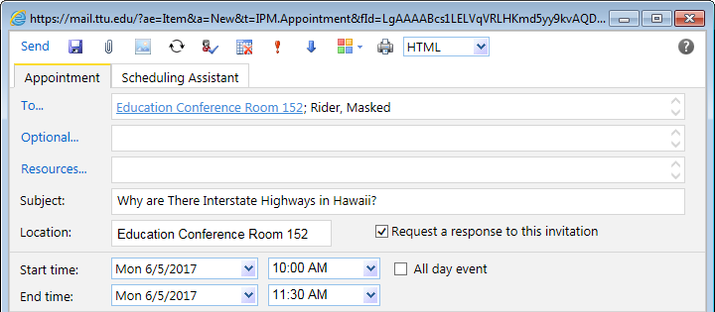

- If the room is available, you’ll receive a confirmation message like the one below.
(Note: If the room is already booked, you’ll automatically get a message that your request was declined.)
- Once your request is approved, you’ll get a confirmation email.

How to Submit a Meeting Request via Outlook 2011 for Mac

- Within Outlook, click to open your Calendar.
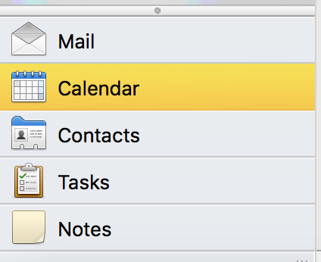
- Under the Home tab of the ribbon, click Meeting.
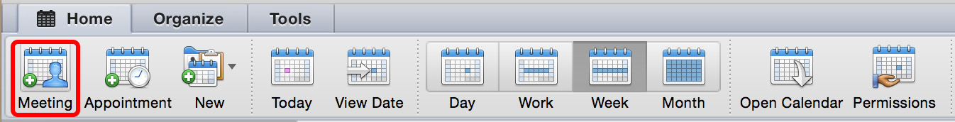
  - If you’d like others to be able to join remotely via Lync, click Online Meeting, then Create Online Meeting.
(Note: You’ll need to be signed in to Lync.)
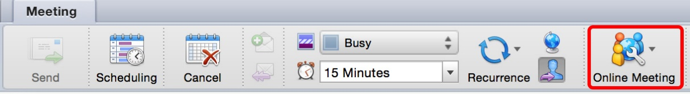
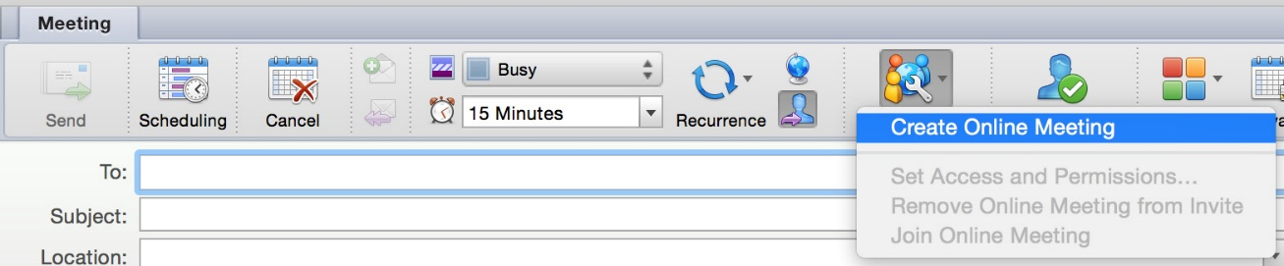
- Click the Address Book icon next to the To: field.

- A Contacts Search box will appear. In the Search field, type the name of the room you’d like to add (e.g., Education Conference Room 152). Click the Required. (Note: Do not click the Delegates mailbox.)
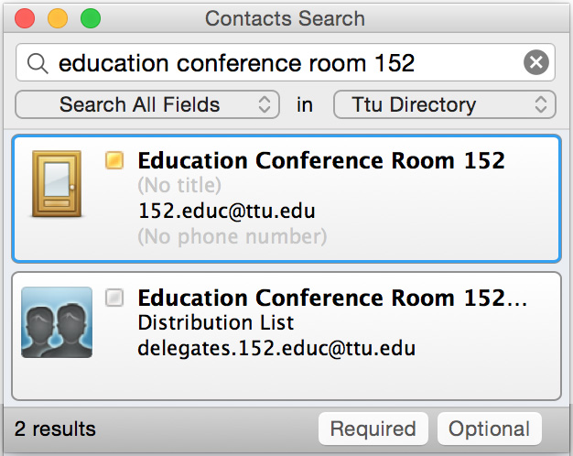
- Complete other details regarding your meeting, including other attendees, the meeting subject, and the date/time. Click Send.
- If the room is available, you’ll receive a confirmation message like the one below.
(Note: If the room is already booked, you’ll automatically get a message that your request was declined.)
- Once your request is approved, you’ll get a confirmation email.

