How to View Conference Room Calendars in the College of Education
How to View Conference Room Calendars in Outlook 2
How to View Conference Room Calendars in Outlook Web Access 4
How to View Conference Room Calendars in Outlook 2011 for Mac 6

How to View Conference Room Calendars in Outlook

- Within Outlook, click to open your Calendar.
- Right-click My Calendars, then click Add Calendar, then click From Address Book….
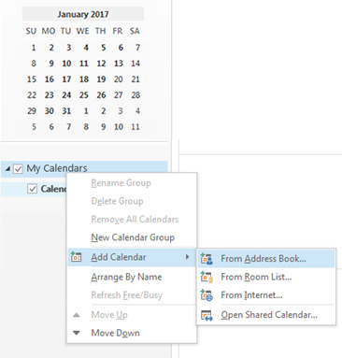

- A pop-up box for the Global Address List will appear. In the Search box, type the name of the room you’d like to add (e.g., Education Conference Room 152). Click the Calendar -> button, then click OK.
(Note: Do not click the Delegates mailbox. The desired calendar won’t be displayed!)
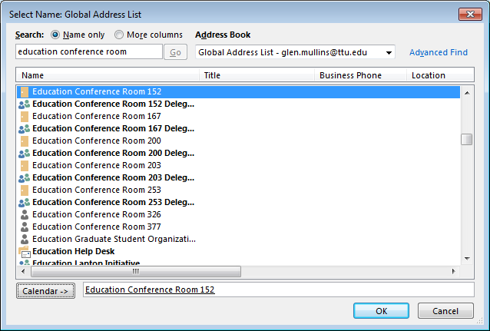
- The desired calendar will now appear as an option under My Calendars. You can view scheduled appointments, and you can click the checkbox to toggle the calendar on and off.
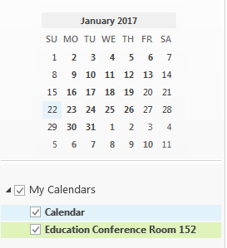

How to View Conference Room Calendars in Outlook Web Access

- Open a web browser, and navigate to mail.ttu.edu.
- Log into your account, then click the Calendar link.
- Right-click My Calendars, then click Add Calendar….
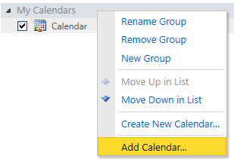
- Under Calendar from your organization, click Name….
- In the Search box, type the name of the room you’d like to add (e.g., Education Conference Room 152). Click the Select -> button, then click OK.
(Note: Do not click the Delegates mailbox. The desired calendar won’t be displayed!)
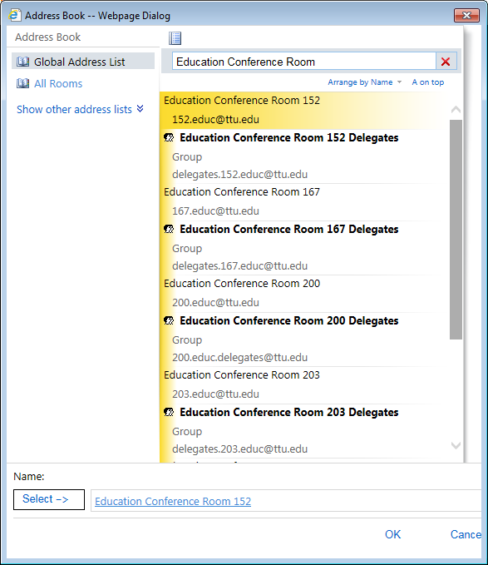
- The desired calendar will now appear as an option under People’s Calendars. You can view scheduled appointments, and you can click the checkbox to toggle the calendar on and off.
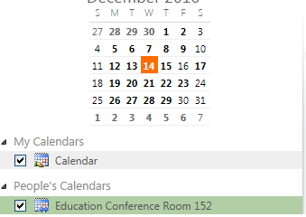

How to View Conference Room Calendars in Outlook 2011 for Mac

- Within Outlook, click to open your Calendar.
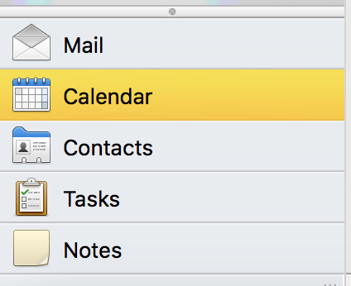
- Under the Home tab of the ribbon, click Open Calendar.
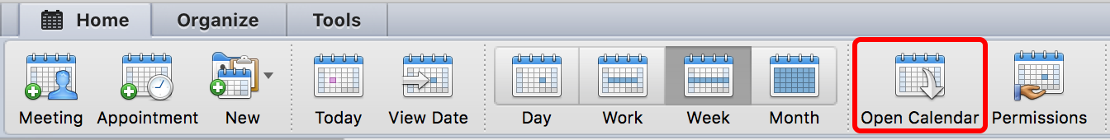
- Click the search button next to the User field.
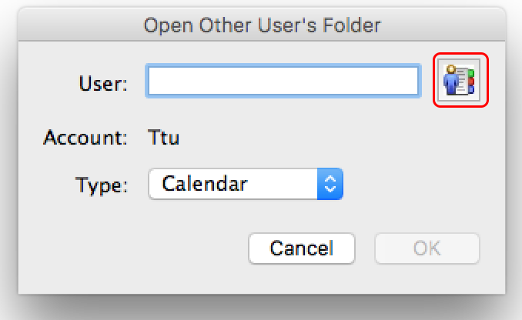

- In the Search box, type the name of the room you’d like to add (e.g., Education Conference Room 152). Click the Find button, then click the name of the conference room, then click OK.
(Note: Do not click the Delegates mailbox. The desired calendar won’t be displayed!)
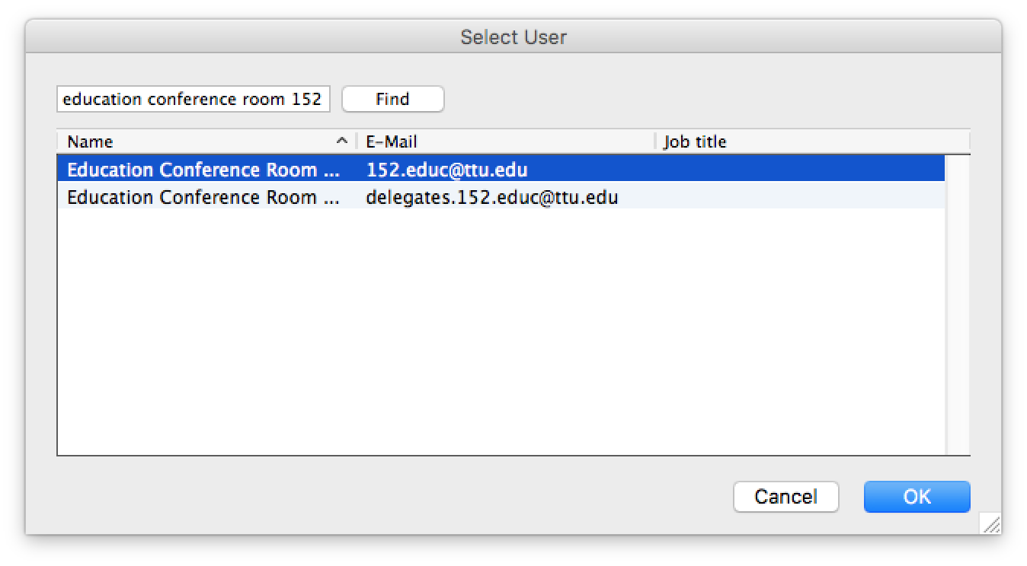
- Click OK.
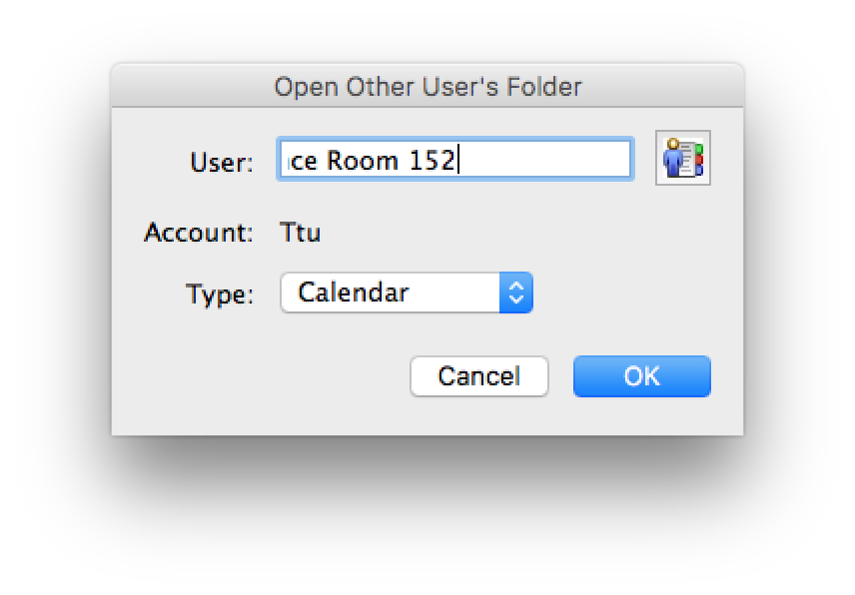
- The desired calendar will now appear as an option under Shared Calendars. You can view scheduled appointments, and you can click the checkbox to toggle the calendar on and off.
