Microsoft Access – Part III (Forms & Reports)
ShortCourse Handout

July 2004
Copyright © 2004 Heide Mansouri, Technology Support, Texas Tech University. ALL RIGHTS RESERVED. Members of Texas Tech University or Texas Tech Health Sciences Center may print and use this material for their personal use only. No part of this material may be reproduced in any form without written permission from the author.

Introduction
Access - Part III (Forms and Queries) is a non-credit, 2-hour course designed as an introductory course to Microsoft Access Forms and Reports. To focus on individual records or to present your data using a custom layout, you can use a form or a report.

Course Objectives
After completing this shortcourse, you should be able to:
- Create a Form;
- Create a Report;
- Recognize different views of a Form;
- Add sections to a Report;
- Recognize different views of a Report;
- Customize Forms and Reports; and
- Print a Form or a Report.

Forms
A form is often the most convenient layout for entering, changing, and viewing records in your database. You specify how data is displayed when you design your form. Most of the forms that you will use are based on either a Table or a Query. After the Form is displayed, you can use the Page Down key or record navigation buttons at the bottom of the form to view more records.

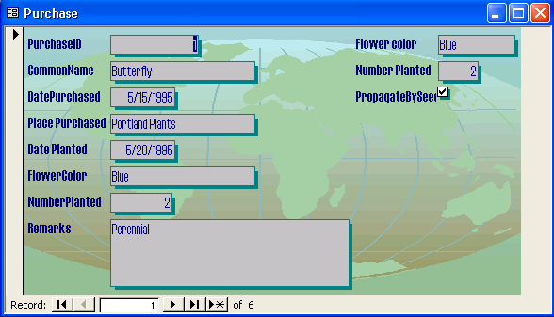

To Create an AutoForm:
- Using the Form Object tab, click New.
- Click AutoForm.
- Follow the steps.

To create a form using the Form Wizard (the easiest way to create a form):
- Click the New button (or Alt + N).
- Select the Form Wizard.
- Choose a table you wish to work with.
- Select the fields you want on your form.
- Select your form layout.
- Select your form style.

Forms have three views:
- Design view
- Form view
- Datasheet view

A Form in Design View
To create a form, you work in Design view.

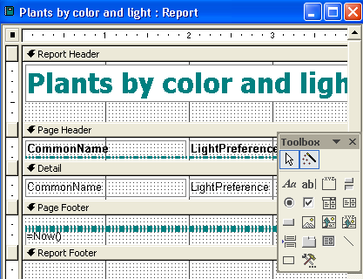

Formatting a Form in Design View:
- Click anywhere on the background of the Form.
- Click the down-arrow button next to the Fill/Black Color button.
- Select the color.
- Do the same for the Form header and Footer.
- Select all the field labels (using the Shift key).
- Use Fill/Back Color to change their colors.
- Select all the field labels in the detail area and footer.
- Press Shift + click the labels to select all;
  - Or use the mouse to go over the fields, and use the Format button to format it.
- You can’t change the background color of an AutoForm, but you can add color to it.
- Select View from the menu.
- Click the Form Header/Footer option.
- Click the Page Header/Footer option. You will see two new grid sections added to your forms: the header at the top and the footer at the bottom.
- Click the Label button on the Toolbox. (The mouse changes to the letter A with a plus sign.)
- Click in the Header area of the form, and drag to create a box.
- Type a Title.
- Press the Enter key (to switch out of edit mode and select the new label). On the toolbar, click the Bold and Center buttons, and change the font size from 8 to 24 (no need to highlight the text).
- Increase the size of the Header grid by clicking the top of the Detail bar and dragging down. The mouse cursor changes shape to a horizontal bar with arrows. This control is not bound to a field. You can select this text and edit it.
- Double-click the form selector to open the properties sheet (the left corner).
- Select “Picture” from Format tab and click the build (…) button.
- Find your picture
  - Specify the Picture Type (linked).
  - Specify your Picture Size Mode (Stretch).
  - Using the Size Mode, adjust the size of your picture.
  - Give your picture a Special Effect.

Reports
Reports are used to present data in printed forms. Many of the techniques you learned for building a form can be used to create a Report. Reports are often based on Queries rather than tables. This lets you select only the records that will be included, instead of automatically reporting on all records. You can create Reports for mailing labels, invoice tags, address and phone lists, sales and purchases analysis, and any other information that you store in a table.

To create a Report:
- On Reports Object Tab > click New.
- Select the Design View.
- Choose a table or a query > click OK.
- Use the “Field List” button to add fields the same way as you would for a form.
- Manipulate fields the same way you would in a form Design view.

Adding different sections of a Report:
- From the View menu, click Report Header/Footer (printed once at the beginning; for example: a cover page).
- Click Page Header/Footer (printed at the top of each page).
- Group Header/Footer (printed at the top of each group).
- Detail (printed once for each record).
- Group Footer (printed at the bottom of each group to display subtotal, for example).
- Page Footer (printed at the bottom of each page).
- Report Footer (printed once at the end of report to display grand total, for example).

Formatting a Report:
- In design view, Insert > Page Number.
- Click the Page N of M and Bottom of Page option, and Center.
- Check box Show Number on First Page.
- Click OK.
- Click Insert Date and Time > make your choice.
- Insert picture.
- Create a label.
- Click the Box tool on the Toolbox, and drag a box around the label.
- Click the Fill/Back Color button, and select a color.
- Click OK.

Printing number of records on the Report:
- Open the report in Design view.
- Add a calculated text box to the report header or footer.
- Select the textbox.
- Click the Properties button on the toolbar.
- Set the ControlSource property of the text box to Type =Count(*).

Printing Reports
Work both with File > Page Setup and in your design view to achieve the right look.
- From File menu, choose Print.
- Select your options.
- Click OK.

Where to Get Help
If you need help with your project, you may contact Help Central Office at 742-HELP. If you need help from your instructor, you may e-mail heide.mansouri@ttu.edu.

Exercise
Using the given tables below create:
- A database
- A Plants table
  - Choose the CommonName as the primary key.
- A Purchase table
  - Choose the CommonName and the SupplierID (together) as the primary key.
- A Supplier table
  - Choose the SupplierID as the primary key.

Plants Table
CommonName | Flowering | Light Preference | Fertilize Frequency | Watering Frequency
Butterfly | Yes | Full sun | Annually | Keep Dry
Canterbury | Yes | Full sun, Filtered sun | Monthly | Weekly
Costmary | Yes | Full sun | Monthly | Weekly
Foxglove | Yes | Shade, Filtered sun | Annually | Weekly
Catnip | Yes | Full sun | Monthly | Weekly
Geranium | Yes | Full sun | Monthly | Weekly

Purchase Table
Common Name | SupplierID | Date Purchased | Place Purchased | Date Planted | Remarks
Butterfly | 1 | 5/15/1995 | Portland Plants | 5/20/1995 | Perennial
Canterbury | 4 | 12/10/1996 | Nichol's Plants | 2/1/1997 | Biennial
Costmary | 4 | 3/15/1997 | NW Hardy Check Plants | 3/15/1997 | Perennial
Foxglove | 2 | 5/1/1994 | N/A | 6/1/1994 | Biennial, Perennial
Catnip | 3 | 6/1/1995 | St. John's Perennials | 6/3/1995 | Perennial
Geranium | 2 | 6/1/1997 | St. John's Perennials | 6/1/1997 | Perennial

Supplier Table
SupplierID | Supplier | Address | City | State | ZIPCode | Telephone
1 | St. John's Perennials | 111 N. Main | Portland | OR | 97222 | (503) 555-4231
2 | Portland Plants | 4256 NW 23rd | Portland | OR | 97333 | (503) 555-8763
3 | NW Hardy Check Plants | PO Box 3095 | Vancouver | WA | 98456 | (360) 555-9834
4 | Nichol's Plants | Star Rt. 4 NW | McMinnville | OR | 96589 | (514) 555-9988

Please e-mail your comments or suggestions to: heide.mansouri@ttu.edu

