Faculty Search Committee Procedures
Annually, usually at the start of the fall semester, each department chair, school director, and area coordinator will complete the Faculty Search Notification Form to provide the Office of Faculty Success with information about active searches in their units. They may use this single form to enter data for up to ten faculty searches. While this process generally occurs at the start of each academic year, a chair, director, or area coordinator may access the form and enter new information anytime.
Director Paul Ruiz, from the Office of Faculty Success, will then contact each search committee chair, informing them of the Search Committee Chair Briefing. After completing the briefing, each committee chair will receive an email with the Faculty Hiring Search Committee Information Form link. Completing the form is necessary to generate the evaluation matrix. Among other things, the form asks for the search committee members’ names, when the search will close, and when the evaluation matrices will be completed. The evaluation matrix will not be generated until the search committee chair completes the Faculty Hiring Search Committee Information Form.
The hiring specialist will create a OneDrive folder for each search. The name of the folder will be Search (BrassRing Requisition ID). Each folder will have three subfolders:
- Specialist Folder – only accessible to the hiring specialist
- Members Folder accessible to all members
- Completed Matrices Folder – accessible to all members and is upload only.
Members will initially have three Excel workbooks:
- AL (BrassRing Requisition ID).xlsx contains the applicants’ aliases;
- CML (BrassRing Requisition ID).xlsx contains the committee members’ aliases; and
- Member Matrix Search Committee (BrassRing Requisition ID).xlsx is the customized blank evaluation matrix.
A fourth file, Final Summary Search Committee (BrassRing Requisition ID).xlsx, will be added after all member matrices are uploaded. It contains a summary of the ratings of each applicant.
Each committee member will receive two emails – one with access to Members and another with access to Completed Matrices.

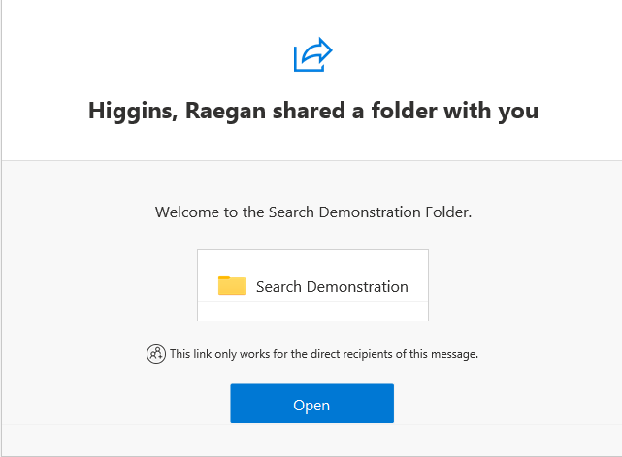
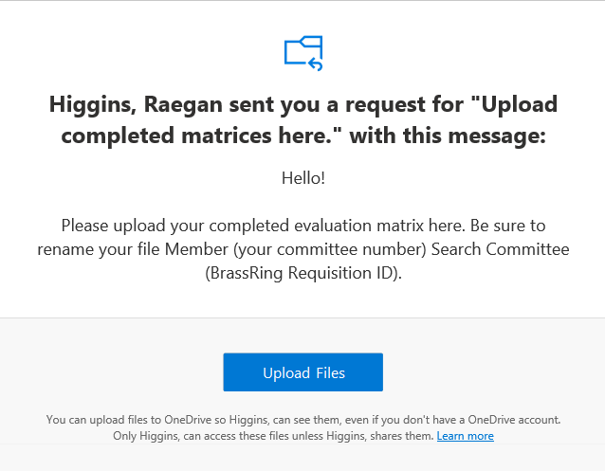

We encourage search committees to meet before individual members begin completing their matrix. We also recommend that search committees meet after all members have completed their matrices and before the committee members upload their matrices to the upload-only folder. This provides committee members with the opportunity to discuss their evaluations of applicants. Engaging in this kind of discussion can help identify possible errors in evaluation, such as a member accidentally overlooking a key accomplishment in an applicant’s research record or accidentally confusing one applicant’s teaching record with another’s.
The search committee chair must complete the Faculty Hiring Applicant Removal Form if
- the chair pre-screens applications and desires to remove any that do not meet certain required qualifications, or
- the committee reviews all applications and, during discussion, agrees to remove any applications from further review/discussion because certain required qualifications are not met.
Each committee member will download and complete an evaluation matrix that will be used to assess each application for the open position. Committee members will rate each applicant according to the required and preferred qualifications. The ratings are:
- E (exceeds expectations) - The applicant provided documentation of a sustained record of accomplishments exceeding expectations for performance in the required or preferred area.
- M (meets expectations) - The applicant provided documentation of a sustained record of accomplishments meeting expectations for performance in the required or preferred area. The applicant’s record may occasionally indicate exceeding expectations for performance in the required or preferred area, but most of the record meets expectations.
- D (does not meet expectations) – The applicant’s documentation does not meet expectations for performance in the required or preferred area. The applicant’s record may indicate occasionally meeting expectations for performance in the required or preferred area, but most of the record does not meet expectations.
Here’s a useful video: The Revised Matrix.
Once the search committee member has completed their matrix, the member will rename it as Member (committee member number) Search Committee (BrassRing Requisition ID).xlsx and upload it to Search (BrassRing Requisition ID) > Completed Matrices using the link provided via email.
Once all completed matrices are uploaded to the appropriate folder, the staff specialist will generate the Final Summary Search Committee (BrassRing Requisition ID).xlsx and upload that to Search (BrassRing Requisition ID) > Members. The committee will use the summative assessment (see below) as a guide to determine the applicants to be interviewed via phone or virtual meeting. This group is known as the semi-finalists.

Description of Rating Categories Provided on the Summative Assessment
Highly Qualified
- Exceeds all required and preferred qualifications
- Provides extensive documented evidence of required and preferred qualifications
Mostly Qualified
- Meets or exceeds all required and preferred qualifications
- Provides moderate to extensive documented evidence and evidence that demonstrates promise of required and preferred qualifications
Moderately Qualified
- Meets all required qualifications
- Meets a minimum number of preferred qualifications
- Provides moderate documented evidence or evidence that demonstrates promise of required and preferred qualifications
Minimally Qualified
- Meets all required qualifications
- Meets minimal to none of the preferred qualifications
- Provides minimal evidence that demonstrates promise of required and preferred qualifications

After the phone or virtual interviews, the committee will meet to discuss the interviewed semi-finalists and choose the finalists for on-campus interviews (or virtual interviews for remote positions). The search committee chair must complete the Faculty Search Certification Form, which requires a written justification for each candidate the committee recommends for an on-campus interview, along with general information about the position posting and advertisement. Review the certification form PDF in your Members folder before accessing the web-based form. The summary matrix is needed to answer certain questions when completing the certification form. After the search committee chair submits the Faculty Search Certification Form, the Offices of Equal Opportunity and Faculty Success review the information and certify the search. This step is required before any finalists are contacted about interviews. Initial administrative certification review will be completed within five (5) working days of receiving the search committee's request to interview selected candidates.
After the committee interviews the finalists, it should meet and generate a list of candidates recommended for hire. The chair will then complete the Faculty Candidates Recommended for Hire Form. The responses will be uploaded as a PDF to the Members folder within one working day of submission. The hiring specialist will inform the search committee chair when it is available.
Once the signed official offer letter from the provost is returned or if the search fails, the committee, including the chair, will no longer be able to access Search (BrassRing Requisition ID). This is to prevent information from the search from being inadvertently shared after the search is closed.
Lastly, be sure to complete all the necessary steps required by HR. The person who entered the requisition in Kenexa should be able to assist you with that. If not, contact LaDonna Johnson at Ladonna.Johnson@ttu.edu.

