Outdoor Pursuits Center
Leadership Candidate Training and Staff Application
Texas Tech University Recreational Sports Department Outdoor Pursuits Center
806.834.4005Contact :David Young
www.recsports.ttu.edu

Informational Meetings: February 14th & 19th at 5:30 pm at the OPC

Applications may be emailed to david.young@ttu.edu or dropped off at the Outdoor Pursuits Center front Desk. *Application Materials Due: February 23rd by 5pm*

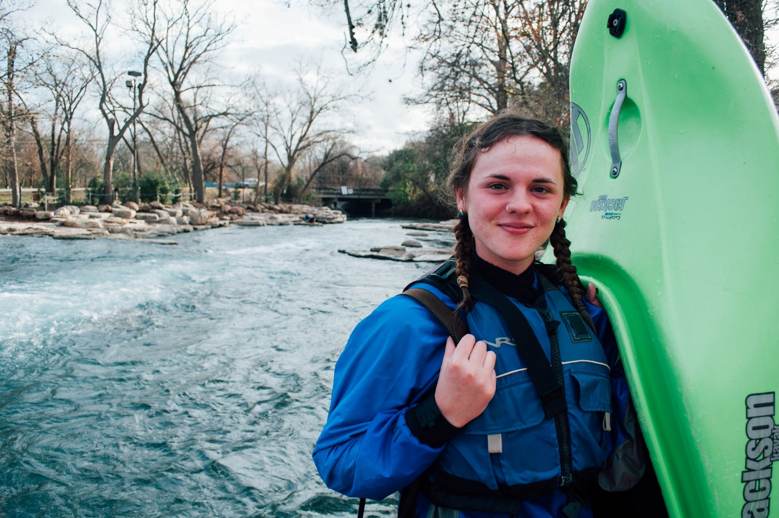
Rachel Veale- Senior OPC leader

Thank you for your interest in joining the Outdoor Pursuits Center!

Each spring semester the OPC seeks highly motivated students who want to enrich their college experience by increasing their workplace and leadership skill sets. Students who desire to get the most out of their college years and are not
afraid of challenging themselves are invited to apply to become a part of our program.

We want staff who are lifelong learners and highly skilled beyond their classroom learning. We help our staff learn life skills that are important no matter your career. Here are a few examples:
- How to handle logistics, details, and make organized plans.
- How to cook good food
- How to back up a trailer
- How to respond in emergency situations.

If you are interested in joining the OPC team, review the application materials provided here, and complete the Student Employment Application. Include a typed cover letter and resume. Email it to David.young@ttu.edu or Return it to the OPC by Friday February 23rd, at 5pm.

OPC Staff in Big Bend during Canoe Training

Qualifications and Job information.

Required Qualifications:
- Current Texas Tech University student
- Must possess a valid and violation free driver’s license
- Must be 18 or older
- Must be capable of carrying a backpack load of at least 60lbs over several miles of rough terrain
- Interest in backcountry travel and outdoor activities
- Capable of committing one year to the program
- Desire to learn how to teach, lead, supervise, and provide fun and meaningful activities for the Texas Tech community on campus and in challenging environments

Preferred Qualifications
- Belay Skills Verified at the Texas Tech Climbing Center
- Experience on one or more OPC adventure trips
- Personal experience with outdoor recreation activities
- Knowledge of outdoor equipment such as tents, backpacks, stoves, skis, and snowboards
- Current Wilderness First Aid or Wilderness First Responder certification

Applicants who are selected for the job will be invited to attend the mandatory Leadership Candidate Training (LCT) course. This is tentatively scheduled for August 10th-22nd. This rigorous expeditionary course is the final step in the hiring process. It is designed to holistically challenge each participant. You will be responsible for teaching up to three pertinent outdoor or related skills topics, significant learning and skill comprehension, self-leadership, and healthy behaviors. Lastly, you will receive feedback on your performance throughout the course and you will be expected to give constructive feedback to your peers. The course will cost $185 which will cover all food, necessary equipment, transportation, and professional leadership.

Trip Leaders are required to hold a current Wilderness First Responder (WFR) Certification. We host a Wilderness First Responder course each year over the entire Spring Break. The Recreational Center helps support OPC staff members by paying part of their course fee.

Finally, once accepted into the program, the development and promotion process begins. Staff partake in specialized trainings to work in the equipment rental shop and indoor climbing center. Staff also begin to gain field experience serving as part of leadership teams for trips in non-paid roles. However, once staff attend activity specific trainings (e.g. Canoeing Site Management) and increase their experiences on trips, they are considered for promotion to the paid positions of Assistant and Trip Leader. See the following documents for more information about the promotion process.

I appreciate your application -

David Young – Assistant Director- Outdoor Pursuits Center

Personal Information
Texas Tech University Department of Recreational Sports Student Employment Application

Outdoor Pursuits

Name: ID Number:

Local Address: Permanent Address: Local Phone: Permanent Phone:
E-mail: Is this e-mail current now & during summer?

Emergency Contact
Name:

Telephone:

General Information
University classification: (i.e. Freshman, Senior, Grad Student, etc.)

Major: Anticipated Graduation Date:

Are you presently employed on campus? No Yes (where):

Have you been awarded College Work Study? No Yes Amount (hours):

Are you Community CPR certified? No Yes Expires:

Please list any emergency medical training you have received (WEMT, First Aid, and CPR etc.) and

include photocopies of certifications (both sides):

Are you willing to work some Holiday hours? No Yes

Do you know anyone who works here now? No Yes (who):

Employment References

Name of Supervisor Place of Employment Phone Number Dates of Employment

Name of Supervisor Place of Employment Phone Number Dates of Employment

Name of Supervisor Place of Employment Phone Number Dates of Employment

I believe and understand that the aforementioned information is true to the best of my knowledge and that any false or misleading information is sufficient grounds for disqualification of this application or termination of employment. Completion of and s ubmission of this application does not guarantee employment with the Department of Recreational Sports or Texas Tech University.

Signature Date

The Texas Tech Student Recreation Center is strongly and actively committed to diversity and providing equal opportunity within its community. No applicant or employee will be discriminated against because of race, color, religion, gender, sexual orientation, familial status, age, national origin, lifestyle, height, weight, marital status, political persuasion, veteran status, or disability concerning employment or during the course of employment in the department

Please write a cover letter with your application. This is your chance to tell us anything you want. Here are a few topics you could include, but we appreciate creativity.
- Why do you want to work for the OPC?
- Have you ever been on an OPC trip? What was it like?
- What do you want to gain from your time at the OPC?
- Tell us more about who you are.
- How do you spend your time? Tell us about your other commitments, hobbies, and things you like to do.

Please submit the Student Employment Application, resume, cover letter, and your responses to these questions all together by February 24th, at 5pm in the OPC.

The documents below provide more information about the culture of the leadership development program, staff responsibilities, and qualifications for staff promotion. We strongly encourage interested students to thoroughly read the provided information and to speak with current staff about their experience in being part of this program.

OPC Mission

Inspire Community, Develop Students, Unleash Spirit

OPC Culture

1. Self-Leadership
We strive to be conscious of our personal responsibilities and take ownership of our attitudes and actions.
2. Effective Collaboration
We recognize and honor the agency of others. Honest and direct feedback promotes healthy relationships and decreases frustration in cooperative efforts.
3. Covenant of Consistent Character
We are a group of individuals who look to the welfare of others before satisfying our own needs. We value mutual respect, honesty, agency, and personal responsibility. We recognize that every day we are at all times representatives of the OPC and Texas Tech.
4. Learning
The objective of teaching is learning. We invite learning in others by being passionate about learning ourselves. Imparting knowledge so that others can grow in competency and in judgment is a program priority.
5. Judgment
Learning increases with increased responsibility. The high degree of responsibility placed on all staff demands the development of judgment. Paul Pedzoldt said “judgment is the process of using previous learning and experience to make a decision and execute decisions.” Protocols must be applied to specific situations where judgment then guides decisions and the appropriate application of resources.
6. Invite Change
By honoring the agency of others, I, whenever possible, allow those in my care the freedom to choose. Why?
To invite responsiveness rather than resistance. Promoting autonomy rather than forcing behaviors respects the humanity of others and creates opportunity for meaningful relationships and meaningful learning

Leadership Candidate Training

Leadership Candidate Training (LCT) is an expeditionary course that combines the best in outdoor education and leadership training from the Wilderness Education Association, Leave No Trace, Wilderness Medicine Training Center, Steven Covey’s Seven Habits of Highly Effective People, The Arbinger Institute, and the Texas Tech Outdoor Pursuits Center. The educational curriculum is rooted in Albert Bandura’s Social Cognitive Theory and also borrows from Constructivist and Self-Determination Theories. As a result, this course will expand students’ current leadership and teaching capabilities and into their future careers.

The LCT expedition is a rigorous staff development course that is designed to incorporate all new student staff into the OPC program through standardized training. LCT introduces students to relational leadership, group management, Leave No Trace environmental ethics, effective teaching strategies, and Informative Tutoring Feedback. Candidates are exposed to three basic skill sets (outdoor, educational, and human) and a unique leadership philosophy that forms the core of OPC staff development. The integration of these skills begins on LCT and continues throughout a student’s employment. The effectiveness of an outdoor leader and the promotio n of staff is directly related to constant personal development and conscious integration of these skills.

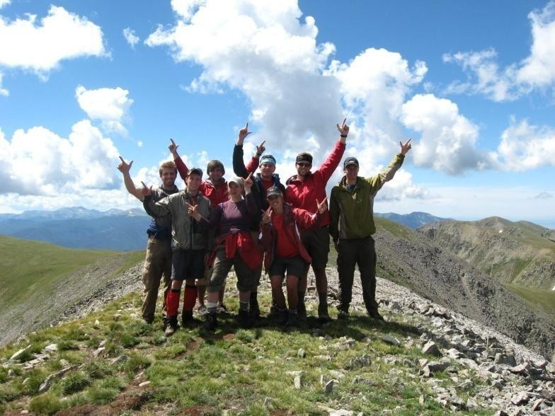
Finally, this course has a foundation of assessment. Accurate assessment skills are a prerequisite to developing quality judgment. Feedback from experts and peers is crucial to accurate self-assessment as it is often a significant trigger for thorough evaluation of your decisions. On a daily basis we will give and receive informative and constructive feedback. It’s important to remember that unexpected changes will occur and we will have to plan, re-plan and adapt. Students will need to use their creativity, flexibility, educational strengths and wild senses of humor to make each course the best it can be. We look forward to hiking, scrambling, and discussing how to improve each new student’s abilities as leaders and educators.

Beyond the field - The OPC administration invests a great deal in each student both in time and in finances. Beginning with this course staff receive financial assistance to offset the cost of the
trainings offered during a student’s employment. The cost involved in training one student on this expedition is approximatel y
$1000 of which we ask students to invest $185. To become a trip leader for the specific activities such as climbing or kayaking staff must complete additional trainings that normally cost $300 to $500. Fortunately, the program is able to cover these costs for the activity trainings because of the professional staffs’ levels of training and experience. Additionally, staff lead backcountry trips and therefore must attend a 90hr Wilderness First Responder course that is offered over spring break each year. Students are required to pay approximately $410 of the course cost. At the end of a typical students’ career at the OPC they have invested much energy, time, and about $585. The OPC has a financial investment of about $3,200 in training alone for a student who works two years leading trips. Regardless, the OPC strives to invest much more than financial resources. Each student is seen as having great potential. We have specifically designed our program to assist students in reaching their academic, outdoor, and career goals. Students who invest in the program will receive the relationship, leadership, and group management skills that set them apart from others in future employment opportunities.

Thank you for your interest in our program. Please consider how your values and personal/career development goals align with our program. For any job, both parties receive greater satisfaction when they share common goals and perspectives.

David Young. Kevin Hoffman
Assistant Director – Outdoor Pursuits Coordinator – Outdoor Pursuits

