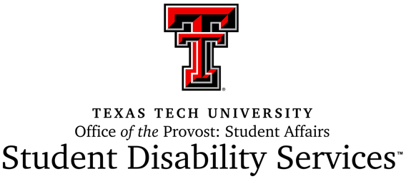

Service Animals in Training Policy

ADA Service Animal Terms
The document (https://www.ada.gov/regs2010/service_animal_qa.html) published by the Office of Civil Rights, addresses two key points:
- The ADA does not require service animals to be professionally trained. People with disabilities have the right to train the dog themselves and are not required to use a professional service dog training program.
- HOWEVER, service-animals-in-training are not considered service animals. Under the ADA, the dog must already be trained before it can be taken into public places. Thus, until the training is complete, the service animal in training does not have the same protection and privileges as a fully trained service animal. Some State* or local laws cover animals that are still in training.
The State of Texas* does recognize Service Animals in Training to have access to the same areas as trained service animals as long as they are accompanied by an approved trainer. Texas Tech University requires the student provide documentation of their certification as the trainer from an approved organization.
* State of Texas Code Sec.121.003 (i) A service animal in training shall not be denied admittance to any public facility when accompanied by an approved trainer.

Requirements for Students
- Complete the Student Disability Services Verification Form for Service Animals in Training. This form does not register the student with Student Disability Services for classroom accommodations, but if the student wants to apply for services, he/she can do so. This SDS Verification Form, along with documentation certifying the student as an approved trainer (#2), will be kept on file in the Student Disability Services Office.
- Provide Student Disability Services a Certification of Training document. An approved trainer recognized by Texas Tech University is an individual who has been certified by an organization whose primary mission is to train service animals for people with disabilities. If the student is not an approved trainer, the student must provide proof an approved trainer will be with the student and the dog while in campus buildings.
- Meet with Student Disability Services Staff to obtain approval for bringing a Service Animal in Training into campus buildings. A campus building is any building on campus, including housing facilities. During this meeting, SDS Staff and student will:
  - Review published ADA language that allows for the person to train the dog themselves, but does not recognize service animals in training as a protected accommodation.
  - Review State of Texas statute that does allow service animals in training to access the same areas as Service Animals as long as they are accompanied by an approved trainer.
  - Review TTU’s policy on what constitutes a recognized approved trainer. *
  - Review TTU policy that Service Animals in Training must be identified by a vest or tag indicating they are in training, and must comply with and abide by the same University policies and procedures that any Service Animal or Assistance Animal follows. This includes policies within the Code of Student Conduct (http://www.depts.ttu.edu/dos/handbook/).
- Housing Requirements – If the student resides in TTU Student Housing, then the Verification Form will be sent to Housing as well.

Requirements for Service Animal (dog) in Training
- The animal must be at least one year of age.
- The animal must meet all standards of behavior that mirrors a trained service animal. These standards include that the animal is under the owner’s control at all times, and that the animal is leashed at all times.
The ADA requires service animals be under the control of the handler at all times. The service animal must be harnessed, leashed, or tethered while in public places unless this interferes with the service animal's work or task. In that case, the person must use voice, signal, or other effective means to maintain control of the animal. Under control also means a service animal should not be allowed to bark repeatedly in an otherwise quiet place.
- Additional service animal guidelines include:
  - Animal must be housebroken,
  - Current required vaccinations, and
  - Wearing collars and tags at all times.

