CLIFTONSTRENGTHS LOGIN INSTRUCTIONS
- Go to www.strengthsquest.ttu.edu and click on the “New User” image.
- Use your eRaider username and password to access your complimentary code
which will allow you to take Clifton'sStrengths™. Copy the access code, which will be toward the bottom of the page.

- In a new tab, go to www.strengthsquest.com. Then, click “Redeem Access Code” and use your code to create your account.
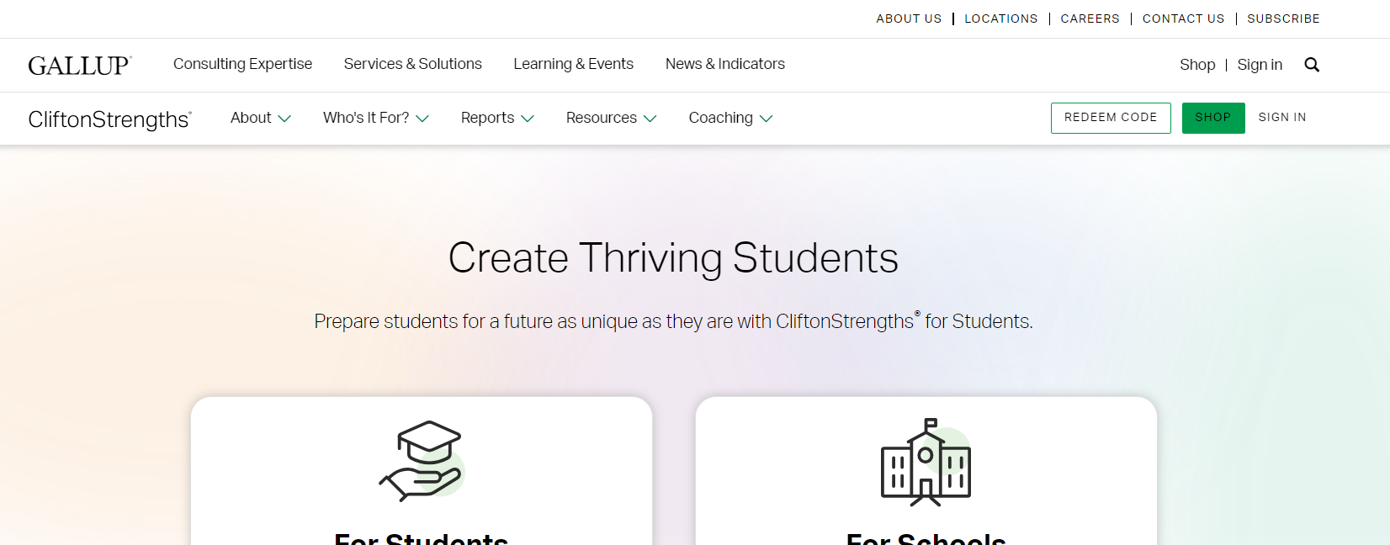

Please allow up to 40 minutes of uninterrupted time to take the assessment.

If you receive an error, please see instructions on the next page.

- Returning Users: If you have already taken StrengthsQuest, you will click
“Sign In” and use the login information you created (this is different from your eRaider information). If you try to enter your code again, you may receive an error stating the code is either invalid or had already been used.

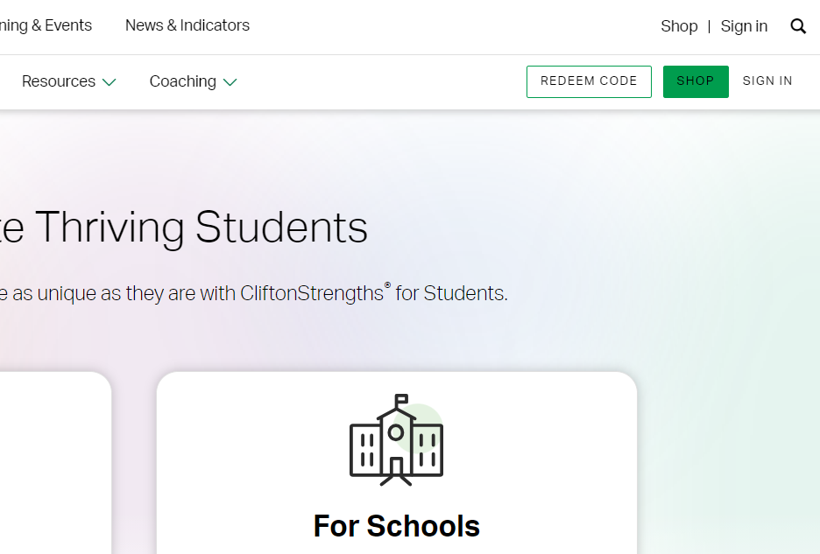
If you do not remember your login information, you will need to complete the password reset steps or contact Gallup Customer Service if you do not remember your login information. The number for Gallup is 1-888-486-9104.

If you have any questions, please contact the University Career Center at 806-742-2210 or careercenter@ttu.edu.

