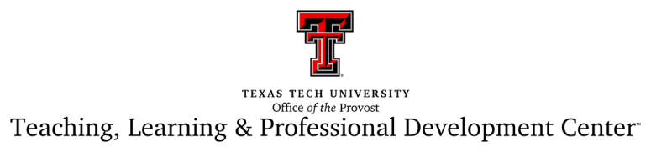

PERSONAL STATEMENT OF STUDENT SUPPORT
OPTION 3

My classrooms (replace with a different term if you teach in something other than a classroom) are safe spaces. I am fully committed to fostering learning environments that support all students. If you’re not sure of where or how to find information about resources to support your success here at TTU, please don’t hesitate to reach out to me. Here is my preferred method of communication: (insert email, phone, Blackboard, etc.).

