Business Plan Template Sample

Company Logo Here

Company Name Business Plan
Date

This document contains confidential and proprietary information belonging to [Company Name \] the producers of [Product Name],
[3 to 5 word product description]

Contact information for the company: CEO Contact Information

INFORMATION REGARDING BUSINESS PLAN
This Business Plan (the “Business Plan”) contains certain information regarding the current and planned operations and business of [Name] (the “Company” or “[Short Name]”); including the projected financial performance of the Company. This Business Plan has been provided to the recipient solely for the purpose of assisting the recipient in deciding whether to proceed with an Location in-depth investigation of the Company in accordance with procedures established by the Company and its advisors.
By accepting a copy of this Business Plan, the recipient agrees, among other things, to keep the information contained herein confidential. The recipient agrees to restrict the use of any information contained herein to those people within the recipient’s organization or its designated representatives who have been informed of the confidential nature of such information and who need to have such information in connection with the organization’s evaluation of the Company.
The Company has prepared this Business Plan on the basis of internally prepared information, as well as information from public and private sources, including trade and statistical sources commonly used in the industry. This Business Plan does not purport to contain all of the information that may be required to evaluate all of the factors that would be relevant to a recipient in considering a transaction with the Company. The Company makes no warranty or representation, either express or implied, as to the accuracy or completeness of either the material contained herein or any other written or oral information provided by the Company to the recipient, and no liability shall attach thereto.
Nothing contained in this Business Plan is, or should be relied upon as, a promise or representation as to the future. The projected financial information contained herein was prepared expressly for use herein and is based upon the Company’s stated assumptions and analysis of information available at the time this Business Plan was prepared. There is no representation, warranty, or other assurance that any of the projections set forth herein will be realized. This Business Plan does not purport to contain all of the information that may be required to evaluate the Company and any recipient hereof should conduct its own independent investigation and analysis.

Table of Contents (please note table of content numbering is not reflective in doc)
INFORMATION REGARDING BUSINESS PLAN 2
- Executive Summary 4
- [Name] Product Description 5
  - Current Components 5
  - Market-sector Product Packaging 5
  - Development timeline 5
  - Product, Support, Production and Certification 5
  - Product Feature and Technology Plan 6
  - Intellectual Property 6
- The Market for [Product Name] 6
  - Market Description 6
  - Market Size 6
  - Compelling Market Indicators 6
  - Revenue Model 6
  - Price Positioning 6
- Competition 6
  - Competitor Analysis 6
  - Categorizing Competitive and Related Products (as appropriate) 7
  - Competitive Differentiation 7
- Sales and Marketing 7
  - Go to Market Strategy 7
  - Customer value proposition by focus market segment 7
  - Company Brand Development and Demand Generation Marketing Approach 7
  - Sales Organization 8
  - Sales and Channel Programs 9
- Our Strategy 9
- Management Team 9
- Financial Plan 9
- Risk Management 10
- Conclusion 10
Exhibit 1 11
Exhibit 3 Market Projection Methods 13
Exhibit 4 Pricing: Structure, Competition and Company 13
Exhibit 5 Customers and Other References 15
Exhibit 6 Management Team, Board of Directors and Advisory Board 16
Exhibit 6 Management Team, Board of Directors and Advisory Board 16
Exhibit 8 Financial Statement Projections as of [Date] 17
Exhibit 8 Financial Statement Projections as of [Date] 17
Table of Figures
Figure 2-1 [Name] Major Components 5
Figure 2-3 [name] Product Time Line (Visio sample follows) 5
Figure 2-5 Technology Roadmap Summary (sample follows) 6
Figure 3-1 Market Size 6
Figure 4-3 Competitive Strengths and Weaknesses – Positioning to win 7
Figure 5-1 Go to Market (graphic representation) 7
Description 7
Figure 5-2 Marketing Roadmap summary 7
Figure 8-1 Summary Operating Statement and Key Ratios 10

Executive Summary
Introduction
The Company, [short description], [location], [product name, usage, uniqueness, business model.

The Challenge Market challenge The Solution
How product solves the challenge
The Market
Market description – Overall, taxonomy, CAGR
Product Development
Short product description, end user value proposition, and market validation.

Intellectual Property
Description and status of patents.
Business Validation
Why business will be viable and strong.
.
The Competition
Why the company’s products fit market problem better than competitor’s products.
The Management Team
- Names and descriptions citing key successes related to the company.

The Business Opportunity
How the company will return value to investors.
Upside Potential
Blue sky opportunity when available
Funding Requirements
How much, how used, company results with implication of what the results mean to the investor.

[Name] Product Description
  - Current Components
Description…
Figure 2-1 [Name] Major Components

  - Market-sector Product Packaging
  - Development time line

Description…

Figure [name] Product Time Line (Visio sample follows)

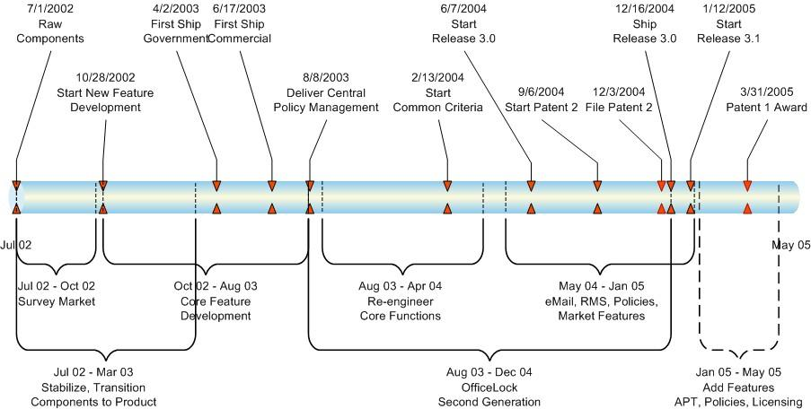

Product, Support, Production and Certification
  - Product Feature and Technology Plan

Description…..

Figure Technology Roadmap Summary (sample follows)

Product Support (method of) Summary

  - Intellectual Property
Description…

The Market for [Product Name]
  - Market Description
Description citing certifiable references and studies
  - Market Size
Description overall with CAGR, taxonomy, focus sector size and CAGR. Unique focus sector requirements matching unique product features. Summary in figure with detail in an Exhibit.
Figure 3-1 Market Size –

  - Compelling Market Indicators
    - Third party comments (analysts, pundits, trade associations, etc.
  - Revenue Model
Company’s revenue model
  - Price Positioning
Price strategy and description Investors like annuity revenues..

Competition
  - Competitor Analysis

Figure Competitor Comparison
  - Categorizing Competitive and Related Products (as appropriate)
  - Competitive Differentiation
    - Clear description of unique features, functionality and why the end users have a better value proposition than competitors.

Figure 4-3 describes [product name’s] strengths, weaknesses and position against other products.

Figure 4-3 Competitive Strengths and Weaknesses – Positioning to win
Company | Strengths | Weaknesses | We Win/We Lose
 | ∙ |  | Win When:  - Flexible Lose When:  - Size of  ∙
 | ∙ | ∙ | Win when:  - Stong Lose When:  - Strong auditing required
 | ∙ | ∙ | Win when:  - Full solution  - ops Lose When:  - Only
Win when:
∙ .
Lose When:
- Concerns about Company size

Sales and Marketing
Summary description of go to market strategy as intro

  - Go to Market Strategy
Description…

Figure 5-1 Go to Market (graphic representation)

  - Customer value proposition by focus market segment
.
  - Company Brand Development and Demand Generation Marketing Approach and activities
Description

Figure 5-2 Marketing Roadmap summary

This is an example of an exhibit:
- Organization Phase
  - Sales i.
  - Marketing
    - Complete end user selling tools
    - Define telemarketing resources
    - PR and news worthy articles, drive brand
    - Industry Analyst vision, prod. mgt., relationships
    - Establish level 1 web branding and pull program
- Build Traction Phase
  - Sales
    - Add sales personnel according to plan
    - North America geography focus – primary
    - 2nd Tier Industry Sectors: Financial & Business Services, Government, CPA & Law Firms
    - Direct metrics to drive sales
  - Marketing
    - Expand web lead generation program
    - Expand sales tools & testimonial stories
    - Drive demand generation
    - Participate in key industry exhibitions
    - Identify next focus markets
    - Develop essential channel tools
    - Secondary: one tier and geo. channel
- Leverage Distribution Phase
  - Sales
    - Add sales
  - Marketing
    - Develop additional industry analyst resources
    - Enhance we lead
    - generation
- Leverage Distribution Phase
  - Sales
    - Expand focus to key EMEA, A/P and LAC markets
    - Formalize channel sales function
    - Add global sales management resource
    - Shift metrics to drive channel sales
    - Add consumer sales (strategic partners)
  - Marketing
    - Tailor messaging to multinational markets
    - Develop additional
- Exploit Global Markets
  - Sales
    - Expand focus to key EMEA, A/P and LAC markets
    - Formalize channel
- Marketing
  - Tailor messaging to multinational markets
  - Develop additional industry

  - Sales Organization
Describe
∙
  - Sales and Channel Programs
    - Describe.

Our Strategy
- One or two paragraph company strategy description.

- Management Team
Detail on management team emphasizing why their backgrounds match the challenge.
The Board of Directors consists of …… experts who advise the Company on pertinent business matters.

Financial Plan
Financial Plan (Refer to Exhibit Financial Statements and Operating Plan)
Figure 8-1 Summary Operating Statement and Key Ratios

Financial Summary Total Total Total Total 2016 2017 2018 2019

Target Market Size-(000's) Growth Rate (Yr/Yr.) Market Share %
Total Bookings Revenue Projection
Growth Rate

Operating Income
% of Sales

EBITDA
% of Sales EBITDA-CapEx
Operating Cash Flow (Incls CapEx)
% of Sales Employees
Sales per Employee
Sales per Field sales Employee

Sales Breakdown- % of Total Software
Software Maint/Support

Operating Expenses as % of Revenue Customer Support
Development
Sales and Marketing General and Administrative
Basic Operating Statement assumptions include:

Risk Management

Describe categories and how risks will be managed.

Conclusion
On paragraph about making it happen

Exhibit

Exhibit Market Projection Methods

Exhibit: Pricing Structure, Competition and Company
Exhibit 4-1 Price and Channel Discount Model

The competitor product pricing information contained in Figure 8 was obtained through publicly available information on the internet.
Exhibit Competitor Product Pricing Data

Exhibit [Product Name] Price List

Exhibit: Management Team, Board of Directors and Advisory Board
Management Team Board of Directors
Advisory Board

Exhibit: Financial Statement Projections as of [Date]

.
Exhibit 8-1 Income Statement

Financial Projections (X $000) |  | 2012 |  |  | 2013 |  | 2014
Revenue | $ | - |  | $ | 4,349 | $ | 4,656 | $ | -
Cost of Goods | $ | - |  | $ | 1,185 | $ | 1,200 | $ | -
Gross Margin | $ | - |  | $ | 3,164 | $ | 3,456 | $ | -
Operating Expenses:
Sales & Marketing | $ |  |  |  | 30,261 | $ | 65,279
Research & Development - -
General & Administrative 67,225 122,700
Operating Income - EBITDA | $ |  | - | $ | (94,322) | $ | (184,523) | $ | -
EBITDA % of Revenue |  | 9.3% |  |  | 27.7% |  | 39.0% | 49.6%

Exhibit Balance Sheet

Exhibit Cash Flow
Cash Flow Statement |  | 2012 |  |  | 2013 |  | 2014
Cash Beginning of Period | $ | -
Cash In from Investment |  |  |  | $ | - | $ | - | $ | -
Cash In from Loans |  |  |  | $ | - | $ | - | $ | -
Interest Income
Interest Expense |  |  |  |  |  | $ | - | $ | -
Cash Used In Operations
Cash at End of Period

Ownership |  | Projection @ 5X Revenue  2012 2013 2015
Total Shares | 10,000,000
Owners | 8,214,286
Investors | 1,785,714
Valuation | $ 14,000,000
Share Value | $ 1.40 | $ 4.58 | $ 11.87 | $ 16.30
Projection |  | #DIV/0! | #DIV/0! | #DIV/0!

