Bibliography
{This is formatted in MLA style. Use your department-approved citation style or Turabian
The “Backmatter” section starts here with page numbering at “50” your document should have continuous page numbering from your main text through the backmatter.
Single-space within the lines of an individual reference and leave space between each entry. Do not divide individual references between pages. Be sure that all blue hyperlinks are changed to black text.}

Alangar, Sadhana. “Incentive Problems and the Structure of Executive Compensation: Theoretical and Empirical Evidence.” Ph.D. Dissertation, Texas Tech University, Lubbock, TX, 1993.
Bratton, Wesley L. “Slab-on-Ground Foundations Constructed over Expansive Clay: Parameters to Predict Volume Change Potential.” Ph.D. Dissertation, Texas Tech University, Lubbock, TX, 1991.
CBE Style Manual: A Guide for Authors, Editors, and Publishers in the Biological Sciences. 5th ed. Bethesda, MD: Council of Biology Editors, 1983.
The Chicago Manual of Style. 14th ed. Chicago, IL: University of Chicago Press, 1993.
Garton, L., Haythornthwaite, C., & Wellman, B. “Studying online social networks.” Journal of Computer-Mediated Communication, 3.1 (1997): 63 paragraphs. Online. Available WWW: http://www.usc.edu/dept/annenberg/vol3/issue1/garton.html.
Gibaldi, Joseph. MLA Handbook for Writers of Research Papers. 4th ed. New York: The Modern Language Association of America, 1995.
___________. MLA Style Manual and Guide to Scholarly Publishing. 2nd ed. New York: The Modern Language Association of America, 1998.
Harwell, David E. “The Design, Synthesis, and Characterization of Polydentate Polyphosphine Ligands for Actinide and Lanthanide Extraction.” Ph.D. Dissertation, Texas Tech University, Lubbock, TX, 1993.
Hodges, John C., Whitten, Mary E., Horner, Winifred B., and Webb, Suzanne S. Harbrace College Handbook. 11th ed. New York: Harcourt Brace Jovanovich, 1990.
Jackson, Robert A. “Psychiatric Nurses’ Attitudes Towards Pain Assessment in the Psychiatric In-Patient Population.” M.S.N. Thesis, Texas Tech University Health Sciences Center, Lubbock, TX, 2003.
Pérez, Janet. “Presence of the Picaresque and the Quest Romance in Mercè Rodoreda’s Quanta quanta guerra,” Hispania, 76.3 (1993), 428-438.
Preparing Your Manuscript for Microfilming. Ann Arbor, MI: University Microfilms International, n.d.
Publication Manual of the American Psychological Association. 5th ed. Washington, DC: American Psychological Association, 2001.
Turabian, Kate L. A Manual for Writers of Term Papers, Theses, and Dissertations. 6th ed. rev. John Grossman and Alice Bennett. Chicago, IL: University of Chicago Press, 1996.
Wang, Jung-Hua. “Performance Characterization of Higher-Order Neural Network Associative Memories.” Ph.D. Dissertation, Texas Tech University, Lubbock, TX, 1991.

Appendix A

IRB Exemption
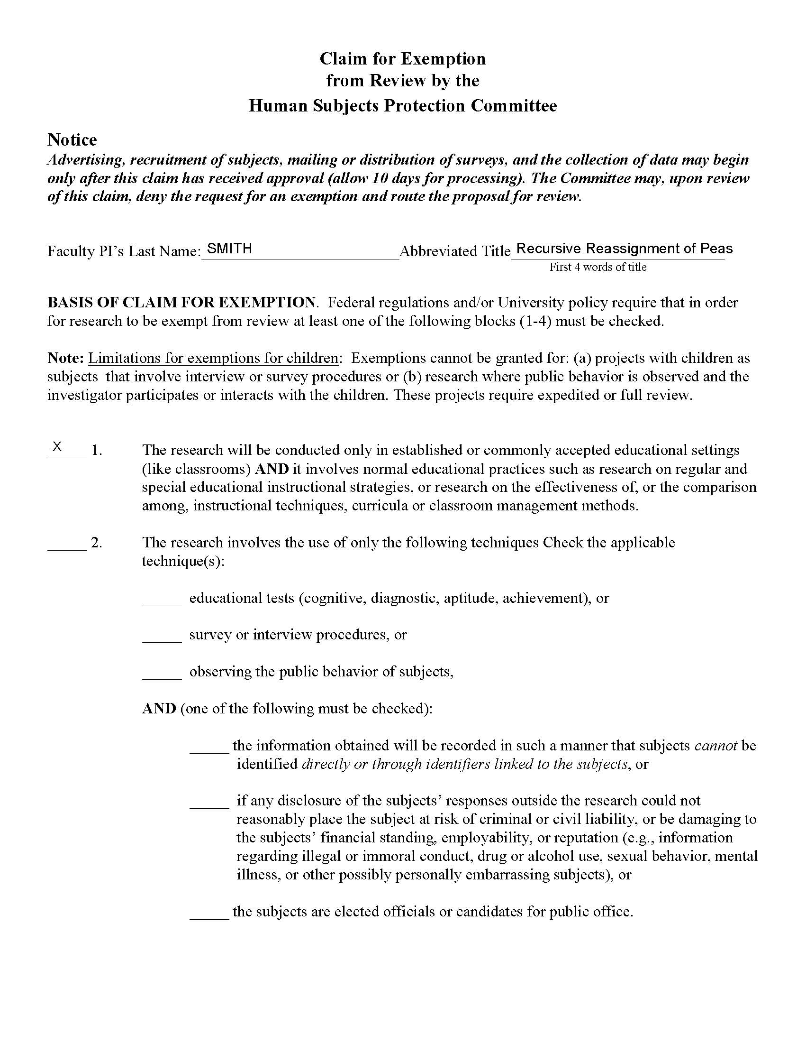
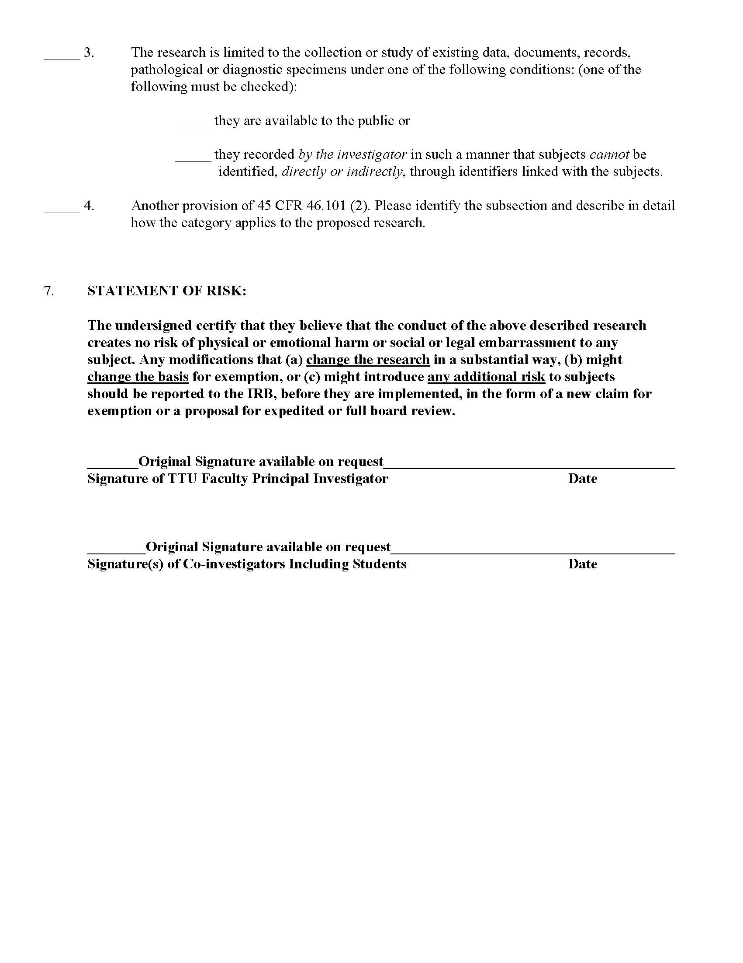
{This is a PDF that has been saved as a .jpeg file and then inserted as a “picture” into this document.
NOTE: You should NOT include scans of original signatures in your electronic documents.}

Appendix B

FEMA 2004 Storm Mapping
{This is the alternative style for an Appendix heading, centered on its own page. Use this style for appendix material that takes up an entire page.}
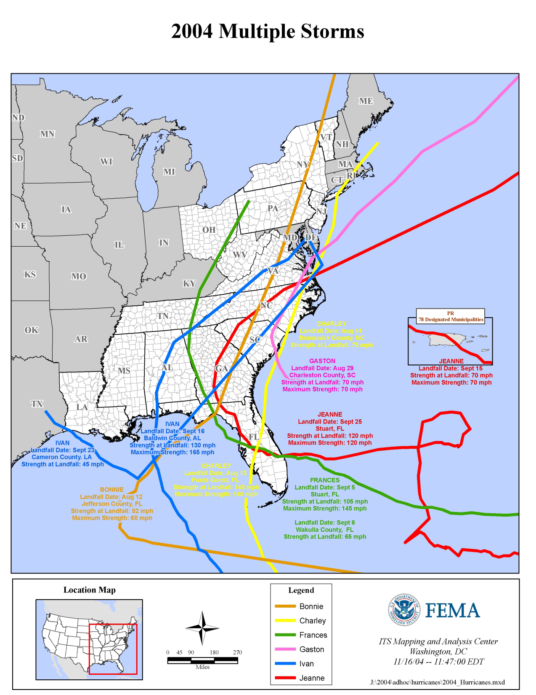
Figure B.1 2004 Multiple Storms Image courtesy FEMA

