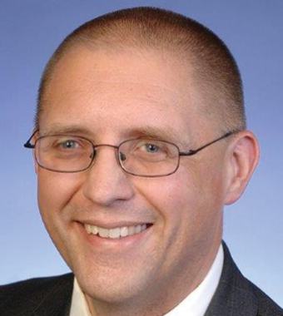
Department of Chemical Engineering
Seminar Schedule

Modular Chemical Process Intensification - Transforming the Process Industries
James Bielenberg
Chief Technology Officer of the RAPID Manufacturing Institute

Abstract
For several decades, the ideas of process intensification and modular chemical processes have offered the promise of fundamentally changing the way the process industries operate – from the types of equipment employed to the business models of industry participants. In this talk, we will look at recent developments that suggest that the time may have come for the promise of these concepts to finally be fully realized. We will touch briefly on market, economic, and regulatory forces and technology trends that are creating a pull for modular and intensified process and will finish with a discussion of the t formation of RAPID, a Manufacturing USA institute that is focused on creating a public-private partnership to catalyze research and development in the space of modular processing and process intensification.

Bio
James Bielenberg joined AIChE in the role of chief technology officer of the RAPID (Rapid Advancement in Process Intensification Deployment) Institute in March, 2017. RAPID was selected by the Department of Energy as the 10th Manufacturing Institute in the federal “Manufacturing USA” program. Leveraging $70 million in federal funding and more than $70 million in cost-share from partners, RAPID is focused on developing breakthrough process intensification technologies to reduce cost and boost energy productivity and energy efficiency.
Bielenberg is responsible for defining the technical direction of the institute through the development of technology roadmaps and project selection. To date, James Bielenberg and CEO Karen Fletcher have greenlighted 25 projects that encompass developing new technologies, enhancing current manufacturing processes, as well as augmenting new approaches in design, modeling and simulation.
Prior to joining RAPID, Bielenberg served in several roles within ExxonMobil, including a range of technical assignments supporting a range of ExxonMobil’s business lines, supply chain and marketing roles within the ExxonMobil Chemical Company, and numerous supervisory roles in the Research and Engineering division of ExxonMobil. His research and leadership roles span several technology areas, including upstream, downstream, chemicals, and biofuels applications.

Seminar
Wednesday, January, 24th
Livermore 101
3:00 pm

