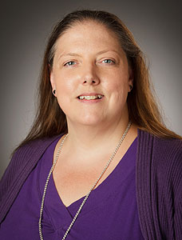
Department of Chemical Engineering
Seminar Schedule

Responsibility and Accountability in Academic Research Careers
Marianne Evola
Responsible Conduct of Research (RCR) Administrator
Abstract
Academic research careers, and the aspiring researchers that pursue these careers, are unique. In contrast to the goals of other careers, for academic researchers, making a significant contribution to one’s discipline often takes precedent over mere financial gain. To make a notable impact on one’s discipline, researchers must build and maintain a reputation of innovation, productive and rigorous research and most importantly, Integrity. As such, maintaining the integrity of research procedure and data is a high priority in most laboratories because greatness in research comes with a great deal of responsibility and often, unforgivable accountability. This seminar will address the definition of responsible research conduct but also the high costs of misconduct.

Bio
Marianne Evola, Ph.D. serves as the Responsible Conduct of Research (RCR) Administrator in the Office of the Vice President for Research. In this role, Marianne works under the supervision of Alice M. Young, Ph.D. to raise awareness to the importance of responsible and safe research practices in all research trainees. Furthermore, for personnel subject to mandatory RCR training, she monitors training compliance.
Prior to joining the OVPR at the start of the year, Marianne conducted postdoctoral research on the cognitive and behavioral impact of psychoactive drugs in preclinical models of substance abuse. Her postdoctoral research was first conducted at Wayne State University in Detroit and more recently at Texas Tech University Health Sciences Center. Marianne earned a bachelor’s degree in Psychology and a doctorate in Cognitive and Behavioral Neuroscience from Wayne State University in Detroit, Michigan.

Seminar
Friday, January, 19
Livermore 101
3:00 pm

