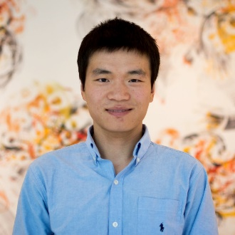
Department of Chemical Engineering
Seminar Schedule

Bioinspired Assembly of Ribonucleoproteins for RNA-based Therapeutics
Jiahe Li
Postdoctoral Researcher
Massachusetts Institute of Technology

Abstract
RNA-based therapeutics such as small interfering RNAs (siRNAs), antisense oligonucleotides (ASOs), aptamers, and synthetic messenger RNAs (mRNAs), hold great promise for targeting many currently undruggable genes and gene products and for generating entirely new therapeutic paradigms in diseases ranging from cancer to pandemic influenza to Alzheimer's disease. However, there remains an unmet need to improve their therapeutic efficacy. In this talk, I will describe a novel approach of preassembling mRNA and siRNA with their complementary proteins by utilizing inherent molecular recognition and polymer chemistry to enhance the potency of existing RNA-based therapeutics in primary cells and animal models. At the end, I will share my future research interests in leveraging state-of-the-art protein and nucleic acid engineering strategies, mouse cancer models, and polymer chemistry to push the boundaries of existing nucleic acid therapeutics. I will also discuss how these technologies can open the opportunity for a broad collaboration in Texas Tech University.

Bio
Jiahe Li obtained his PhD with Professor Michael King at Cornell University in 2015, and then became a postdoctoral fellow in Professor Paula Hammond’s lab at the Koch Institute for Integrative Cancer Research at MIT, where he has developed a novel approach of preassembling nucleic acids and complementary proteins with synthetic polypeptides to enhance the efficacy of RNA-based therapeutics, which has led to active collaborations with academic laboratories and biotech companies.

Seminar
Monday, Feb 19th
3:00 pm
Livermore 101

