POSITION ANNOUNCEMENT SUMMARY

GRADUATE ASSISTANT – RAIDER RED’S FOOD PANTRY

Job Responsibilities:
- Departmental Events – Assisting with various duties associated with departmental events such as resource fairs, tabling opportunities, presentations, and food drives, including assisting with planning, implementation, coordinating donation bin drop-off/pick-up, and corresponding with donors.
- Social Media/Email – Provide oversight and help in coordination of social media campaigns and posts for the departmental Facebook account. Manage emails sent to Raider Red’s Food Pantry.
- Food Pantry Responsibilities – Manage inventory and stock donations, facilitate intake process, maintain confidentiality with student/client information, pick up food from farm/store, practicing sensitivity to the needs of a diverse clientele, and providing referrals to students/clients for additional resources. This position involves a high level of contact with people, requires basic knowledge of Texas Tech University resources and strong communication skills.
- Administrative Responsibilities – Perform data entry, answer phones, and general office duties. Must be able to work quickly and accurately with a strong attention to detail. Excellent face-to-face and telephone customer service and computer/typing skills are crucial.
- Other – Complete other duties as assigned.

Requirements: The successful candidate will possess strong communication and presentation skills. A bachelor’s degree is required, and candidates should have previous student affairs, student activities or student leadership experience. This position is designed for the individual who is pursuing a graduate degree. At time of employment, candidates must be accepted into a graduate degree program at Texas Tech University. This position is security sensitive. Applicants will be subjected to a background check. All candidates will be required to submit academic transcripts to verify education. This position will also include utilizing a university vehicle, so a driver’s license will be necessary.

Preferred skills/experience: Enrollment in Nutrition and Dietetics, Higher Education, Human Sciences, Social Work, or other fields focusing on Nutrition, Education, or Social Needs is preferred.

Remuneration: $14 per hour

Hours: 20 hours per week. Graduate Assistants are expected to work all University workdays unless prior arrangements have been made with their supervisor and all job responsibilities are completed.

To Apply: Applicants should submit a cover letter, resume, and three (3) current references when applying to foodpantry@ttu.edu. Review of applicants to begin immediately and will continue until position is filled. Texas Tech University System will not discriminate in its employment practices because of an applicant's race, color, religion, sex, sexual orientation, gender identity, national origin, age, disability, genetic information, status as a protected veteran, or any other legally protected category, class or characteristic.

Questions regarding this position should be directed to foodpantry@ttu.edu

Graduate Assistant Application
Raider Red’s Food Pantry

NAME: _________________________________ R NUMBER: ________________________________

PHONE: ________________________________ E-MAIL: ___________________________________

Institutional GPA: _________________________ Classification: ______________________________

Please attach a resume, fall class schedule. Submit electronically to foodpantry@ttu.edu. Please make sure your resume includes the following:

- Work history, volunteer experiences, academic information, awards/honors
- References (2 work related and 1 personal). Include name and contact information for each reference.

Incomplete applications will not be considered.

DAYS AND HOURS AVAILABLE FOR WORK DURING FALL 2021:

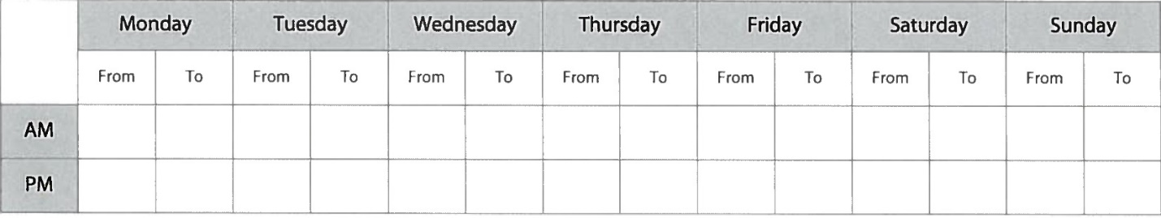

PLEASE LIST ANY DAYS, WEEKENDS, ETC. THAT YOU ARE NOT AVAILABLE TO WORK FALL 2021 (Between September 1st and December 17th)

_________________________________________________________________________________________

_________________________________________________________________________________________

Please list any languages you are proficient in other than English:

_________________________________________________________________________________________

ESSAY (Use back of this page or attach one (1) page only if needed)

How does a campus food pantry support students?

By filling out this application, I authorize Raider Red’s Food Pantry/Center for Campus Life to make reference checks relating to my employment. I understand that any offer of employment is contingent upon my agreement to abide by the rules and regulations of Texas Tech University.

