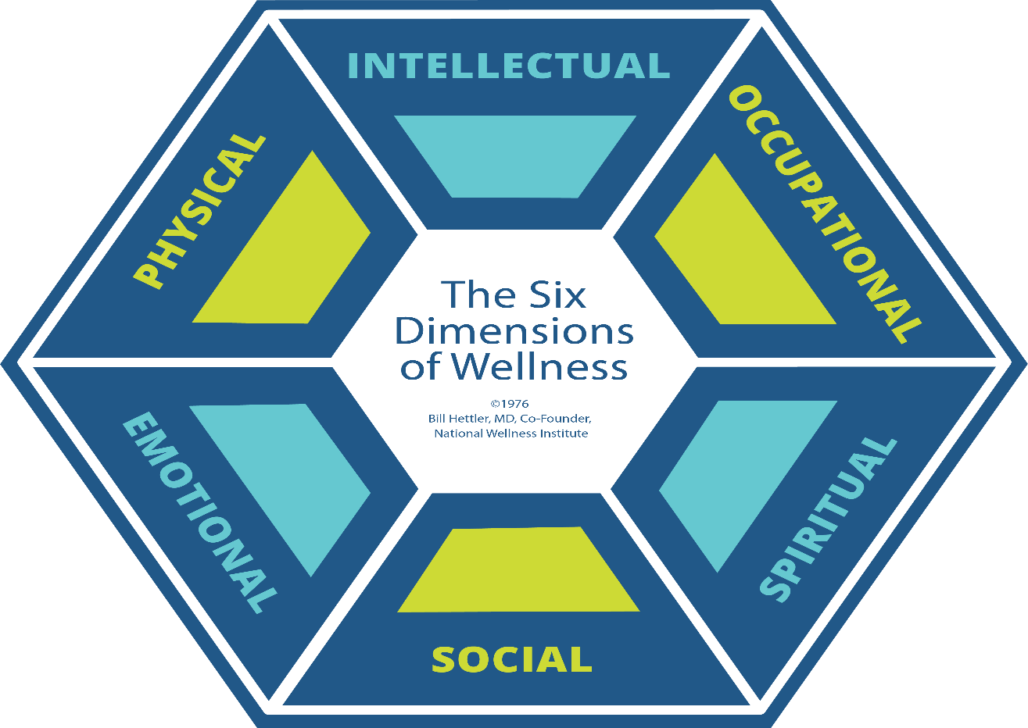

https://nationalwellness.org/wp-content/uploads/2023/01/6Dimensions_1080px.png
Tips for improving your mental wellbeing
- Try to relax and reduce stress.
- Find ways to learn and be creative.
- Spend time in nature.
- Connect with others.
- Look after your physical health.
- Try to improve your sleep.
https://www.ncbi.nlm.nih.gov/pmc/articles/PMC10355843/#:~:text=Mental%20health%20is%20another%20aspect,impact%20in%20all%20health%20areas.

