

**Professional Positions [1][1]**

(Texas Education Agency Data, 2004/05 to 2016/17)

Most TTU graduates are employed as teachers, but many individuals also find fulfilling careers as administrators, counselors, diagnosticians, and numerous other positions of responsibility.

|  |  |
| --- | --- |
| **Professional Positions** | **Number** |
| Assistant Principal | 237 |
| Assistant Executive Director | 1 |
| Assistant Superintendent | 28 |
| Athletic Director | 3 |
| Athletic Trainer | 3 |
| Audiologist | 1 |
| Business Manager | 4 |
| Corrective Therapist | 1 |
| Counselor | 260 |
| Department Head | 5 |
| Director of Personnel/Human Resources | 9 |
| District Instructional Program Director | 83 |
| Educational Aide | 85 |
| Educational Diagnostician | 203 |
| Instructional Officer | 8 |
| Interpreter | 2 |
| Librarian | 80 |
| Licensed Specialist in School Psychology | 8 |
| Occupational Therapist | 1 |
| Other Campus Professional Personnel | 77 |
| Other Non-Campus Professional Personnel | 8 |
| Other Non-Instructional District Personnel | 84 |
| Orientation Mobility Specialist | 13 |
| Principal | 219 |
| Social Worker | 2 |
| Special Duty Teacher | 14 |
| Speech Therapist | 11 |
| Substitute Teacher | 8 |
| Superintendent | 89 |
| Supervisor | 1 |
| Teacher Facilitator | 114 |
| Teacher | 8,102 |
| Teacher Supervisor | 22 |
| Visiting Teacher | 1 |
| Vocational Education Coordinator | 3 |
| **TOTAL** | **9,790** |

**Locations of Candidate Employment**

**Certified by Texas Tech University [2][2]**

(Texas Education Agency Data, 2004/05 to 2015/16)

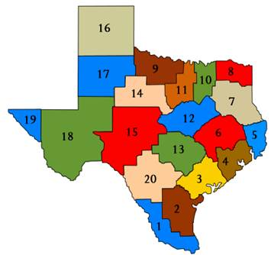

|  |  |  |
| --- | --- | --- |
| Education Service Center | Employment | Percentage |
| 1  Edinburg District | 52 | < 1% |
| 2  Corpus Christi District | 36 | < 1% |
| 3  Victoria District | 42 | < 1% |
| 4  Houston District | 818 | 8% |
| 5  Beaumont District | 22 | < 1% |
| 6  Huntsville District | 137 | 1% |
| 7  Kilgore District | 102 | 1% |
| 8  Mount Pleasant District | 41 | < 1% |
| 9  Wichita Falls District | 105 | 1% |
| 10 Richardson District | 1,489 | 15% |
| 11 Fort Worth District | 1,094 | 11% |
| 12 Waco District | 203 | 2% |
| 13 Austin District | 641 | 7% |
| 14 Abilene District | 224 | 2% |
| 15 San Angelo District | 156 | 2% |
| 16 Amarillo District | 369 | 4% |
| 17 Lubbock District | 3,152 | 32% |
| 18 Midland District | 516 | 6% |
| 19 El Paso District | 94 | 1% |
| 20 San Antonio District | 443 | 5% |
| Not Determined | 54 | < 1% |
| **Total** | **9,790** | **100%** |

This table indicates positions by Education Service Center Districts. Although data are not currently available, candidates secure jobs throughout the nation—e.g., our special needs programs in vision, hearing, and mobility are found in Montana, Arkansas, Wyoming, Idaho, and elsewhere.

The Texas Education Agency (TEA) provides some additional overview data indicating employment within a year of completion and retention in the profession.

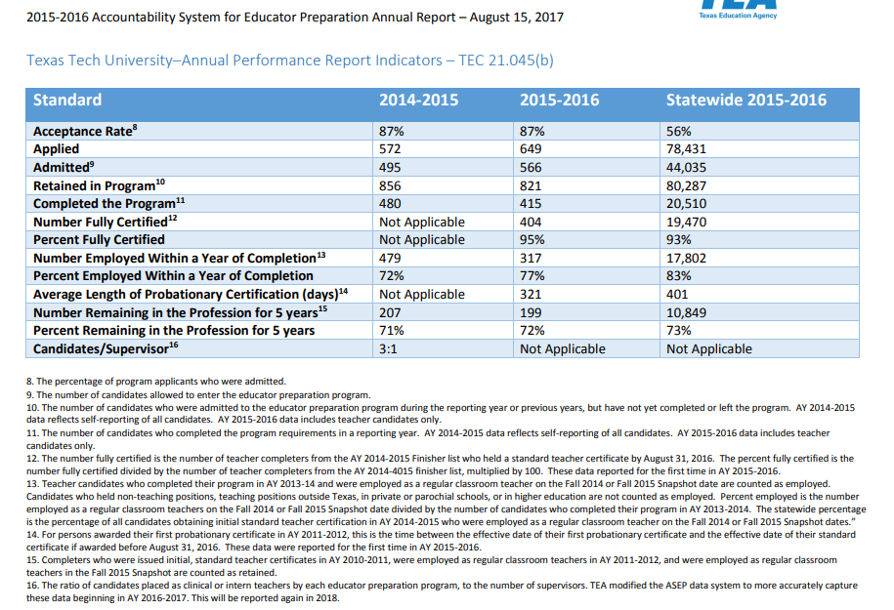

1. [1] Individuals may have moved several times, with these data as last employments.
2. [2] Individuals may have moved several times, with these data as last employments