How to Use the Conference Room Technology
Getting Started 2
Meet Now 3
Starting Presentations 3
Presentation Button Options 3
Adding Additional Users 6
Using External Devices 9
Dial Pad 14
Start Whiteboard 15
Whiteboard Controls 15
Crestron Whiteboard Options 17

Getting Started
When you first sit down to the Crestron touch panel, you’ll see an image like the one below.
(Note: If the screen is black, simply touch it and it’ll wake up.)

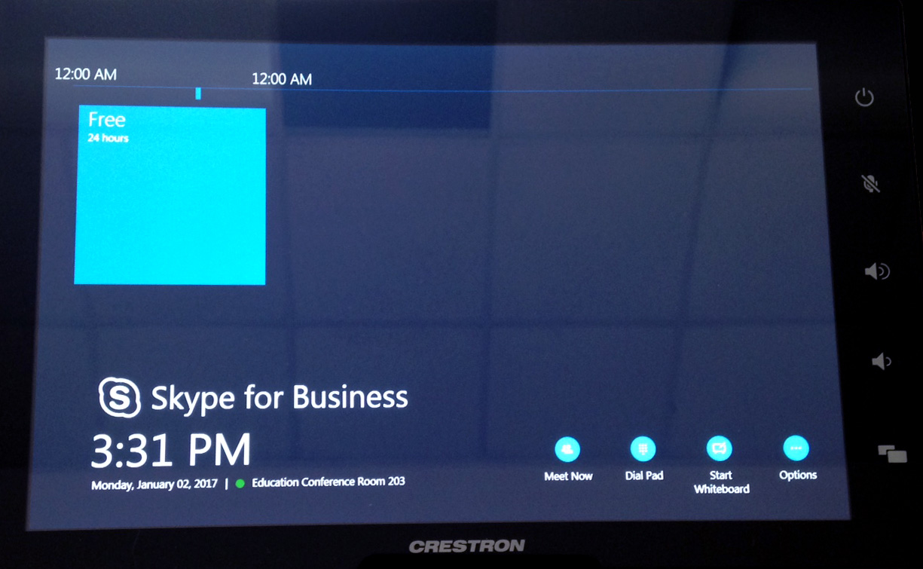

The home screen presents four icons in the lower right corner of the touch panel:
- Meet Now
This button is the one that is used most often. It’s used to present information to others, either within just the room or including other attendees at a distance. See the Meet Now section for more information.
- Dial Pad
Pressing this button allows users to place a simple one-to-one call, either via phone or Lync. See the Dial Pad section for more information.
- Start Whiteboard
This button allows users to start a digital whiteboard. See the Start Whiteboard section for more information.
- Options
This button has limited functionality and is rarely used.

Meet Now
The meet now button is used to present information to others. Information is typically shared in one of three ways:
- In-Room Presentations
- Distance Meetings
  - Lync/Skype for Business
  - Other Technologies

Starting Presentations
For meetings that are contained entirely within the conference room (i.e., no one is connecting remotely), starting a presentation is straightforward:
- Press Meet Now.
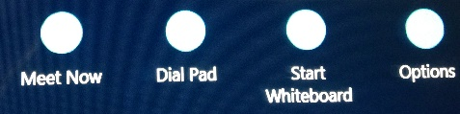
- Press Start Meeting.
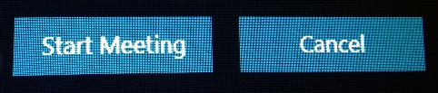
- Press Desktop/Device,
then press Start Presenting.
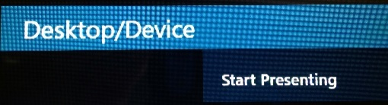
- You’ll be presented with a typical TTU login screen. Any faculty, staff, or student can sign in with a valid eraider and password.
(Note: If you don’t the login screen, the computer is probably asleep. Tapping the keyboard or mouse will wake it up.)

Presentation Button Options
When a presentation is started, you’ll see a series of buttons at the bottom of the Crestron touch panel, as shown below:
- Stop Video
This icon turns off the video camera(s). Use this option if you don’t want to use video for your presentation, or if you won’t have anyone connecting from a distance.
- Hold Call
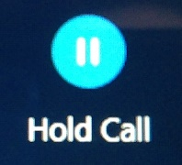
This icon places all participants on hold until it’s pressed again.
- Mute Room
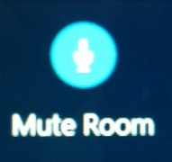
This icon mutes the audio for the meeting. Its functionality is similar to Hold Call, but the audio from remote participants is still enabled.
(Note: Either the Hold Call or Mute Room buttons are good options for defense proposals and dissertations when you don’t want remote participants to hear the in-room discussion.)
- Speaker Off
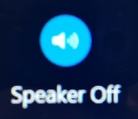
This icon mutes the incoming audio. Remote participants will be able to hear the in-room discussion, but you won’t be able to hear them.
- Room Volume
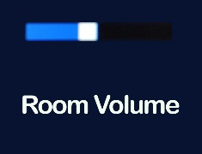
The Room Volume icon doesn’t have any functionality. The volume has to be controlled through the device that’s currently presenting data.
- Dial Pad
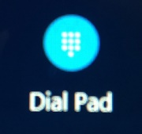
This icon allows you to place a call and add additional participants to the meeting. More details can be found in the Dial Pad section.
- New Whiteboard, Email Whiteboard
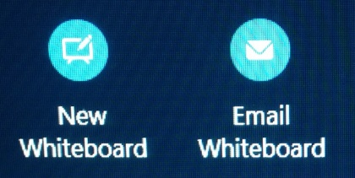
These icons present options for interacting with the digital whiteboard capability of the monitors. For more information, see the Start Whiteboard section.
- Leave Meeting
Pressing this icon ends the current presentation.

Adding Additional Users
You may want to add users to the presentation in addition to those physically present in the same room. You can do so in a number of ways, including the Dial Pad, Skype for Business/Lync, and other technologies.

- Adding Users via the Dial Pad
Users can be added via the touch panel as follows:
  - Press the Dial Pad button.
  - Press Add to Call to add a user via phone.
(Note that this option allows remote users to hear audio only; they won’t be able to see any information being presented.)
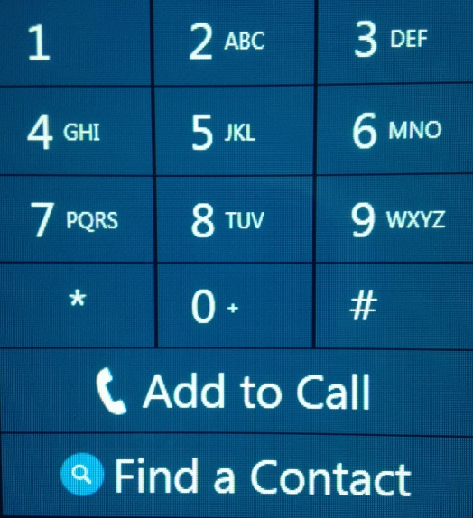

- Adding Users via Skype for Business/Lync
Adding users via Lync can be done in a couple of ways:
  - Press Dial Pad and Find a Contact as shown in the images above. You’ll be presented with a screen like the one shown below, where you can enter the person’s name in a Last Name, First Name format.
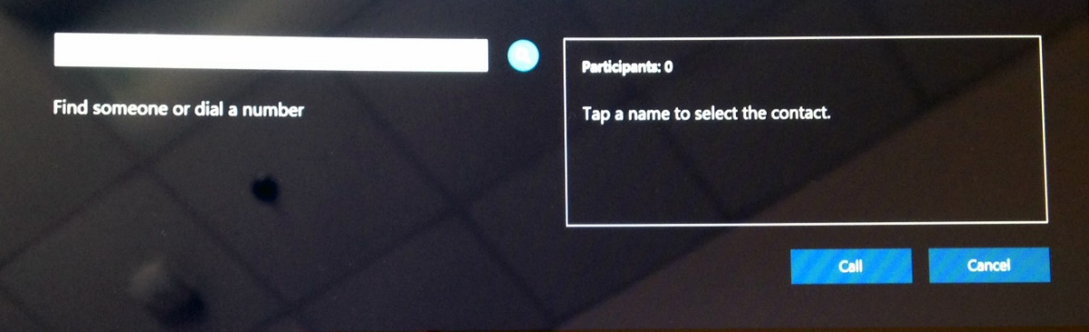
  - Alternatively, when you schedule your meeting, you can invite both attendees and the conference room via a Skype Meeting in Outlook. Attendees will see text like the message below, and will have several options:
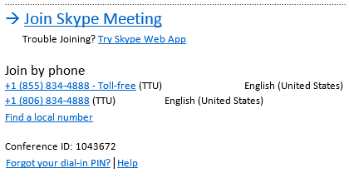
    - Users internal to TTU can click the Join Skype Meeting link, and they’ll be connected to the meeting automatically.
(Note: Users will need to be signed into Lync first.)
    - Users external to TTU can click the Try Skype Web App to download a small file. This way, they’ll be able to see information being presented.
    - Those who want or need to join via audio only can use either of the phone numbers shown. When prompted, they’ll need to enter the Conference ID.

- Adding Users via Other Technologies
Users who do not wish to use Lync can connect with others via virtually any technology (e.g., Blackboard Collaborate, Zoom, GoToMeeting), with some caveats:
  - The right-side monitor won’t be available; it functions only for video for Skype for Business/Lync calls.
  - The video input will need to be changed, as follows:
    - Press the Windows button on the right side of the Crestron display.
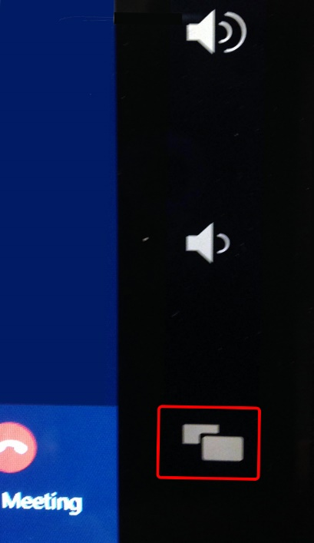
    - Press the Send Cameras to PC button.

Using External Devices
Each of the conference rooms has its own computer that can be used to present information and connect remote users, but the room can also accommodate a number of external devices, such as laptops, iPads, and smartphones. The following steps show you how to connect external devices:
- Start the system by following the steps in the Meet Now section.
- Press the Windows button on the right side of the Crestron display.
- You’ll see a list of Content Sources, as shown below.
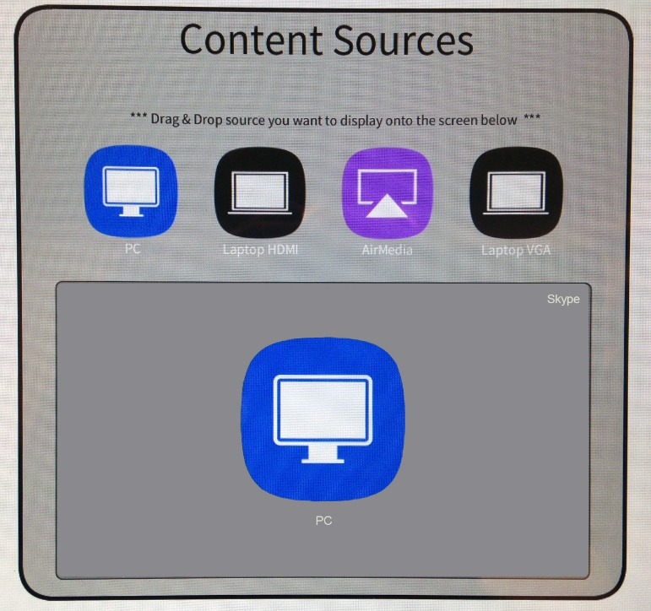
The content sources include the following:
  - PC
  - Laptop HDMI
  - AirMedia
  - Laptop VGA
To change a content source, touch the button on the top row you’d like to use, and drag it to the bottom section. These options are explained in more detail below:
- PC
This option is the default selection, and it utilizes the in-room computer.
- Laptop HDMI
The Laptop HDMI option allows users to connect several different types of devices, as follows:
  - HDMI
This connection is most often used for PC laptops, but it can be used for any device with an HDMI connection.
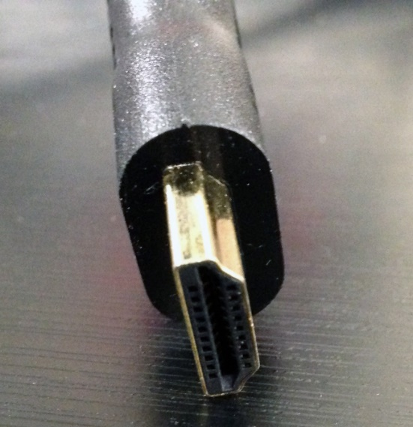
  - Mini DisplayPort
This connection is typically used for Mac laptops.
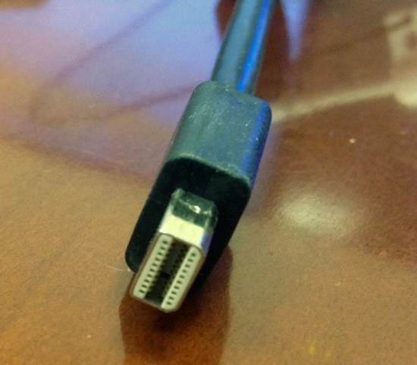

  - Lightning
This connection is used for iPhones.
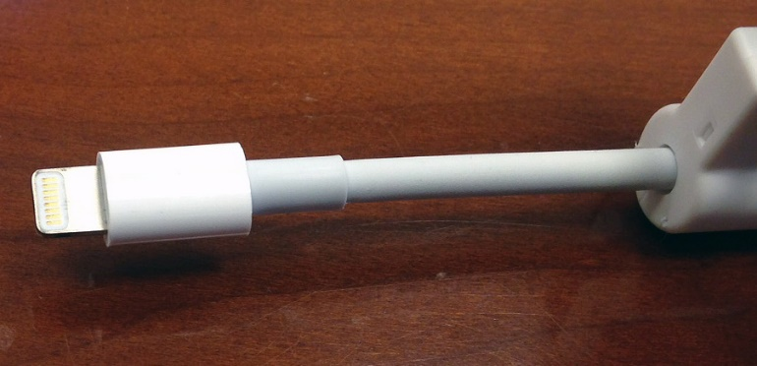
  - Mini HDMI
This connection is used for phones and computers that are compatible with the Type C mini HDMI port.
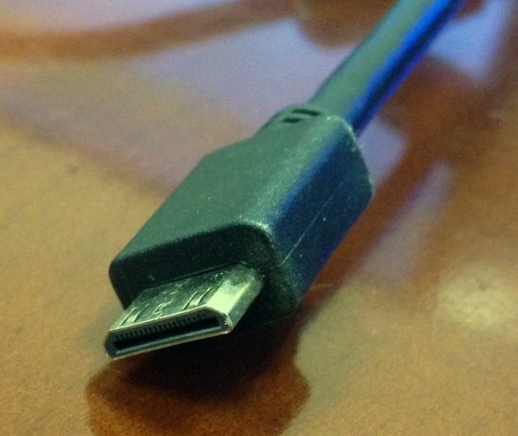
  - Note: Use of the Mini DisplayPort, Lightning, and Mini HDMI connections require those adapters to be plugged into the HDMI connection, as illustrated below.
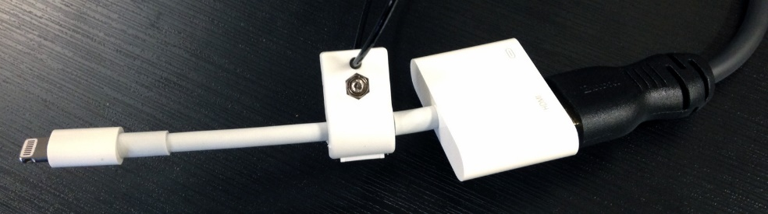

- AirMedia
AirMedia allows nearly any type of device with wireless Internet capability to present information, with a couple of caveats:
  - Android devices cannot connect to AirMedia.
  - AirMedia cannot transmit sound.

To present information via AirMedia, use the following steps:
- Change the content source to AirMedia.
- The monitor will display a splash screen like the one below.
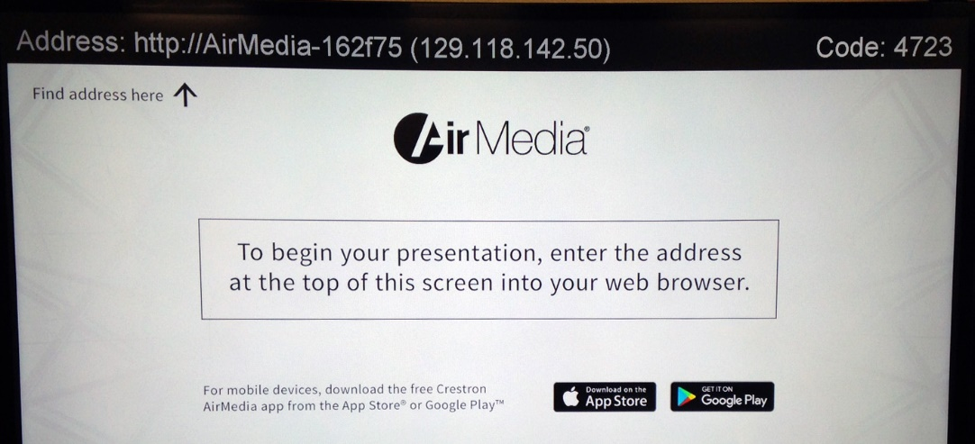
Note: If you want to present information from an iPhone, you’ll need to download the AirMedia app.
- In a browser window on your device, enter either the web address (in this case, http://AirMedia-162f75), or the IP address (129.118.142.50).
- If you’re presenting from a laptop or tablet, you’ll need to click the appropriate link to download a small file to your device.
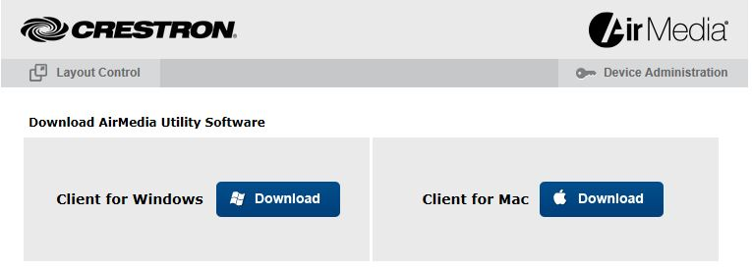
- When prompted, enter the code displayed in the top right corner of the monitor.
Note: This code will change for each AirMedia session.

- Laptop VGA
This connection is used for laptops with the older VGA connections. An audio cable is available if you need to include sound with your presentation.
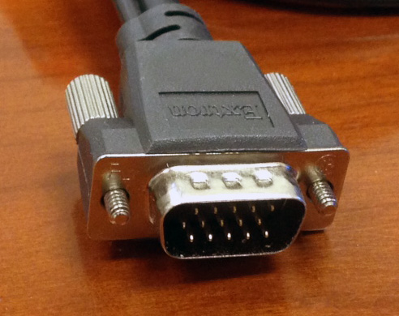

Dial Pad
Pressing the Dial Pad button displays the image below.
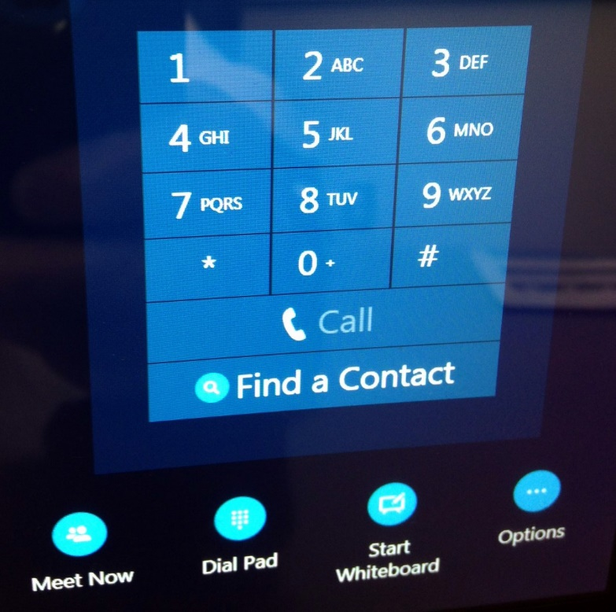

Calls can be placed in one of two ways:
- Enter the phone number, and press Call.
- Press Find a Contact. Doing so will display a dialog box allowing you to enter the name of the person you wish to contact. Use the touch panel’s keyboard to enter the person’s name in a “Last Name, First Name” format, then press Call.
(Note: This option is only available to contact people internal to TTU.)
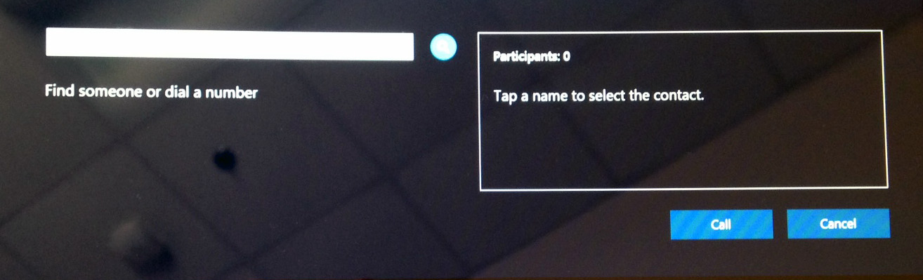

Please note that this method of dialing can only be used for one-to-one calls. If you’d like to add more than one person, see the Meet Now Section.

Start Whiteboard

Whiteboard Controls
When you press the Start Whiteboard button, a digital whiteboard will appear on the monitor, and you’ll see a row of icons in the bottom right corner, as shown in the image below.

The first two icons have little use. The others can be manipulated with the pens and erasers provided and/or with a finger, and are explained as follows:
- Pen
This icon allows you to write and draw freehand lines and figures. Touching the down arrow provides options for colors and weight (i.e., thickness) of the line.
- Highlighter
The highlighter has options similar to the pen, in that touching the down arrows provides options for colors and weight.
- Eraser
Touch the eraser icon, then any part of the screen to erase something on the whiteboard.
- Stamp
The stamp icon allows you to insert an arrow, check, or X. Touching the down arrow provides these options:
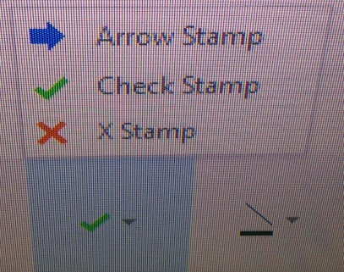
- Shape
The shape icon provides options for adding lines, arrows, squares, and circles. Options for the shapes are shown below:
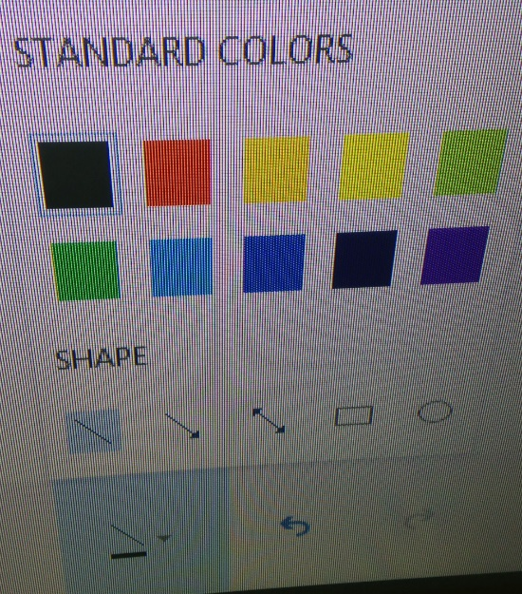
- Undo/Redo
These icons provide standard options for undoing or redoing the last action.
- Delete
This option allows you to clear everything on the whiteboard.

Crestron Whiteboard Options
When a digital whiteboard is started, the Crestron touch panel presents three new options, as shown below.

- New Whiteboard
Touching the New Whiteboard icon allows you to add another whiteboard to the existing one. The current whiteboard isn’t lost or changed, and you have the option to switch among multiple whiteboards.
- Email Whiteboard
This icon allows you to send the current whiteboard diagram via email. Once pressed, a dialog box will pop up like the one below. Press the Add button, then enter the recipient’s name in a Last Name, First Name format. (Note: It’s typically easiest to send the image to one person, then forward it along to others that need to see the same image.)
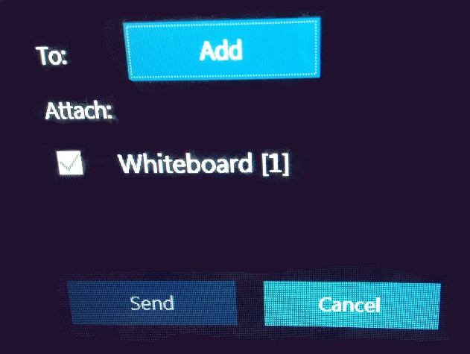
- Leave Meeting
This icon closes the digital whiteboard.

