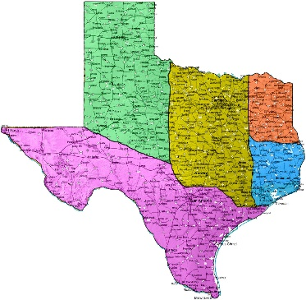
TEXAS HISTORY
Study Resources

Quizlet – Texas History Study Guide Flashcards
https://www.google.com/#q=Texas+History+study+guide
Kahn Academy
https://www.khanacademy.org
You Tube:
Texas History – 4th grade (videos)
https://www.youtube.com/watch?v=T3Pc_1zhBKY&list=PLcMbNVaRJC3Wjjd8WYyCXlWOoCS8nGDOR
4th Grade Texas History (videos)
https://www.youtube.com/watch?v=5JlG6_IEobs&list=PLIe25eyMBy8ihlMGXsA-X94cz2aFxmsk-
ITunesU - Courses
Texas History – 7th grade overview
4th Grade Texas History
The Bob Bullock Texas State History Museum – Educator Guide
TEKS for Social Studies:
http://ritter.tea.state.tx.us/rules/tac/chapter113/index.html
Time Line and Key Events:
https://web.archive.org/web/20130802160305/http://www.lsjunction.com/events/events.htm
Texas History Web Guide:
https://web.archive.org/web/20130709134455/http://www.lonestar.edu/library/kin_TexasHistory.htm
Dallas Historical Society:
https://web.archive.org/web/20130724025635/http://www.dallashistory.org/history/texas/texas_history.htm
Texas State Historical Association:
https://web.archive.org/web/20130812063023/http://www.tshaonline.org/handbook

