
Caprock
Texas Tech University | Department of Geosciences

Fall 2018

Connections
Texas Tech University College of Arts & Sciences • Department of Geosciences

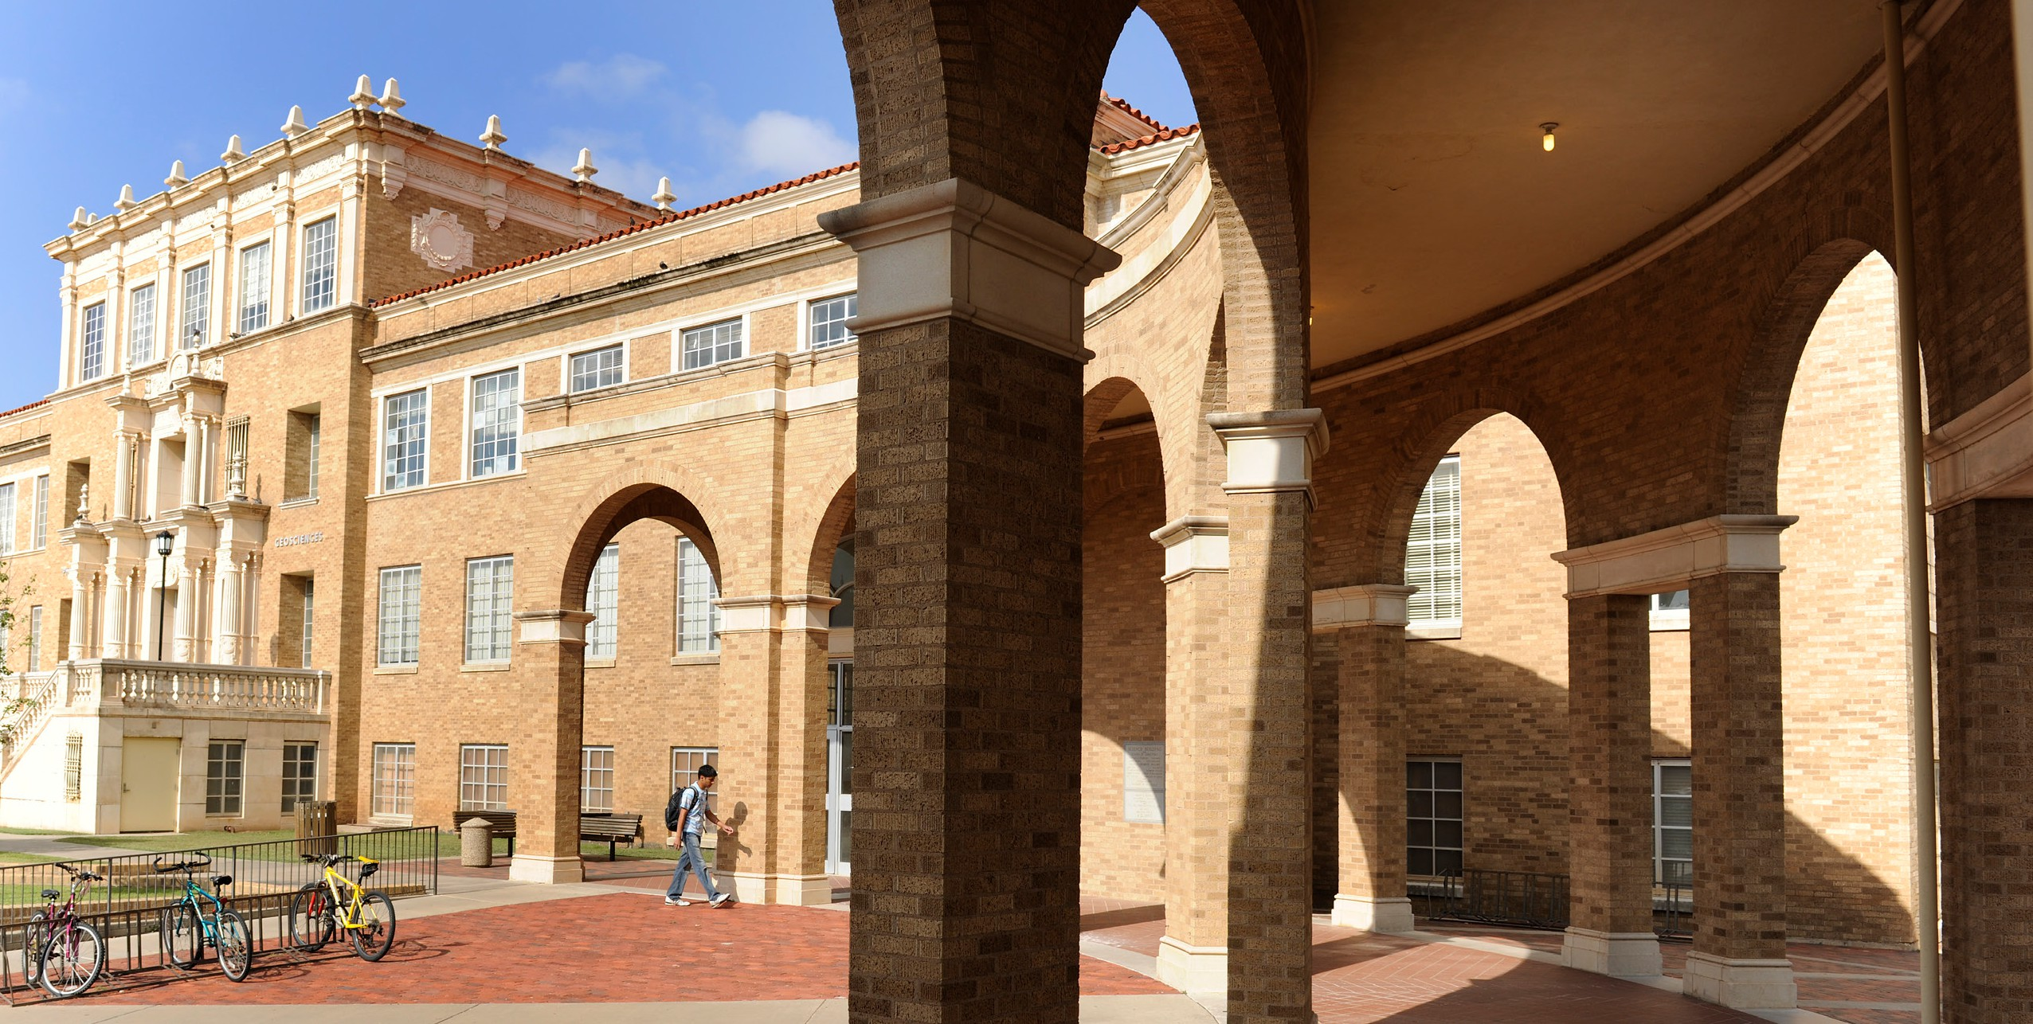
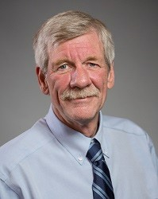

As the new department Chair, I would like to first thank Dr. Jeff Lee for his service over the past five years. During this time, the department replaced six faculty members, the faculty secured more than

From The Chair
Kevin Mulligan
Associate Professor & Department Chair
CONTENTS
Chair’s Welcome 1
Scholarship Awards and Giving 2&3 Field Camp/Trip Reports 3 New Faculty/Science Report 4 Seagraves Meteorite Anniversary 5 Science Report/Connections 6 Sylvia C. Cearley Endowment 7 Mineral Resources Project 8
U.S. Census Bureau Career 9
Alumni Profiles 10
INNOVATORS
www.artsandsciences.ttu.edu
BUIL D
$15 million in external research funding, our course enrollment topped 33,000 and 385 students earned
their undergraduate or graduate degrees. It takes quite a bit of effort behind the scenes to make this happen – and I would like thank Dr. Lee and the department staff on behalf of all of us in Geosciences.
I am also pleased to report that two new faculty members have joined us this year. Dr. Neo McAdams and Dr. Sandip Pal started in the fall semester and you can read more about their research and teaching interests on page 4. In other news, Dr. Gary Elbow (geography) will be retiring at the end of the fall semester after 48 years of service to the university. Dr. Elbow was one of the founding members of the geography program at Texas Tech and we all wish him the very best in his retirement.
I would also like to thank our industry recruiters this year for their excellent support. During the fall semester, 8 companies conducted over 50 interviews of our students. Obviously, we are very proud of our students and these companies know where to go to find the best talent.
Lastly, I am very happy to report that we have established a new Geology Summer Field Camp Scholarship. Every summer, our senior geology majors spend four weeks in Colorado gaining valuable
WE
field experience – but it costs each of the students quite a bit for travel, housing and tuition. If you would like to help support our students in this endeavor, I encourage you to consider donating to this
new fund (page 3). Our alumni support is greatly appreciated – and I would like to thank you again for all that you do to support the department. Kevin Mulligan

Student Scholarship Awards - 2018/2019

Undergraduate Students (BA, BS) – Geology/ Geophysics
Ann and Dennis Bell Geology Scholarship – Al-Baqi Badru
Dr. F. Alton Wade Geology Scholarship – Ryker Allison
Dr. Grover E. Murray Endowment –
Jarrod Bridges, Kimberly Dominguez, Lara Fly, Royce Massey, Daniel Okoro-Sokho, Aziza Omari, Joshua Sundgren
Frank M. Hall Scholarship –
Joyce De Figueiredo, Meaghan Tangaye Geosciences Sigma Gamma Epsilon Scholarship –
Bryan Joiner
Heather S. Anderson Arts & Sciences Scholarship – Marco Benevides, Daniel Lavery, Joshua Sundgren
Michael Jerome Rogers and Avery Dawson Rosen Memorial –
Kimberly Dominguez
Michael Louis Kincer Memorial Scholarship – Andrew Shotwell
Stephens Exploration Inc. Geology Scholarship – Markicia Horton
Vestal and Ouida Yeats Scholarship –
Tania Babu, Michael Beam, Alex Blizzard, Jacob Cilfone, McKenzie Morrison, Henry Okorie

Undergraduate and Graduate Students – Geography
Gary Elbow Scholarship –
Amal Aljaddani, Ruba Al-Zubi, Fernando Angel, Cole Edwards, Aaron Flores, Ryan Jost, Tarek Kandakji. Ankush Saha, Cameron Shoemaker, Hannah Webb, Junxue Zhang
Geography Excellence Fund and Presidential Fellowship Awards –
Ying Liu, Congliang Zhou
Otis & Josephine Templer Geography Scholarship – Mason Jones, Dillon Sahs, Prudence Venner
how chaos works, and why it tmosphere from activities such as
larger weather systems far from
e. A Plinko board is used to demonstrates how a puck placed

xplaining that if air is made more moist xample, the relatively small difference can

Graduate Students (MS, PhD) – Geology/ Geophysics
AAPG Grant-in-Aid (Eddie David Fellowship) – Giovanni Zanoni
Alonzo D. Jacka Scholarship –
Khaled Chowdhury, Giovanni Zanoni CH Foundation Graduate Fellowship –
Valerie Tewell
Deskin Shurbert Scholarship – Elyas Ainiwaer
E A McCullough Fund –
Ethan L. Backus, Derek Berman, Susan Lieb Geological Society of America –
Shane Dailey, Don Maute George B Asquith Fund –
Rui Liu, Saheed Obitayo
Helen Jones College of A& S Fellowship and Permian Basin Geophysical Society Scholarship –
Alex Washburn
Hess Leadership and Excellence Scholarship – John Akoto, Luka Badurina
John P Brand Fund –
Carla Eichler Lewis G Weeks Fund –
Don Maute
Margaret Talking Graduate Fellowship – Danielle Spencer
Pan-Handle Geological Society – Ethan L. Backus
Presidential Doctoral Fellowship – Maria Van Nostrand
South Central Federation of Mineral Societies Fellowship –
Ethan L. Backus, Katie Gates
Southwest Section - AAPG Research Fellowship – John Brotherton
Virginia Clair Research Award –
Ethan L. Backus, Rui Liu, Don Maute, Susan Lieb
West Texas Geological Society Scholarship – Derek Berman, John Brotherton

Recent Alumni Snapshots
Matthew Garvin (BS Geology 2005), Heather Anderson (BS Geology 2006), Mark Hermann (BS Geology 2005),
Dr. Harold Gurrola. Pictured at the Fall 2018 College of Arts & Sciences Fort Worth Alumni Scholarship Reception

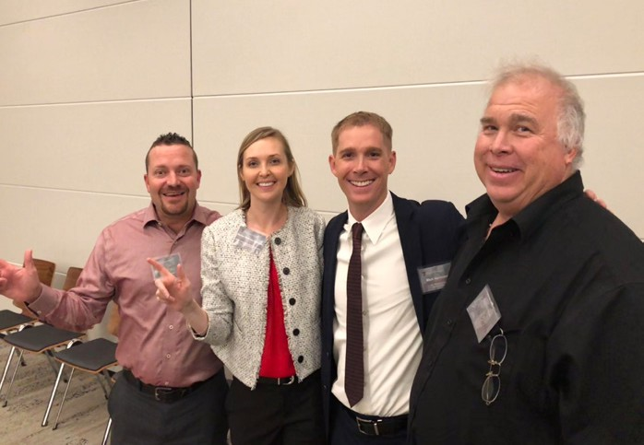
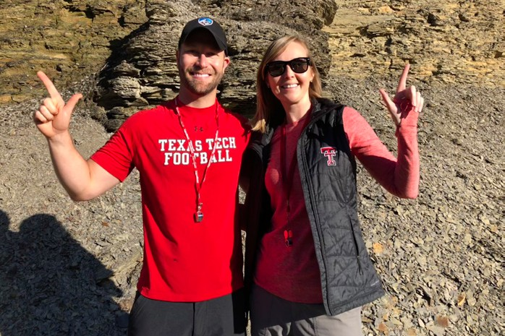

2 Caprock Connections
XTO Energy Geologists Michael Williams (BS ‘10) and Heather Anderson (BS ‘06), pictured south of Lexington, KT as part of ExxonMobil’s Mudrock School (Fall 2018) field training course.

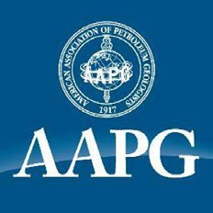
Supporting Geology/Geophysics
How you can help our students
Save the date: May 20, 2019 College Alumni Reception AAPG Annual Convention: - San Antonio, Texas
Field Camp Fund-

Each summer our junior and senior undergraduates head to field camp outside of Canon City, Colorado, where they apply all of their geologic skills in mapping in and around
the Dakota hogbacks. While we have made every effort to keep the cost of field camp low, many students struggle to find the funds to cover the cost. We have developed a scholarship specifically for Tech students attending field camp for the Summer of 2019. Please consider making a donation so we can help these young geologists on their way. Please send a check to the department or the excellence fund https://donate.give2tech.com//?fid=4167-44-2145
Geosciences Graduate Scholarships-
Graduate student support includes stipends and fee waivers however, stipends have not increased with inflation and the students pay mandated in-state tuition. This financial gap can be met with graduate student scholarships. Your support of recruitment scholarships, research fellowships, and grants-in-kind will help the department maintain our success in recruiting and supporting excellent students. Your support of our students has a BIG impact. https://www.depts.ttu.edu/geosciences/giving/donating.php

Supporting Geography
Gary Elbow Scholarship -
Dr. Elbow is retiring from TTU in December 2018 after 48 years of service to the Geography Program and the University community. Please consider honoring his retirement by contributing to the Gary Elbow Scholarship to help undergraduate and graduate students in Geography. https://donate.give2tech.com//?fid=44EB-44-9246
Otis Templer Scholarship -
As a founder of the Geography Department, Dr. Templer leaves a legacy to the Geography Program. This legacy continues in his scholarship that supports geography graduate and undergraduate students. https://donate.give2tech.com//?fid=44CT-44-9183

Supporting Atmospheric Sciences
Jurica Scholarship - Graduate student support includes stipends and fee waivers however, stipends have not increased with inflation and the students still have state tuition expenses which are not covered in their waivers. The gap can be met with graduate student scholarships. Contibute here: https://donate.give2tech.com//?fid=44GN-44-9379


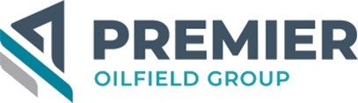


Thank you to our AAPG/Geosciences Society Chili Cook-off Sponsors
Caprock Connections 3

Summer 2018 Geology Field Camp, Colorado by Lara Fly, Graduate Student (Geoscience)
Field camp 2018 was among the best experiences of my undergraduate career. It was the culmination of everything I had learned about geology in previous classes. Four weeks of hands-on experience mapping, measuring stratigraphic sections, and interpreting structures in the field not only
taught me new techniques, but also showed me how much I already knew about geology. It wasn’t until field camp that I realized just how far I’d come since I started college.
Our field camp took us all around Cañon City, Colorado, to places like Temple Canyon and the “mixing bowl” in Temple Canyon Park, the Wind Gap in the Dakota Hogback, and the Royal Gorge. The facilities at Bartell Field Station were nothing short of amazing. Between the cabins, study rooms and the mess hall, it started to feel like a home away from home. The view from just about anywhere of the Cañon City Embayment and Pikes Peak was beautiful. Coming back from a hard day in the field to a place like that made the experience a lot easier than it could have been, and it was hard to leave it at the end of the month.
At first, I dreaded all the hiking that comes part and parcel with any field course. And it certainly wasn’t easy, but it got better with time—I became a better hiker than I ever thought I could. I was never much of an outdoor lover growing up. But after spending so much time in the field in Colorado, I have a new appreciation for it, and camping and hiking have become some of my favorite hobbies.
Every field camp experience is unique. In 2018, we dealt with an unusually dry summer, a massive hailstorm washing out the roads, a near-bear-encounter, and more dog sightings than anyone could track. Who knows what experiences next year’s camp will bring?

Fall 2018 Structural Geology Field Trip to the Manzano

Mountains, New Mexico
The 2018 structural geology field trip was led by Prof. Aaron Yoshinobu to the Manzano Mountains, just south of Albuquerque, NM. The goal was to understand all of the complex theory involved in structural geology that they had been learning about in the classroom by observing a sequence of deformed metamorphic rocks. The students certainly got that, and more, as they began their trek up Estadio Canyon in the cold, windy morning of late October.
by Alex Washburn, Graduate Student (Geoscience)

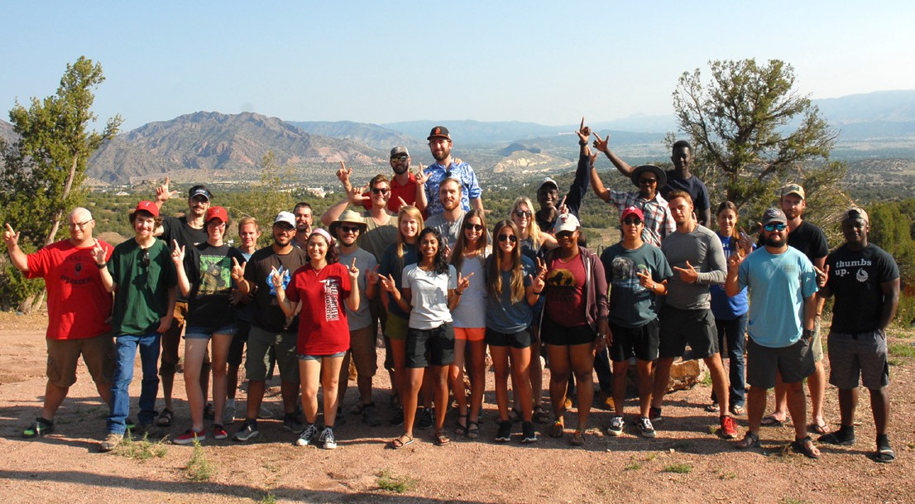
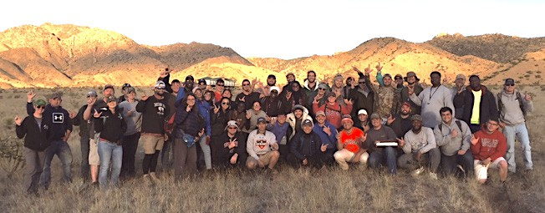
The students were taken from the mouth of the canyon, where they had to identify metamorphic rocks of several varieties and measure strikes and dips on the foliations of the metamorphosed masses. As they moved up the winding drainage that defined the base of the canyon, they found themselves stopping nearly at every turn, confronted with new subtle changes in metamorphic rock types and drastic changes in structure defined in the foliations. Finally, they reached the end of the canyon, the “stadium” morphology of Estadio Canyon.
Drawing on all of their education thus far, the students were able to observe in clear detail the contrast between the metamorphic foliations that they had already become familiar with, and the great mass of granite striking in a clear contact against their metamorphic hosts. It then became apparent that the metamorphism was the result of the contact with the intrusive granitic pluton. The complex structures that the students had been observing since entering the mouth of the canyon were now possible to explain via magmatic intrusion.
But the question still remained: did the students have the full picture of the geology? Thus, as part of their final project, Dr. Yoshinobu challenged them to integrate data from other researchers with their own observations in order to the define the geologic history of this terrane more fully.
Caprock Connections 4

Meet Our New Faculty
Dr. McAdams’ research interests include integrated conodont and carbon isotope bio-chemostratigraphy, high resolution chronostratigraphic correlation, and geological time
scale improvement (collaborative work combining high-resolution chronostratigraphy with high-precision geochronology). She
uses this interdisciplinary skill

Dr. Sandip Pal Assistant Professor Sandip Pal is a new assistant
professor in the Atmospheric
Science Group. He received
(Laboratoire des Sciences du Climat et de l’Environnement (LSCE) and LMD-Ecole Polytechnique) in Paris, France as a postdoctoral scholar. Between 2013 and 2015, he worked in the University of Virginia as a Research Associate. Before joining Texas Tech, Sandip was affiliated as an Assistant Research Professor in the Department of Meteorology and Atmospheric Science at the Pennsylvania State University.

Dr. Neo McAdams Assistant Professor Neo McAdams is a new Assistant Professor in the Geoscience Group. She received her PhD in
Geoscience from the University of Iowa. Prior to coming to
TTU she worked as a junior research coordinator for Veterans Affairs at the Iowa City VA CADRE research center.
set to document major climatic and biotic events, establish timing and rates of change, and to address questions of how increasing terrestrial influence in the Late Paleozoic affected carbon cycle perturbations and associated biotic extinctions.
She is also delighted to carry on the strong tradition of economic paleontology at TTU.
his Ph.D. (magna cum laude) in Atmospheric Sciences from the University of Hohenheim, Stuttgart, Germany. His thesis work involves development and application of an eye safe mobile scanning aerosol lidar system for studying atmospheric boundary
layer and aerosol transport mechanisms in the lower troposphere. He worked in two French Laboratories
His main research interests lie in the fields of boundary
layer meteorology, turbulence, and carbon cycle. Sandip mainly uses ground-based and airborne lidar remote sensing
observations to study kinematics and thermodynamics of the atmospheric boundary layer
and other in-situ measurements to explore land-atmosphere
interaction and its impact on mixing of tracers in the lower troposphere.

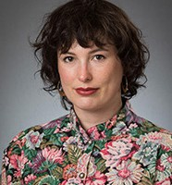
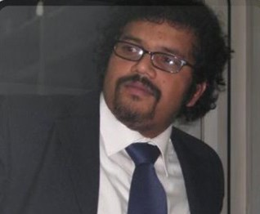
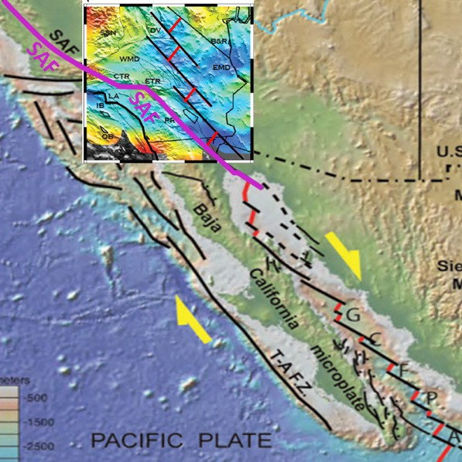
Science Report
by Harold Gurrola, Associate Professor (Geophysics)

We all know California is falling apart but:
Where? And How?
The earthquakes in California are a constant reminder that the boundary between the North American Plate and the Pacific Plate runs through the State. In Southern California, the plate boundary is generally accepted to be the San Andreas Fault system, which is in fact a wide fault zone. The purple line on the figure shows the location of the San Andres Fault, which accommodates the northwestward motion of the coastal region of California and Baha California relative to the North American plate.
Baha California was attached to the Mexican landmass but in recent time
(geologically speaking) it has been rifted from Mexico. The system of transform faults (black lines in the figure) and rifts (red lines) through the Gulf of California unquestionably represents the plate boundary but as the fault system enters California the tectonic story becomes tricky.
The figure shows topography of the southwestern US and northwestern Mexico and the bathymetry of the Pacific Ocean floor. The insert is a figure from a paper in revision that was submitted to the journal Nature Communications (Ainiwaer and Gurrola in review). This insert shows depths to the base of the lithosphere estimated using seismic receiver functions. The blue shading are areas where the lithosphere (the tectonic plates upon which the continents drift) is very thin. Small “pockets” of thin lithosphere appear to follow a similar pattern to the system of transform faults and small rifts that has ripped Baha California from Mexico. Implications are that the lithosphere is being ripped apart or eroded from the bottom up and this band of thinned lithosphere may become a plate boundary in a few million years. It is uncertain if this band of thinned lithosphere will replace the San Andreas as the boundary between the North American Plate and the Pacific Plate or if the Mojave Desert will become (or perhaps already is) a microplate between the North American and Pacific Plates.
5 Caprock Connections

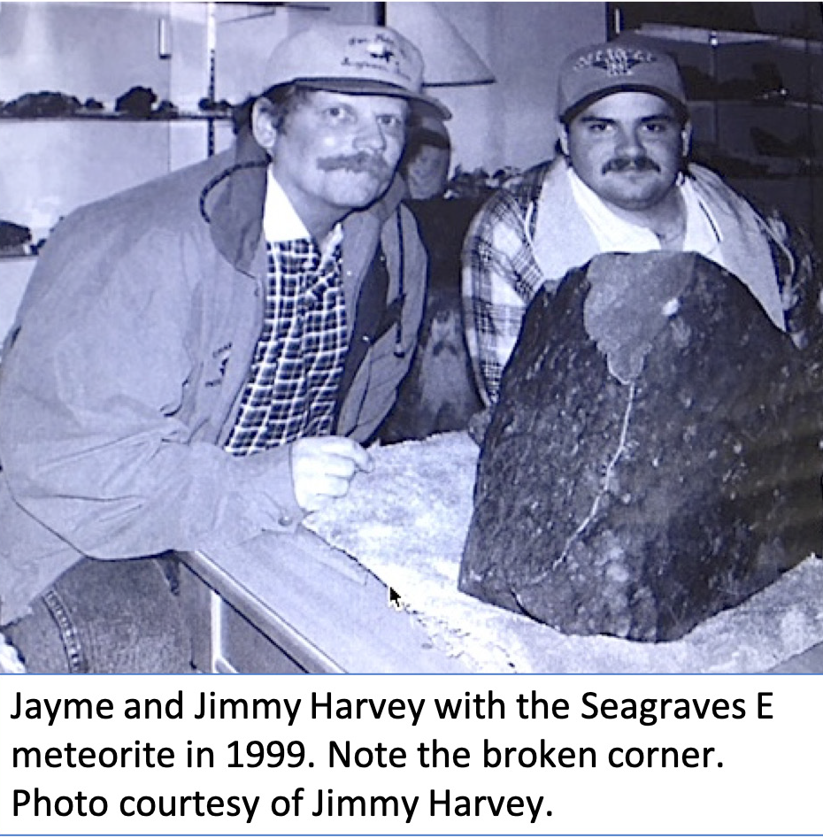
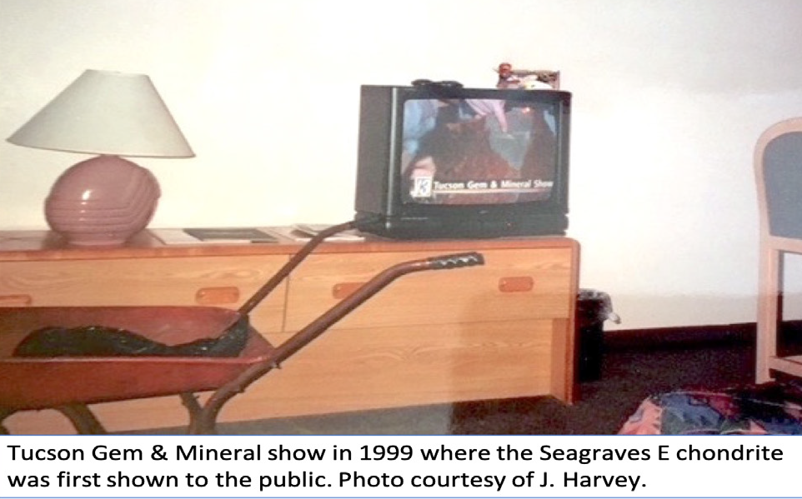
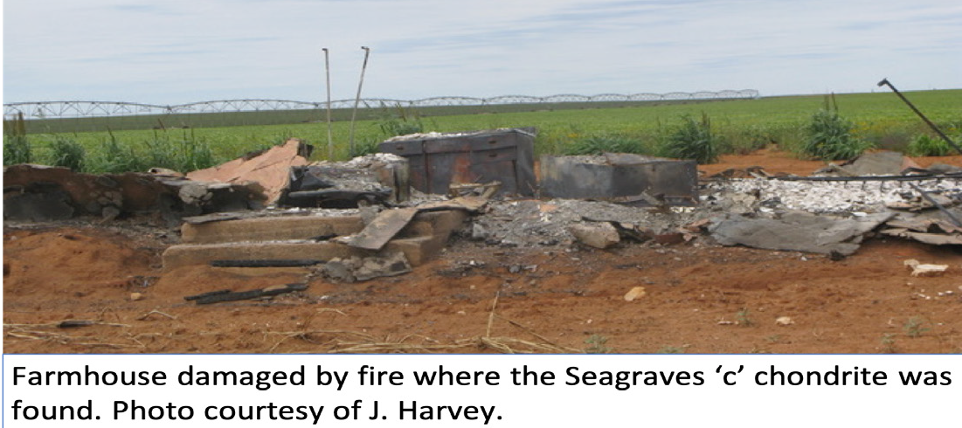
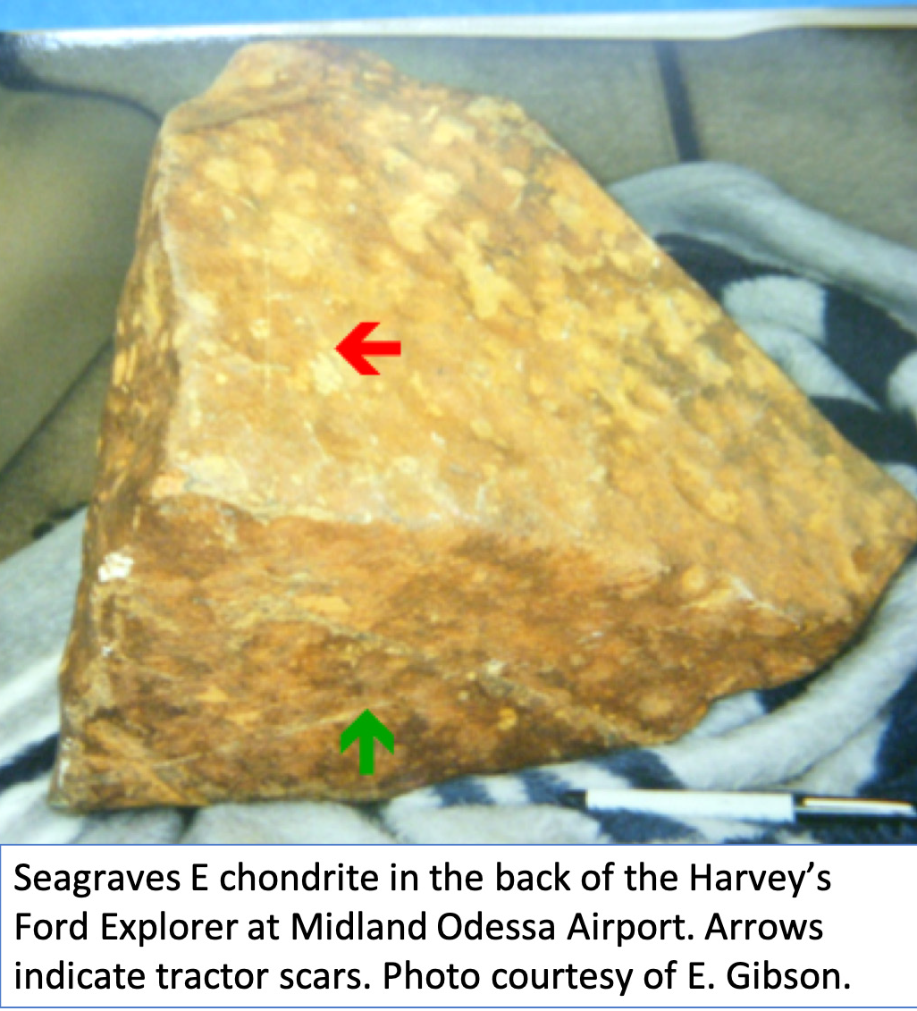
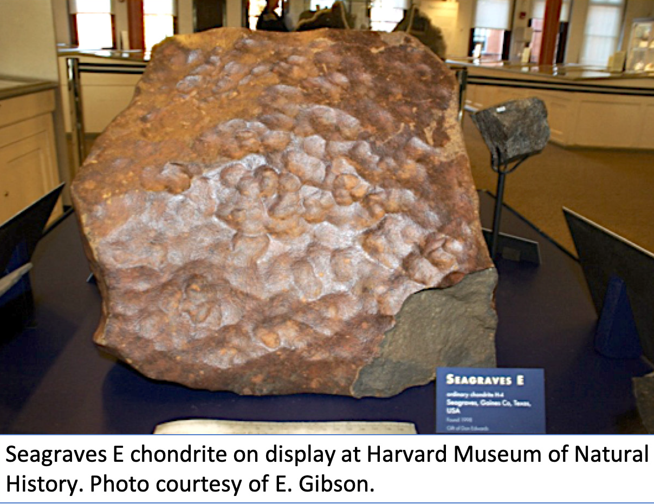
20th Anniversary of the Seagraves ‘E’ Meteorite Discovery
Early in 1999, Jimmy and Jayme Harvey were plowing their field west of Seagraves TX and noticed a large heavy rock, 186 lbs, sticking out of the ground with a distinctive color. They thought it might be a meteorite like several others that had been found on west Texas farms, so they dug it up, loaded into their pickup and took it to Texas Tech in Lubbock. At Tech, Professor Cal Barnes of the Geosciences Department knocked off a piece from the corner for detailed examination and advised them that their ‘big rock’ was indeed very likely a meteorite. Part of that piece is still on display in the Geosciences Department today.
Jimmy then contacted Dr. Everett Gibson, a meteorite scientist from
NASA Johnson Space Center in Houston, and TTU alumnus (Chemistry, B.S. 1963, M.S. 1965),
who agreed to meet them and view
the rock at the Midland/Odessa airport, on his way to Monahans. Jimmy said that Dr. Gibson “just kind of smiled” when they removed the blanket from the back of their Ford Explorer, exposing the rock with its shiny “fusion crust” surface formed by melting during passage through Earth’s atmosphere. Red and green streaks of paint on the meteorite were recent ‘scars’ from Massey Fergusson and John Deere tractor blades used in the fields.
In February 1999, the Harvey’s showed their meteorite in the hotel room of a dealer at the Tucson Gem and Mineral show, using an old wheel-barrow (which they still own!) to move it around.
They thought about what to do with the rock. Six months
later, they sold it to a dealer in New York who in turn sold it to a collector back in Texas, who turned around and donated it to the Harvard Museum of Natural History in Cambridge, MA, where it remains on display for all to see today.
Scientists classify Seagraves E as an ‘L6 chondrite’, which is a type of stony meteorite. Although several chondrite
meteorites have been found in and around Seagraves, Brownfield and SeminoleTX, they are probably not all related to a single‘fall’event, according to Dr. Gibson. This is because some of the meteorite finds are part of the ‘H-Group’ (high-iron) of chondrites, rather than the ‘L-Group’ (low-iron) like Seagraves E, and others, including Seagraves‘c’, a 59 lb L6/7 chondrite, which was found
by farmer Dwayne Billings in an abandoned farmhouse in Terry county in 1989. More research is needed to determine exactly when west Texas chondrites fell to Earth and which asteroids they came from. Most meteorites are black or brown, solid (without pores),
dense (heavy) compared to other local rocks and at least slightly magnetic, and some have shiny fusion crusts. Folks finding likely meteorites should contact the Geosciences Department for advice
Caprock Connections 6

Science Report by Moira Ridley, Professor (Geochemistry)
Taking Mineral-Water Interface Studies to the Molecular Scale
Metal contamination of water and soils, dissolution and precipitation of minerals, redox reactions, environmental toxicity of natural and engineered nanoparticles, water filtration processes, and remediation of radioactive elements by clays are just a few examples of the myriad mineral-water interface reactions. Aqueous geochemistry research at TTU, aims to understand the inherently complex interactions at the interface of minerals, water, and the ions and compounds present in natural waters.
Our approach to studying the solid-water domain has typically used laboratory studies and high-resolution characterization of mineral surfaces. The observable experimental results have been
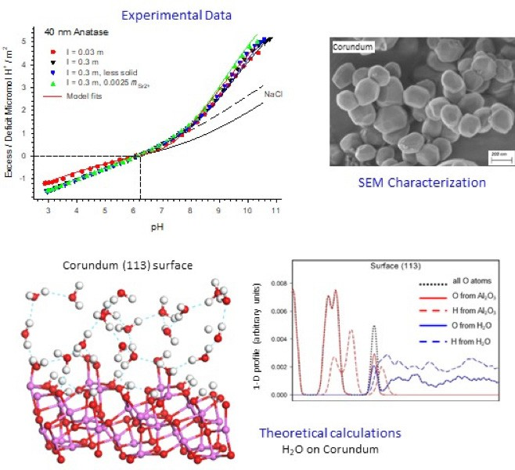
rationalized through empirical modeling. Graduate and undergraduate students have successfully applied the combined experimental-empirical modeling approach to a broad range of studies; including interface studies of rutile, anatase, barite, manganese oxides, and aluminum-oxides. Several environmentally important mineral
phases (e.g., manganese-oxides and aluminum-oxides) that we have studied were highly soluble, making the experiments challenging and complicating the interpretation of results. To effectively
study reactive mineral phases, we required additional techniques beyond our experiments. Moreover, to investigate the underlying molecular mechanisms occurring at mineral-water interfaces we needed techniques to evaluate phenomena at the molecular level. Consequently, we added theoretical studies, utilizing TTU’s High Performance Computing Center, to our research approach. This new research focus has allowed for exciting studies, with more detail, simulating the interaction between mineral surface atoms and water molecules. We collaborate with scientists in the USA, Europe and China, and our research is funded by the NSF.

Stay Connected!

We Want To Hear From You!
Geosciences Alumni, Keep Up Your Connections With Us! We would like to hear from you! If you would like us to include a profile of your career
or some recent news in a future newsletter, or just update your contact information, please drop us an email or letter or visit the ‘Texas Tech Geosciences Alumni’ page on Facebook.
NEW! Connect with us on LinkedIn at Texas Tech Department of Geosciences
Editor
Paul Sylvester
Professor and Pevehouse Chair
E-mail: paul.sylvester@ttu.edu phone: 806-834-5091


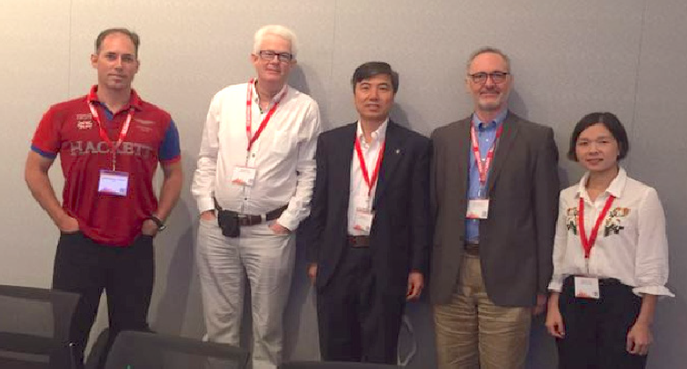

Department of Geosciences
Texas Tech University
125 Science Building, Lubbock TX 79409-1053

7 Caprock Connections
6 Caprock Connections

Prof. Paul Sylvester, Editor-in-Chief of the Journal Minerals, chairing an Editorial Board Meeting held at the Goldschmidt 2018 Conference in Boston MA. From left to right, Dr. Javier Sánchez-España (Geological Survey of Spain), Prof. Nigel J. Cook
(University of Adelaide, Australia), Prof. Huifang Xu (University of Wisconsin - Madison), Prof. Sylvester, and Managing Editor Jingjing Yang.

The Sylvia C. Cearley Endowment
Legacy of One of the First Women Geologists from Texas
Ms. Sylvia Clementine Cearley of Fort Worth TX passed away February 10, 2018 at the age of 93. The Sylvia C. Cearley Endowment was established by designation of Texas Tech as
a beneficiary of Ms. Cearley’s estate. The University is making preparations to receive her multi-million-dollar bequest that should generate some $80,000 in annual student support
for “Geoscience Majors,
with preference being given to those with links to organizations focused on encouraging young women in Science.”  Sylvia was one of the first women to graduate in geology from Texas Tech, in 1947, and to work as a geologist at Shell Oil  Company, from 1948 until | 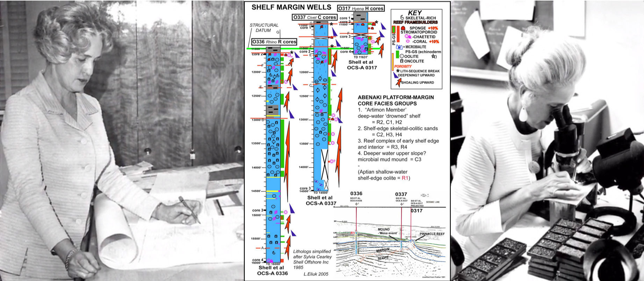
her retirement in 1986. Her 38-year career as a geologist with Shell attests to the company’s recognition of the value of her fundamental geologic skills – despite women rarely
being promoted quickly in those days, and several cycles of boom-to-bust employment “downsizing” in the industry.
Sylvia’s geologic expertise was in
stratigraphy. She was one of Shell’s leading experts on the stratigraphy of frontier wells and carbonates. She was able to work effectively with well cuttings, where core was unavailable, which was often case, whereas most other geologists tried to “out-source” stratigraphic work in those situations. She believed that there was no short-cut from actually looking at rock to develop stratigraphic models, even where (or perhaps especially where) there were |  | 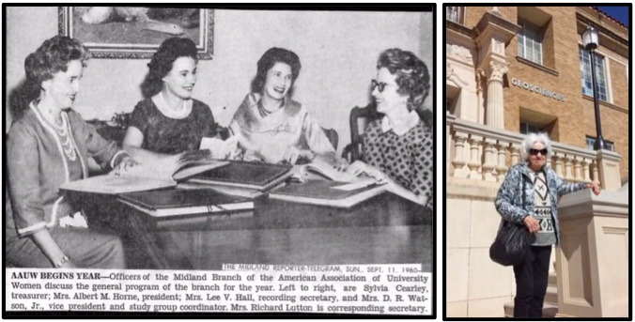
detailed seismic data and interpretations.
Les Eliuk, now retired from Shell Canada, recalls working with Sylvia in 1984 on her carbonate logs of cuttings from the Baltimore Canyon Trough Shell wells, off the east coast of the USA, shown in the figure above. The Jurassic-Cretaceous reef margin tests still provide the only well control for intervals of this age located on the edge of the USA continental margin. Les reported a simplified version of Sylvia’s logs publicly for the first time at the
joint CSPG-AAPG convention in Calgary AB in 2005 and, later, at the Conjugate Margins Conferences in 2008 and 2018 in Halifax NS, demonstrating the enduring value of Sylvia’s work.
Sylvia had a passion for promoting and recognizing the careers of women in geology. During the years she lived and worked in Midland TX, she was active in several professional groups: The American Association of University Women (AAUW), for which she served as an officer, the West Texas Geological Society and the Society of Economic Paleontologists and Mineralogists. Sylvia is rightly considered a trailblazer for Texas women in geology.

8

Green Management of Mineral Resources Project - student exchanges with Norway
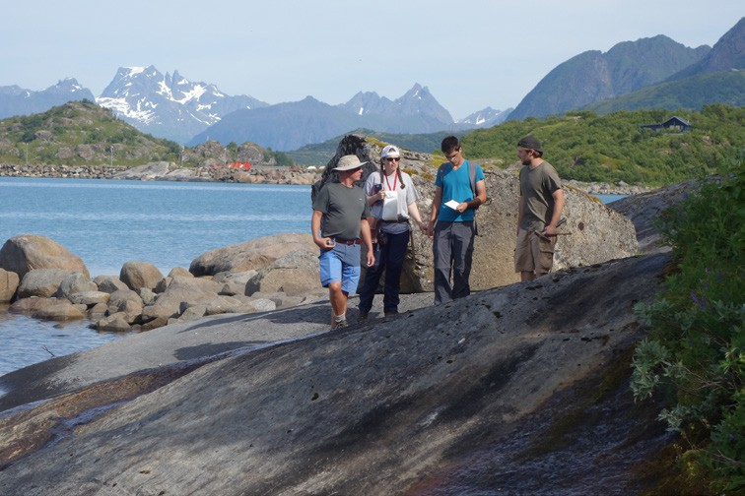
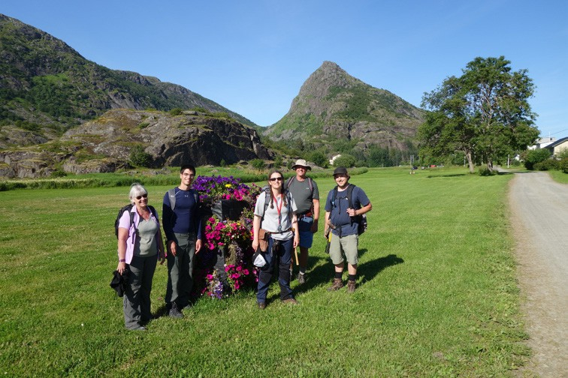
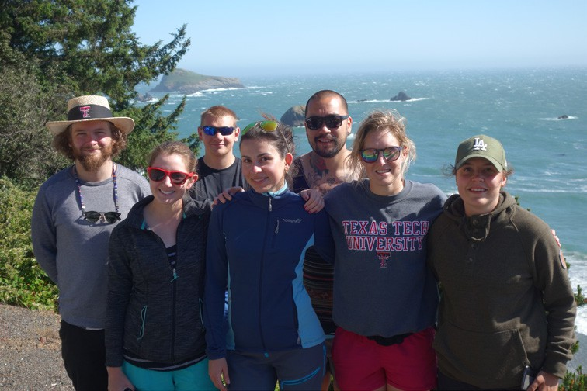
In 2016 Dr.’s Cal Barnes, Melanie Barnes, Callum Hetherington and Aaron Yoshinobu were named scientists on a project supported by the Norwegian Centre for International Cooperation in Education (SiU). The program supports partnerships in higher education between Norway and institutions in Canada and the U.S., and our proposal built upon long-standing collaborations involving Faculty at the Norwegian University of Science and Technology (NTNU) in Trondheim and Texas Tech. The funding, awarded to Dr. Rune Larsen (NTNU), supports student-exchange programs between our campuses, and participation in collaborative research projects.
Braue, Nolwenn Coint, C and Don Maute near the Årsteinen in the Lofoten
Norway
From left to right: Steinar Mokkelgjerd (NTNU), Susan Leib (TTU), Shane Dailey (TTU), Anna Pryadunenko (NTNU), Alf
Orvik (TTU), Katie Gates (TTU), and Kristine
Nymoen (NTNU) on the Oregon Coast after
a traverse of the Josephine Ophiolite.
allum Hetherington southern tip of Archipelago,
From left to right: Melanie Barnes, Ross
From left to right: Callum Hetherington, Nolwenn Coint, Ross Braue and Don Maute on coastal exposure of the Raftsund Batholith, Lofoten Islands, Norway
by Callum Hetherington,
Associate Professor (Mineralogy)
The project entitled Green Management of Mineral Resources (GEMS) provides funding to promote research in the general field of economic geology, for what has been described as a new stone age! The increasingly sophisticated technology of the modern world demands an ever-increasing diversity and abundance of elements, the majority of which must be recovered from ore-deposits somewhere on Earth.
In the summer of 2017 TTU MS students Ross Braue and Don Maute traveled the Lofoten Islands in Northern Norway to conduct fieldwork in and around the Raftsund Batholith, which is part of the much larger Lofoten–Vesterålen-Anorthosite-Mangerite-Charnockite-Granite (AMCG) Suite. The fieldwork was led by Dr. Nolwenn Coint (PhD, TTU 2012) and was conducted over 8 days of glorious 24-hour-a-day sunshine. Braue focused his fieldwork on documenting and sampling a suite of ferro-diorite dikes that are the youngest rocks in the suite, but have enigmatic origins, and unknown source regions in the mantle. Maute chose to work on a suite of apatite-magnetite- ilmenite- ± zircon-bearing zones exposed along the southern edge of the island of Årsteinen.
Maute returned to Norway in August 2018 and at the time of writing is visiting the Seiland Igneous Province in the far north of Norway with a group of students and Faculty from NTNU. The Seiland region of Norway is close to Nordkapp in Finnmark, is home to the Sami people and their reindeer herds, and potentially to important platinum-group element (PGE) deposits. Don will return to Trondheim to spend the semester at NTNU. Braue will also travel back to Norway in early 2019 where he and Don will attend the Winter Meeting of the Geological Society of Norway in Bergen.
The Department of Geosciences has also hosted several Norwegian students working on the GEMS project. MS students Steinar Mokkelgjerd, Kristine Nymoen and Alf Orvik, spent the Spring 2018 at Texas Tech, where besides enrolling in several courses, participated in fieldtrips to West Texas and New Mexico and the Klamath Mountain Province. Anna Pryadunenko, a PhD student studying spinel geochemistry related to potential chromium and PGE deposits visited campus in March and April to use instrumentation in the GeoAnalytical Laboratories, and Even Nikolaisen is visiting us for the Fall semester. Nikolaisen studies magnetic anomalies and is interested in using electron and ion-beam microscopy techniques available at Texas Tech to study magnetite-ilmenite relationships in samples from Australia.

Caprock Connections
9

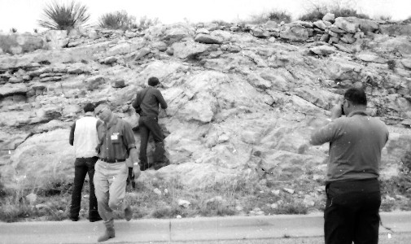
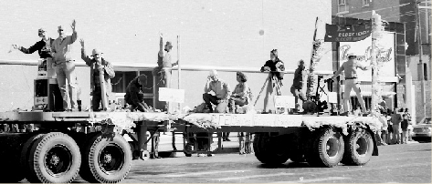
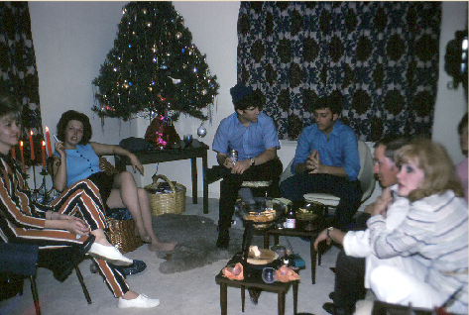
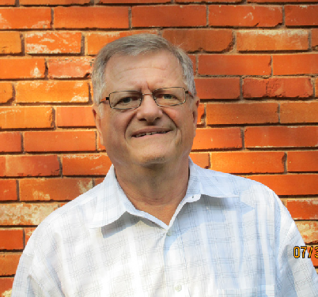
A Career in the U.S. Census Bureau – Ken Harris, B.A., Geography, 1972
Historical Snapshots -
courtesy of Larry Bauer, B.S.1966, M.S.1972
I spent four great years at Texas Tech, graduating with a B.A. in Geography in 1972. It is a field of study I have enjoyed all my life. My course work included all professors in the Geography Dept. at that time: Drs. William Conroy, Claude Davidson, Gary Elbow, and Otis Templer. The range of course offerings within the Dept. was broad and varied and gave me a very good knowledge and appreciation of the field.
After graduation I began working for the U.S. Census Bureau, in a career that lasted 35 years. I was hired in the Dallas Regional Office (RO) and spent my entire career working out of that office. The Dallas office was one of the Bureau’s 12 RO’s, or field offices, with Census headquarters located in Suitland, Maryland. Soon after I had been hired in the 1970’s, the Bureau initiated a new program – the hiring and
staffing of Geographers within the 12 RO’s. The timing was perfect with my degree in Geography. Prior to that, the Bureau’s geographic operations had primarily been confined to the Geography Division at Census headquarters. The geographic operations in the RO’s were expanded over the decades so that eventually each RO had approximately three professional geographers on staff. However, Geography Div. in Suitland has always had oversight of the program and procedures.
There had been a growing need to decentralize many of the Geography programs to the 12 RO’s. This allowed for more direct work in partnership with local cities, counties, councils of government, etc. The Dallas RO had jurisdiction over three states: Texas, Louisiana, and Mississippi. We worked with the cities and others on numerous programs. One was allowing them to review and update the Census Tracts, Block Groups, Census Designated Places, etc., for their area. These would be used for official data tabulation purposes. There was also extensive cooperation with the locals in the area of mapping. Needless to say, over time I saw the field of Geography advance from paper mapping to the advanced GIS and computer mapping of today. During the 1980’s the Bureau teamed with the U.S. Geological Survey to develop the first nationwide digital mapping system, called TIGER. Over time TIGER has been greatly enhanced. The Census Bureau has to maintain a mapping system for the obvious purpose of ongoing data collection as well as tabulation. Geographers were also in charge of the Local Update of Census Addresses (LUCA) Operation. The Bureau maintains and continually updates its address files covering the entire nation. The LUCA program allows cities and towns to review and update the Bureau’s residential address list for their jurisdiction prior to each Decennial Census, with the goal of ensuring the most complete address list possible for the Census. These are just some of the programs the RO Geographers worked.
A side note is necessary here regarding the current Census Bureau structure: there had been 12 RO’s since 1961 but, after the 2010 Census, the Bureau reduced this to 6 and did a reorganization of assignment areas. 6 RO’s, including Dallas, were closed. The 6 RO’s now are now Atlanta, Charlotte, Denver, Los Angeles, New York, and Philadelphia, all under the umbrella of Census headquarters in Suitland, Maryland, as always.
Today they say Geography majors are able to get good jobs after graduation. I can understand why. In general throughout my career I noticed Geography majors were always able to get good jobs. There is just something very special about this field, and the type of talent and ability that is attracted to it. Thank you Texas Tech.

Dr. Alonzo Jacka taking photos of Geology graduate students examining the Brushy Canyon Formation near Guadalupe Peak. Circa 1970.
Sigma Gamma Epsilon Geology Float in the TTU Homecoming Parade. 1971.
Geology graduate student Christmas party. Circa 1970.

Caprock Connections 10

Alumni Profiles
Kristie White
M.S.

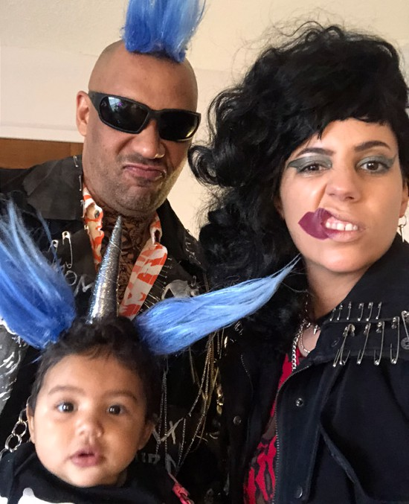
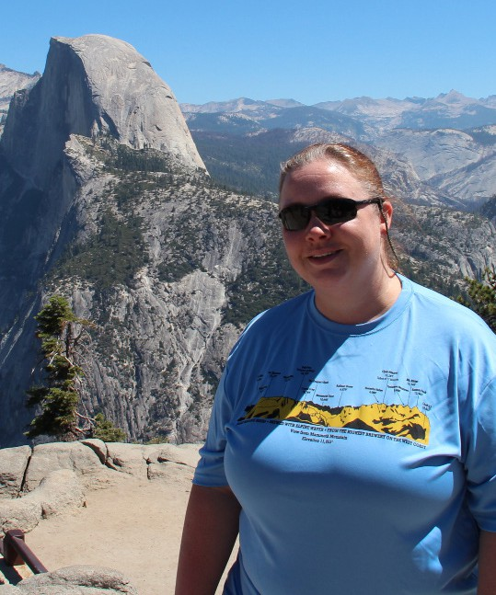
Kristie White is originally from the Dallas/Fort Worth area. She attended Texas Tech University from Fall 1993 through Spring 1997, originally majoring in geology. With the hiring of Dr. Harold Gurrola in 1995, she switched to geophysics, eventually graduating with a Bachelor of Science degree. She is one of Dr. Gurrola’s first undergraduate students. Her undergraduate research involved magnetic profiling of Railroad Mountain, New Mexico.
visiting Yosemite National Park
Lewis Matthews M.S.
with wife Jessica and daughter Aurelia, ready for Halloween 2018
After graduation, she attended the University of Oklahoma, where she received a Master of Science degree in Geophysics in the Fall 2000. She was a research assistant for Dr. Alan Witten. Many of his research trips involved using ground penetrating radar (GPR), magnetics, gravity, and electromagnetics to search for unmarked graves, dinosaur bones, and archaeologic sites. Her research involved writing a program to help identify and determine how deep landmines and unexploded ordinance were using electromagnetic induction spectroscopy.
Kristie started her career with Fugro Seismic Imaging, Inc. in Houston as a seismic processing geophysicist. She worked for Fugro for 11 years until their merger with CGG in January 2013. In the summer of 2014, she began working for TGS as a Senior Processing Geophysicist. Early in her career, Kristie primarily processed 2D/3D high resolution marine seismic surveys required by companies prior to drilling in the Gulf of Mexico. Eventually she worked on large scale 3D marine exploration surveys, both narrow and wide azimuth. She has had the opportunity to work on projects in the Gulf of Mexico, California, Alaska, Canada, Benin, Tanzania, Trinidad, Venezuela, and Colombia, and to travel to Mexico and Brazil.
Kristie continues to be involved with Texas Tech as a member of the College of Arts and Science Dean’s Circle Advisory Board. She has been a board member of the Houston Chapter of the Texas Tech Alumni Association for the past 15 years, and served as chapter president for 2006 and 2007. Her current position is Scholarships, where she organizes applications and schedules interviews.
11 Caprock Connections
Lewis Matthews is originally from the United Kingdom of Great Britain. At the tender age of 17, Lewis emigrated to America and enlisted in the United States Navy. He served 9 years honourably as a Corpsman of Marines and then went on to earn a degree in economics from Washington College, a BS in geology from Central Michigan University, and a MS from TTU in 2016.
Lewis worked with Dr. Harold Gurrola on the ‘The Fractal Geometry of Petrophysical Logs and Applications using Artificial Intelligence’. His work was novel despite cramming every twitter #trending scientific buzzword into the thesis. In all fairness, Lewis independently discovered high dimensional fractal clustering in petrophysical logs which it turns out isn’t particularly useful to anyone (so far).
After graduation, Lewis joined CrownQuest Operating, an exploration and production company in Midland, TX, as a self-titled data scientist. In his current role, he encourages broad collaborations across industry, complains about the technical difficulties, and evangelizes technical solutions that typically take triple the quoted time and money to successfully implement. Lewis also teaches applied O&G machine learning bootcamps to engineers and scientists both for CrownQuest, SPWLA, PPDM, and the West Texas Data Science Institute. After two days filled with rambling tangents, incoherent thoughts, and forgetting topics mid-sentence, a typical student can go from never having programmed before to running, modifying, writing, and evaluating machine learning workflows.
At some point he fell in love with his latest venture which involves using blockchain technology as a substrate for companies in the Permian Basin to exchange data. Since the oil and gas industry transitioned to a process requiring ‘manufacturing-like’ optimization solutions, there has been an increased demand for data to flow between non-competing entities. Lewis has managed to convince himself that this effort will ultimately accelerate the velocity and veracity of scientific discovery and that might just lower costs for everyone.

