
Caprock
Texas Tech University | Department of Geosciences
Spring 2017

Connections
Texas Tech University College of Arts & Sciences • Department of Geosciences

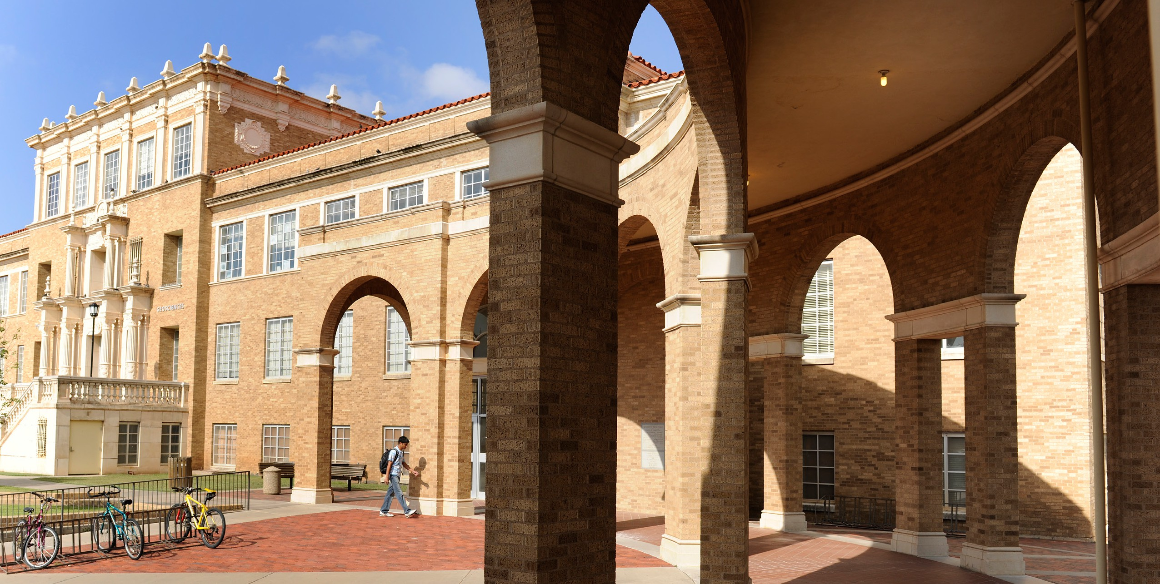
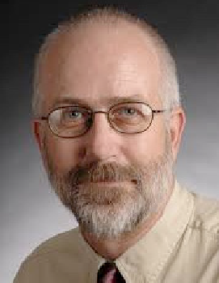

Hello Alumni. As Spring semester starts to wind down, here’s a quick update. Combining May and August, we will have thirty-one Geoscience and fifteen Geography undergraduates graduating. Our geology field camp, taught by Prof. Aaron Yoshinobu, will be in a new location this year, with thirty students in

From The Chair
Jeff Lee
Professor & Department Chair
CONTENTS
Welcome 1
SCAMS Student Chapter 2 Environmental Geology 2 Geoscience Society 3
Science Report 3
New Faculty/Golf Outing 4 NSF CAREER Grant Exhibit 5 Science Report 6
AAPG Student Chapter 7
Alumni Profiles 8
INNOVATORS
www.artsandsciences.ttu.edu
BUIL D
attendnace. We have reserved the University of Oklahoma Bartell Field Station in Canon City, Colorado. OU, OSU, and Colorado also use this facility for their field camps. Geography’s field course, taught by yours truly, will be held on the TTU Junction Campus as it has been for the last forty or so years.

You may not want to hear this, but I have a homework assignment for you. Please tell me one or two things that you wish were covered or given more emphasis in your program at TTU. These can include content areas of your major, skills (math, writing, etc.), or anything else you can think of. Please send them to jeff.lee@ttu. edu. We like to tweek our programs to better prepare students for life and careers and your opinions are important. Thanks. And, for this assignment only, you don’t have to cite your sources. Unless you want to.
WE

Thanks and keep in touch, Jeff Lee

SCAMS Student Chapter
by Kaitlin Rutt, SCAMS Student Chapter President
The Student Chapter of the American Meteorological Society (SCAMS) at Texas Tech University is a local chapter which anyone can join with a small membership fee. A committee made up of Texas Tech Atmospheric Sciences graduate students run our local chapter. Members of the chapter include Atmospheric Sciences Doctorate and Master’s students, along with undergraduates involved with the Atmospheric Sciences minor or who simply enjoy weather. Our purpose is to promote science education and awareness of severe weather safety.

Already this school year our local chapter has been involved with several community outreach events. In the Fall of 2016, SCAMS participated in the South Plains Food Drive to help end hunger. Also, in the Fall we were able to bring in a guest speaker, Paul Markowski, to meet individually and speak with the Atmospheric Sciences faculty and students. Paul gave a seminar during his visit, which was open to the entire Geosciences Department and the public.

This Spring, our chapter volunteered to help clean up after five home baseball games. Community outreach is a great way to represent our chapter to the University. One of our biggest events of the school year is the Severe Weather Awareness Day (SWAD), which is held every mid-Spring at the Science Spectrum in Lubbock, TX (see photos above). This year was the 11th annual event, which is student run and provides the public with severe weather preparedness items and tips, especially with severe weather season right around the corner. SWAD is a one-day event with experiments, raffle prizes and information booths from local weather companies that brings in approximately 1600 people.

SCAMS is always looking for more members, even if weather is just a hobby or past-time, and speakers for our group including alumni. The local chapter looks to improve the awareness of weather around Lubbock one step at a time. Other community outreach events and activities are important to our society, along with keeping the traditions of the past.
New Bachelor of Science concentration in Environmental Geology by Celeste Yoshinobu,
Academic Advisor, Geosciences
We are excited to announce that the Department of Geosciences will offer a new Bachelor of Science concentration in Environmental Geology which will complement our traditional concentrations in Geology and Geophysics. This concentration will start with

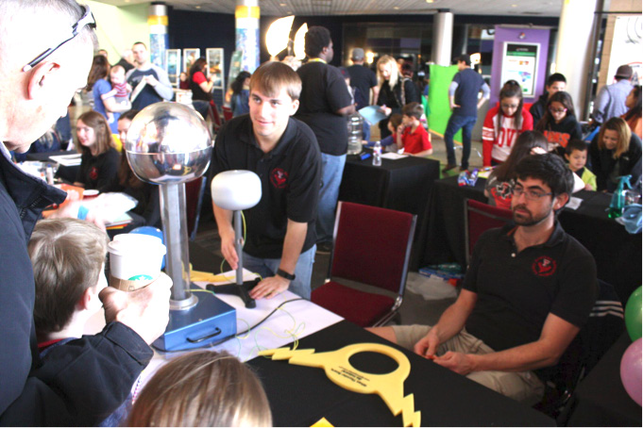
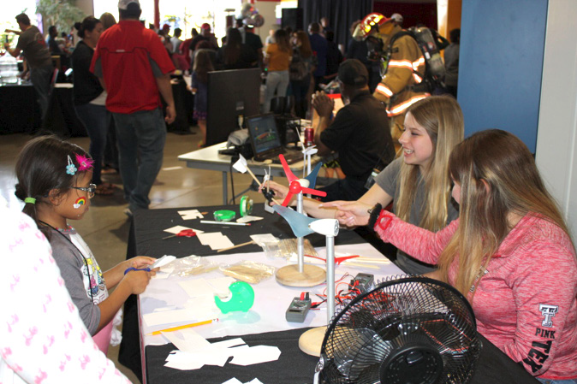
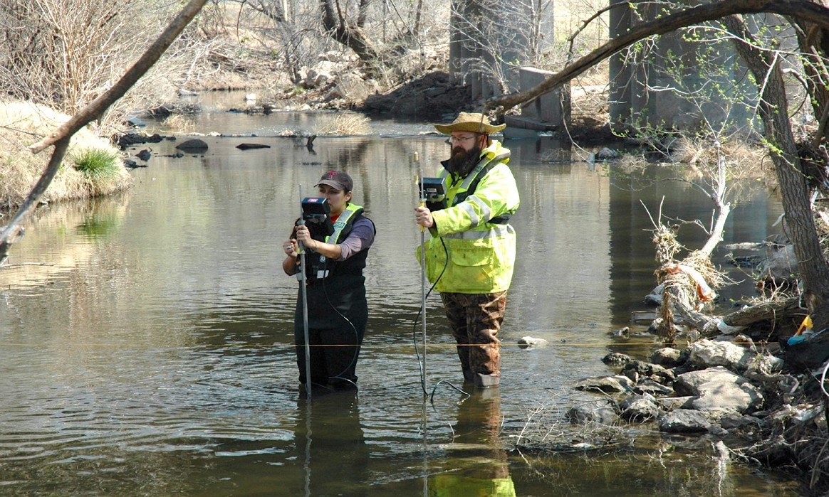
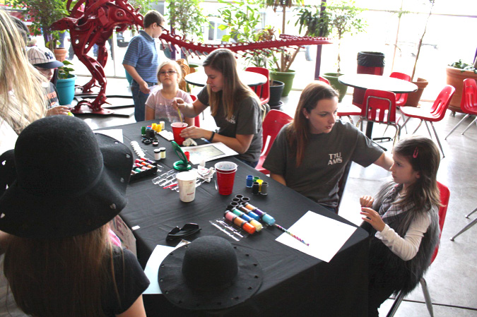
the 2017-2018 catalog and be quite rigorous. It will include physical hydrogeology and courses in soils, GIS, organic chemistry, the full sequence of calculus and calculus-based statistics. Announcement of this new concentration is already attracting a number of undergraduates to the program.

2 Caprock Connections
Elena Crowley-Ornelas (Geosciences Masters Student and USGS Pathways Intern) making discharge measurement with USGS staff (Gary F. Burke, USGS Wichita Falls Field Office) at new USGS streamflow-gaging station 08079510 North Fork Double Mountain Fork Brazos River at Loop 289 near Lubbock, Texas on March 7, 2017. (Photograph courtesy of William H. Asquith [USGS Lubbock Field Office and Geosciences Adjunct Scientist].)

Geoscience
Society
by Audrey Pattat, Geoscience Society President
G

eoscience Society had a fun Fall! The semester kicked off with Tailgate season—a group favorite. Members
got together for games against Louisiana Tech, West Virginia, and Texas to cheer on the Red Raiders. In October GSS members volunteered at Tech or Treat here on campus, setting up a make-your-own-pet-rock booth that was a huge success. Officers organized the First Annual Friendsgiving Potluck just before the Thanksgiving holiday, bringing together students and faculty to share a meal and enjoy each other’s company (see photo above). We took part in two book sales with Friends of the Library; all the proceeds go directly to the public libraries of Lubbock.
E
vents happening this Spring included two fundraising ventures: helping clean up the TTU Baseball Stadium, and a
give back night at Local Bar. Funds raised will go toward next year’s social activities. We

Science Report
by Guofeng Cao, Assistant Professor (Geography)

Harness large scale of social media data for human mobility and epidemiological disease surveillance.
In the past several years, social media (e.g., Twitter and Facebook) has experienced a spectacular rise in popularity and has become a ubiquitous location for discourse, content sharing and social networking. With the widespread adoption of mobile devices and location-based services, social media typically allows users to share the status (e.g., health related status) and whereabouts of daily activities (e.g., check-ins and taking
photos), thus strengthening the role of social media as a proxy for understanding human behaviors and complex social dynamics in geographic spaces.
Figure 1
Unlike conventional geospatial data, this new modality of data is dynamic, massive, and typically represented in a stream of unstructured media (e.g., texts and photos), which pose fundamental representation, modeling and computational challenges to geographic data analysis. By taking advantage of modern high performance computing resources, Dr.
Guofeng Cao in Texas Tech’s Geosciences Department recently developed a scalable computational framework to harness ``big’’ location-based social media data for efficient and systematic geospatial data analysis, and successfully applied this framework for human mobility analysis and epidemiological disease surveillance across multiple geographic scales.
The framework is implemented based upon
a public data stream of Twitter feeds posted on the continent of North America. Figure 1 displays the mobility patterns

also participated in Arbor Day, planting trees
of travelers from
Figure 2

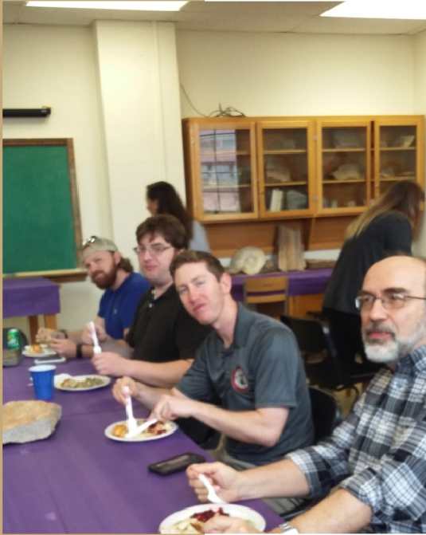
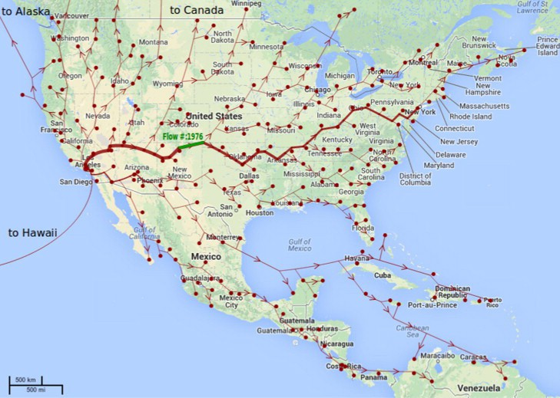
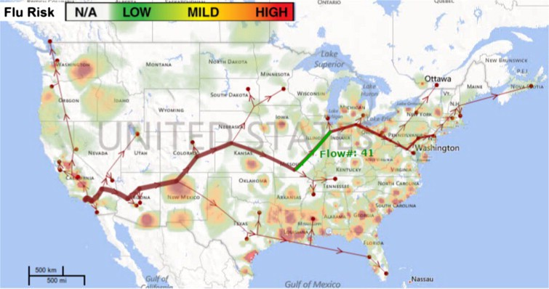
and flowers to beautify Tech’s campus. GSS will be catering lunch for the Annual Student Research Day in the Geoscience Department to wrap up the semester. If you’d like to keep up with events as they happen, join our Facebook Group—Texas Tech Geoscience Students. Alumni are always welcome!
Need Photo
Los Angeles International Airport during a week of time window. Figure 2 shows the travel patterns of only the travelers detected with high influenza risks based on the archive of the Twitter posts, and the background color indicates the variations of influenza risks across the
content of North America. This framework has also been applied to other areas, including presidential election and survey of public opinion.

Caprock Connections 3

Meet Our New Faculty
Fall Golf Outing
by Matthew Brothers, Graduate Teaching Assistant (Atmospheric Science)
The Fall installment of the ATMO/GEOSCI Golf Outing took place at Shadow Hills Golf Course on October 29, 2016. Five teams of four golfers participated in the scramble with each team composed of golfers at all skill levels. For the scramble, each team member starts by teeing off. Then the location of the best shot is where all team members hit their next shot from, and so on, until the hole is completed. Less emphasis is thus placed on an individual’s skill level while still providing a competitive format for all players.

All golfers were also provided the opportunity to warm-up on the range with a complimentary bucket of balls before the round began. This event gives all participating students, faculty, and staff the opportunity to meet and interact with each other in a non-classroom setting. The winning group of Brian Ancell, Keely Ancell, Dustin Sweet, and Dave Templet shot a 62 (-10) beating out the rest of the field by at least two strokes.

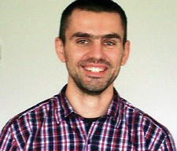
Dr. Branimir Segvic
Assistant Professor

Branimir Segvic joined the University in January 2017 as an assistant professor in
Geosciences. He received his Diploma degree in Geology
in 2003 from the University of Zagreb, Croatia, and his Ph.D. in Mineralogy in 2010 from the University of Heidelberg, Germany. Branimir served as a Post-Doctoral Fellow, first at the Institute of Applied

(Left) Golfers preparing to board their golf carts ahead of the shotgun start right at 8:30am. (Right) Dr. Callum Hetherington teeing off in good form on the par 4 16th hole.
Student Awards - External

Geosciences of the Darmstadt Technical University in Germany (2010-2012), and then at the Department of Earth Sciences of the University of Geneva in Switzerland (2013-2016). He has also spent a year working as a researcher in the field of Applied Mineralogy at COREM (Québec, Canada). Dr. Segvic is a broadly trained mineralogist whose research has primarily been focused on clays and
clay minerals. He is particularly interested in the study of
clays in paleoenvironmental reconstructions and clay mineral diagenesis in clastic sediments in the context of reservoir characterization and hydrocarbon exploration.
M.S. student Lexie Herdt, a member of Prof. Vanos’s research group, received an Outstanding Poster Presentation Award from the AMS Board of Urban Environment for her presentation at the AMS Annual Meeting in January 2017 in Seattle, WA. Her
presentation was titled “Urban Microclimate Monitoring in Seoul, Korea: Fine Scale Summer Heating along the Cheonggye Stream Renewal Project.”

Ph.D. student Vanna Chmielewski, of Prof. Bruning’s research group, received an Outstanding Student Paper Award for her oral presentation at the 2016 AGU Fall Meeting, “An analysis of small changes
in environment which resulted in diverse charge structures on 4 June 2012 in West Texas.”

Ph.D. student Brock Burghardt, a member of Prof. Ancell’s research group, was awarded 1st place among all student poster presentations at the 2016 AMS Conference on Severe Local Storms for his work “Improving Spread Characteristics in a Convection Allowing Ensemble.”
M.S. student Angela Norman, a member of Prof. Sylvester’s research group, received a SEPM/ Sedimentary Geology Division Best Poster award for her presentation at the 2016 GSA Annual Meeting in Denver, CO. Her presentation was titled, ‘Investigating the provenance of Icelandic black sand: local vs. distal sources.’

Ph.D. student Giovanni Zanoni, a member of Prof. Segvic’s research group, received a 2017 AAPG Foundation Grant-in-Aid.

Ph.D. student Khaled Chowdhury, a member of Prof. Sweet’s research group, received the Lauren A. Wright and Bennie W. Troxel Student Research Award from GSA.

M.S. student Travis Sparks, a member of Prof. Yoshinobu’s research group, received a 2017 AAPG Foundation Grant-in-Aid Jean G Funkhouser Memorial Grant.

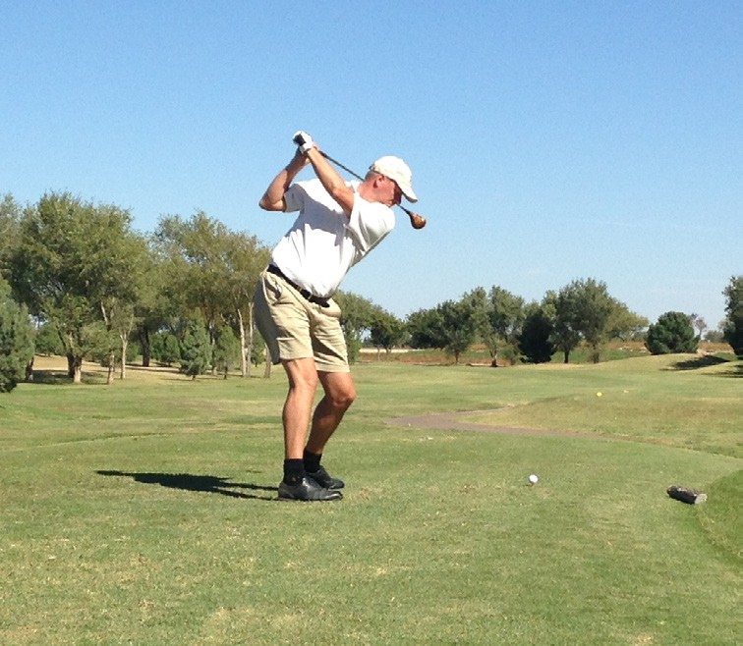
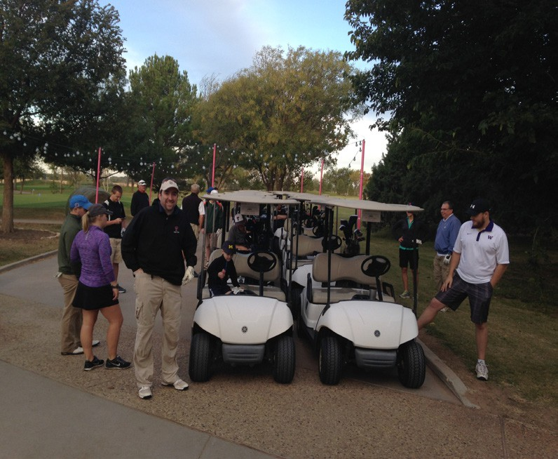
4 Caprock Connections

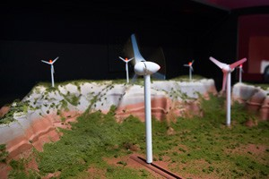
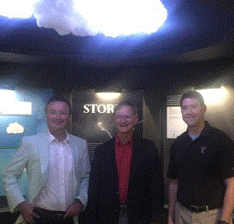
NSF CAREER Grant Exhibit
by Dr. Brian Ancell, Associate Professor (Atmospheric Science)
T
he TTU Museum Exhibit “How Weather Works: Our Place between the Sun and a Storm” is a journey through the processes that create weather from the largest scales down to things we can feel, like rain and wind. It is funded through an NSF CAREER grant to Dr. Brian Ancell; these grants
require a strong educational component. The exhibit is one of a number of educational activities funded by the grant including summer camps for local middle-school students and educational resource kits
to help area teachers with lesson plans involving atmospheric science and the weather. The exhibit is planned to be up through 2017, and is designed to be interactive, teaching museum visitors about the weather through hands-on experiences.
O
rganized into two main areas, the exhibit covers (1) the processes that create weather in the first place, and (2) how changes to the atmosphere from
human activities such as wind farms or irrigation can amplify through chaos to play a significant role in the evolution of our atmosphere. The first half of the exhibit demonstrates how the uneven heating of the Earth by the Sun causes pressure forces in the atmosphere, leading to winds that increase with height. These winds turn due to the spin of the Earth through the Coriolis Effect, ultimately leading to the West-to-East flowing jet stream in both hemispheres, which is the phenomenon that controls much
of the Earth’s weather. Waves in the jet stream lead to rising and sinking air, which cause areas of high and low pressure at Earth’s surface - these are the weather systems that
cause the movement of warm and cold air and fronts. Fronts then cause local lift, sometimes resulting in precipitation and thunderstorms, which can cause severe weather like large hail, high winds, and tornadoes. These basic fundamentals are explained to visitors through hands-on demonstrations and text panels in this first part of the exhibit, and culminate in the “Storm Room” (see photo above) – an immersive thunderstorm experience where visitors learn about the processes involved with the dangers of severe thunderstorms.
C
haos is the focus of the second half of the exhibit, particularly how chaos works, and why it means that small changes to the atmosphere from activities such as irrigation can grow to modify much larger weather systems far from the source of the modification in the first place. The exhibit
provides a local example of how a wind farm (see photo at right) can change the weather locally, and then shows simulations with a weather model that reveal much more substantial, nonlocal effects from large wind farms and local irrigation. The ethical implications of inadvertent weather modification are also discussed. The exhibit ends with interesting weather facts - questions like what U.S. state receives the most
lightning? If you don’t know the answer, come see the exhibit!

Caprock Connections 5

Science Report
by Juske Horita, Professor (Geochemistry)

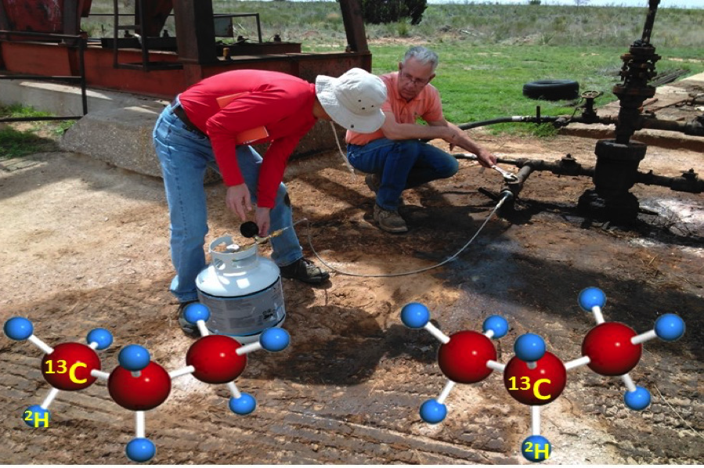
New Look at the Isotopes of Natural Gases
Stable isotopes (12C and 13C of carbon and 1H and 2H of hydrogen) belong to the same elements, but they differ
slightly in their masses. In the past decades, stable isotope geochemists like me have been utilizing these naturally occurring stable isotopes of light hydrocarbons (methane, ethane, propane, and others) to understand many aspects of oil and gases, including their sources, formations, and migrations.
Such knowledge has also been supporting the exploration of petroleum resources by oil and gas companies. Now, our group at Texas Tech University has developed a new way to look at their isotopes: measurements of position-specific isotope ratios of light hydrocarbons such as center vs. terminal C’s and H’s within propane molecules (see the figure at right), rather than conventional bulk, average isotope ratios of all carbons and
hydrogens within the molecules. Funded by ACS-Petroleum Research Fund and U.S. DOE, we have been busy traveling and collecting natural gases from several oil-gas fields in Texas and Oklahoma, including the Permian Basin, Arkoma Basin, Eagle Ford Formation and others (see the photo). Connections with our alumni have been
indispensable to gain the access to oil-gas fields. Thank you! Our team is also international, including graduate students and visitors from abroad with affiliations to Saudi Aramco in Saudi Arabia and Sinopec in China. In the coming years, this innovative approach developed
at Texas Tech Geosciences Department is expected to change our understanding of many processes of natural gas formation.

Stay Connected!

We Want To Hear From You!
Geoscience Alumni, Keep Up Your Connections With Us! We would

Natural gas sampling in an oil-gas field, east of Lamesa. A household propane tank is used to collect samples of natural gases. TTU’s new technique allows measurements of 13C/12C and 2H/1H ratios of center vs. terminal C and
H of propane, respectively.


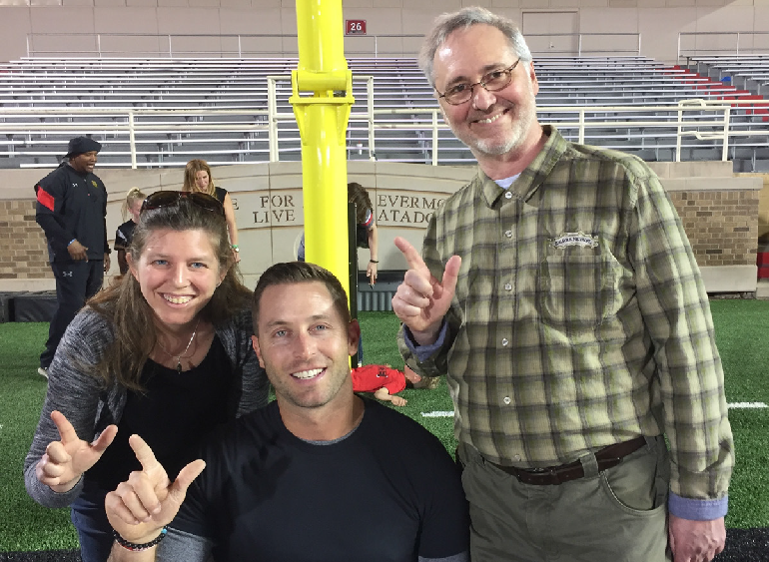

like to hear from you! If you would like us to include a profile of your career or some recent news in a future newsletter, or just update your contact information, please drop us an email or letter or visit the ‘Texas Tech
Geosciences Alumni’ page on Facebook.

Editor
Paul Sylvester
Professor and Pevehouse Chair
E-mail: paul.sylvester@ttu.edu phone: 806-834-5091

Co-Editor
Kate Souders
Research Assistant Professor
E-mail: kate.souders@ttu.edu phone: 806-834-8989

Department of Geosciences
Texas Tech University
125 Science Building, Lubbock TX 79409-1053
6 Caprock Connections
6 Caprock Connections

AAPG Student Chapter
by Jared Olafsson, AAPG Student Chapter President
The Texas Tech student chapter of AAPG has enjoyed continued success this year with several excellent events and activities. We look forward to another great Spring semester and the transition of power with upcoming
officer nominations.
Our annual chili-cookoff was a huge success. We thank everyone (100+) who came out in support and enjoyed great music and food. Special thanks to Riley, Workstrings, AADE, and the SPWLA for contributing to this event. Our next major social activity will be our annual end-of-year

Houston Chapters
of the Texas Tech
Alumni Association:
Upcoming Events
from Kristie White,
BS (Geophysics) 1997

Kendra Scott Gives Back Party

department BBQ and Salsa Competition on May 6th. More details will be coming soon, be sure to add us on Facebook for the latest information.

Our 2016-2017 IBA Team recently wrapped up their final presentation to a panel of judges in Dallas, TX on March 18th and we are proud to announce that we took 2nd place at this year’s Southwest regional competition. This year’s team brought home a check for $1000 for our chapter! The majority of the funds will be used by next year’s chapter to improve
This year’s chili-cookoff winners along with officers Lauren Garde & Daniel Pike.

5/19/2017 6:00 PM
North Houston for an evening of fun and shopping!

Golf Tournament

6/12/2017
Raveneaux Country Club

Texas Tech Day at the

the quality and efficiency of our IBA program. The remainder will be used to support student travel and conference fees.
IBA Team members from left to right: John Brotherton, Miles Rand, Travis Sparks, Rui Liu, and Jordan Coe

Houston Astros

7/15/2017

Fill Minute Maid Park with

Our chapter remains active in our community by continuing our commitment to the adopt-a-highway program. We are also expecting to continue our efforts in providing a clean, fun atmosphere at the TTU baseball games by assisting in the cleanup of Dan Law Field after home games.

The officers would like to thank everyone for their continued support of our department and the commitment to furthering the education of our future petroleum geologists. Wreck ‘em!

Red Raiders!
Houston Chapter webpage (http://www. texastechhouston.com/) and Facebook page (https://www.facebook. com/HoustonTTU)
Geological Society of America Annual Meeting - Denver - Sept 2016

TTU attendees enjoying the conference icebreaker.
From left to right: Dustin Sweet, Kate Souders, Celeste Yoshinobu, Cal Barnes.

North Houston Chapter Facebook page (https:// www.facebook.com/ NorthHoustonTTU/)
Contact Us!

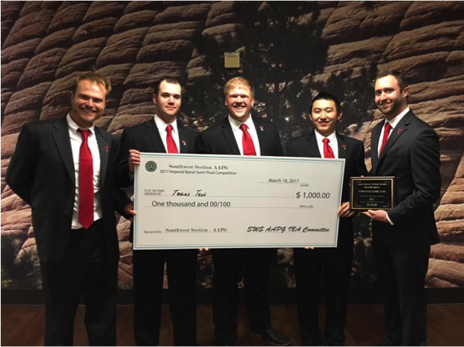
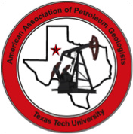
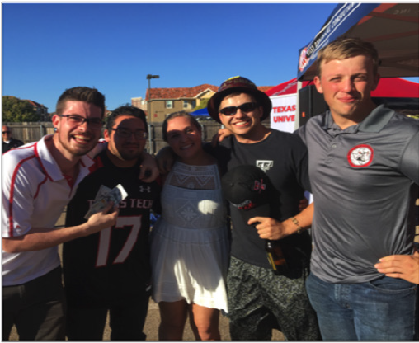
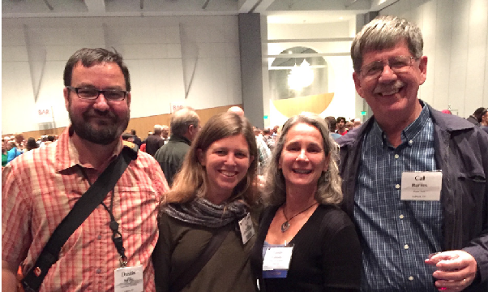
Caprock Connections 7

Alumni Profiles

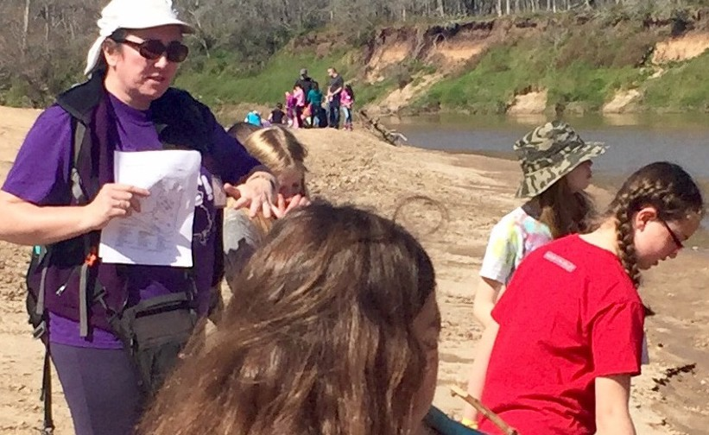
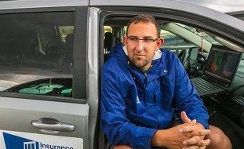
Imelda G. Johnson, Ph.D.
I
melda Gorman Johnson received her Ph.D. from Texas Tech in 1999. Imelda arrived in Lubbock in 1994, with the specific goal of working with Dr. George Asquith.
Between that time and graduation Imelda met her husband, and fellow Department of Geosciences alum, Ken Johnson (MS, 1991; Ph.D. 1995).

Upon graduation Imelda returned to the UK, and started her professional career. Her first job was with Badley Ashton & Associates (BAAL), where she worked exclusively on carbonate reservoir characterization projects, in the Middle East (Kuwait, Oman, UAE). Imelda accepted a job offer from ExxonMobil in 2002 and moved to Houston.
She continued to develop her carbonate skillset, but following a transfer to the Exploration Company in 2004 she was introduced to 2D and 3D seismic datasets.
Ultimately this led to a shift in focus from the reservoir scale into exploration and regional-scale studies.

In 2013 Imelda made a work/life balance decision and applied for a Senior Technical position with Chevron, where she currently works. Over the course of her career Imelda has continued to broaden her knowledge of Middle Eastern carbonate reservoirs, but she has also worked
on projects in the Barents Sea, offshore west Africa and Brazil, SE Asia, and Kazakhstan, the Gulf of Mexico, and most recently had an opportunity to return to her roots and work on a project in the Permian Basin.

Imelda has been actively involved in educational outreach programs for many years. She currently serves on the Girl Scouts of San Jacinto’s STEM Committee, where she and a dedicated group of volunteers work to enhance STEM programming for girls in grades K-12.

8 Caprock Connections

Ian Giammanco, Ph.D.
an Giammanco earned a Master’s degree in Atmospheric Science at Texas Tech. His research focused on applying data collected from the National Wind Institute’s (NWI)
I
200 m instrumented tower to diagnose nocturnal low-level jet features and how they impact wind energy systems. Dr. Giammanco then moved to the NSF IGERT Wind Science and Engineering doctoral program. His research used GPS dropsonde data, collected by hurricane hunter aircraft, and coastal National Weather Service radars to understand
the characteristics of vertical wind profiles in hurricanes. He completed his PhD in 2010 and then a post-doctoral research study at Texas Tech in 2011, which examined hurricane wind effects on offshore oil platforms.

Dr. Giammanco accepted a Research Scientist position at the Insurance Institute for Business & Home Safety’s (IBHS) laboratory, in Richburg, South Carolina (SC). The laboratory opened in 2010 with the mission to improve resiliency to natural hazards. In 2013, Dr. Giammanco became a Lead Research Meteorologist at IBHS. He provides leadership in instrumentation design and data
collection, wind-flow characterization, multi-hazard testing including hail and wildfire, field programs, and guidance on weather and climate issues for the public policy program. He currently serves on the American Meteorological Society’s Committee on Financial Weather Risk Management and the Publications Board of the National Weather Association. Dr. Giammanco is an Adjunct Faculty Research Associate within the NWI and continues to participate with the Texas Hurricane Research Team.

Ian and his wife, Dr. Tanya Brown-Giammanco, also a graduate of the Wind Science and Engineering doctoral program, reside in Rock Hill, SC. She works at IBHS as a Lead Research Engineer and holds the endowed South Carolina Wind and Hail Junior Research Scientist Chair.

