Employee Name:
Supervisor: Overall Evaluation Rating:
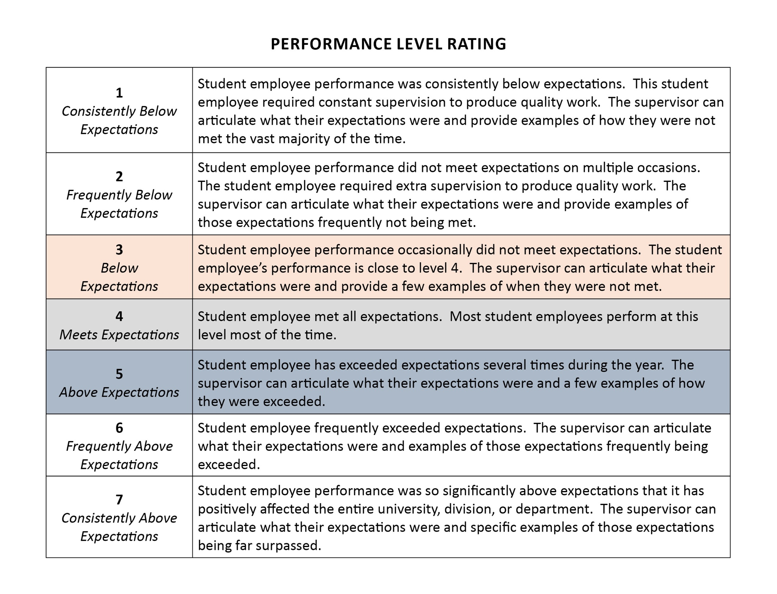
Date:

ESSENTIAL JOB FUNCTIONS
Summarize essential job functions here
JOB DUTIES | PERFORMANCE LEVEL RATING
- INSERT JOB FUNCTIONS SPECIFIC TO YOUR DEPARTMENT

EXAMPLE: A student employee is expected to assist supervisors with administrative tasks:
- The student employee schedules appointments and manages calendars for the supervisor
- The student employee maintains accurate student records and updates files
- The student employee serves as front-line support for student inquiries via email, phone, or in-person visits
Comments: Include justification for your performance level here. Include specific instances where these job functions were completed or not completed.
- A student employee for our department is also expected to maintain certification and comply with university and department administrative requirements.
  - Completed required trainings: compliance training (EEO, Title IX, Clery, and Ethics), FERPA, Cybersecurity, and Safety Awareness within the first 30 days of employment
  - [INSERT ANY ADDITIONAL TRAINING REQUIREMENTS HERE]

Comments:

GLOBAL COMPETENCIES | PERFORMANCE LEVEL RATING
- Quality of Customer Service/Relationship with Others/Communication (oral & written)
  - Respectful, cooperative, and effective in getting along with a diverse group of peers and staff
  - Maintains professional and positive boundaries with students and staff
  - Expresses ideas/information in a complete, clear, concise, organized, and timely manner
  - Reads and responds to all work-related emails
  - Actively listens to others and is open to suggestions
  - Exudes a positive attitude
Comments:
- Compliance/Staff Development
- Complies with all university and department rules, laws, policies and procedures; attends all required training within the appropriate timeframe
- Maintains a professional appearance and demeanor
- Attended evaluation and all required meetings

Comments:

- Dependability/Accountability
- Degree to which the employee can be relied upon and complete tasks in a timely manner
- Completion of suggestions and/or requests by staff
- Arrives on time for each shift and utilizes entire time allotted
- Communicates concerns with supervisor

Comments:

DEVELOPMENT & GOALS
Evaluation Summary and Recommended Development:

Supervisor Employee
Signature: __________________________ Signature: _____________________________

Date: __________________________ Date: ____________________________

