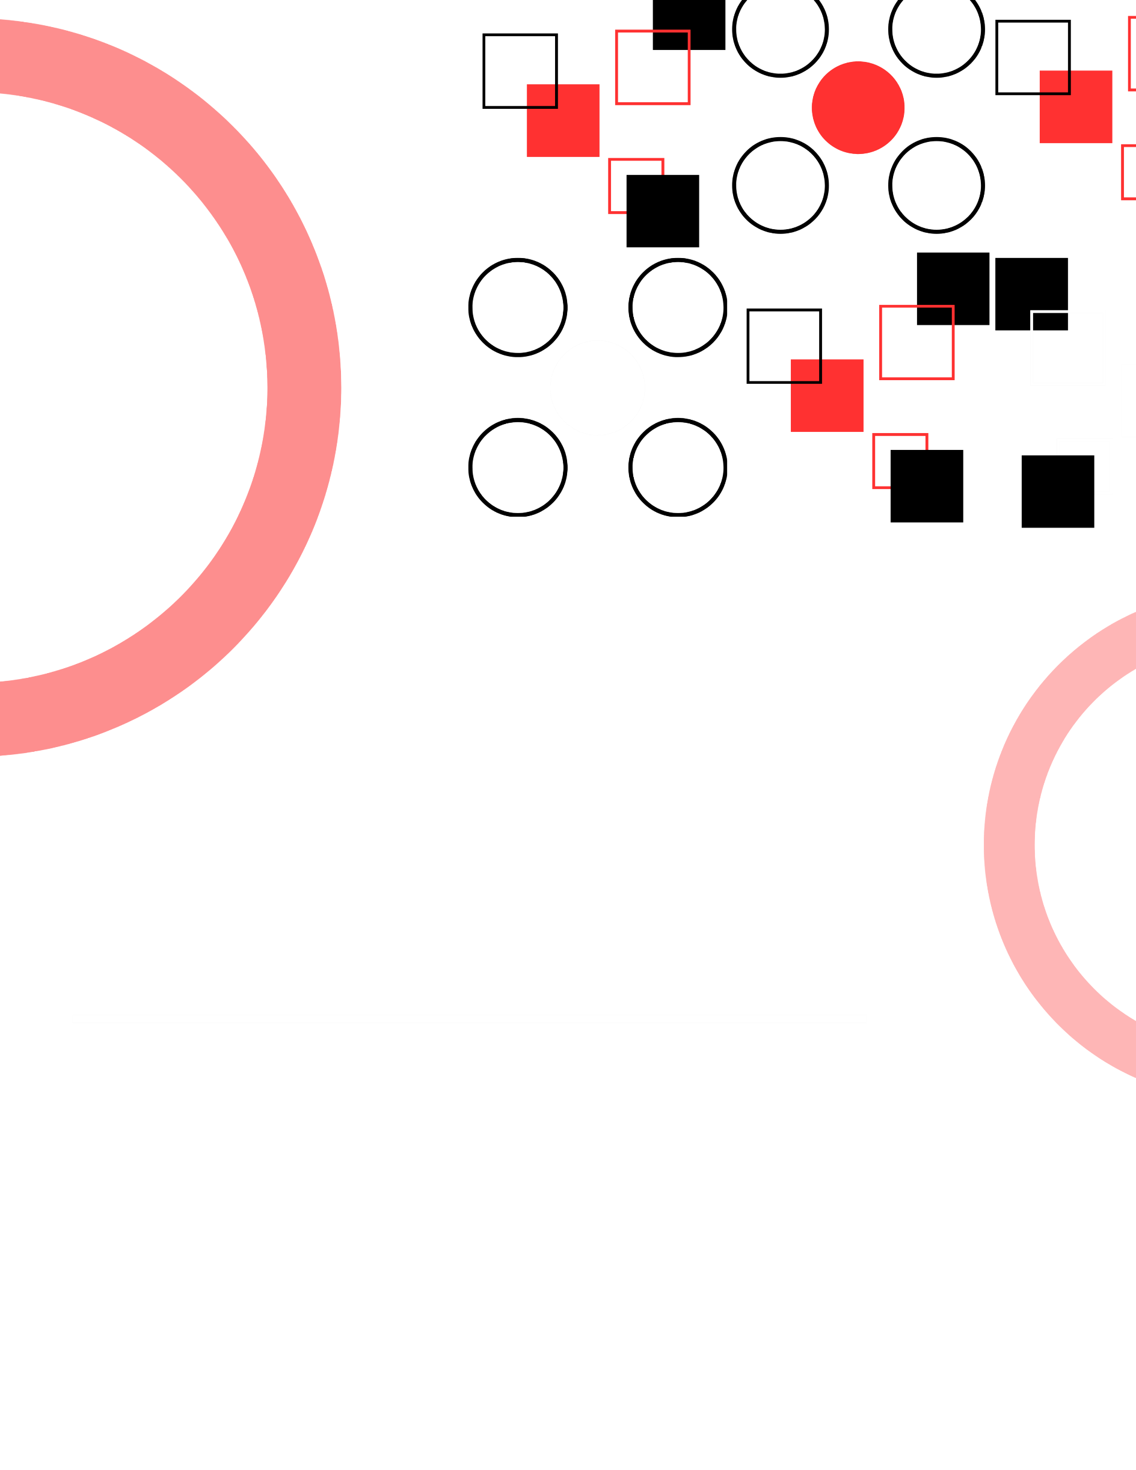

EPAF
Wizard Guide

Contents
Introduction 6
Understanding Wizard Basics 7
Wizard Logic 7
Effective Dates 7
Common examples: 7
No Multi-Action ePAFs 7
Editing Wizard Transactions 7
Wizard Transaction Types 8
How the ePAF Wizard Determines the Correct ePAF Action Needed 8
New Hire 8
Job Begin 8
Add Secondary Job 9
Add Overload 9
Add Summer Job 9
Funding (Labor) Change 9
FTE Change 9
Pay Change 9
End Job 9
Termination 9
ePAF Wizard Fields 10
Searching for an employee 10
Position Number/ Suffix 11
Personal Information 12
Effective Date 13
Hourly/ Monthly Rate 13
Employee Class Codes 13
FTE 14
Leave/ Benefit Category 14
FT/ PT Status 14
Hours per Pay/ Day 15
Time Entry Method 15
Job Change Reason 15
Factor/ Pays 15
Job Effective Date 16
Timesheet COAS 17
Timesheet Org 17
Supervisor R Number 17
Default Earnings 17
Labor Distribution 18
Comments vs. Wizard Comments 19
Approval Information 20
Terminate Employment 21
Term Code Chart 23
Understanding Approvals 25
Adding Attachments 26
Attachment Requirements 27
New Hire (paper onboarding; not through Kenexa) 27
New Hire (online onboarding; through Kenexa) 27
Job Begin (when employee changes from non-benefits eligible to benefits eligible, any transaction (re)appointing for semester) 27
Termination 27
Accessing the Wizard 28
Through Raiderlink’s Employee Dashboard: 28
Through the HR Homepage: 29
Searching Wizard Records 30
To Search Records 30
Glossary of ePAF terms 33
Annual Salary: 33
Approved: 33
Benefit Category Code: 33
Cancelled: 33
Comments: 33
Completed: 33
Current Hire Date: 33
Default Earnings: 33
Disapprove: 34
Distribution COA: 34
Distribution Orgn: 34
Electronic Personnel Action Form (ePAF): 34
Employee Class Code: 34
Encumbrance: 34
Encumbrance Begin Date: 34
Encumbrance End Date: 34
End Job ePAFs: 34
ePAF Wizard: 35
Exempt Employees: 35
Factor: 35
Fair Labor Standards Act (FLSA): 35
FT/PT Status: 35
Full Time Equivalent (FTE): 35
Home COAS: 35
Home Organization: 35
Hourly Rate: 36
Hours per Day: 36
Hours per Pay: 36
Job Begin Date: 36
Job Change Reason: 36
Jobs Effective Date: 36
Last Paid Date: 36
Last Work Date: 36
Leave Category Code: 36
Leave Without Pay (LWOP): 36
Location Code: 37
Labor Distribution: 37
Modifying Job ePAFs: 37
New ePAF Job Selection: 37
New Position Request Form: 37
Non exempt Employees: 37
Partial: 37
Pay Plan: 37
Pays: 37
Pending: 38
Personal Info: 38
Personnel Date: 38
Position Class Code: 38
Position Number: 38
Premium Pay Code: 38
Primary Job ePAFs: 38
Returned: 38
Routing Queue: 38
Secondary Job ePAFs: 39
Special Rate: 39
Supervisor R Number: 39
Termination: 39
Termination Reason Code: 39
Time Entry Method: 39
Employee Time Entry via Web: 39
Third Party with Approvals: 39
Timesheet Organization or Timesheet Orgn: 39
Voided: 39
Wizard Status In Progress: 40
Wizard Status Submitted: 40
Work Address: 40
Appendices 41
New Hire Step by Step Guide 42
Employee Default Earnings Guide 52
Employee Record Job Aid 53
New Hire Paperwork Checklist 55

Introduction
The ePAF Wizard is TTU’s updated electronic Personnel Action Form tool designed to simplify and streamline personnel transactions. Instead of requiring users to choose from dozens of legacy ePAF types, the Wizard guides users through a series of intuitive questions and automatically determines the correct transaction type. This reduces errors, improves routing accuracy, and creates more consistent experience across departments.

The Wizard supports personnel actions—including hiring, rehires, job changes, funding updates, pay adjustments, and job endings. It also introduces a more guided workflow, clearer field requirements, and an updated look that aligns with Banner 9 functionality.

Overall, the ePAF Wizard is intended to make processes more user-friendly and more efficient, while still capturing the information required by HR, Budget, and Payroll to process personnel actions correctly.
See Figure 1.
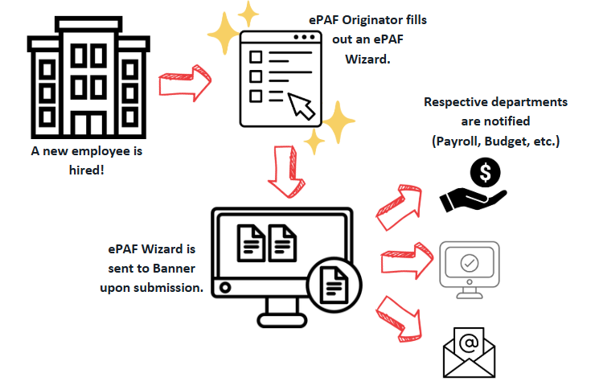
Figure 1. Overview of the ePAF Wizard process from new hire paperwork to Banner submission and departmental notifications.
Access the TTU ePAF Wizard

Understanding Wizard Basics
The ePAF Wizard uses a decision-based workflow to determine which ePAF is needed. Users begin at the same starting point, and the Wizard directs them based on how they answer key questions. This approach minimizes guesswork and ensures that the correct type of ePAF is generated every time.

Key Concepts to Understand:

Wizard Logic
The Wizard evaluates your answers and automatically produces the appropriate ePAF type. You no longer must manually select the ePAF category (e.g., New Hire, Add Secondary Job, Pay Change). The system determines this for you.

Effective Dates
The Effective Date is the date the transaction or change will take effect in Banner. This date drives most other date fields in the Wizard. With few exceptions (such as contract dates or job end dates), additional date fields will default to the Effective Date and should be reviewed for accuracy.

Common examples:
- New Hires: Effective Date = first day the employee works
- Promotions, Pay Changes, or FTE Changes: Effective Date = the date the change becomes effective
- Job Endings: Effective Date = the employee’s last day working in the job

The Wizard is designed to make this clearer, but departments should still double-check dates to avoid incorrect effective dates.

No Multi-Action ePAFs
Previously, users could submit multiple actions in one ePAF. The Wizard separates these. Each action must now be processed individually, and departments should communicate when multiple coordinated actions are needed.

Editing Wizard Transactions
Once submitted, no edits can be made unless they are returned by an Approver in Banner. Ensure all information looks correct before saving and submitting.

Wizard Transaction Types
Previously, users had to select from more than 40 ePAF types. With the new Wizard, that step is eliminated. The Wizard automatically guides you to the correct ePAF type based on your responses. Below are the ePAF transactions that can be completed using the Wizard. See Figure 2.
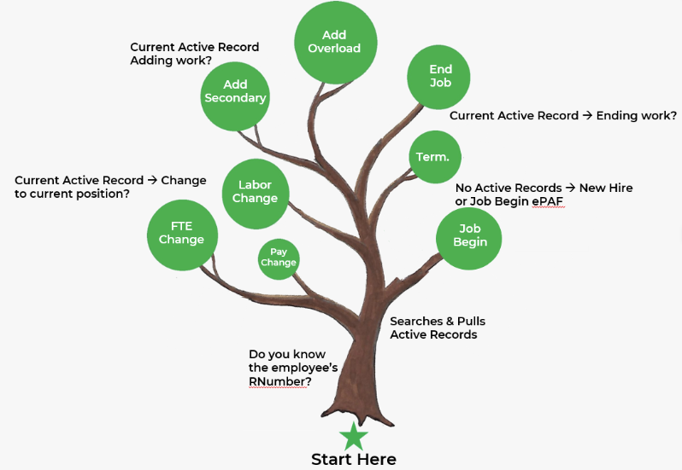
Figure 2. Visual overview of the ePAF Wizard’s automated routing based on employee record status.

How the ePAF Wizard Determines the Correct ePAF Action Needed
The ePAF Wizard uses automated logic to evaluate the employee’s current record status in Banner. Based on whether the employee has an active record and the nature of the requested action, the system prompts relevant questions and automatically routes the transaction to the appropriate ePAF type.

New Hire
Initiates employment at Texas Tech.

Job Begin
Initiates or restarts a position within your organization, including situations where an employee is moving from one position or home organization to another.

Add Secondary Job
Adds additional FTE to an employee. NOTE: Students cannot exceed a total FTE of .5. Faculty and Staff FTE may not exceed 1.0. Commonly used for non-exempt employees.

Add Overload
Adds compensation for work performed when FTE remains at 0. Full-time exempt employees only.

Add Summer Job
Adds employment specifically for the Summer.

Funding (Labor) Change
Updates or changes the funding source for a position.

FTE Change
Modifies the full-time equivalency (FTE) for a position. Rate of pay and funding sources may also change.

Pay Change
Updates the rate of pay for a position. Funding sources may also change.

End Job
Ends employment in a specific position but maintains the employee’s status within the organization.

Termination
Ends the employee’s relationship with Texas Tech.

ePAF Wizard Fields

Searching for an employee
The ePAF Wizard automatically generates the fields required for your transaction based on the responses you provide. Below is a review of all possible fields you may encounter, along with explanations for each section.
See Figure 3.
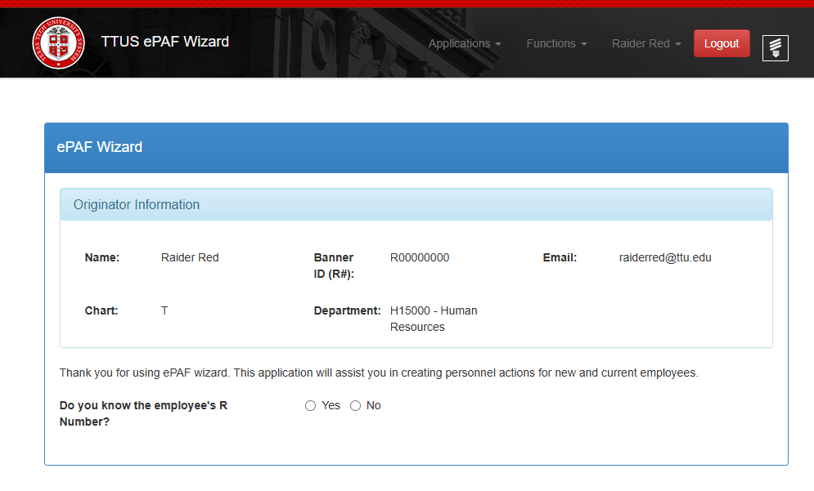
Figure 3. Snippet of the initial screen in the ePAF wizard.
To begin, answer the question, “Do you know the employee’s R Number?” If you do not, select No and search for the employee using their Social Security Number. Select Search. This verification step prevents the creation of a duplicate R Number. See Figure 4.
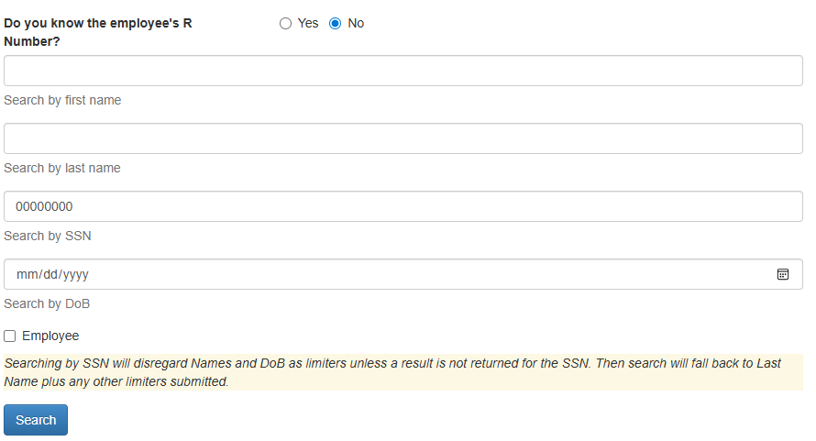
Figure 4. Snippet showing search options for locating an employee’s existing Banner record.
If the employee has an R Number in the system, a record will appear. See Figure 5. If the record matches your employee, select the radio button and hit Select Match.
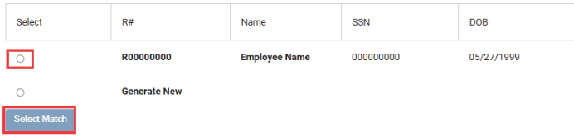
Figure 5. Snippet showing an existing Banner record found. If the information is correct, the originator selects the record and chooses Select Match.
If no record appears, select Generate New. Once your ePAF Wizard transaction is submitted and approved/applied, the Banner system will automatically create an R Number for the employee. See Figure 6.
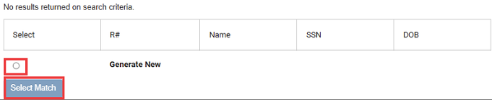
Figure 6. Snippet showing no current Banner records found. The originator is prompted to Generate New and then select Select Match to create an R-number upon successful submission.

Position Number/ Suffix
If prompted to enter a new position number and suffix, obtain these details from your department and enter them in the fields provided. See Figure 7.
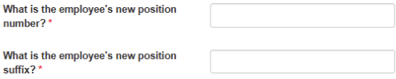
Figure 7. Snippet of the ePAF Wizard requesting the position number and suffix.
Each department has a list of position numbers assigned to the Home Organization. All primary appointments and most secondary appointments use a 00 suffix. If the employee is being reappointed to a previously held job (position #-suffix).
Secondary appointments on a position number which is currently assigned to the employee will use a different suffix to distinguish it from the primary. Summer appointments of 9-month faculty/students use 10, 20 or 30, etc. when the primary appointment is on summer leave without pay. HR may advise the use of a Z1 suffix under certain circumstances. These secondary appointments will have an assigned FTE.
The department may assign additional payment with 0 FTE to full-time exempt employees using an overload appointment. Part-time employees are not eligible for overloads; additional FTE must be assigned instead.
Non-exempt employees are not eligible for overloads; all time worked is reported on timesheets and overtime rates apply for work above 40 hours in a week.

Assigning Overloads
The position number may be the same as the employee’s primary appointment or another position number assigned to the department. The appropriate suffix for an overload appointment is dependent on the Earnings Code that best describes the payment.
The table below notes the appropriate suffix to be assigned with the position number based on the earnings code used. 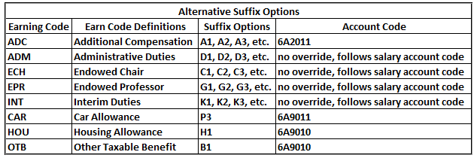

Personal Information
Originator may be required to enter personal information for their employee. This will collect general personal data for the employee. See Figure 8.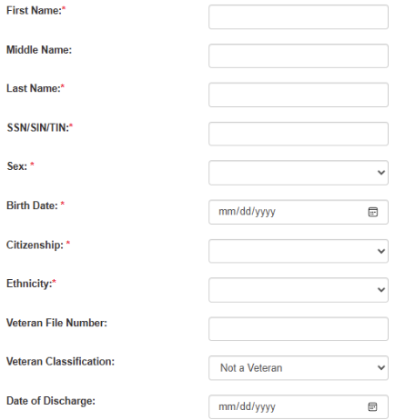
Figure 8. Snippet of the Personal Info section within the ePAF Wizard.
If the employee already has an R Number, some of the data will pull into the Wizard. The ePAF originator can make changes to that existing data by filling in new information.
If no employee record appears, the ePAF originator will need to enter the required fields. Refer to the Biographical Data Form for the necessary information.
If the employee is a Veteran, fill in the Veteran fields. Their paperwork will indicate this status.

Effective Date
When asked, “What is the effective date?” enter the date the action occurs. See Figure 9.
New Hire: Start date
Job Modification: Date the change starts
Job End/Termination: Last working day
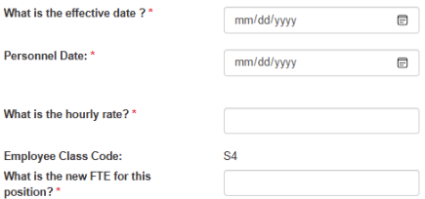
Figure 9. Snippet of the ePAF Wizard for effective date, hourly rate, auto-populated employee class, and FTE entry.

Hourly/ Monthly Rate
Enter the hourly or monthly rate for the employee. This will be provided to you by your department.

Employee Class Codes
The Employee Class Code will auto-populate based on position number; just ensure it looks right by referring to the Employee Record Job Aid. See Figure 10.
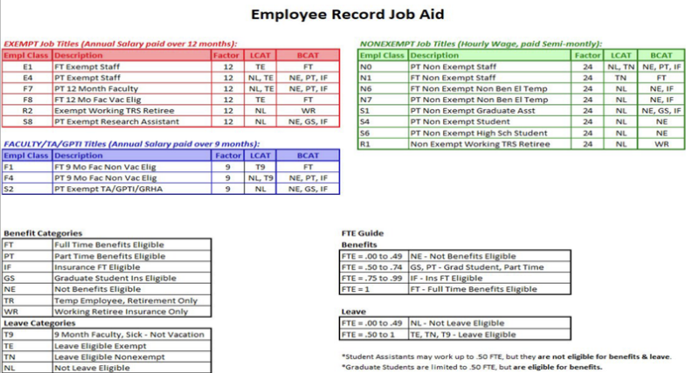
Figure 10. Employee Class Code chart used to verify the Wizard’s auto-populated information.

FTE
FTE is the abbreviation for Full Time Equivalent. FTE represents the employees’ workload. FTE is based on the number of hours per week the employee will work. A full-time employee, or 100% FTE employee, will work 40 hours per week.
An employee’s FTE can be figured by using the following calculation: Number of Hours the employee works in one week/40 hours = FTE Example: An employee works 27 hours per week. The FTE for that employee would be 0.675 or 67.5%.

Leave/ Benefit Category
Leave and benefit categories will auto-populate based on the submitted FTE. See Figure 11. Double-check them against the Employee Record Job Aid to ensure accuracy.
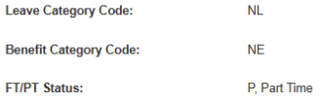
Figure 11. Snippet of the Leave and Benefit Category codes auto populated in the Wizard, along with the FT/PT Status populated based on the originator’s earlier entries.

FT/ PT Status
The submitted FTE will have the wizard auto-populate whether the position will be P, Part Time or F, Full Time. Double-check to ensure accuracy.

Hours per Pay/ Day
Hours per Day and Hours per Pay will auto populate based on the FTE entered. See Figure 12. Hours per Day represent the average number of hours an employee will work each day.
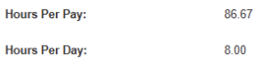
Figure 12. Snippet of the Hours per Day and Hours per Pay fields auto populated in the Wizard.
For a full-time employee, this is 8 hours. The calculation for this field is: Hours per Day = 8 × FTE
The wizard will display this value up to two decimal places.
Hours per Pay represents the average number of hours an employee will work each pay period.

Time Entry Method
The originator will identify which timekeeping system the employee will be using to report hours worked. See Figure 13.
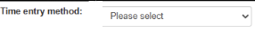
Figure 13. Snippet of the Time Entry Method dropdown the originator will use to select the appropriate method.
Employee Time Entry via Web is used for employees who will enter time in Web Time Entry on Raiderlink.
Third Party with Approvals is used for employees who will enter time in Time Clock Plus

Job Change Reason
The Job Change Reason indicates the specific purpose of the ePAF transaction. It will automatically populate in Banner based on the selections made within the ePAF Wizard. See Figure 14.

Figure 14. Snippet of the Wizard auto-populating the Job Change Reason based on the originator’s previous entries.

Factor/ Pays
The Factor and Pays will be auto populated. See Figure 15. Factor and Pays indicate the number of pay periods and number of paychecks per year.
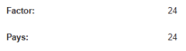
Figure 15. Snippet of the Factor and Pays fields auto-populated by the Wizard based on earlier entries.
Employees in a 9-month faculty position who have elected to have a portion of their monthly pay deferred to pay out during the summer months may show a factor of 9 with a pay of 12. If the ePAF originator sees this type of factor and pay difference, other considerations should be taken so the summer payments to the employee will not be affected.

Job Effective Date
The Wizard will ask when the change should go into effect. See Figure 16. NOTE: Submit ePAFs on or before the effective date to avoid delays in payment or job changes.
Figure 16. Snippet of the Job Effective Date as it appears in the Wizard.
Even though these fields auto-populate, it’s important to understand how effective dates work in common scenarios:

9-Month Summer Processing
- 6/1 LWOP Placement: At the end of May, an automated script places all active 9-month appointments on Leave Without Pay (LWOP).
- Appointments already ending 5/31 will not be updated.

Return from LWOP
- 9/1 Return to Active: A second script reactivates 9-month appointments at the end of August.
- Appointments ending 8/31 will not be updated.

May Graduation – Student Employees
- Students may work through the month they graduate.
- Submit termination ePAFs effective no later than 5/31, unless the student is entering a new graduate program.

Overload Appointments
- Fall overloads: effective 9/1
- Spring overloads: effective 1/16
- Some end-date scenarios may use 1/15 or 5/31 depending on appointment timing.

Timesheet COAS
The chart of account the timesheet organization resides in. See Figure 17.
- T = Texas Tech University
- S = Texas Tech System
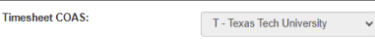
Figure 17. Snippet of the Wizard auto-selecting the Timesheet COAS based on the position number entered by the originator.

Timesheet Org
The Wizard will ask the originator, “What is the timesheet org for this position?” This is the organizational code used to route, house, and approve the employee’s timesheet or leave documentation. Your department will provide the appropriate code. See Figure 18.
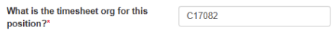
Figure 18. Snippet showing where the originator will enter the Timesheet org.

Supervisor R Number
This will always be the R Number of the individual that will serve as the employee’s supervisor.
This field will set up access in the electronic Performance Management (ePM) system for the supervisor to establish a Position Description and Evaluation for the employee. See Figure 19.
Figure 19. Field where the originator enters the supervisor’s R Number. Once entered, the supervisor’s name displays to the right of the field in red.

Default Earnings
The Wizard will automatically populate the Default Earnings field based on the originator’s previous selections and the information entered earlier in the process. See Figure 20.
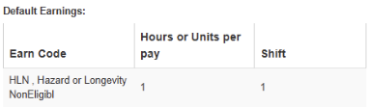
Figure 20. Snippet of the Default Earnings section auto-populated by the Wizard based on the originator’s previous entries.
The Earnings Code is the Banner code that allows the position to flow through the payroll process and determines which type of earning is paid to the employee.
Common earnings codes include:
• HLD: Longevity-eligible staff
• HLN: Nonexempt employees who are not eligible for longevity
• RGS: Exempt employees who receive a fixed monthly salary
Refer to the chart below for a detailed explanation of each earnings code and how it is applied. See Figure 21. HAZ for Hazard Pay is for peace officers and may only be used by the TTU Police Department. HR Comp and Ops will manually add HAZ pay after the ePAF is applied.
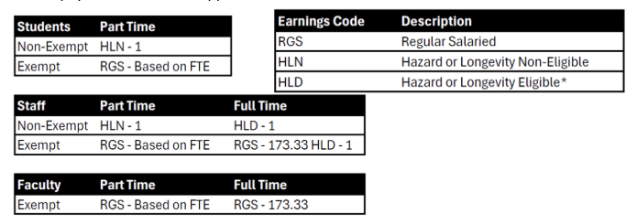
Figure 21. Default Earnings Guide showing earning code definitions and eligibility by employee type (full-time or part-time).
Secondary and overload 0 FTE appointments (which use a default earnings code other than RGS) must end 5/31 if they are not meant to continue through the summer. The department will be responsible for ending these appointments, so the employee is not overpaid.

Labor Distribution
This section is known as the Funding Source. It identifies the FOAP (Fund, Organization, Account, Program) information from which the position will be funded. This section establishes or updates the funding source(s) for the appointment and is made up of the following components:
- Chart of Account (COA)
- T: TTU Departments
- S: System Departments
- Fund
- Organization
- Account
- Program
The fund, organization, account, and program values should be provided by your department.
The Percent field indicates how much of the appointment will be paid from each funding source. The Wizard will automatically populate the Labor Distribution, but the originator may edit any field within this section.
If additional funding sources are needed, select Add Row. After entering the information, choose Save to retain the changes, or Cancel to discard them.
Regardless of how many funding sources are added, the total percentage must equal 100%. See Figure 22.
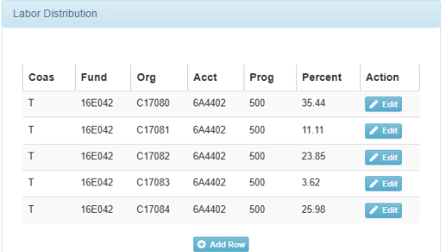
Figure 22. Snippet of the Labor Distribution section in the ePAF Wizard. Originators may edit or add funding sources using the Edit and Add Row buttons.

Comments vs. Wizard Comments
The Wizard ePAF transaction includes two separate comment areas, each serving a different purpose. See Figure 23.
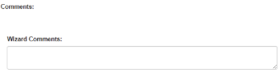
Figure 23. Snippet showing the Comments and Wizard Comments fields. Comments are reserved for approvers; Wizard Comments may be used by the originator to enhance communication.

Comments:
This section only displays any comments added by approvers during the routing and approval process in Self Service 9.
- The originator cannot enter or edit anything in the Comments section within the ePAF Wizard.
- This field will often remain blank unless an approver has added notes while reviewing the transaction.
- Approver comments become a permanent part of the employee’s job record in Banner.
Because approvers cannot take action or complete system changes based solely on comments, originators should not rely on this section for notifying an office about required actions.

Wizard Comments:
Directly below the Comments field is the Wizard Comments section. This is where the originator can enter comments when creating the ePAF in the Wizard.
This field may be used to:
- Provide a brief explanation of the purpose of the ePAF
- Offer clarifying details for approvers
- Add required information depending on the type of appointment
All comments entered here also become a permanent part of the ePAF record.

Examples of Information Originators May Need to Include in Wizard Comments:
- Non-Tech Employee Appointments: State the purpose of the appointment and identify who is funding the individual.
- Temporary Worker Appointments: Include the purpose and anticipated end date.
- Split Appointments: Note the FTE and title of the other appointment and include the transaction number if available.
- Kenexa-Posted Positions: Provide the Requisition Number.

Examples of Approver Comments (in SS9 Comments Section):
Approvers may return ePAF with comments such as:
- Corrections needed on Form I-9
- Missing or incorrect attachments
- Instructions to add approvers to the routing queue
- Funding not available or funding errors

Approval Information
Approval Info is the section of the ePAF Wizard where the originator will assign approvers for the ePAF Wizard transaction. The required routing does change for certain ePAF types. The transaction will load with the required minimum routing queue to be submitted. Any additional approvals may be added using the Add Row button. See Figure 24.
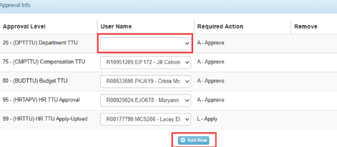
Figure 24. Snippet of the Approval Info section of the ePAF Wizard. Approver levels 75-99 are auto filled. The originator must select their department-level approver from the dropdown. Additional approvers may be added using Add Row.
Once the Add Row button is selected, use the drop down to select the appropriate Approver Level. Next, select the correct User Name using the drop down and then the action required. Ensure to save changes by selecting Save. See Figure 25.
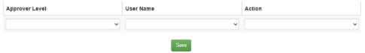
Figure 25. If additional approvers are needed, selecting Add Row allows the originator to choose the approver level, user name, and action. Selecting Save stores the changes.

Terminate Employment
When terminating an employee, the Wizard will guide you directly to the required termination fields.

Enter the Job End Date
The Wizard will ask: “What date will this job end?” Enter the appropriate date. The Personnel Date directly below will automatically populate with the same date.

Select the Job Change Reason
Choose the correct job change category:
- R: Retirement
- T: Termination

Auto-Populated Dates
After the initial date is entered, the following fields will appear and will automatically match the date you provided:
- Job End Date
- Last Work Date
- Termination Date

Choose the Termination Reason Code
Use the dropdown to select the appropriate Termination Reason Code that reflects why the employee is separating from the University.
NOTE: Do NOT end deferred pay appointments on 5/31 or at any point mid-summer.
Doing so will disrupt the employee’s deferred pay and may cause their benefits to be interrupted or terminated, resulting in unintended charges to the department.
- An ePAF submitted with only the End Job section will end the appointment but will NOT terminate the employee.
  - This means the employee will stop receiving pay,
  - But their benefits will remain active,
  - And the department may continue to be charged for those benefits.
If a benefits-eligible employee is no longer working for the University, the originator must submit a Termination ePAF, which will:
- End the appointment and
- Terminate the employee from University employment
This ensures both payroll and benefits are closed out correctly. See Figure 26 for what a termination ePAF Wizard transaction will consist of.
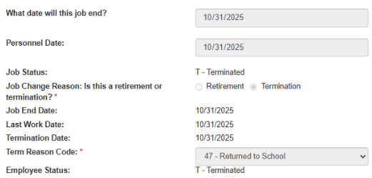
Figure 26. Snippet of what a termination transaction looks like in the ePAF Wizard.

Term Code Chart
If you are terminating an employee, it is important for the originator to document as accurately as possible the reason the employee is leaving. Use the chart below to determine the appropriate termination code. In most cases, the employee’s resignation letter will provide the information needed to select the correct code.
Term Code | Explanation
02 – Lack of Funding | Used when grant funding runs out for a specific position.
03 – Completion of Contract | Used for employees who are hired on a contract basis.
04 – Reorg/ Reduction in Force | Used for employees who are being terminated due to their department downsizing or being reorganized. Must be approved by HR.
05 – Leave of Absence Expiration | Used for employees who do not return upon completion of their leave of absence.
20 – Excess Absence or Tardiness | Used for employees who have excessive absences or tardiness. Must work with Talent Management.
21 – Unsatisfactory Performance | Used for employees who are not meeting the minimum standards and qualifications for their position. Must work with Talent Management.
22 – Misconduct/ Violation of Rules | Used for employees who violate the rules of the department. Must work with Talent Management.
30 – Retirement | Used for employees who are retiring from the university.
40 – Accepted New Job | Used when employees are leaving their position for another job outside of the TTU System (TTU, TTUS, TTUHSC, TTUHSC – El Paso).
41 – Job Abandonment | Used for employees who abandon their position without notice, and the department is unable to make further contact.
42 – Marriage/Domestic Obligation | Used for employees who leave their position due to marriage and domestic obligations.
43 – Dissatisfied with Pay | Used for employees who are dissatisfied with their pay.
44 – Personal Reasons | Used for employees who quit due to personal reasons. This is the most common reason code.
45 – Quit without Notice | Used for employees who quit without notice.
46 – Relocation | Used for employees who are leaving their position to move to a different location.
47 – Returned to School | Used for employees who leave their position due to returning to school.
48 – Dissatisfied w/ Working Conditions | Used for employees who are dissatisfied with their working conditions.
49 – Lack of Opportunity for Advancement | Used for employees who are leaving due to lack of opportunity for advancement.
51 – Dissatisfied w/ Superiors, Employment | Used for employees who are dissatisfied with their superiors, or other employees they work with.
52 – Travel | Used for employees who are dissatisfied with the amount of travel required for their position.
53 – Working Hours | Used for employees who are resigning due to their working hours not fitting with their needs.
54 – Resign in Lieu of Involuntary Separation | Used for employees who are resigning in lieu of involuntary separation, in association with job termination reason codes 20, 21, and 22. Must work with Talent Management.
55 – Degree Completed | Used for employees who are leaving due to completing their degree.
56 – Transfer to Another State Agency | Used for employees who are transferring to another state agency anywhere in the state of Texas.
60 – Medical | Used for employees who are leaving their position due to medical reasons.
70 – Military | Used in the event that an employee is leaving their position due to military duties and obligations.
80 – Death | Used only for active employees who pass away. If the employee is a retiree, please contact HR for further assistance.

Understanding Approvals
The ePAF transaction will load with the required minimum routing queue to be submitted. Other levels can be added on at the department’s discretion or as the appointment requires. The table below provides a reference for what approval levels may be added.
Approval Level | Required Action | When to Add
5 – FYI Only TTU | FYI | Department Choice
7 – Academic Support FYI TTU | FYI | Will default if required
10 – Principal Investigators TTU | Approve | Department Choice
20 – Department TTU | Approve | Every ePAF; may add additional lines
32 – Financial Aid TTU | Approve | Work Study appointments only
33 – Graduate School TTU | Approve | Graduate Student Appointments only
35 – Research Services TTU - SPAR | Approve | Grant Funding
37 – Dean or Area TTU | Approve | If required
50 – Vice President TTU | Approve | If required
51 – Provost TTU | Approve | All faculty ePAFs (not Instructors)
60 – President TTU | Approve | If required
75 – Compensation TTU | Approve | Will default if required
80 – Budget TTU | Approve | Will default if required
95 – HR TTU Approval | Approve | Will default if required
99 – HR TTU Apply-Upload | Apply | Every ePAF

Adding Attachments
Many ePAFs will require additional documentation that must be added to the employee’s file. Once a Wizard transaction has been started and saved, the Attachments button will become active.
To attach documents, select Attachments. Choose the appropriate file and upload any related paperwork. After uploading, the originator may view the document by selecting Display Document, which will open the file in a pop-up window. When finished, select Close to return to the transaction. Select Save. See Figure 27.
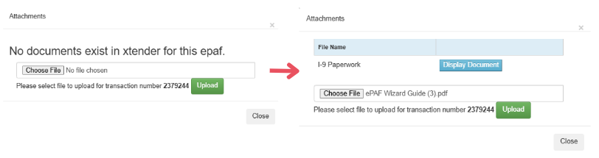
Figure 27. The originator may upload a file by selecting Choose File, selecting the document, and reviewing it in the attachments window. Display Document will show the file, selecting Close returns to the Wizard.
Only PDFs may be uploaded. Review the scan for readability and page orientation. Please do not upload documents upside down. Verify that you can read the information on the I-9 documents; if scanned too dark, you will be asked to submit a new copy

Attachment Requirements

New Hire (paper onboarding; not through Kenexa)
- Form I-9 and copies of documents used in verification
- e-Verify case results
- W-4 (Employee’s Withholding Allowance Certificate Form)
- Biographical Data Form
- Voluntary Self-Identification of Disability (Form CC-3305)
- Veteran’s Self-Identification Form (post-offer) (VEVRAA)
- TTUS Confidentiality Agreement
- TTUS Student Records Confidentiality Agreement
**When Benefits Eligible
- Benefits Enrollment Information Form
- TRS Eligibility Form (faculty and staff; not grad students)
**Exempt Graduate Student Appointments
- GPTI/TA Certification -or- RA Certification

New Hire (online onboarding; through Kenexa)
- Form I-9 and copies of documents used in verification
- e-Verify case results
- (if online onboarding fails, additional documents may be required as directed by HR)

Job Begin (when employee changes from non-benefits eligible to benefits eligible, any transaction (re)appointing for semester)
**When Benefits Eligible
- Benefits Enrollment Information Form (including benefits eligible grad students)
- TRS Eligibility Form (faculty and staff; not grad students)
**Exempt Graduate Student Appointments
- GTPI/TA Certification -or- RA Certification

Termination
- Resignation letter (if provided by the employee)

Accessing the Wizard
There are two ways to access the ePAF Wizard:

Through Raiderlink’s Employee Dashboard:
Log in using your eRaider credentials → go to Raiderlink Menu → A&F Work Tools → locate ePAF Wizard link. See Figure 28.
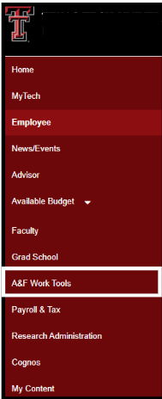
Figure 28. Raiderlink menu bar showing the A&F Work Tools option, which expands to display Human Resources links, including the ePAF Wizard.

Through the HR Homepage:
Go to Employee Resources → Quick Links → ePAF. See Figure 29.
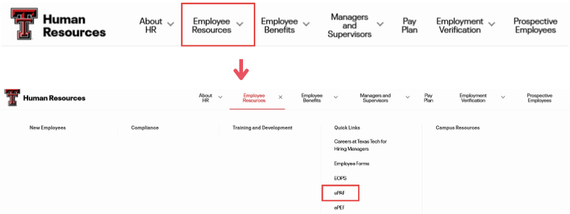
Figure 29. Snippet of the HR Homepage showing Employee Resources. Originators may select ePAF within Employee Resources to access the Wizard.

Searching Wizard Records
On the ePAF Wizard page, the originator can begin working through a new ePAF transaction. If the originator needs to review previous entries, they can do so by selecting Functions in the top-right corner of the screen and choosing Search. See Figure 30.
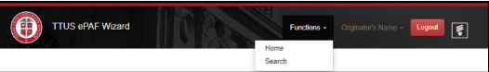
Figure 30. Snippet of the ePAF Wizard Functions tab, where originators may select Search to view their Wizard transactions.

To Search Records
There are several ways to filter pending and submitted ePAF Wizard transactions using the search features. See Figure 31.
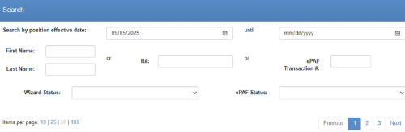
Figure 31. Snippet of the various search features available for originators to locate their ePAF transactions.

Effective Date
Search for ePAFs based on their effective date.

Until
Search within a date range that the ePAF’s effective date may fall into.

First Name
Search by the employee’s first name listed on the ePAF.

Last Name
Search by the employee’s last name listed on the ePAF.

R#
Search by the employee’s R Number listed on the ePAF.

ePAF Transaction #
Search by ePAF transaction number. NOTE: This is different from the Wizard ID number.

Wizard Status:
- Submitted: View only Wizard transactions that were successfully submitted to Banner.
- In Progress: View Wizard transactions that have been saved but not yet submitted.

ePAF Status:
- Approve: View Wizard transactions that have been approved in Banner.
- Disapprove: View Wizard transactions that have been disapproved in Banner.
- Void: View Wizard transactions that have been voided.
- Cancelled: View Wizard transactions that have been cancelled.
- Partial: View Wizard transactions that are partially approved.
- Pending: View Wizard transactions that are pending approval in Banner.
- Completed: View Wizard transactions fully completed in Banner.
- Returned: View Wizard transactions that have been returned for correction.

Pagination
Allows the originator to choose how many records are displayed on the search results page and to navigate through multiple pages of records.
When a search is completed or when the originator accesses the Search page, any Wizard transactions that have been started will automatically display. These records appear in a table format.
Kenexa-generated ePAFs will also appear on the Search page. Users can identify these transactions by the ePAF types ATNHF, ATNHE, and ATNHN.
Each column header may be selected to sort the results.

Wizard #
Sorts from the earliest Wizard transaction to the latest (smallest to largest number).

First Name
Sorts alphabetically by first name (A–Z).

Last Name
Sorts alphabetically by last name (A–Z).

R#
Sorts from the smallest R Number to the largest.

Effective Date
Sorts from the earliest effective date to the most recent.

ePAF Transaction #
Sorts from the earliest transaction number to the latest.

ePAF Type
Sorts alphabetically by ePAF type.
Selecting any column header a second time will reverse the order (e.g., First Name from A–Z will switch to Z–A). See Figure 32.
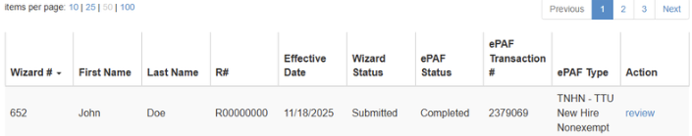
Figure 32. Snippet of the table on the Search page. Originators may refine the data displayed by selecting the table headers.

Glossary of ePAF terms
Address and Telephone Selection: Allows the originator to see if a work address and work telephone number have already been assigned to the employee.

Annual Salary:
- Nonexempt: Hourly rate multiplied by 2080 multiplied by FTE
- Exempt (12 mo.): Monthly rate multiplied by 12
- Exempt (9 mo.): Monthly rate multiplied by 9 -or- Semester rate multiplied by 2

Approved:
Transaction status of an ePAF that is pending upload to the Banner system. The ePAF has been through all approvals and this is the last level before changes are made to the employee’s record.

Benefit Category Code:
Code used by Banner defining what type of benefits an employee is eligible to have. This code also drives the deduction codes the employee will be assigned.

Cancelled:
Transaction status of an ePAF that has been removed from the routing queue and will not be resubmitted.

Comments:
The section of the ePAF that shows approver’s comments (if any).

Completed:
Transaction status of an ePAF that has been uploaded to the Banner system. Changes to the employee’s job record have been done and should be visible on the HR 121 Current and Future report the day after the ePAF has been completed.

Current Hire Date:
Date in which the employee will begin working at the University. This date will default from the Start Date in ePAF transactions.

Default Earnings:
Code used in Banner to allow the position to run through the payroll process and pay a specific earning to the employee. Most common earnings codes:
- HLD for longevity eligible staff
- HLN for nonexempt employees who are not eligible for longevity
- RGS for exempt employees who earn a consistent monthly salary

Disapprove:
Transaction status of an ePAF that has been disapproved by approver.

Distribution COA:
A field in the ePAF transaction that will have the same information as the Home COAS.

Distribution Orgn:
A field in the ePAF transaction that will have the same information as the Home Organization.

Electronic Personnel Action Form (ePAF):
A system delivered from our vendor that allows departments to communicate employee appointments to the payroll system for payment of wages.

Employee Class Code:
Code used by Banner defining an employee’s whole employment as exempt, nonexempt, what benefits the employee is eligible for, what leave the employee is eligible for, and full time or part time status.

Encumbrance:
Amount of funds held to pay for an employee for the duration of the appointed job.

Encumbrance Begin Date:
Date in which the ePAF originator intends for funds to begin to be held to pay for an employee’s appointed job.

Encumbrance End Date:
Date in which the ePAF originator intends for funds to be released from an employee’s appointed job. The employee will either be ending the job on this date or be placed on leave without pay as of this date.

End Job ePAFs:
End the appointment of an employee. The appointment can either be a primary or secondary job.

ePAF Wizard:
A guided form that walks the originator through a series of questions and collects the information needed for the appropriate ePAF. Once submitted, the Wizard sends that information into Banner, where the actual ePAF is created and processed.

Exempt Employees:
Are exempt from the overtime recordkeeping standards of the Fair Labor Standards Act. These employees must meet certain criteria to be considered exempt under FLSA guidance.

Factor:
The number of pay periods per year for the position.
- Nonexempt: 24
- Exempt (12 mo.): 12
- Exempt (9 mo.): 9

Fair Labor Standards Act (FLSA):
The Federal Fair Labor Standards Act (FLSA) establishes minimum wage, overtime pay, recordkeeping, and youth employment standards affecting employees in the private sector and in Federal, State, and local governments.

FT/PT Status:
Code used by Banner to define the full time or part time status of an employee. If the overall FTE is 100%, the employee is considered full time. Anything below 100% is considered part time. Other is defined as non-compensated or a retiree.

Full Time Equivalent (FTE):
Employee’s workload. Average working hours in a week divided by 40.

Home COAS:
The chart of account in which the employee will be assigned. Most likely will depend on the home organization assigned.

Home Organization:
The organization who will carry the primary appointment for an employee.

Hourly Rate:
Rate of pay per hour for nonexempt employees. Calculations = Annual Salary divided by 2080 divided by FTE.

Hours per Day:
The average number of hours the employee will work each day. For all employee types: 8 multiplied by FTE.

Hours per Pay:
The average number of hours the employee will work each pay period.
- Nonexempt: 86.67 multiplied by FTE
- Exempt (9 or 12 mo.): 173.33 multiplied by FTE.

Job Begin Date:
The first day an employee is appointed to a specific Position-Suffix.

Job Change Reason:
Reason code used in the Banner system to quickly define the reason for the new job record added to the person’s job information.

Jobs Effective Date:
The date the change (i.e. add new, change, end) to the appointment takes effect.

Last Paid Date:
Last date of a pay period in which an employee was processed through payroll.

Last Work Date:
The date in which the employee was last at work working in the appointed job.

Leave Category Code:
Code used by Banner defining what type of leave an employee is eligible to accrue and use.

Leave Without Pay (LWOP):
Job status in which an employee is not paid for various reasons.

Location Code:
Building code in which the employee will be stationed most of the time or where their office is located.

Labor Distribution:
Made up of the Fund (F), Organization (O), Account (A), and Program (P) or FOAP. These fields identify where the funding for payment will be taken from.

Modifying Job ePAFs:
Are used to change pay, FTE, or funding source.

New ePAF Job Selection:
The originator will choose the position number and suffix combination that will be assigned, modified or ended.

New Position Request Form:
The electronic form used to request a new position for a department organization.

Non exempt Employees:
Are subject to overtime pay when that employee works over 40 hours during the work week. Overtime pay is calculated at time-and-a-half for all hours actually worked in excess of 40 hours during one work week.

Partial:
Transaction status of an ePAF in which the job has been ended, but the employee record section of the ePAF has not been unloaded to the Banner system. This is most common on Termination ePAFs but can happen anytime information is changing on the employee record.

Pay Plan:
Texas Tech University’s list of established position titles we share with the Texas Tech University Health Sciences Center as well as the HSC El Paso Entity.

Pays:
The number of paychecks per year for the position.
- Nonexempt: 24
- Exempt (12 mo.): 12
- Exempt (9 mo. 9

Pending:
Transaction Status of an ePAF that has been submitted for approvals. The ePAF will remain in pending status until it has been through all assigned approval levels 5 through 95.

Personal Info:
ePAF section in which general personal data about the employee is entered for uploading into the various HR data screens of the Banner system.

Personnel Date:
Either the date the change takes effect or the date it would have taken effect (only in cases when ePAF was submitted after payroll processing).

Position Class Code:
The alpha numeric combination assigned to each position on the pay plan.

Position Number:
The T, S, or W number that is used to assign a position to an organization or department. The alpha part of the position number will be determined by the chart of account in which the position will be funded or paid.
- T = Texas Tech University Funds
- S = Texas Tech University System Funds
- W = Federal Work-Study Funds

Premium Pay Code:
Identifies if the full time employee will receive longevity pay or hazardous duty pay. If neither are applicable, the field should remain blank.

Primary Job ePAFs:
ePAF transactions which establish a primary job for an employee.

Returned:
Transaction status of an ePAF that has been returned to the originator for correction, reconsideration, and should be resubmitted after changes to the ePAF have been made.

Routing Queue:
The section of the ePAF where the originator will assign approvers for the ePAF transaction.

Secondary Job ePAFs:
Adds an additional position number to a person with a primary position already assigned. Secondary jobs can be from the same organization or with a different organization, but the total FTE for one individual cannot exceed 1.0 for faculty and staff positions or 0.5 for student positions.

Special Rate:
Field in the Default Earnings section that designates the monthly amount paid to the employee. This is blank for earnings codes of RGS, HLN, and HLD.

Supervisor R Number:
R Number of the person who will be the supervisor of the employee.

Termination:
Ending an employee’s job as well as severing the employee/employer relationship.

Termination Reason Code:
A code used in the Banner system to describe why the employee is terminating from position appointment.

Time Entry Method:
The information used to communicate how the employee will report time worked.

Employee Time Entry via Web:
Used for employees who will enter time in Web Time Entry on Raiderlink

Third Party with Approvals:
Used for employees who will enter time in Time Clock Plus

Timesheet Organization or Timesheet Orgn:
The Organizational code in which the timesheet or leave from for the employee will be housed, routed, and approved.

Voided:
Transaction Status of an ePAF that has been returned for correction but will not or cannot be resubmitted. This may be necessary if the originator must start a new one to enter changes.

Wizard Status In Progress:
Transaction status for a saved transaction that has not been submitted or re-submitted by the ePAF originator.

Wizard Status Submitted:
Wizard Transaction was submitted by Originator.

Work Address:
Will be the mail stop number used by the university. Format should be MSXXXX (no spaces).

Appendices

New Hire Step by Step Guide

Step 1: Locate the ePAF Wizard
- Begin by navigating to the ePAF Wizard.

Figure 33. ePAF Wizard landing page with Originator Information and R number prompt.

Step 2: Search Banner for an Existing Record
- Before creating a New Hire, search Banner to confirm the individual does not already have an R Number or active/inactive record. **Searching by SSN is recommended.
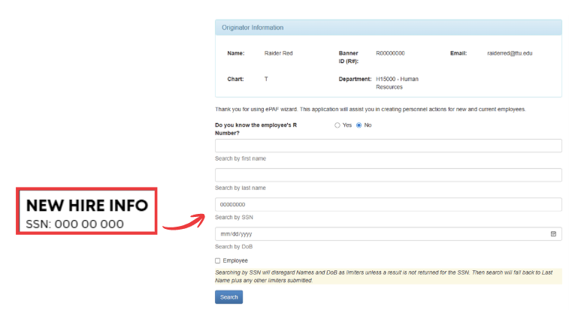
Figure 34. ePAF Wizard search screen for a new hire when the employee’s R number is unknown.

Step 3: Review Search Results
- If a matching record appears, review the details carefully and select Select Match.
- If no record appears, click Generate New to create a new profile. Then select Select Match.
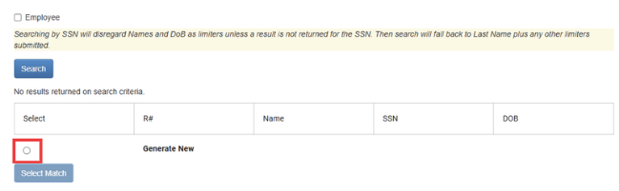
Figure 35. Selecting Generate New when no employee records are returned.

Step 4: Enter Position Details
- Input the Position Number and Position Suffix provided by your department.
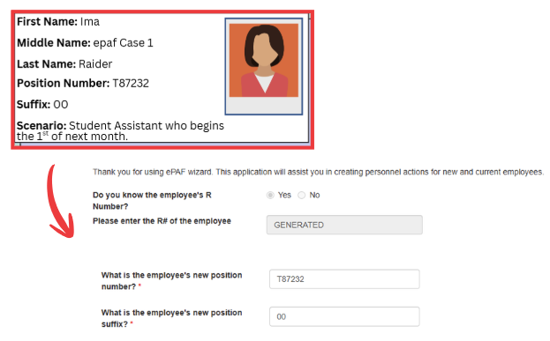
Figure 36. Using the mock new hire profile to enter position and employee information into the ePAF Wizard.

Step 5: Enter New Hire Personal Information
- Complete all required personal information fields.
- If the New Hire has veteran-related documentation, enter those details; otherwise, leave those fields blank.
- Enter the Effective Date (the individual’s first day of employment).
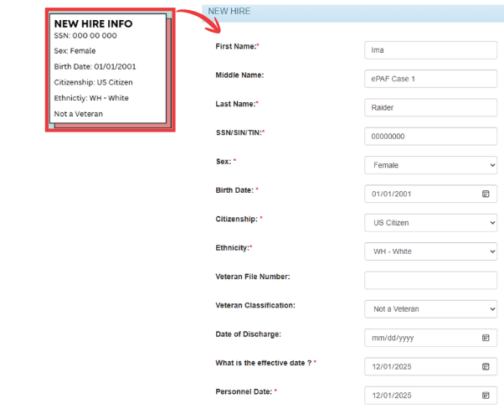
Figure 37. Mock new hire profile information used to complete required demographic fields in the ePAF Wizard.

Step 6: Enter Compensation Information
- Enter the hourly rate.
- The Employee Class Code will auto-generate from the inserted Position Number.
- Enter the FTE. This will populate the Leave Category and Benefits Category, Hours per Pay/Day automatically.
- If applicable, enter the Premium Pay Code. Note: Part-time students do not qualify for Longevity or Hazard Pay, so this field will remain blank.
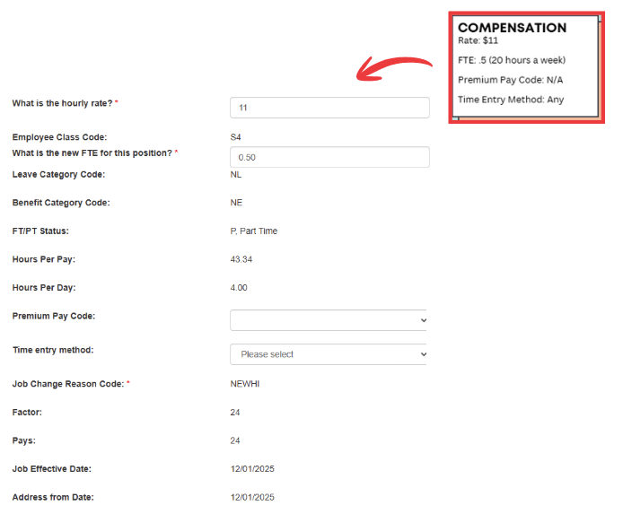
Figure 38. Mock compensation scenario used to complete required pay and FTE fields in the ePAF Wizard.

Step 7: Enter Mailing Address Information
- Enter your area’s TTU Mail Stop in the format: MSxxxx
- Enter City and State.
- Tab to County, begin typing Lubbock, and select the code when it appears.
- Enter the Postal/ZIP Code.
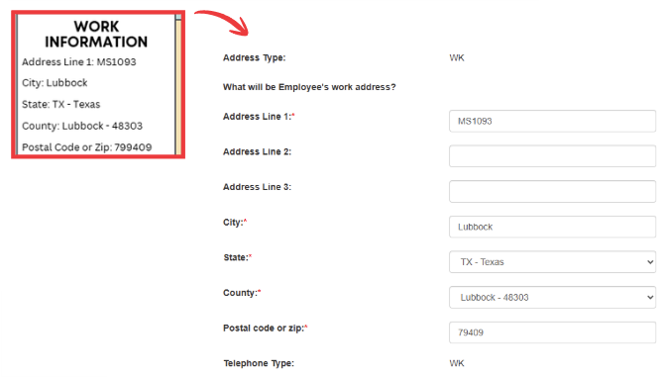
Figure 39. Mock work information used to complete required work address fields in the ePAF Wizard.

Step 8: Enter Job and Organization Details
- Enter the Area Code and phone number for the New Hire (often the department’s main phone line). Home COAS will auto-populate.
- Enter the Home Org. Distribution COAS and Distribution Orgn will populate automatically.
- Search for and select the appropriate Location. Timesheet COAS will generate automatically. Enter the Timesheet Org (this should match the Home Org).
- Enter the Supervisor’s R-Number using the following format: Rxxxxxxxx. The supervisor’s name will display automatically once entered correctly.
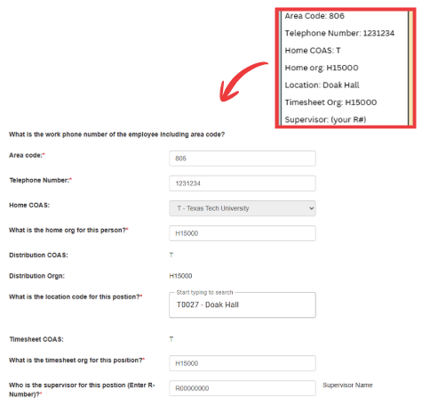
Figure 40. Mock contact and organizational details used to complete required phone, COAS, location, and supervisor fields in the ePAF Wizard

Step 9: Review the Default Earning Table
- The Default Earnings Table will generate automatically based on the information entered in previous steps.
- Review the table for accuracy.
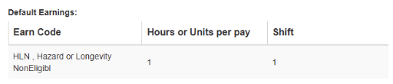
Figure 41. Default Earnings table showing earn code HLN with hours per pay and shift values.

Step 10: Review and Edit Labor Distribution
- The Labor Distribution section will populate automatically based on the Position Number you entered.
- If funding needs to be edited, select the generated source and click Edit.
- To add additional funding sources, select Add Row.
- Ensure the total distribution equals 100%, regardless of how many funding lines are included.
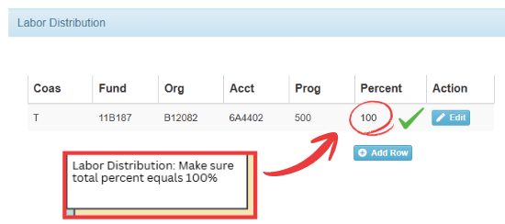
Figure 42. Labor Distribution example with percent allocation totaling 100%.

Step 11: Wizard Comments
- Use the Comments field to provide any clarifying information for approvers, including unique scenarios, explanations, or instructions that may support the approval process.
- If an ePAF is returned with comments, those comments will also appear above under Comments.
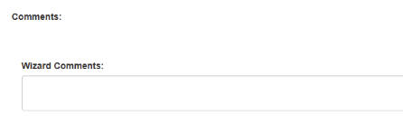
Figure 43. Wizard Comments section for entering additional notes.

Step 12: Select Approvers
- Use the dropdown menu to select your department-level approver. The following approver levels will auto-generate for you:
  - Compensation TTU
  - Budget TTU
  - HR TTU Approval
  - HR TTU Apply Upload
- If additional approvers are needed, Select Add Row. Choose the appropriate Approver Level (e.g., 5 – FYI Only TTU). Select the User Name from the dropdown list. Use the action dropdown to indicate whether the approver should Approve or receive an FYI.
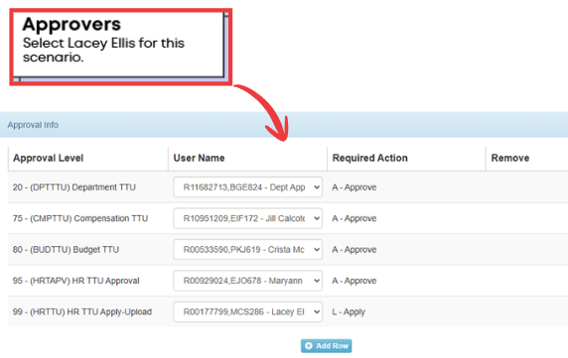
Figure 44. Approval Info section showing assigned approvers and required actions for the mock scenario.

Step 13: Save/ Submit
- Once all fields have been completed, select Save. A confirmation message will appear in the bottom-left corner of the screen indicating the transaction was saved successfully.
- If you need to add attachments:
  - Select Attachments.
  - A pop-up window will appear. Click Choose File and select the file you wish to attach.
  - The file will display in the pop-up window once uploaded.
  - To preview, select Display Document.
- When finished, click Close to exit the attachment window.
- You may save the transaction again to ensure all updates are captured.
- When you are ready to proceed, select Submit. A confirmation message will appear in the lower-right corner of your screen indicating that the ePAF Wizard transaction was successfully submitted to Banner.
- At the top of the transaction, if successfully submitted to Banner, an ePAF Transaction Number will be assigned to your submission.
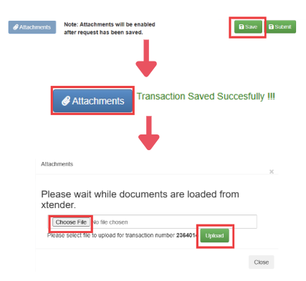
Figure 45. After saving the transaction, accessing the Attachments section to upload supporting documents.
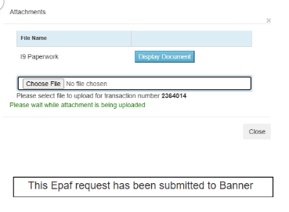
Figure 46. After uploading attachments, close the Attachments window, save the transaction, and then select Submit.

Employee Default Earnings Guide

Earnings Code Reference
Earnings Code | Description
RGS | Regular Salaried
HLN | Hazard or Longevity Non-Eligible
HLD | Hazard or Longevity Eligible

Students
Status | Part-Time
Non-Exempt | HLN - 1
Exempt | RGS – Based on FTE

Staff
Status | Part-Time | Full-Time
Non-Exempt | HLN – 1 | HLD – 1
Exempt | RGS – Based on FTE | RGS – 173.33; HLD - 1

Faculty
Status | Part-Time | Full-Time
Exempt | RGS – Based on FTE | RGS – 173.33

Employee Record Job Aid

Exempt Job Titles (Annual Salary – 12 Months)
Description | Employee Class | Factor | LCAT | BCAT
FT Exempt Staff | E1 | 12 | TE | FT
PT Exempt Staff | E4 | 12 | NL, TE | NE, PT, IF
PT 12 Month Faculty | F7 | 12 | NL, TE | NE, PT, IF
FT 12 Month Faculty Vacation Elig | F8 | 12 | TE | FT
Exempt Working TRS Retiree | R2 | 12 | NL | WR
PT Exempt Research Assistant | S8 | 12 | NL | NE, GS, IF

Faculty/TA/GPTI Titles (Annual Salary – 9 Months)
Description | Employee Class | Factor | LCAT | BCAT
FT 9 Month Faculty Non Vacation Elig | F1 | 9 | T9 | FT
PT 9 Month Faculty Non Vacation Elig | F4 | 9 | NL, T9 | NE, PT, IF
PT Exempt TA/GPTI/GRHA | S2 | 9 | NL | NE, GS, IF

Nonexempt Job Titles (Hourly – Paid Semi-Monthly)
Description | Employee Class | Factor | LCAT | BCAT
PT Non Exempt Staff | N0 | 24 | NL, TN | NE, PT, IF
FT Non Exempt Staff | N1 | 24 | NL | FT
FT Non Exempt Non Ben. Elig Temp | N6 | 24 | NL | NE, IF
PT Non Exempt Non Ben. Elig Temp | N7 | 24 | TE | NE, IF
PT Non Exempt Graduate Assistant | S1 | 24 | NL | NE, GS, IF
PT Non Exempt Student | S4 | 24 | NL | NE
PT Non Exempt High School Student | S6 | 24 | NL | NE
Non Exempt Working TRS Retiree | R1 | 24 | NL | WR

Benefits Categories (BCAT)
Code | Description
FT | Full Time Benefits Eligible
PT | Part Time Benefits Eligible
IF | Insurance FT Eligible
GS | Graduate Student Insurance Eligible
NE | Not Benefits Eligible
TR | Temporary Employee, Retirement Only
WR | Working Retiree Insurance Only

Leave Categories (LCAT)
Code | Description
T9 | 9 Month Faculty, Sick – Not Vacation
TE | Leave Eligible Exempt
TN | Leave Eligible Nonexempt
NL | Not Leave Eligible

FTE Guide
FTE Range | Eligibility
FTE = .00 to .49 | NE – Not Benefits Eligible
FTE = .50 to .74 | GS, PT – Grad Student, Part Time
FTE = .75 to .99 | IF – Insurance FT Eligible
FTE = 1 | FT – Full Time Benefits Eligible

Leave Guide
FTE Range | Eligibility
FTE = .00 to .49 | NL – Not Leave Eligible
FTE = .50 to 1 | TE, TN, T9 – Leave Eligible

New Hire Paperwork Checklist

Required for All New Hires
- Form I-9 – Verify employment eligibility
- W-4 (Federal tax form)
- Direct Deposit Form
- Employee Acknowledgement Form
- Drug-Free Workplace Policy
- Veterans’ Self-Identification Form (VVEVRAA)
- TTU Student Records Confidentiality Agreement
Employes hired through Kenexa will complete their forms within the Kenexa platform.

Additional Documents
- Proof of Selective Service (male U.S. citizens 18-25 only)
- I-20 or DS-2019 (international employees only)
- Enrollment Authorization Form (benefits eligible only)
- Benefits Enrollment Information Form
- Direct Deposit Form (international employees only)
- Research Assistant Certification (graduate students, if applicable)

