

TTU HDFS IDEA Graduate Student Handbook
Master of Science and Graduate Certificate Programs
in
Gerontology (M.S. & Certificate)
Early Childhood and Family Policy (Certificate)
Youth Development (M.S. & Certificates)

WWW.HDFS.TTU.EDU

Facebook: https://www.facebook.com/TTUHDFS/
Twitter: @ttuhdfs
Instagram: @techhdfs

Table of Contents
Greetings from the HDFS Chairperson 5
Welcome 6
Purpose of Manual 7
Glossary of Terms 7
Departmental Leadership and Administrative Staff 8
Getting Started 9
Before the Semester Begins 9
Technical Skill Requirements: 10
Working with your TTU/IDEA Campus Coordinator 10
Course Enrollment 10
Faculty Advisor 12
Communication in an Online Program 12
Program Descriptions and Requirements 13
Gerontology 13
General Procedures for the Gerontology Master of Science Degree 13
Suggested Plan of Study for the Gerontology Master of Science Degree 13
Gerontology Final Comprehensive Exam: Portfolio. 13
General Procedures for the Gerontology Graduate Certificate 14
Early Childhood & Family Policy 14
General Procedures for the Early Childhood & Family Policy Graduate Certificate 14
Suggested Plan of Study for the Early Childhood & Family Policy Graduate Certificate 14
Youth Development 15
General Procedures for the Youth Development Master of Science Degree 15
Suggested Plan of Study for the Youth Development Master of Science Degree 15
YD Final Comprehensive Exam: Portfolio. 15
General Procedures for the Youth Development Graduate Certificates 16
Graduate Student Responsibilities & Policies 17
Satisfactory Academic Progress 17
Grades 18
Grade Replacement Policy 18
Switching degree options 19
Preparing for Graduation 20
Participating in Commencement 20
Leave of Absence 20
English Proficiency 20
Academic Misconduct 20
Academic Integrity 21
Generative Artificial Intelligence Usage 21
Policy on Appealing a Dismissal 21
Student Grievance Procedures 22
Resources 22
Physical or Learning Accommodations 22
E-mail 22
E-Mail Etiquette 23
Software for Assignments 23
Learning Management Systems 23
Library Access 24
Finances 25
Financial Aid 25
Tuition and Billing 25
Course Drops/Withdrawals and Tuition Refunds 25
Appendices 26
Appendix A: Additional Resources 27
Appendix B: Gerontology 28
Appendix B.1: Master of Science in Human Development and Family Sciences, Gerontology Concentration 28
Appendix B.2: Graduate Certificate in Human Development and Family Sciences, Gerontology Concentration 29
Appendix C: Graduate Certificate in Human Development and Family Sciences, Early Childhood & Family Policy Concentration 30
Appendix D: Youth Development 31
Appendix D.1: Master of Science in Human Development and Family Sciences, Youth Development Concentration 31
Appendix D.2: YD Master’s Non-Thesis: Portfolio General Procedures 31
Portfolio Format 32
Portfolio Assessment 33
Faculty Committee Members' Role with the Portfolio 33
YD Advisor Role with the Portfolio 33
Basic Written and Oral Portfolio Format: 33
Appendix D.3: Youth Program Management & Evaluation Graduate Certificate 35
Appendix D.4: Youth Development Specialist Graduate Certificate 35
Appendix E: IDEA Course Login Tracking Sheet 37

Greetings from the HDFS Chairperson

Dear Graduate Students,
On behalf of Texas Tech University and the HDFS faculty, we are excited that you are a student in our department. This handbook is your go-to resource when you have any questions about policy and procedures as a TTU graduate student in Youth Development, Gerontology, and Early Childhood and Family Policy. The handbook is a living document that will be a vital tool for you throughout your graduate program. I encourage you to read the handbook closely and consult regularly throughout your graduate career. When questions arise, you should reach out to our outstanding staff and exceptional program directors.
We look forward to working with you and nurturing your growth as a student. In HDFS, we covet engaged scholarship, innovative research, and community programming which enhances and improves the human condition. You are encouraged to communicate and make connections with your fellow students, the program directors, and the faculty who make up our program. I hope you will utilize all the resources our department, the TTU Graduate School, the university, and IDEA offer. Please remember that while you are not physically on campus, you have access to all the resources TTU offers graduate students, including our writing center, the library, financial aid opportunities, and student disability services.
We are honored to be part of your educational and professional development and look forward to supporting you on this journey. We know that the information and skills you learn in this program will aid you in your professional goals. As our university motto states, “From here, it’s possible” and we cannot wait to see all the important work you do!

Sincerely,
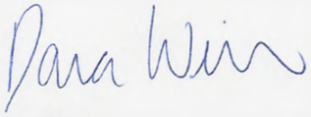
Dana Weiser, Ph.D.
Chairperson and Professor, Human Development and Family Sciences
Texas Tech University

Welcome
Texas Tech University, Human Development and Family Sciences &
The Innovative Digital Education Alliance
You have been admitted to a unique online program! These programs are part of a multi-state, multi-institution consortium offering fully online graduate programs in the human sciences. The Innovative Digital Education Alliance, or IDEA, offers degrees in Health & Human Sciences and Agriculture and Natural Resources. Each program is supervised by the Board of Directors of the Alliance and each member institution has a representative on the Board.
Programs are facilitated and supported by eleven public research universities, each of which brings unique strengths to the academic programs. Several universities share knowledge through a body of faculty with expertise in all disciplines that are offered. This inter-institutional consortium allows each campus to contribute course offerings to the degree, while allowing students to learn from the best scholars in the field without applying to several different universities.
The Innovative Digital Education Alliance (IDEA) was founded in 1994 capitalizing on the institutional resources of 11 major research universities to sponsor graduate education programs through distributed learning technologies. The Alliance offers fully-online graduate coursework and program options in high-demand professional fields. Academic programs are the core of the Alliance. Each member institution awards academic credit and degrees for programs in which they participate. Curricula are developed by inter- institutional faculty teams. Every program meets the requirements of these accredited institutions of higher learning.
You have been admitted to and are considered a graduate student at Texas Tech University (TTU), with the same rights, privileges and responsibilities as students who take classes on campus. Students have access to TTU resources including the library, graduating writing center, and so many more! Students’ academic home is in the department of Human Development and Family Sciences in the College of Health & Human Sciences. Upon completion of the program of study, the Master of Science degree or Graduate Certificate will be conferred from Texas Tech University, with a major in Human Development and Family Sciences (HDFS) with a concentration in the selected program. Students should be mindful of university deadlines and forms to apply for graduation for degrees and certificates to be awarded. As a graduate student, it is your responsibility to be familiar with the information in this handbook and with the applicable rules, regulations and procedures it contains. We hope this handbook will assist you in completing your program by providing a guide for your enrollment and program progress.
IDEA programs are 100% online, allowing students to work toward the degree while allowing students the flexibility to maintain students’ busy life. The courses in each program are asynchronous, so students can learn on their own time. Courses may use a 16-week semester or an 8-week term, depending on the program.
Students pay the IDEA common price per credit hour for graduate courses or undergraduate courses at all universities, regardless of degree program or course, or whether in-state or out-of-state.
All IDEA member universities are accredited by regional agencies approved by the U.S. Department of Education to evaluate academic institutions in specific states.

For additional information on the IDEA program, visit: http://www.idea.edu/

Purpose of Manual
This manual is intended to assist students with completing a variety of important tasks throughout the program and to help students succeed as effectively and efficiently as possible. Students should carefully read through this manual at the beginning of the program and talk with their advisor about any questions they may have. Please consult this manual often throughout the program; it will be a vital source of help to students.
This manual is not meant to displace or in any way void the TTU Graduate School (https://www.depts.ttu.edu/opmanual/) or IDEA policies (https://www.idea.edu/student-handbook).

Glossary of Terms
Because of the unique nature of these programs, the following terms will be helpful to understand as you read through this document and as you move through your chosen degree program.

Home Institution –The institution that you applied to and were admitted to for the program you are pursuing and from which you will receive your degree or certificate. Your home institution is Texas Tech University.

Teaching Institution – The institution that is teaching the class in a particular semester. You are typically a guest student or visiting scholar at this institution.

Learning Management System – The online software program used for access to course materials at a university. These sites are available 24 hours a day, 7 days a week. Examples of what you would find there could include: class e-mails, documents posted here for access 24 hours a day, 7 days a week, discussion boards and announcements. The course management system used for Texas Tech courses is Canvas, found at: https://texastech.instructure.com/. Other institutions may use Blackboard, Desire 2 Learn, or another online management system. See https://www.idea.edu/learning-management-systems-lms for a list of each institution’s course/learning management system. It is your responsibility to learn how to use each management system from each institution in which you enroll for coursework (there is a helpful tracking sheet at the end of this document). It is a good idea for new students to set up their computer login IDs as soon as possible and access the Learning Management System before the course begins. Most have tutorials or demos to familiarize you with the layout.

Campus Coordinator – Person at your home institution who coordinates your registration with the teaching institution. There is a campus coordinator at each institution.

Wait List – The process used for enrolling students into courses when a course reaches capacity before the first day of class AND after the enrollment information exchange date. The wait list is used after the enrollment information exchange date as a way to ensure students from all institutions receive equal, first-come, first-serve chance at enrollment.

Important TTU Websites:
- eRaider: https://eraider.ttu.edu
- Raiderlink: https://raiderlink.ttu.edu
- Canvas LMS: https://www.depts.ttu.edu/lms/ or https://texastech.instructure.com/
- Microsoft Office (email access, Word, Excel, etc.): www.office.com

Departmental Leadership and Administrative Staff

Program Director for Early Childhood and Family Policy
Stephanie Shine, Ph.D.
Associate Professor of Practice
stephanie.shine@ttu.edu | 806-834-4664

Program Director for Gerontology
Page Heisser, Ph.D., LMFT
Lecturer
page.heisser@ttu.edu

Program Director for Youth Development & Assistant Graduate Program Director
Ali Luempert, Ph.D.
Lecturer
ali.j.luempert@ttu.edu | 806-834-5741

HDFS/IDEA Coordinator of Business Operations
Brooke Wells
Coordinator of Business Operations
brooke.wells@ttu.edu | 806-834-1508

TTU/IDEA Campus Coordinator
Ashlee Murden
TTU IDEA Campus Coordinator
ashlee.murden@ttu.edu | 806-834-4140

Department Chair
Dana Weiser, Ph.D.
Chairperson
Dana.Weiser@ttu.edu | 806-834-4912

Getting Started
Admission to the TTU HDFS/IDEA master’s degrees and graduate certificate programs are based on an applicant’s undergraduate grade point average (GPA), the extent to which our programs match the applicant’s academic objectives, and the applicant’s potential for graduate study as reflected by transcripts, and letters of recommendation for all applicants, plus a personal statement and resume/CV for master’s applicants. The GRE is not required for admission to these programs. Admission is not contingent upon having a specific type of undergraduate degree. Youth Development programs admit students every term, Gerontology and Early Childhood & Family Policy (ECFP) admit students for fall and spring terms only. Graduate transfer credits may be accepted on an individual basis after review from the appropriate program director and the graduate program director.

When students are accepted to the MS or certificate-seeking programs they will receive:
- a welcome letter from the Human Development and Family Sciences Department
- a welcome letter from the IDEA Campus Coordinator
- a welcome letter from Texas Tech University Office of Graduate School including:
  - a student ID (R#) from the Graduate School
  - TTU eRaider ID and password from the Graduate School
  - approval to enroll in coursework from the Graduate School

Students will use their eRaider ID and password to set up an e-mail address and login ID, https://eraider.ttu.edu. Your eRaider account is your TTU electronic identification. Your eRaider is a single username and password that is required to access many resources at TTU. Please save this important information to avoid future problems. Texas Tech uses Canvas as the learning management system (LMS). Raiderlink (https://raiderlink.ttu.edu) is used to view your academic records Your eRaider ID is used to login to Canvas and Raiderlink.

*Note: you will NOT register or drop classes yourself in this system, you will contact the IDEA Campus Coordinator for these actions).*

Students will be contacted by the TTU IDEA Campus Coordinator to register for all IDEA courses each semester. If the course is also taught by your home institution, you will access the class through your home institution’s LMS.

If the class is taught at another institution, you will be assigned guest or visiting scholar status at the teaching institution and receive another student number, login ID, and e-mail address through the teaching institution. You will also access the course through the teaching institution. Important links to other institutions are listed later in this handbook.

Please note that courses are listed with different course numbers at different institutions. The course number you enroll in at your home institution will be different from the course number at the teaching institution. Please remember you will have a student number, computer login and password for more than one institution. The TTU/IDEA Campus Coordinator will provide students with a log-in tracking sheet for their use.

Responsible Academic Conduct Training
All TTU Graduate Students are required to complete the Responsible Academic Conduct Training in their first semester. If this is not completed, the Graduate School will place a hold on your account preventing future registration. Once complete, please send the HDFS/IDEA Support staff person a confirmation email with the certificate attached (this can be a screenshot, link, etc.).
The Graduate School will send information and instructions to your TTU email regarding this required training. Please be sure to select the Social and Behavioral Responsible Scholarship Course when making your selection.
- Training Website: https://www.depts.ttu.edu/gradschool/training/responsible-academic-conduct-training.php
- FAQs: https://www.depts.ttu.edu/gradschool/training/responsible-academic-conduct-training-faq.php
You must access the training through the link above, and you should ensure that you are affiliated with Texas Tech University Graduate School before completing the courses otherwise we may not receive your results which could result in you receiving a registration hold.

Before the Semester Begins
Prior to the beginning of each semester (about two weeks) students will receive a course information sheet for the course(s) in which they are enrolled. The course information sheet will include:
- Course information including teaching university, course name/number, and credit hours.
- Course start and end date, these vary by teaching institution

Instructor information, textbooks, and other required materials for courses can be found on the IDEA website. Most students choose to purchase texts from non-university vendors (Amazon, Barnes & Noble, half.com, etc.); however, be attentive to the edition of the textbook being used when ordering. Any course taught at TTU will also have the book listed through our university bookstore.

Many professors only use online resources such as academic journals though Google Scholar or the library collection at the teaching institution, as well as other databases. Professors try to be considerate of cost, whenever possible.

Technical Requirements:
- Internet Access (preferably high speed), E-mail, Audio and Video Capabilities
- Microsoft Office (as a TTU student you can download Office 365 for free with your eRaider: https://www.depts.ttu.edu/ithelpcentral/solutions/o365/, this will give you access to Word, Excel, Outlook, PowerPoint, Skype, and Microsoft Teams).
- Adobe Reader (download for free from http://get.adobe.com)
Faculty may also ask you to use additional software systems, but these are the base technical requirements for the program.

Technical Skill Requirements:
- Be comfortable with the following:
  - Using a word processor
  - Using email for communication, attaching documents in email
  - Internet search engines and browsers
  - Downloading plug-ins, if needed

Working with your TTU/IDEA Campus Coordinator
The TTU IDEA Campus Coordinator will enroll you in all IDEA courses (regardless of teaching institution) for each semester. If you have any questions or concerns about enrolling or registering, you should contact the Campus Coordinator. Course Schedules will be sent with a priority deadline in which you should submit your registration request(s). Please be aware that you are not guaranteed a spot in the class at the teaching institution. Your Campus Coordinator will ensure you are successfully registered for your courses as soon as requests are sent and pending availability. The Campus Coordinator’s role is to:
- Help students navigate through a distance education program.
- Inform students of upcoming course schedules to assist them in completing their degree program.
- Keep on file the student acknowledgement form allowing the university to share student information with the other idea institutions.
- Inform students when it is time to register for courses according to the IDEA calendar.
- Assist students with referrals to technical help desks; answer basic questions.
- Enter student admissions and enrollment data into the IDEA database.
- Process all drop and withdrawal request(s) and manually adjust tuition as needed.
Note: To drop a course, this must be requested through the TTU/IDEA Campus Coordinator and the student is not to contact TTU Student Business Services (SBS) directly as their tuition is adjusted manually with a request only the Campus Coordinator can submit.

Course Enrollment
To view course offerings, please visit the IDEA web site at http://www.idea.edu/. Course schedules are posted for upcoming semesters and details on each course (including start dates, instructor information, and textbook information). Your advisor can help you determine which courses would be appropriate for you to take, and at what time in your program you should take them. It is the student’s responsibility to check the IDEA course planner (https://www.idea.edu/course-planner) to determine course availability for any given semester.
Following admission to the program, students are assigned to Faculty Advisors, who are also the Program Directors at TTU, in their concentration areas. Students are responsible for contacting their advisors prior to the beginning of the first semester and during pre-registration periods each semester thereafter for advice on classes in which to enroll and necessary permissions to register.
Students must register for courses during the assigned registration period. The Graduate Program Coordinator will notify students of the specific dates each semester and deadlines are included in the calendar provided to graduate students. Your TTU IDEA Campus Coordinator will contact you at the beginning of each semester with course offerings open for enrollment. If needed, contact your Program Director for advising needs. Once you have confirmed which course you would like to take, email your IDEA Campus Coordinator with your selection to secure course enrollment. Your IDEA Campus Coordinator will contact you with confirmation once you have been enrolled. Typically, the dates fall:
- Fall semester: by mid-April
- Spring semester: by mid-November
- Summer semesters 1 and 2: by mid-April

Start and end dates vary across all participating IDEA institutions as each follows their individual university’s calendar which may differ from your home institution.
- Youth Development (YD)
  - The YD program offers all required core classes in the Spring and Fall semesters, with elective courses typically offered throughout the academic year and in the Summer semester.
  - The YD master’s program is designed so that students can finish the MS degree in as little as two years, or slower, depending on the student’s preferred pace.
- Gerontology
  - The Gerontology program has five blocks from which students can select courses.
  - Courses are offered in an 8-week format, primarily during Spring and Fall semesters with some being offered in the Summer semesters.
- Early Childhood & Family Policy (ECFP)
  - The ECFP program has a sequence of 8-week courses offered in the fall and spring semesters (no summer courses available).
  - ECFP students will take two 3-credit hour courses in the fall and two in the spring semesters for their graduate certificate.
Your TTU IDEA Campus Coordinator will contact you at the beginning of each semester with course offerings open for enrollment. If needed, contact your Program Director for advising needs. Once you have confirmed which course you would like to take, email your IDEA Campus Coordinator with your selection to secure course enrollment. Your IDEA Campus Coordinator will contact you with confirmation once you have been enrolled.
Timely enrollment in courses is required so that if a student receives financial aid or an assistantship, all required paperwork can be completed by HDFS staff prior to university mandated deadlines. If students are not enrolled prior to these deadlines and HDFS staff are therefore unable to complete required paperwork prior to university deadlines, the student will be responsible for all outstanding financial balances. Timely enrollment is also important to ensure that there are spaces available in the courses you need to complete your degree.
You may always confirm your course enrollment by logging in through the Raiderlink portal, under the MyTech tab, and selecting Registration.
Students should be registered for the number of hours that reflects the extent of their involvement in the graduate program. This applies to capstone/portfolio courses as well as formally structured classes. The minimum enrollment to be considered full-time graduate status is 9 credit hours in the regular semester. Full-time graduate enrollment in a summer term is from 3 to 6 hours.

Faculty Advisor
At TTU your faculty advisor is also the Program Director. The faculty advisor’s responsibilities include:
- helping students navigate program and university policies, procedures, and requirements
- assisting with departmental and university paperwork
- meeting regularly with academic advisors and issuing annual progress letters
Your advisor is responsible for assisting with your plan of study and all documents and steps related to completion of your graduate program. Your advisor is also the person who should be consulted about course enrollment each semester.
Faculty are responsible for understanding the information in this handbook, including deadlines, forms, processes, etc., as well as the information provided in the department’s webpage and the information provided by the TTU Graduate School. Faculty should be knowledgeable enough to provide this information to advisees, graduate assistants, and students in general and keep them “on track” in terms of meeting requirements and deadlines. Faculty must retain a copy of all forms turned into the department and/or Graduate School.

Communication in an Online Program
Each student is given a TTU email address and this is the official means of communication. Students are required to check their TTU email account (@ttu.edu) regularly and should use their official email address to contact faculty and staff. In addition, students are responsible for maintaining contact with their TTU advisor at least once a semester. In this contact, the student and advisor will review the student’s progress toward degree and determine what courses or other activities should be done next.
While taking a course, students are responsible for keeping up with the assignments of the course according to the deadlines set in the syllabus. Students must contact the instructor of the course if they have any questions or concerns about their learning in the course. Courses can and will be administered through other institutions in the alliance, and it is the student’s responsibility to use the official forms of communications the instructor outlines.

Program Descriptions and Requirements
The objective of the Human Development and Family Sciences graduate programs are to provide substantive knowledge in the development of individual, family, and interpersonal processes, and their applications across the lifespan. Core courses introduce students to theory and research in the field. Our goal is to foster intellectual development, stimulate meaningful research, and develop skills that will facilitate the pursuit of the student’s professional goals.
The Department is committed to the principle that in no aspect of its programs shall there be any discrimination based on race, creed, national origin, sexual orientation, age, gender, or disability, and that equal opportunity and access to facilities shall be available to all individuals.

Gerontology
Gerontology is an emerging field with job opportunities in areas related to health promotion, education, research, inter-generational activities, senior centers, and retirement communities. Growth of the aging population will result in an increased demand for professionals with knowledge and expertise in aging. A Graduate Certificate in Gerontology is also available, with 15 credits of coursework required.

General Procedures for the Gerontology Master of Science Degree
Students are responsible for meeting all departmental and TTU Graduate School Deadlines. Please review the information on this website thoroughly and discuss with your advisor for further guidance.
Please note that you, as well as your faculty advisor, need to retain copies of all forms submitted to the HDFS office or the Graduate School.
Students should complete all credit hours toward their master’s degree, complete the final portfolio, and present the portfolio to an academic committee made up of the Program Director and two HDFS faculty at the home institution.

Suggested Plan of Study for the Gerontology Master of Science Degree
Students accepted into the master's program must complete 18 hours of required core courses and 12 hours of electives. The courses may generally be taken in any order. Foundations in Integrative Aging Studies is an introduction course and should be taken the first or second semester. Hours listed under Block 5 should be taken near the end of the program.

Gerontology Final Comprehensive Exam: Portfolio.
Master’s students are required to complete a Portfolio. The Portfolio course (3 credit hours) is taken in the semester of graduation. The student and the advisor will work together to decide on a basis of papers (3-5) to be included in the final portfolio. Students are considered non-thesis; they will follow the deadlines for master’s non-thesis reports on portfolio on the academic calendar.
Because the Portfolio is a terminal project for the master's degree, it should have a form and format akin to the master's thesis. Like the thesis, it should have the following features:
- It should have a title page that includes the title, the author's name, the formula specifying the degree that is being earned, the names of the committee chair and the committee members, and the date (month and year).
- Following the title page, there can be a page of acknowledgements.
- There should be a table of contents indicating the work's primary divisions.
- The work should be divided into chapters (e.g., the reflection essay might be a chapter, and each paper or project might be a chapter).
Additionally, the master’s portfolio should include the student’s resume or curricula vitae as an appendix.
The IDEA-Gerontology advisor will provide a sample document to students with formatting guidance. Students should follow the most recent APA style guide.
Portfolio Assessment. Your portfolio project in combination with your oral portfolio presentation will be assessed based on student learning outcomes (SLOs) established by IDEA Gerontology . The SLOs will be measured on a 4-point scale of “Does not meet acceptable standard” to “Meets the standard of excellence.” The student learning outcomes for assessment are:
- Demonstrate a basic understanding of at least four specific areas, including physical activity, family studies/social, cognition, environment, and/or research.
- Apply research findings and skills to solve problems related to older adults and their families.
- Demonstrate appropriate attitudes and professional conduct in solving problems related to older adults and their families.
- Synthesize critical issues related to aging from a multidisciplinary perspective.
Students will receive one the following determinations of their portfolio:
- Yes, student meets or exceeds expected level of competency for IDEA Gerontology Portfolio project
- Conditional, student generally meets expected level of competency for IDEA Gerontology Portfolio project, however revisions are required to be reviewed and approved by the Gerontology Program Director
- No, student does not meet expected level of competency for IDEA Gerontology Portfolio project
  - If the initial portfolio project receives a “No” determination, the student will be allowed a second attempt. If the second attempt does not meet the expected level of competency, the student will be dismissed from the program.
After completing the master’s oral defense, students are responsible for addressing all feedback provided by the committee under their advisor’s guidance, finalizing the portfolio, and submitting it to their advisor before the required deadline.

General Procedures for the Gerontology Graduate Certificate
Students seeking a certificate in Gerontology must complete 6 hours of core courses and 9 hours of electives, for a total of 15 post-baccalaureate credit hours.

Early Childhood & Family Policy
Society and its policymakers are becoming more and more focused on the importance of the early years and the need for quality services that are distributed equitably and sustainably over time. This graduate certificate places individuals at the helm of framing a new era for early childhood policy.

General Procedures for the Early Childhood & Family Policy Graduate Certificate
Students are responsible for meeting all departmental and TTU Graduate School Deadlines. Please review the information on this website thoroughly and discuss with your advisor for further guidance.

Suggested Plan of Study for the Early Childhood & Family Policy Graduate Certificate
ECFP students will take two 3-hour courses in the fall and two in the spring semesters for their grad certificate.

Youth Development
Youth Development is an emerging professional field. It has a positive orientation, meaning its focus is on promoting the positive development of youth, and it is an applied field, with professionals who put developmental research and theory into practice in structuring and implementing programs and services for adolescents. The master’s degree in youth development requires a 36-credit hour post-baccalaureate program of study. Graduate certificates are also available in Youth Development and Youth Program Management and Evaluation.

General Procedures for the Youth Development Master of Science Degree
Students are responsible for meeting all departmental and TTU Graduate School Deadlines. Please review the information on this website thoroughly and discuss with your advisor for further guidance.
Please note that you, as well as your faculty advisor, need to retain copies of all forms submitted to the HDFS office or the Graduate School.

Suggested Plan of Study for the Youth Development Master of Science Degree
Foundations of Youth Development must be taken in the first semester. Remaining Block 1 courses should be taken within the first one to two semesters. The courses in the remaining blocks can be taken in any order, including the elective. The Portfolio 1 hours should be taken approximately half way through the program, with Portfolio 2 taken in the semester of graduation.

YD Final Comprehensive Exam: Portfolio.
Master’s students are required to complete a Portfolio. The Portfolio 1 (3 credit hours) is taken approximately half way through the course of study. The student and the advisor will work together to decide on a basis of papers (3-5) to be included in the final portfolio. Portfolio 2 (3 credit hours) must be taken the semester the student is graduating. Students are considered non-thesis; they will follow the deadlines for master’s non-thesis comps on the academic calendar.
Because the Portfolio is a terminal project for the master's degree, it should have a form and format akin to the master's thesis. Like the thesis, it should have the following features:
- It should have a title page that includes the title, the author's name, the formula specifying the degree that is being earned, the names of the committee chair and the committee members, and the date (month and year).
- Following the title page, there can be a page of acknowledgements.
- There should be a table of contents indicating the work's primary divisions.
- The work should be divided into chapters (e.g., the reflection essay might be a chapter, and each paper or project might be a chapter).

Additionally, the master’s portfolio should include the student’s resume or curricula vitae as an appendix.
The IDEA-YD advisor will provide a sample document to students with formatting guidance. Students should follow the most recent APA style guide.
Portfolio Assessment. Your portfolio project in combination with your oral portfolio presentation will be assessed based on student learning outcomes (SLOs) established by IDEA-YD. The SLOs will be measured on a 4-point scale of “Does not meet acceptable standard” to “Meets the standard of excellence.” The student learning outcomes for assessment are:
- Effectively explains the rationale and efficacy of a PYD approach.
- Effectively explains developmental processes and the influence of contexts on youth.
- Demonstrates application of research, theory, and evidence-informed practice for effective youth programming.
- Promotes inclusivity in practice with youth.
- Demonstrates the ability to develop, manage, evaluate, and sustain PYD programs.
Students will receive one the following determinations of their portfolio:
- Yes, student meets or exceeds expected level of competency for IDEA YD Portfolio project
- Conditional, student generally meets expected level of competency for IDEA YD Portfolio project, however revisions are required to be reviewed and approved by the YD Program Director
- No, student does not meet expected level of competency for IDEA YD Portfolio project
  - If the initial portfolio project receives a “No” determination, the student will be allowed a second attempt. If the second attempt does not meet the expected level of competency, the student will be dismissed from the program.
After completing the master’s oral defense, students are responsible for addressing all feedback provided by the committee under their advisor’s guidance, finalizing the portfolio, and submitting it to their advisor before the required deadline.
Additional, information related to the portfolio is in included in Appendix D.2.

General Procedures for the Youth Development Graduate Certificates
Each graduate certificate, Youth Development Specialist and Youth Program Management & Evaluation, requires a 12-credit hour post-baccalaureate program of study.
Foundations of Youth Development must be taken in the first semester. Remaining required courses should be taken within the first one to two semesters. Elective coursework can be taken in any order at the student’s discretion and in accordance with the degree plan.

Graduate Student Responsibilities & Policies
As a graduate student at Texas Tech University, you are responsible for:
- Learning and adhering to the academic rules, procedures and policies of Texas Tech University and those outlined in this IDEA Student Handbook, as well as the handbook for your specific program (Youth Development, Gerontology, and Early Childhood and Family Policy each have their own IDEA handbook which you should also review: https://www.idea.edu/student-handbook).
- Meeting the requirements of Texas Tech University for degree or certificate completion pertaining to your degree program in a timely manner.
- Following scholarly codes of ethics in course work, research, and professional activities.
- Exhibiting high standards of professionalism in program course work.
- Understanding and using the most recent American Psychological Association (APA) Publication Manual for formatting and style.

Because this is an online-only program, you will have to be organized, motivated, and self-directed. You will need to navigate different institutions’ websites, course management systems, and libraries. Ask questions as you have them and take advantage of the various resources we (and the IDEA program) offer.
Graduate students are responsible for making themselves familiar with all information in this handbook, including required coursework, deadlines, forms, processes, the information provided in the department’s webpage https://www.depts.ttu.edu/hs/hdfs/ and the information provided by the TTU Graduate School about deadlines and requirements to complete their degree.
Graduate Students are responsible for knowing and meeting all deadlines and program requirements (including but not limited to scholarship applications, enrolling in courses, etc.) set by the department, college, and university.
Graduate students are required to meet once per semester with their faculty advisor to report progress, ask questions, and inform faculty of any issues they have encountered. Graduate students are responsible for responding in a timely manner to all communications with faculty and staff.
Graduate Students are responsible for making timely progress through their graduate program. Per the TTU Graduate School Catalog, the maximum time allowed to complete a master’s degree is six (6) years. See the “Satisfactory Academic Progress” section below.

Satisfactory Academic Progress
Students are expected to maintain a minimum overall grade point average in their program according to their home institution’s policies and to make adequate yearly progress toward their degree or certificate. Students who require interruptions in their programs are urged to discuss this with their advisors.

Each student must make satisfactory progress in the degree program. As an IDEA graduate student enrolled through TTU, to be considered satisfactory, the student must:
- Maintain a cumulative GPA of 3.0 or greater. In all courses taken for graduate credit, the student should earn a B or above. A grade of C or below is permissible only once and will result in academic probation. Earning a C or below in any subsequent graduate course is grounds for immediate dismissal from the degree program.
- Students who earn a grade of C, D, or F in any required course must retake that course. A second failure to pass the course is grounds for dismissal from the program pending faculty discussion and consideration of extenuating circumstances. Exceptions (e.g. compassion waiver) might apply for students with justifiable extenuating circumstances, in which case, the student must inform their advisor and the program director in advance.
- Maintain continuous enrollment in the degree program and/or communicate official leave requests with his/her advisor and Texas Tech University Graduate School. Any student who does not enroll and/or complete courses in three consecutive semesters may be dismissed from the degree program. Failure to enroll in or complete courses for any semester without notice may result in probation. Official Leaves of Absence may not exceed three consecutive semesters.
- Any grade of Incomplete must be successfully resolved within one academic year of its issuance. If the Incomplete is not resolved, the student will be placed on academic probation. For example, an incomplete for a Fall semester course must be resolved by the end of the Spring semester in order to avoid probation.
Students who earn a grade of C, D, or F in any required core course must retake that course. After a second failure to pass the course, this is grounds for dismissal from the program pending faculty discussion and consideration of extenuating circumstances. Exceptions (e.g. compassion waiver) might apply for students with justifiable extenuating circumstances, in which case, the students must inform their advisor and the graduate program director in advance. Faculty will then vote whether the student may remain in the program and an appropriate remediation plan.

Grades
You will be taking courses from institutions with different grading systems. The teaching institution will provide your grade to your home institution according to the matrix (https://www.idea.edu/student-handbook/grades-academic-integrity). Your home institution will then translate the grade according to the matrix and your home institution’s standards.

At the end of the semester, grades are reported on the transcript at the home institution. At TTU, students can view their final grades by accessing their Raiderlink account: http://raiderlink.ttu.edu. There is no need to request a transcript from the teaching institution. Your home institution (TTU) has to await the submission of grades from the teaching institutions. Grades will be posted within 10 days to 2 weeks after the end of the semester. Upon graduation, students will have a Texas Tech transcript as their official transcript.

Students placed on academic probation or suspension by the Graduate School must follow the Graduate School requirements to proceed in the graduate program. It is the student’s responsibility to provide all required documentation requested by the Graduate School. Being on academic probation may result in the termination of your assistantship. Being suspended will result in the termination of your assistantship. Per the graduate school, students must have a minimum of a 3.0 GPA in order for their degree/certificate to be conferred.

Grade Replacement Policy
Graduate students may retake and replace grades for graduate courses under limited circumstances. Grade replacement will adjust the cumulative grade point average. A notation will indicate the original course that is being replaced. The original grade will remain on the student’s transcript; however, the higher grade will be used in the calculation of a student’s grade point average and earned credit hours. Grade replacement is subject to approval by the Dean of the Graduate School.
Grade replacement is not automatically applied; an electronic grade replacement request form must be submitted no later than the grade replacement deadline for that term. The Graduate School will identify courses eligible for grade replacement in consultation with programs/departments and submit those to the Office of the Registrar for processing at the end of each term.
Grade replacement is limited to a total of three (3) credits for students enrolled in a graduate certificate program, six (6) credits for students enrolled in a master’s program, and nine (9) credits for a student enrolled in doctoral program; in the case of concurrent enrollment, the higher credit limit will apply.
The grade replacement policy only applies to regularly scheduled coursework. Special topics, independent study, seminar, thesis, and dissertation hours are ineligible for grade replacement.
Only grades of C, D, or F are eligible for grade replacement. A specific course may be repeated only once for consideration of grade replacement; the most recent A or B will replace a previous grade of C, D, or F in that course.
Courses taken pass/fail for grade replacement can only replace a grade of fail; they cannot replace a grade for which grade points were awarded (i.e., a D grade) in a course not taken pass/fail.
Once a grade replacement has been approved, the process cannot be reversed or changed.
No grade may be replaced after a graduate certificate or graduate degree has been awarded.
A course in which an academic integrity violation has been officially reported may not be repeated for grade replacement.

Switching degree options
A switch in degree option is not automatically granted and must be approved by the graduate admissions committee and the Graduate School. Current students who wish to terminate their studies within one degree option (i.e., Youth Development or Gerontology, etc.) and instead complete their degree in a different option must submit an application through the Graduate School. There is a fee assessed by the Graduate School for doing so, new letters of recommendation may be required if they are more than a year old, and the student will need to submit a personal statement explaining the reasons for the desired switch.
Likewise, current students wishing to move from a certificate program to a graduate program are required to submit an application for the appropriate program to the Graduate School with required fees, and new letters of recommendation may be required if they are more than a year old, and the student will need to submit a personal statement explaining the reasons for the desired switch. Students switching from an IDEA certificate program to an IDEA Master’s program may submit a request to the HDFS Coordinator of Business Operations for a fee waiver for their application. This fee waiver is not guaranteed but all requests will be reviewed and approved based on funding availability.
The personal statement in these situations of program change must include information addressing the following issues:
- How your interest in this field developed.
- What your professional goals are and how this graduate program will help you accomplish your professional goals.
- The experiences you have had (e.g. informal, academic, employment, volunteer) that you see as related to this graduate program or your professional goals.
Similarly, current TTU graduate students wishing to add an IDEA certificate to their studies will need to complete an application with the Graduate School and required fees, and new letters of recommendation may be required if they are more than a year old.
Before making these decisions and completing applications, students are encouraged to speak with the Program Director in their program of interest first. Fee waivers may be available through the HDFS department. If the student’s application is approved by the HDFS graduate admission committee and the Graduate School, the student will work with the appropriate Program Director to update their plan of study.

Preparing for Graduation
Please review the following website for deadlines and forms required for graduation: http://www.depts.ttu.edu/gradschool. The application for graduation from TTU is found in your Raiderlink account.

Early in the semester that a student plans to complete all of their coursework, they are to file the necessary application for graduation. Students are responsible for knowing, following, and meeting the deadlines and procedures of their home institution when filing for graduation. Students will receive a diploma from their home institution, with no distinct difference noted because of the online format with this degree program. Students are encouraged, but not required, to participate in any commencement activities.

Participating in Commencement
Students are eligible to participate in commencement at the end of the semester in which they complete all coursework and their capstone (practicum, thesis, portfolio, or other project). Students completing theses or papers must schedule their final oral examination by the graduate school deadline in order to participate in commencement. Participating in commencement is not proof of earning a degree. The degree is earned and graduation is posted on the date that the Graduate School grants final approval to the student’s capstone.

Leave of Absence
Please note that a leave of absence from the Graduate Program is only for students who experience extenuating circumstances (e.g., serious illness, hospitalization, extreme family situation). If you wish to pursue a leave, you will need to provide appropriate documentation, notify and receive approval from your Faculty Advisor and the HDFS Graduate Program Director. You may notify the Faculty Advisor via email and/or request a meeting. The Faculty Advisor and HDFS Graduate Program Director will then approve/deny your leave request based on information provided and will send a Leave of Absence request to the Graduate School. Supporting documentation may be requested by the Graduate School. Please note that not all leave requests are granted by the Graduate School; the Graduate School has the final determination. A leave is not to be requested due to not making timely progress in the program, being on academic probation or suspension, or deciding you need a break from your studies.

English Proficiency
All Graduate Students (domestic and international) are required to have English proficiency both orally and in written work. English proficiency is required for successful performance and progress in the HDFS program. International students are required to attend the ELS (English Language Services) Educational Services Language Training in the summer prior to matriculation in the fall semester. If you do not pass the proficiency exam, you will not be awarded an assistantship and you will need to take active and immediate steps to achieve proficiency. Please see information provided by the TTU Graduate School for more information and about options of services available to assist: http://www.depts.ttu.edu/international/ieem/admission/englishProof.php

Academic Misconduct
Graduate students in the Department of Human Development & Family Sciences are expected to maintain a high level of academic achievement in their graduate studies and demonstrate campus-wide civility. As conveyed by the Texas Tech University Code of Conduct, students are expected to act with integrity, respect others, and contribute to a safe, inclusive campus environment. They must avoid academic dishonesty, personal misconduct, and behavior that disrupts university operations or endangers others. Violations may result in disciplinary actions ranging from educational sanctions to expulsion. (https://www.depts.ttu.edu/dos/handbook.php). Thus, all students are expected to hold themselves to high standards of ethical conduct in all phases of their academic work, as well as professional, civil and ethical behavior in general.
Students should understand that actions such as plagiarism or cheating, attempts to do so, or any other violation of academic integrity are unethical and will not be tolerated at TTU. Students may not submit the same paper to fulfill requirements for more than one course. To do so constitutes academic misconduct. This is not meant to deter students from further development of a research or topical area through extension of previous work. Students should consult with the course instructor to be clear on the acceptability of papers that are based on prior coursework or other projects. Students should expect each assignment to reflect their original and independent work. Please note that self-plagiarism is plagiarism and is considered academic misconduct. Students should adhere to all assignment guidelines and rules established by the faculty member.
Academic misconduct may result in a course grade of F for coursework or, in some circumstances, dismissal from the program and suspension or dismissal from the University. Violations of academic integrity may also result in termination of an assistantship. Please review TTU OP 34.12 for TTU complete information on Academic Integrity Procedures: http://www.depts.ttu.edu/opmanual/OP34.12.pdf

Academic Integrity
The IDEA Board of Directors Academic Integrity policy is appended at the end of this handbook (for additional information, please see https://www.idea.edu/student-handbook/grades-academic-integrity). In addition, students should note the following:
- Students will be responsible for assessing the validity and fidelity of online sources. When possible, students should utilize primary academic resources over web sources.
- Although students may find common themes between courses, recycling of materials for assignments is not permitted.

Generative Artificial Intelligence Usage
There is no singular TTU policy regarding AI use. It is your responsibility to be aware of and comply with your instructor’s AI policy for a specific course; each teaching institution and each instructor may have differing policies. Instructors may have various policies and failure to follow a specific instructor’s rules regarding AI is academic misconduct. AI may not be used in the writing of any comprehensive exams (e.g., final portfolio) unless the committee explicitly grants permission. If a student wants to use AI for a thesis or dissertation, they should discuss with their committee chair who will make the decision whether AI use will be permitted. The committee chair will notify the other committee members about any AI approval. Students are to follow APA style guidelines to disclose AI use as appropriate.

Policy on Appealing a Dismissal
Students who have been dismissed from any graduate program may appeal to the Texas Tech University Graduate School after the student has been notified of their dismissal. Additional information on this process can be viewed in the TTU Operation Policy and Procedures https://www.depts.ttu.edu/opmanual/OP64.07.php.

Student Grievance Procedures
Students who have a grievance in a course are to follow the following protocol: first, contact the course instructor in writing and discuss the issues in an open, positive, factual and reflective manner. If the concern needs further resolution, contact the Coordinator of Business Operations who will direct the concern to the next appropriate person, which may be the Program Director or the Department Chair at the home institution or the Department Chair at the teaching institution. If necessary, the Coordinator of Business Operations can assist students in elevating their grievance to the appropriate Dean at the home institution or teaching institution.

Students may also discuss their concerns with their assigned faculty advisor, program director, campus coordinator, or Coordinator of Business Operations. The contact will inform the student of the appropriate procedures in the grievance process.

Graduate students should follow and respect the chain of command for addressing questions, asking for guidance, and resolving issues: your course instructor, then the Coordinator of Business Operations, then your faculty advisor and/or Program Director, and then the Department Chairperson. Direct intervention from the Department Chair may be sought only after the departmental chain of command has been followed and an issue continues to be unresolved. If needed, intervention from the Dean’s office might be requested. Graduate students should not contact other offices (e.g., Graduate School, Human Resources, Office of International Affairs) or administrators (e.g., Office of the Provost, Office of the President) outside the HDFS department before following the chain of command established to resolve issues pertaining to the HDFS department.

Resources
The university offers a wide array of support services to our graduate students. Please visit the Dean of Students’ website (https://www.depts.ttu.edu/dos/) and the Graduate School website (https://www.depts.ttu.edu/gradschool/) to view the various services offered through the university. These university resources include the Student Counseling Center, Student Disability Services, Student Health Services, the Graduate Center, the Graduate Writing Center, support for Title IX complaints, the Raider Red Food Pantry, etc. International students can work with the International Affairs office (https://www.depts.ttu.edu/international/). Please do not hesitate to seek help; all these resources are for graduate students, and it is highly recommended that students utilize any and all university resources that can provide support.
If you have any financial concerns, please contact Financial Aid (https://www.depts.ttu.edu/financialaid/) and/or the IDEA Campus Coordinator.

Physical or Learning Accommodations
All institutions have offices to ensure compliance with ADA guidelines, and student should registrar with their home institution. You must register to receive services. Further, students should inform the instructor of the course of their accommodations.
TTU’s Student Disability Services can be reached at: http://www.depts.ttu.edu/sds/
(806) 742-2405, or email at sds@ttu.edu.

E-mail
E-mail is the official mode of communication in the IDEA programs. Use of electronic mail and network connections at the participating institutions is a privilege and not a right. It is the student’s responsibility to ensure that use of their account does not violate the computer and network use policies of any of the participating institutions. Please review your home institution policies on acceptable uses of technology. TTU email can be accessed through Microsoft Office (email access, Word, Excel, etc.): www.office.com, using your eRaider ID and password.

Each teaching institution has its own e-mail system. Your home institution and teaching institutions will only send e-mail messages using that university’s designated e-mail accounts. If students choose to forward their e-mail to an external e-mail account (e.g., AOL, hotmail, gmail) or change any features of their university e-mail account, it is their responsibility to ensure they are receiving messages.
It is the responsibility of each IDEA student to establish and regularly check their individual university e-mail account(s) at least once per day during an enrolled semester. Students should also check their spam or junk mail folders and whitelist any email address going into these folders from participating universities.

E-Mail Etiquette
It is expected that all messages to other students, IDEA faculty and IDEA Campus Coordinators will be sent from your official TTU email or the appropriate institution you are working with) with a relevant subject line and your full name. Do not send advertising, junk mail, chain letters, mass mailings, and harassing or intimidating messages.

Technology and Software Virus Software
Because of the nature of the program and the extent to which materials are shared between and among students and institutions, students are strongly advised to install anti-virus software on each of the computers they use. It is also advised to keep their anti-virus definitions up-to-date. Any file detected to have been forwarded with a virus is subject to penalties as identified by the course instructor in their syllabus. It is the student’s responsibility to scan all materials to be submitted for course work.

Software for Assignments
Students in the IDEA program are required to use Microsoft Office products (e.g., MS Word and MS PowerPoint) in the production of assignments. Students should not use other forms of word processing software and, unless otherwise directed by an instructor, generally should avoid using online/free services such as Google Docs or Google Slides to produce or submit assignments. Consult your course instructor for any additional requirements.

At TTU, all students are eligible for a free copy of Microsoft Office 365. For more information go to: https://www.depts.ttu.edu/ithelpcentral/solutions/o365/

Problems with technology and internet access happen. However, having technical difficulties, losing documents or missing deadlines due to connection problems, viruses or other malfunctions are not accepted reasons in an online program for missing deadlines. TTU students do have access to Microsoft 365/OneDrive which can be an excellent cloud networking and back-up solution. Plan ahead and backup your work!

Learning Management Systems
Each institution has a learning management system (LMS), which is an online, internet-based repository for course materials. It is often used to communicate with students and with instructors. The sites are available 24 hours per day, 7 days per week. See https://www.idea.edu/learning-management-systems-lms for a list of each institution’s course/learning management system. You are encouraged to use the available “help” options within the learning management system if you have technical questions or problems. At Texas Tech University, we currently use Canvas which can be accessed through https://www.depts.ttu.edu/online/canvas/. Students can also direct questions and concerns about the TTU Canvas system through this website.

Library Access
Students are granted access to library materials according to the teaching institution’s policies and while actively enrolled in coursework.

TTU: Students must be actively enrolled in the current or upcoming semester in TTU courses to be eligible to use all the services through TTU Libraries. To gain access, students must use their eRaider user ID and password when prompted. Please see http://library.ttu.edu. Distance learners at Texas Tech University may request library materials, access databases and electronic journals, search the library catalog, and request research assistance from a librarian. All these resources can be accessed at http://library.ttu.edu.
Students may place articles or book requests at this site, chat with a librarian or connect to the extensive online resource network. Students can view abstracts of articles and books, or full-text articles, in most cases. If you need assistance in your searches of library materials, go to https://guides.library.ttu.edu/hdfshome.

ISU: Students currently enrolled in online courses from ISU are eligible to use all the services through the ISU Library at http://www.lib.iastate.edu/info/6219. To gain access, students TTUst use their ISUCard number and password when prompted. These numbers will be provided to the student by the campus coordinator.

KSU: All non-KSU students will create an electronic ID (e-ID) that will act as their email account, K-State Online access (Course Management System) and K-State Library access user ID. About one week in to the course this e-ID will be manually authenticated which will allow library access.

MSU: Students currently enrolled in online courses from MSU are eligible to use all the services through the Library Distance Learning Services at www.lib.msu.edu/ldls/. The first part of your e-mail address will act as your netid and allow you to sign in (e.g., sparty@msu.edu is the MSU e-mail address, sparty is the MSU netid).

Students may place articles or book requests at this site, chat with a librarian or connect to the extensive online resource network. Students can view abstracts of articles and books, or full-text articles, in some cases. Questions or problems using MSU library’s e-resources may call the help desk at 800-500-1554. The helpline is available 24/7 in the US (except University holidays).

NDSU: The North Dakota State University Libraries provide services to NDSU’s distance learning community equivalent to those available on the physical campuses via this website: http://library.ndsu.edu/research-help/distance-education/. Students can access online databases, book, journals, and so forth, similar to on-campus students.

OSU: https://info.library.okstate.edu/distance-library-services

UMISS: https://libraries.olemiss.edu/ & https://library.missouri.edu/

UNL: Students currently enrolled in distance courses from UNL are eligible for distance library services. These services include remote access to databases, e-books, and e-journals; liaison librarian consultation; reference assistance; and delivery of materials from the UNL Libraries collections. The Libraries' Distance Education Coordinator sends an email message to UNL distance students the first week of the semester. The message to each distance student includes a unique library user number; UNL students use their NUID number. The Libraries' Distance Education Coordinator may be reached at: kadams1@unl.edu or 402-472-2560.

Finances

Financial Aid
This program is considered eligible for financial aid, as any other graduate program. You may be eligible for university, college or department level scholarships, fellowships, or awards. The Graduate School also accepts scholarship applications each November through January for the coming school year. Keep in mind, each individual student, school, and your status will determine your aid package.

See https://www.depts.ttu.edu/gradschool/financial/aid.php for information on minimum enrollment requirements to be eligible for financial aid. Always fill out the Free Application for Federal Student Aid! See https://www.idea.edu/students/cost for helpful information.

Tuition and Billing
Students pay a negotiated common price/credit hour to the institution at which they matriculate. There are no out-of-state versus in-state tuition fee scales. To inquire about tuition and fees, please see https://www.idea.edu/students/cost. TTU will post financial aid awards, scholarships and bills in Raiderlink at: https://raiderlink.ttu.edu. If you have questions regrading your bill, please contact the Campus Coordinator (NOT Student Business Services).

TTU IDEA programs are not eligible for TTU Employee Tuition Assistance Program, State of Texas tuition assistance programs, such as Hazelwood, or Federal tuition assistance programs. GradGuard tuition insurance will not apply to IDEA programs through TTU.

Course Drops/Withdrawals and Tuition Refunds
An IDEA student requesting to drop a course, with or without a refund, or withdrawal for the semester is subject to the student’s home institution’s policies and procedures.

To drop or withdraw from a course, you must contact your TTU/IDEA Campus Coordinator to assist you in filing the appropriate paperwork (you should also discuss the plan with your academic advisor). Note that there is a difference between dropping a course and withdrawing from a course.
- Students may drop a course through the end of the business day of the fifth week or the 25th class day of the semester. It will have no effect on the grade point average. As a matter of professionalism, be sure to contact your instructor.
- After the last day to drop, students are withdrawing from a course if they choose to leave the course. The course instructor must be notified. Students may withdraw from a course through the end of the business day of the 10th week or 50th class day of the semester. At this point a grade of W for withdraw is recorded if the student was passing at the time of withdrawal. If the student was failing at the time of withdrawal, the course grade is F. The instructor determines which grade to assign based on the student’s grade to date. A W grade does not affect the grade point average, while a grade of F does.
Please note: Dropping all classes for a term is considered a complete withdrawal from the University and must be completed before the last day the class meets or the last day of the term for regularly scheduled classes (prior to the finals week schedule). In such cases, completion of the Term Withdrawal form is required.
Students who engage in a pattern of dropping credits after the semester has started or failing to complete coursework for which they are enrolled may be put on probation or dismissed from the program. Failing to complete coursework may also result in a loss of eligibility for financial aid (See note about FN above).

Appendices

Appendix A: Additional Resources
Graduate School Forms: https://www.depts.ttu.edu/gradschool/academic/FormsResources.php
HDFS Departmental Forms: http://www.depts.ttu.edu/hs/hdfs/graduate/manuals.php
Academic Catalog: https://www.depts.ttu.edu/officialpublications/

Appendix B: Gerontology

Appendix B.1: Master of Science in Human Development and Family Sciences, Gerontology Concentration
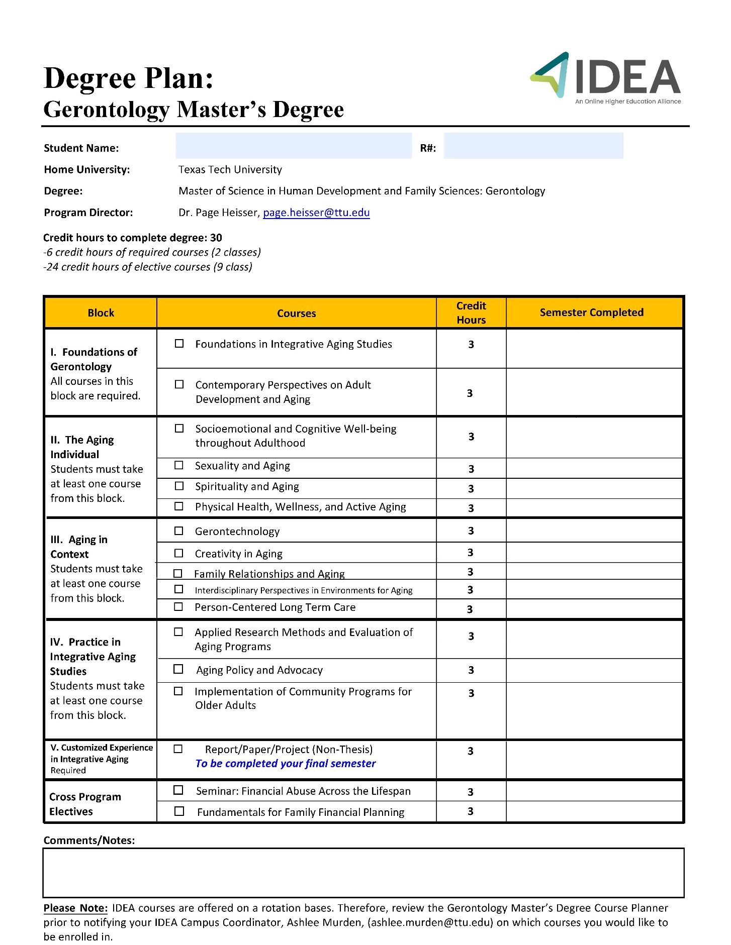
Appendix B.2: Graduate Certificate in Human Development and Family Sciences, Gerontology Concentration
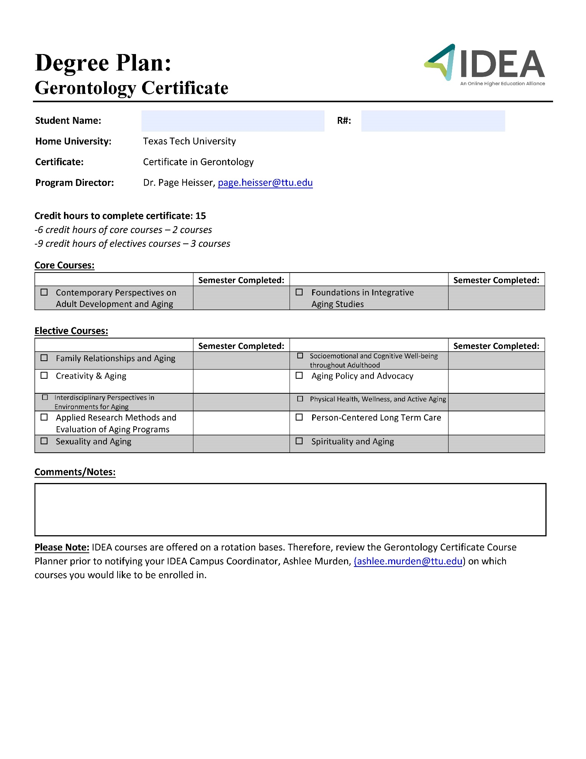

Appendix C: Early Childhood & Family Policy Concentration

Graduate Certificate in Human Development and Family Sciences
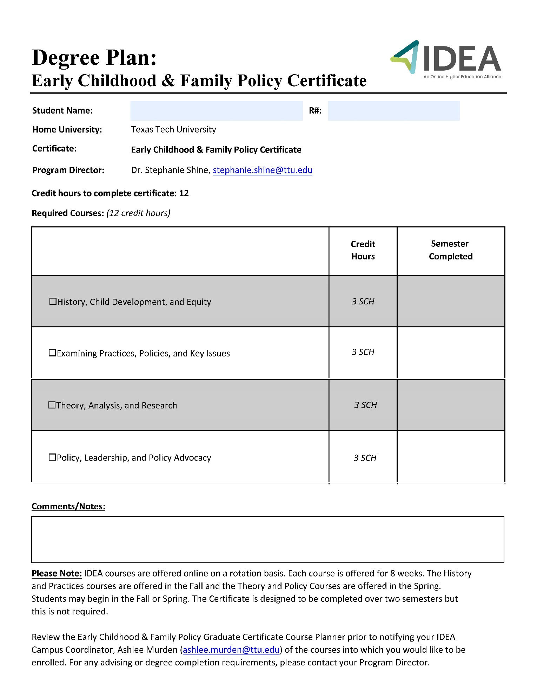

Appendix D: Youth Development

Appendix D.1: Master of Science in Human Development and Family Sciences, Youth Development Concentration
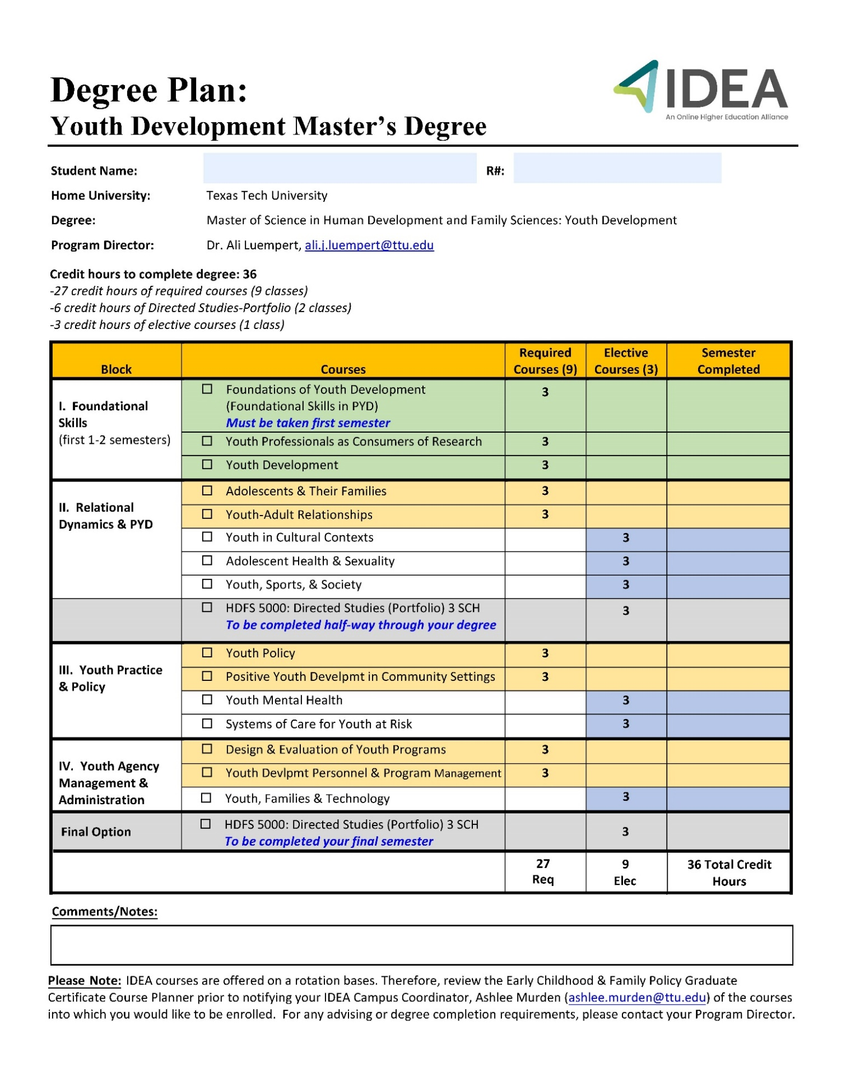
Appendix D.2: YD Master’s Non-Thesis: Portfolio General Procedures *
During the final semester of enrollment, each non-thesis student will complete the final comprehensive component of their degree that will take into account the need to demonstrate the ability to integrate and relate the materials covered in the coursework. Although termed a "comprehensive examination," this is a capstone exercise designed to help the student pull together the courses in the Youth Development concentration into a final portfolio project document and for an oral presentation.
- The Portfolio Option should include a minimum of three research, applied topics papers, or graded documents written in courses taken for the Master of Science (M.S.), and a reflection paper that summarizes the integration of the various courses within the student’s program. Students may choose to include more research papers in their portfolios as deemed applicable to their program of study.
- Portfolios will present the students' original work along with the critiques or commentaries and grades that the projects or papers received at the time that they were submitted. The papers should reflect students' own work; i.e., papers written in collaboration with other students are not acceptable.
- The portfolio will also include a reflection essay that presents the student's views of their development as a scholar and evaluates the learning process that the three projects afforded the student. This reflection paper should give a general overview of the student's experiences during his or her study toward the master's degree. Not only should it assess the work that has been done (by commenting about the included projects or papers), but it should also provide a means for self-examination and exploration. In the reflection paper, the student may make observations about methodologies that the included projects involved and about the strengths and weaknesses of these projects. The reflection paper may show how the student's studies have made inquiries into (or even contributions to) concerns of national or international scholarship. The paper may also show how the projects help to prepare the student to address professional goals. It may illustrate how the master's degree has prepared the student for future challenges or future careers.
- It is important that students think about their portfolio materials as they progress through their studies; certainly, they should begin collecting materials before the final semester. For this reason, students are expected to enroll in a total of 6 hours of HDFS 5000 Directed Studies; the Portfolio 1 (3 credit hours) hours will be completed no later than midway through the program and Portfolio 2 (3 credit hours) completed in the final semester (5 total hours for students entering prior to Fall 2021). The Academic Advisor/Program Director should help students to make important decisions concerning the papers or projects comprising the portfolio.

Portfolio Format
Because the Portfolio is a terminal project for the master's degree, it should have a form and format akin to the master's thesis. Like the thesis, it should have the following features:
- It should have a title page that includes the title, the author's name, the formula specifying the degree that is being earned, the names of the committee chair and the committee members, and the date (month and year).
- Following the title page, there can be a page of acknowledgements.
- There should be a table of contents indicating the work's primary divisions.
- The work should be divided into chapters (e.g., the reflection essay might be a chapter, and each paper or project might be a chapter).

Additionally, the master’s portfolio should include the student’s resume or curricula vitae as an appendix.

The IDEA-YD advisor will provide a sample document to students with formatting guidance. Students should follow the most recent APA style guide.

Portfolio Assessment
Your portfolio project in combination with your oral portfolio presentation will be assessed based on student learning outcomes (SLOs) established by IDEA-YD. The SLOs will be measured on a 4-point scale of “Does not meet acceptable standard” to “Meets the standard of excellence.” The student learning outcomes for assessment are:
- Effectively explains the rationale and efficacy of a PYD approach.
- Effectively explains developmental processes and the influence of contexts on youth.
- Demonstrates application of research, theory, and evidence-informed practice for effective youth programming.
- Promotes inclusivity in practice with youth.
- Demonstrates the ability to develop, manage, evaluate, and sustain PYD programs.

Faculty Committee Members' Role with the Portfolio
As with an examination committee, the committee members' primary duties are to help the student to achieve their goals before graduation and to uphold the standards of Texas Tech University. However, members of the portfolio committee have a few very specific duties:
- The examination committee is to be 3 committee members who are considered graduate faculty at the University. Of your three members on the committee, the IDEA-YD advisor will act at the Chair. This person will spearhead your committee and assign the final grade.
- Faculty members should review the papers that the student chooses to put into the portfolio. They are not required to grade the papers (the papers have already been graded), but they should determine whether the papers are appropriate examples of what the portfolio should contain; i.e., do the papers meet the requirements for inclusion? Thus, it is the responsibility of the committee members to accept or reject the papers that are included in the portfolio.
- Committee members are also responsible for making certain that the reflection essay is suitable for the portfolio. Committee members should carefully read the essay, make suggestions for any improvements that seem appropriate, and generally serve as judges of the academic worth of the reflection essay.
- Finally, committee members should meet as a committee with the master's degree candidate; this meeting will often involve virtual interaction with arrangements made for internet connection, preferably with audio and video. They should discuss the portfolio with the student and review the student's career at Texas Tech. If the committee approves of the portfolio, all of the members should sign the title page of the work. Following this meeting, the chairperson of the committee should notify the Graduate School that the student has successfully completed his or her work on the portfolio.
- For more information: https://www.depts.ttu.edu/gradschool/Programs/FacultyCommittee.php

YD Advisor Role with the Portfolio
- Upon successful completion and presentation of the portfolio project the IDEA-YD advisor will ensure the Comprehensive Exam Report (Non-Thesis Option Only) form is submitted to the TTU Graduate school through the Enrollment Services portal.
- Subsequently, the IDEA-YD advisor will complete the IDEA-YD graduating student assessment survey
*This section is a modification of the portfolio guidelines used by the TTU Interdisciplinary Studies Master’s program, The Graduate School.

Basic Written and Oral Portfolio Format:
The program director will provide a sample portfolio and additional information on both the written and oral portions.
- Written Portfolio Requirements:
  - Introduction
    - Including definition of Positive Youth Development
    - Summaries of included papers
  - 3-5 papers from coursework revised to their best form
  - Conclusion
- Oral Exam Requirements:
  - 1-hour oral exam
    - 15 minute presentation
    - Committee questions
    - Student dismissed while committee convenes
  - Decisions delivered to student

Appendix D.3: Youth Program Management & Evaluation Graduate Certificate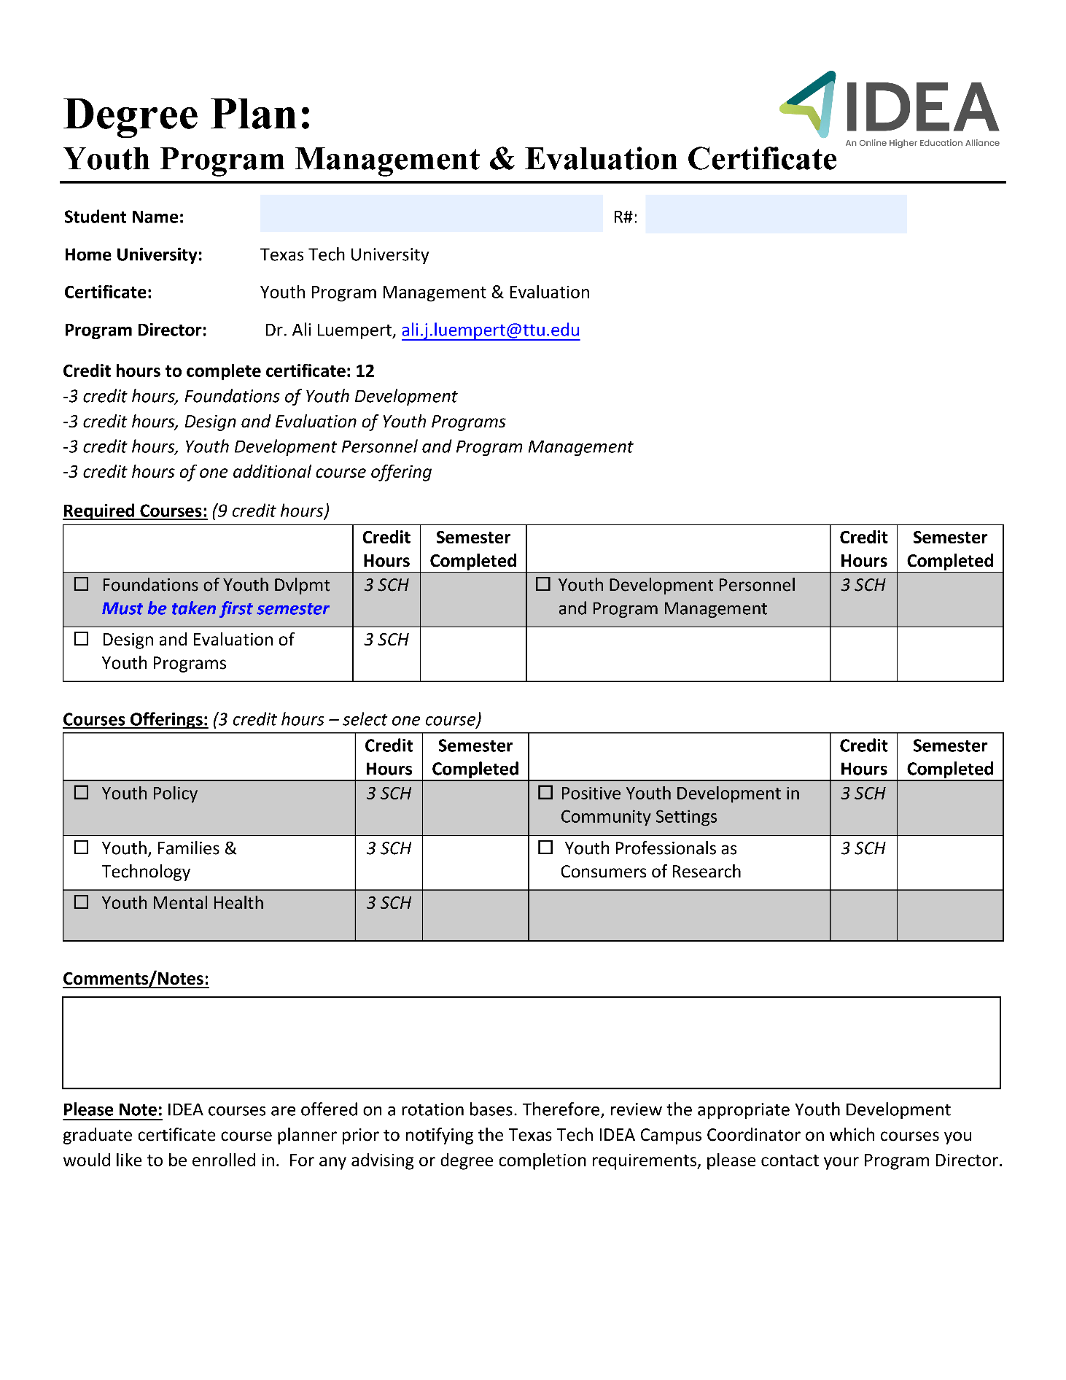

Appendix D.4: Youth Development Specialist Graduate Certificate

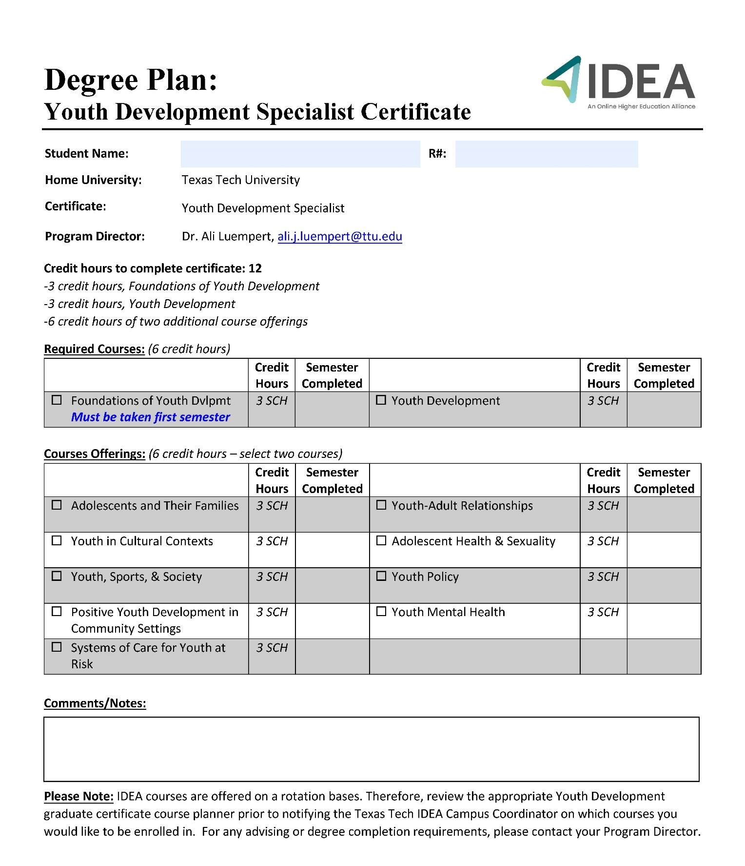

Appendix E: IDEA Course Login Tracking Sheet

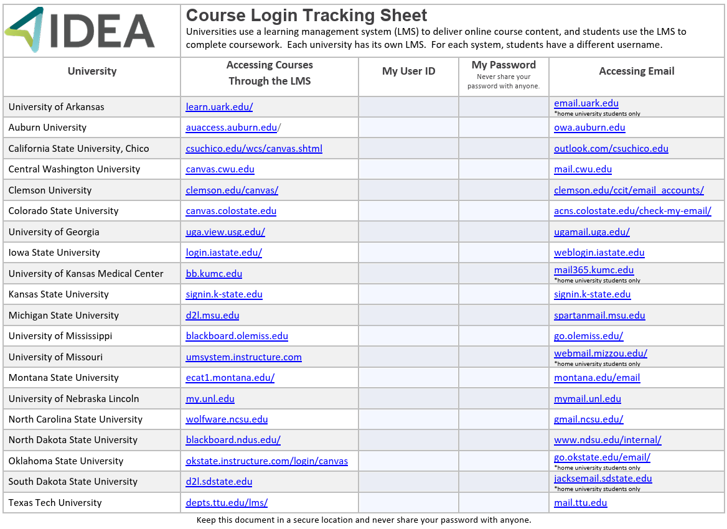
A fillable PDF version of the document can be found here: Course Login Tracking Sheet (PDF)

