Nutritional Sciences Department Newsletter Vol 11, Iss 3; May 2026
Headline Story 2

Class of 2026 Graduation Celebration 4

Nutrition & Metabolic Health Initiative (NMHI) 4

Master's Theses and Doctoral Dissertations 5
Student Achievements 5
Funding 5
Presentations, Publications, and Invited Lectures and Boards 6

Journal Articles 7

Invited Lectures, Presentations, and Workshops 8
Awards, Miscellaneous Board and Other Appointments 8
In the Media 9
Activities that GNO hosted during Spring 2026 9
Home Page Content 11

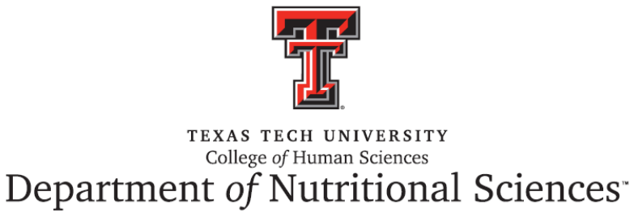

Headline Story

Nutritional Sciences Department Welcomes New Faculty Member

Sergej M. Ostojic, MD, Ph.D., FACP

The Department of Nutritional Sciences is pleased to welcome Dr. Sergej M. Ostojic as a Professor. Dr. Ostojic brings extensive experience in clinical medicine, nutrition science, and translational bioenergetics, and is internationally recognized for his work in creatine biology, energy metabolism, and molecular hydrogen research. His research focuses on bridging fundamental biological mechanisms with clinical and public health applications.

Dr. Ostojic has led and contributed to numerous randomized controlled trials, mechanistic studies, and large-scale data analyses, with over $10 million in competitive funding from academic, governmental, and industry partnerships. His work has significantly advanced the understanding of creatine as a conditionally essential nutrient, as well as bioenergetic interventions targeting human health. He holds multiple patents related to creatine formulations and metabolic interventions.

A highly accomplished scholar, Dr. Ostojic has published in leading journals including The Lancet, Nature, BMJ, and American Journal of Clinical Nutrition. He also serves in several editorial leadership roles across prominent journals in nutrition and bioenergetics.

Dr. Ostojic is deeply committed to mentoring and education, with a strong track record of guiding undergraduate and graduate students as well as postdoctoral fellows. His research interests include mitochondrial function, metabolic health, clinical nutrition, and population-level analyses of chronic disease.

Welcome to Texas Tech University, Dr. Ostojic. We are excited to have you join our faculty!

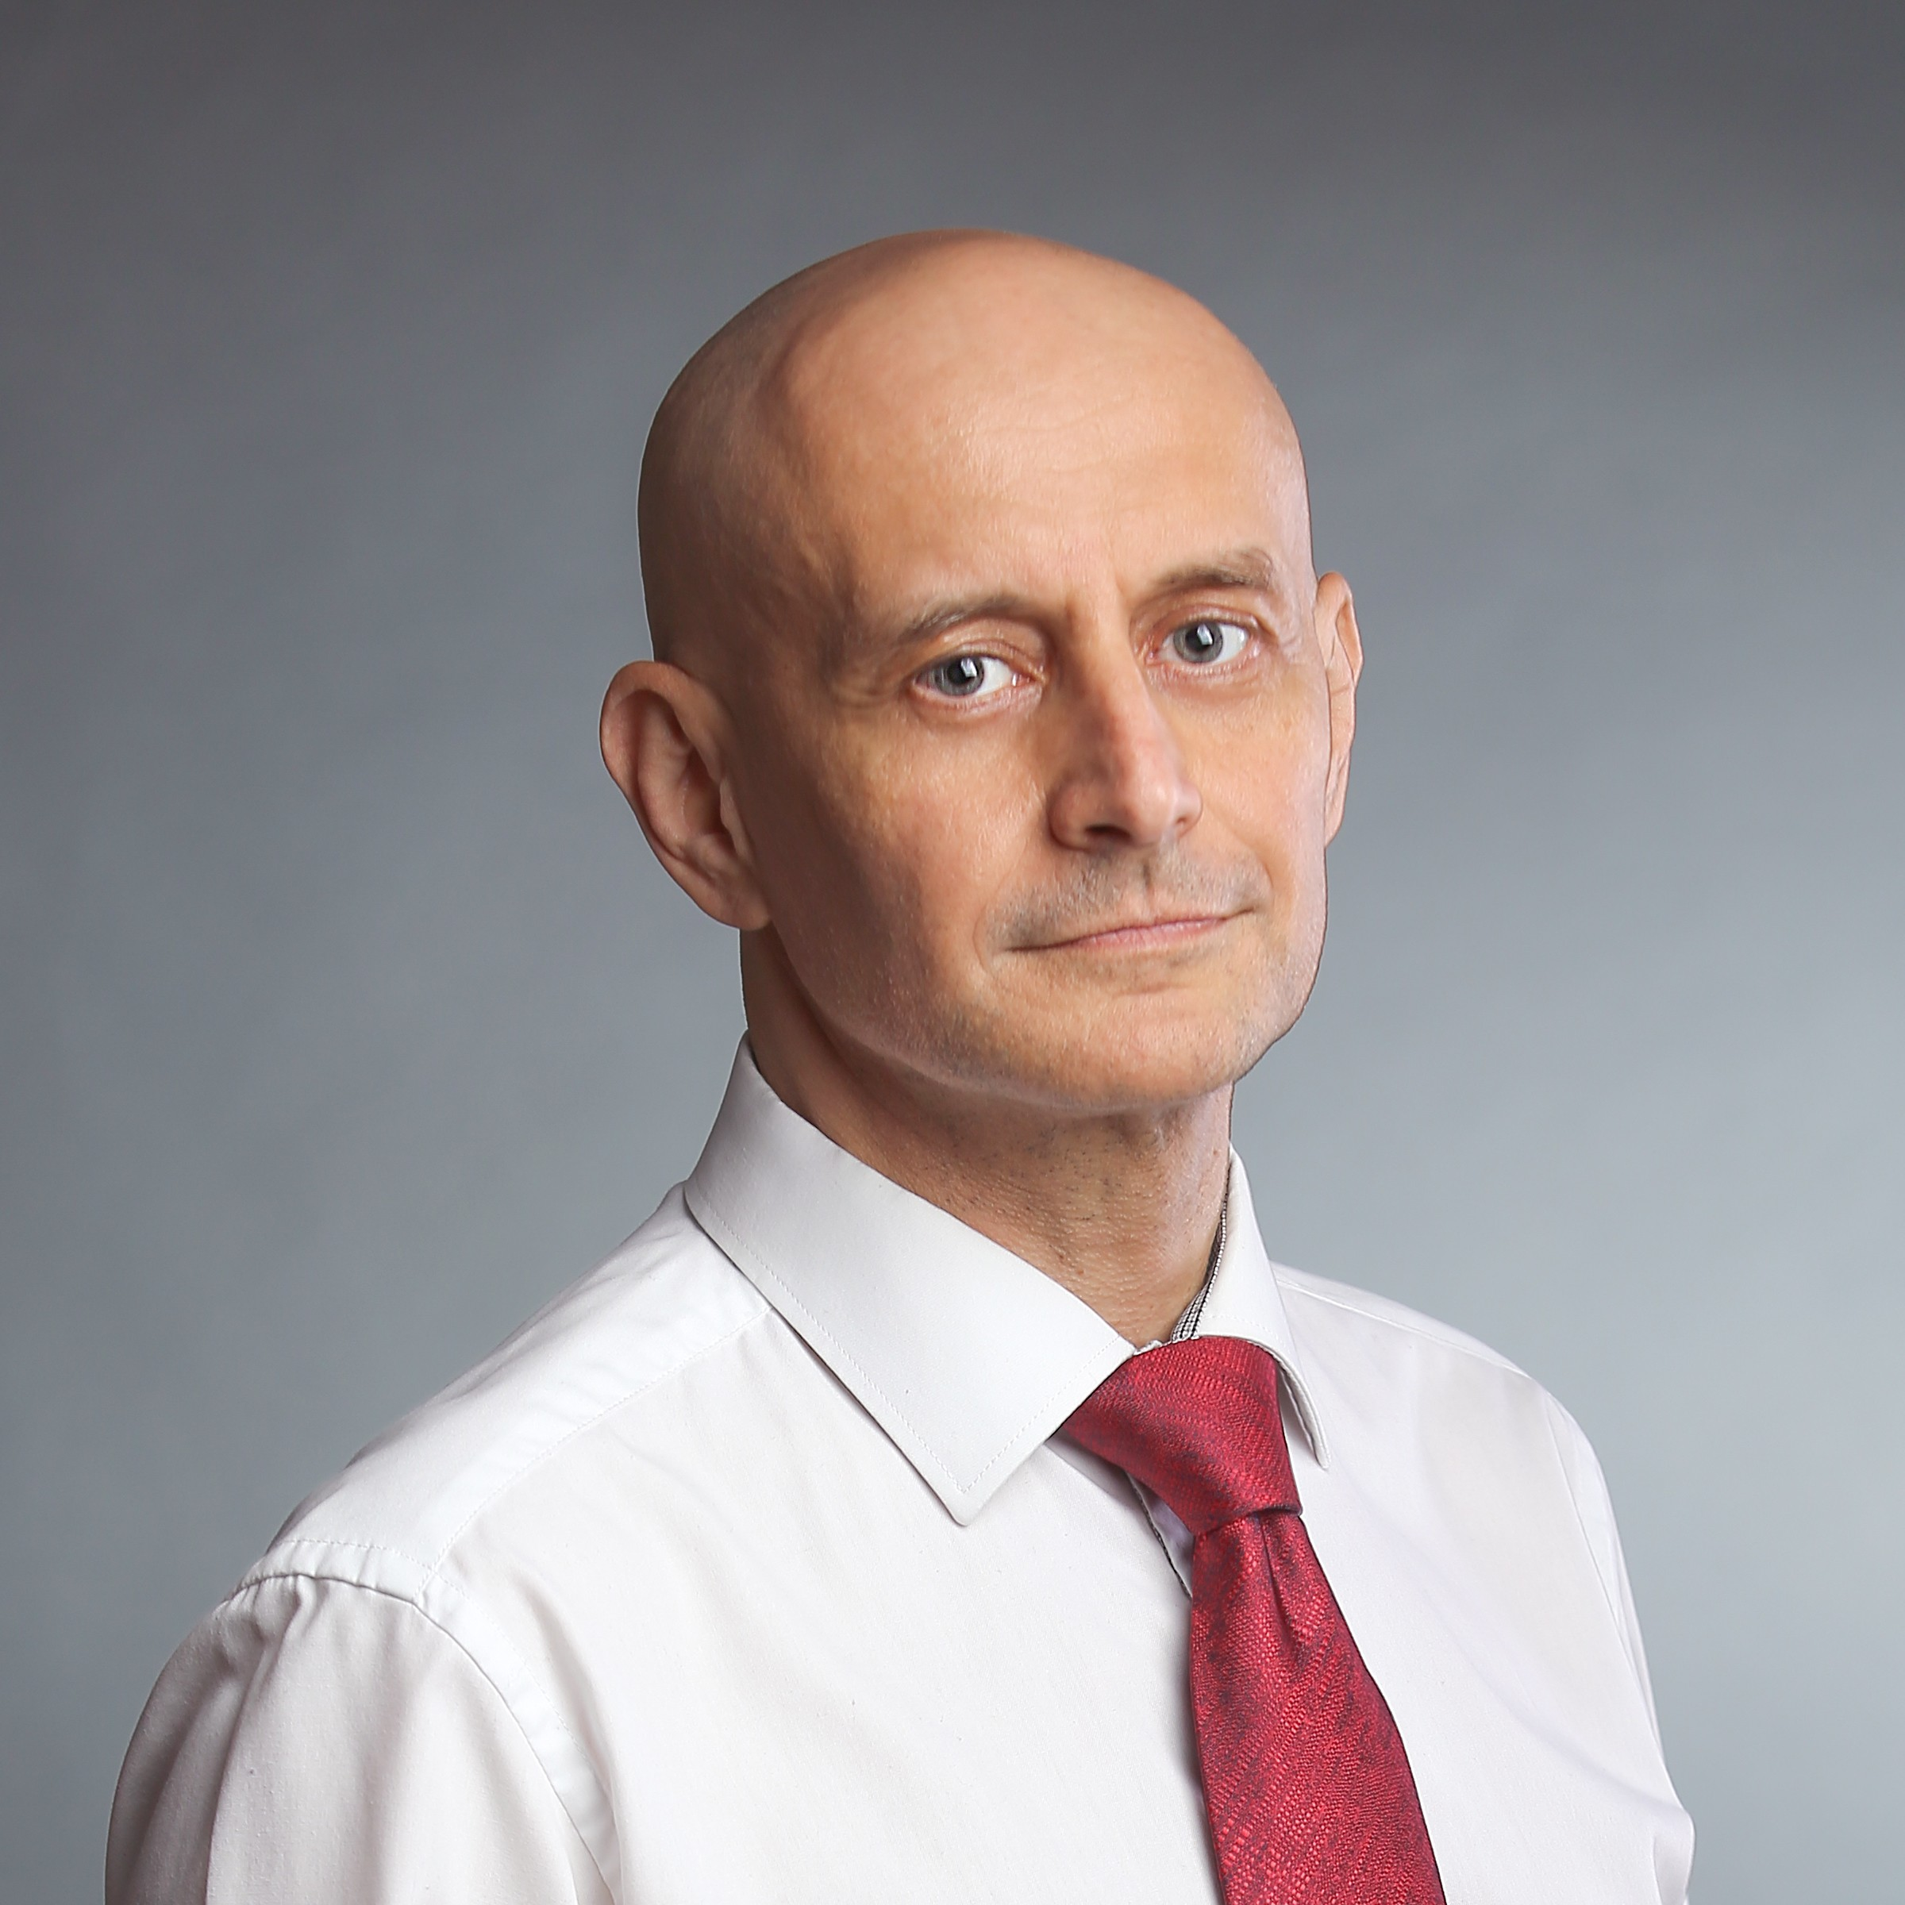
Dr. Sergej M. Ostojic

The Department of Nutritional Sciences proudly congratulates

Dr. Nikhil Dhurandhar, Paul W. Horn Distinguished Professor, Helen Devitt Jones Endowed Chair of Nutritional Sciences, and Associate Dean for Innovation in the College of Health and Human Sciences, on being named a Distinguished Fellow of the American Society for Nutrition (DFASN)—the highest honor bestowed by the society for lifetime achievements in nutrition science.

An internationally recognized leader in obesity and metabolic research, Dr. Dhurandhar is widely known for his pioneering work in “infectobesity,” the study of infectious origins of obesity. His innovative research has advanced understanding of obesity, diabetes, and metabolic disease, generating more than $10 million in research funding and leading to numerous U.S. and international patents.

Throughout his distinguished career, Dr. Dhurandhar has published more than 200 scientific papers and delivered over 150 invited lectures and keynote presentations worldwide. His recognition as a Distinguished Fellow reflects his lasting contributions to nutrition science, research innovation, and mentorship.

The honor will be celebrated at the American Society for Nutrition’s annual meeting, Nutrition 2026, in Washington, D.C.

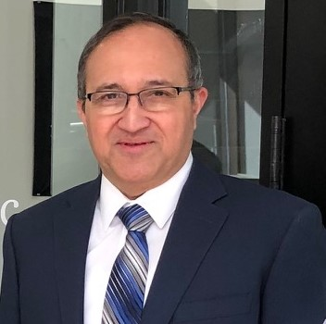
Dr. Nikhil V Dhurandhar

Global Study Finds Signs of Progress in the Fight Against Obesity

A landmark study published in Nature by Dr. Sergej M. Ostojic and Dr. Shariful Islam, along with an international team of researchers, analyzed obesity trends from 1980 to 2024 using data from more than 232 million people across 200 countries and territories.

The study found encouraging signs that obesity rates have slowed, stabilized, or even begun to decline in several high-income countries. The most notable improvements were observed among children and adolescents in countries such as France, Italy, Portugal, Denmark, and Japan, where obesity rates have plateaued or shown modest decreases. Similar trends were later observed among adults in some nations, including Spain.

The findings suggest that obesity is not an inevitable consequence of modern life and highlight the potential impact of public health policies, improved nutrition environments, and greater awareness of healthy lifestyles. While obesity remains a major global health challenge, particularly in many low- and middle-income countries, the study demonstrates that meaningful progress is possible through sustained public health efforts and evidence-based interventions.

Congratulations to Dr. Ostojic and Dr. Islam on their contributions to this impactful international research effort.

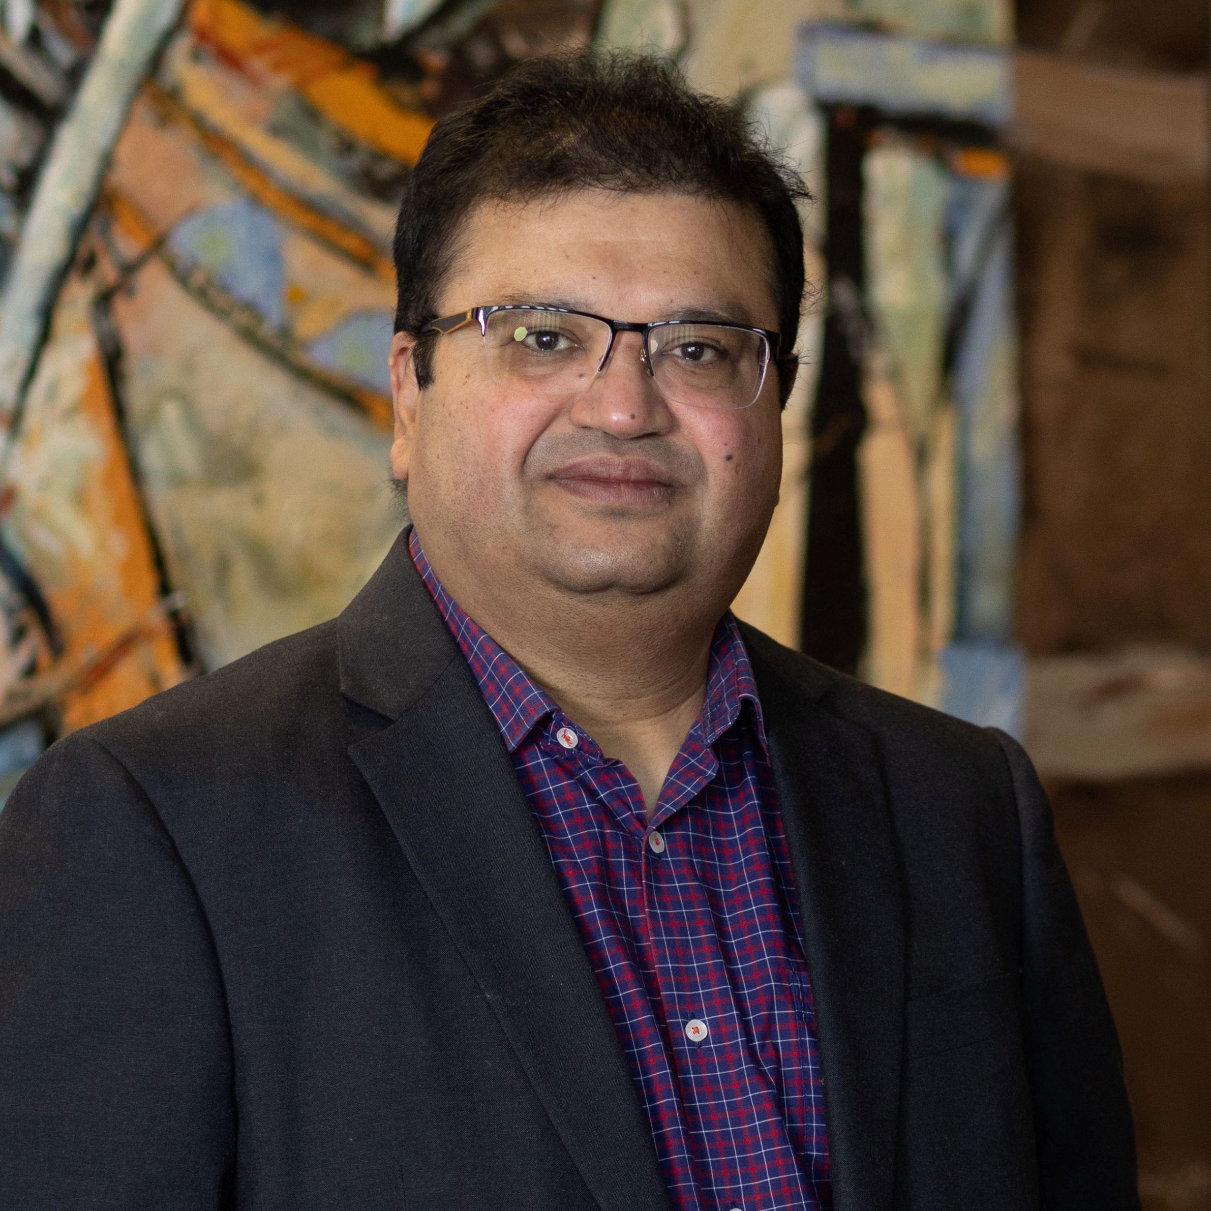
Dr. Sergej M. Ostojic Dr. Shariful Islam

Department Announcements

Class of 2026 Graduation Celebration

The Nutritional Sciences (NS) Department celebrated our Spring 2026 graduates on May 14, 2026.

- Master of Science in Nutritional Sciences
  - Kaylee Grayce Leraan Dickison
  - Diana Karoline Cavalcanti de Lucena Braganca
  - Salman Khan

- Master of Science in Nutrition & Dietetics
  - Alana Jean Olson
  - Jorie Vi Gonzalez
  - Hannah Sharlene Shropshire
  - Olivia Dianne Reeder
  - Juliana Horvath
  - Karen Marie McKneely
  - Jordan Elizabeth Schulz
  - Leah L. Strawn
  - Adriana Elena Miranda
  - Cameron Dionne Atkins
  - Madalynn Hayes
  - Ana Cecilia Maldonado Flores
  - Raymond Campbell IV
  - Tessa Irene Jones

- Doctorate in Nutritional Sciences
  - Amnah Ali
  - Zobayda Farzana Haque

Nutrition & Metabolic Health Initiative (NMHI)
This semester, NMHI's Community Outreach Team led 2 outreach events in April.
- Buckner Family Pathways Program: Student Providers Maria Gonzalez, Avin Everheard, Lara Enriquez, and Anna Nelson provided practical tips for meal planning on a budget to single parents registered in continuing education programs.
- Talkington Nutrition Experience: Student Providers Casen Bigham, Abdulla Behbehani, Maria Gonzales, Lara Enriquez, and Anna Nelson presented different career pathways in nutritional sciences to middle school and high school students. The students then role-played as their favorite nutritional science-based career and solved common nutrition issues.
Both programs have been highly successful, and we look forward to seeing their continued impact in the semesters ahead. This success would not be possible without the dedication of our volunteers, students, and staff at NMHI, whose support makes these programs thrive.

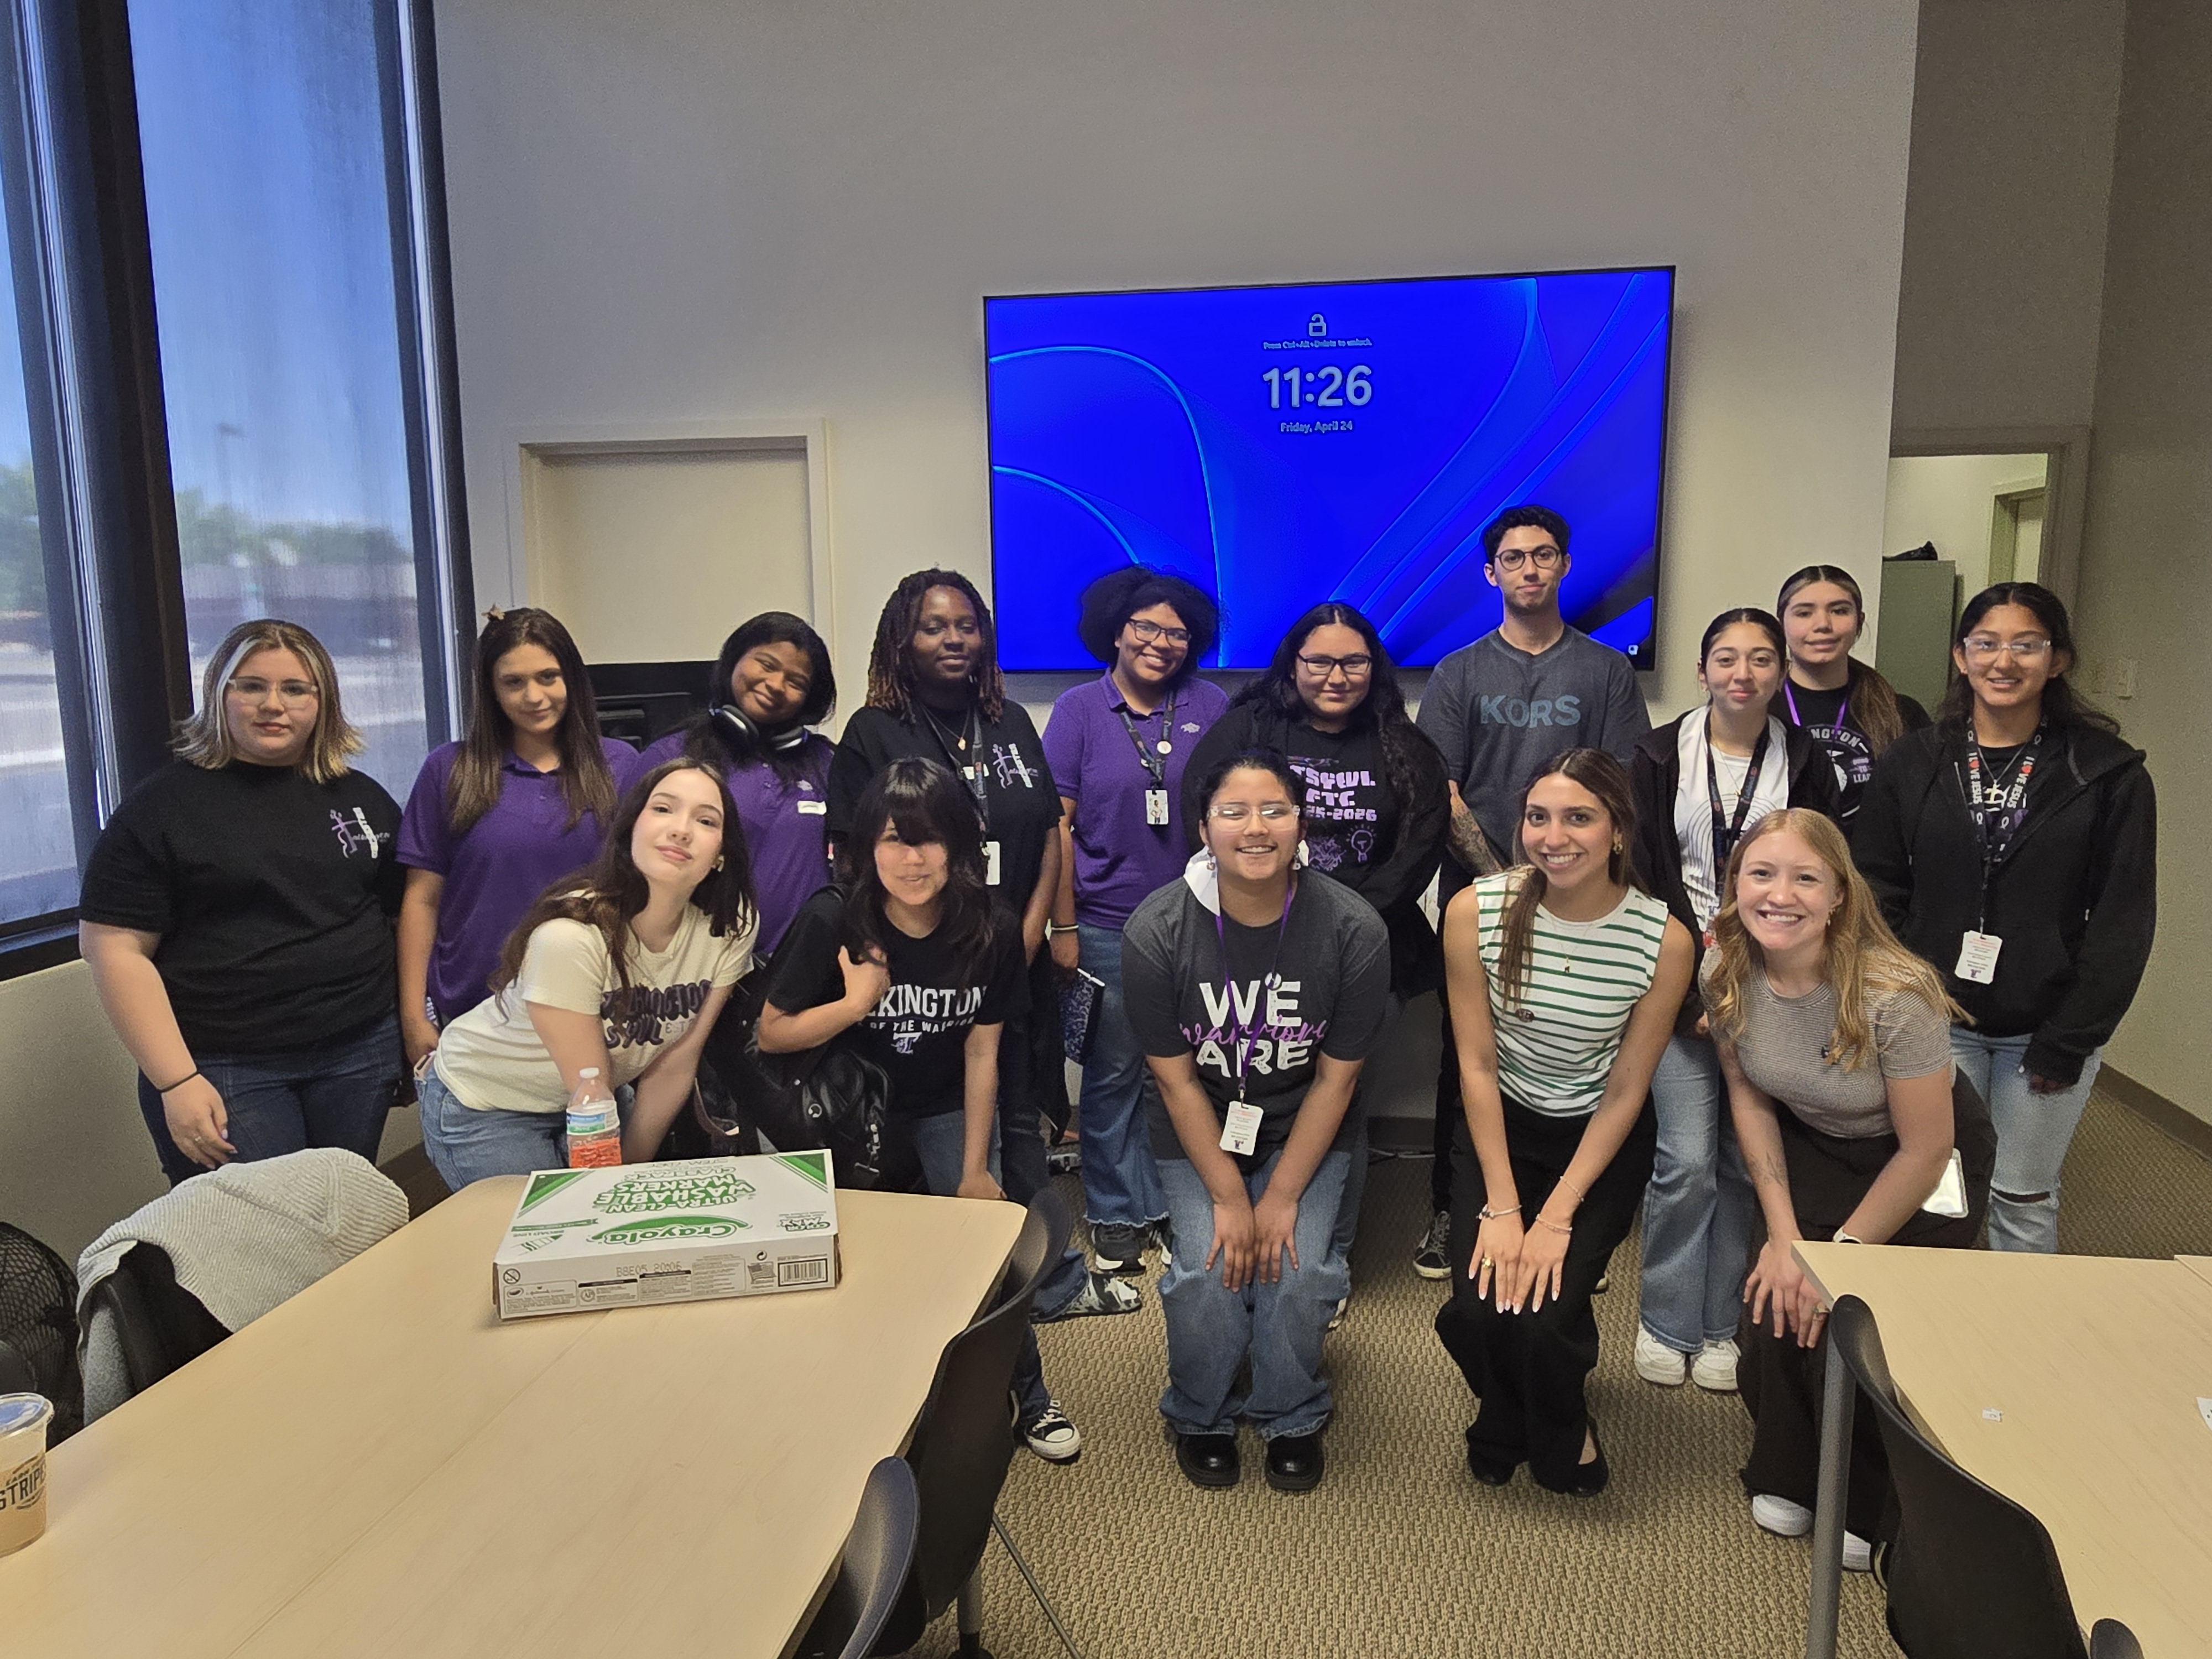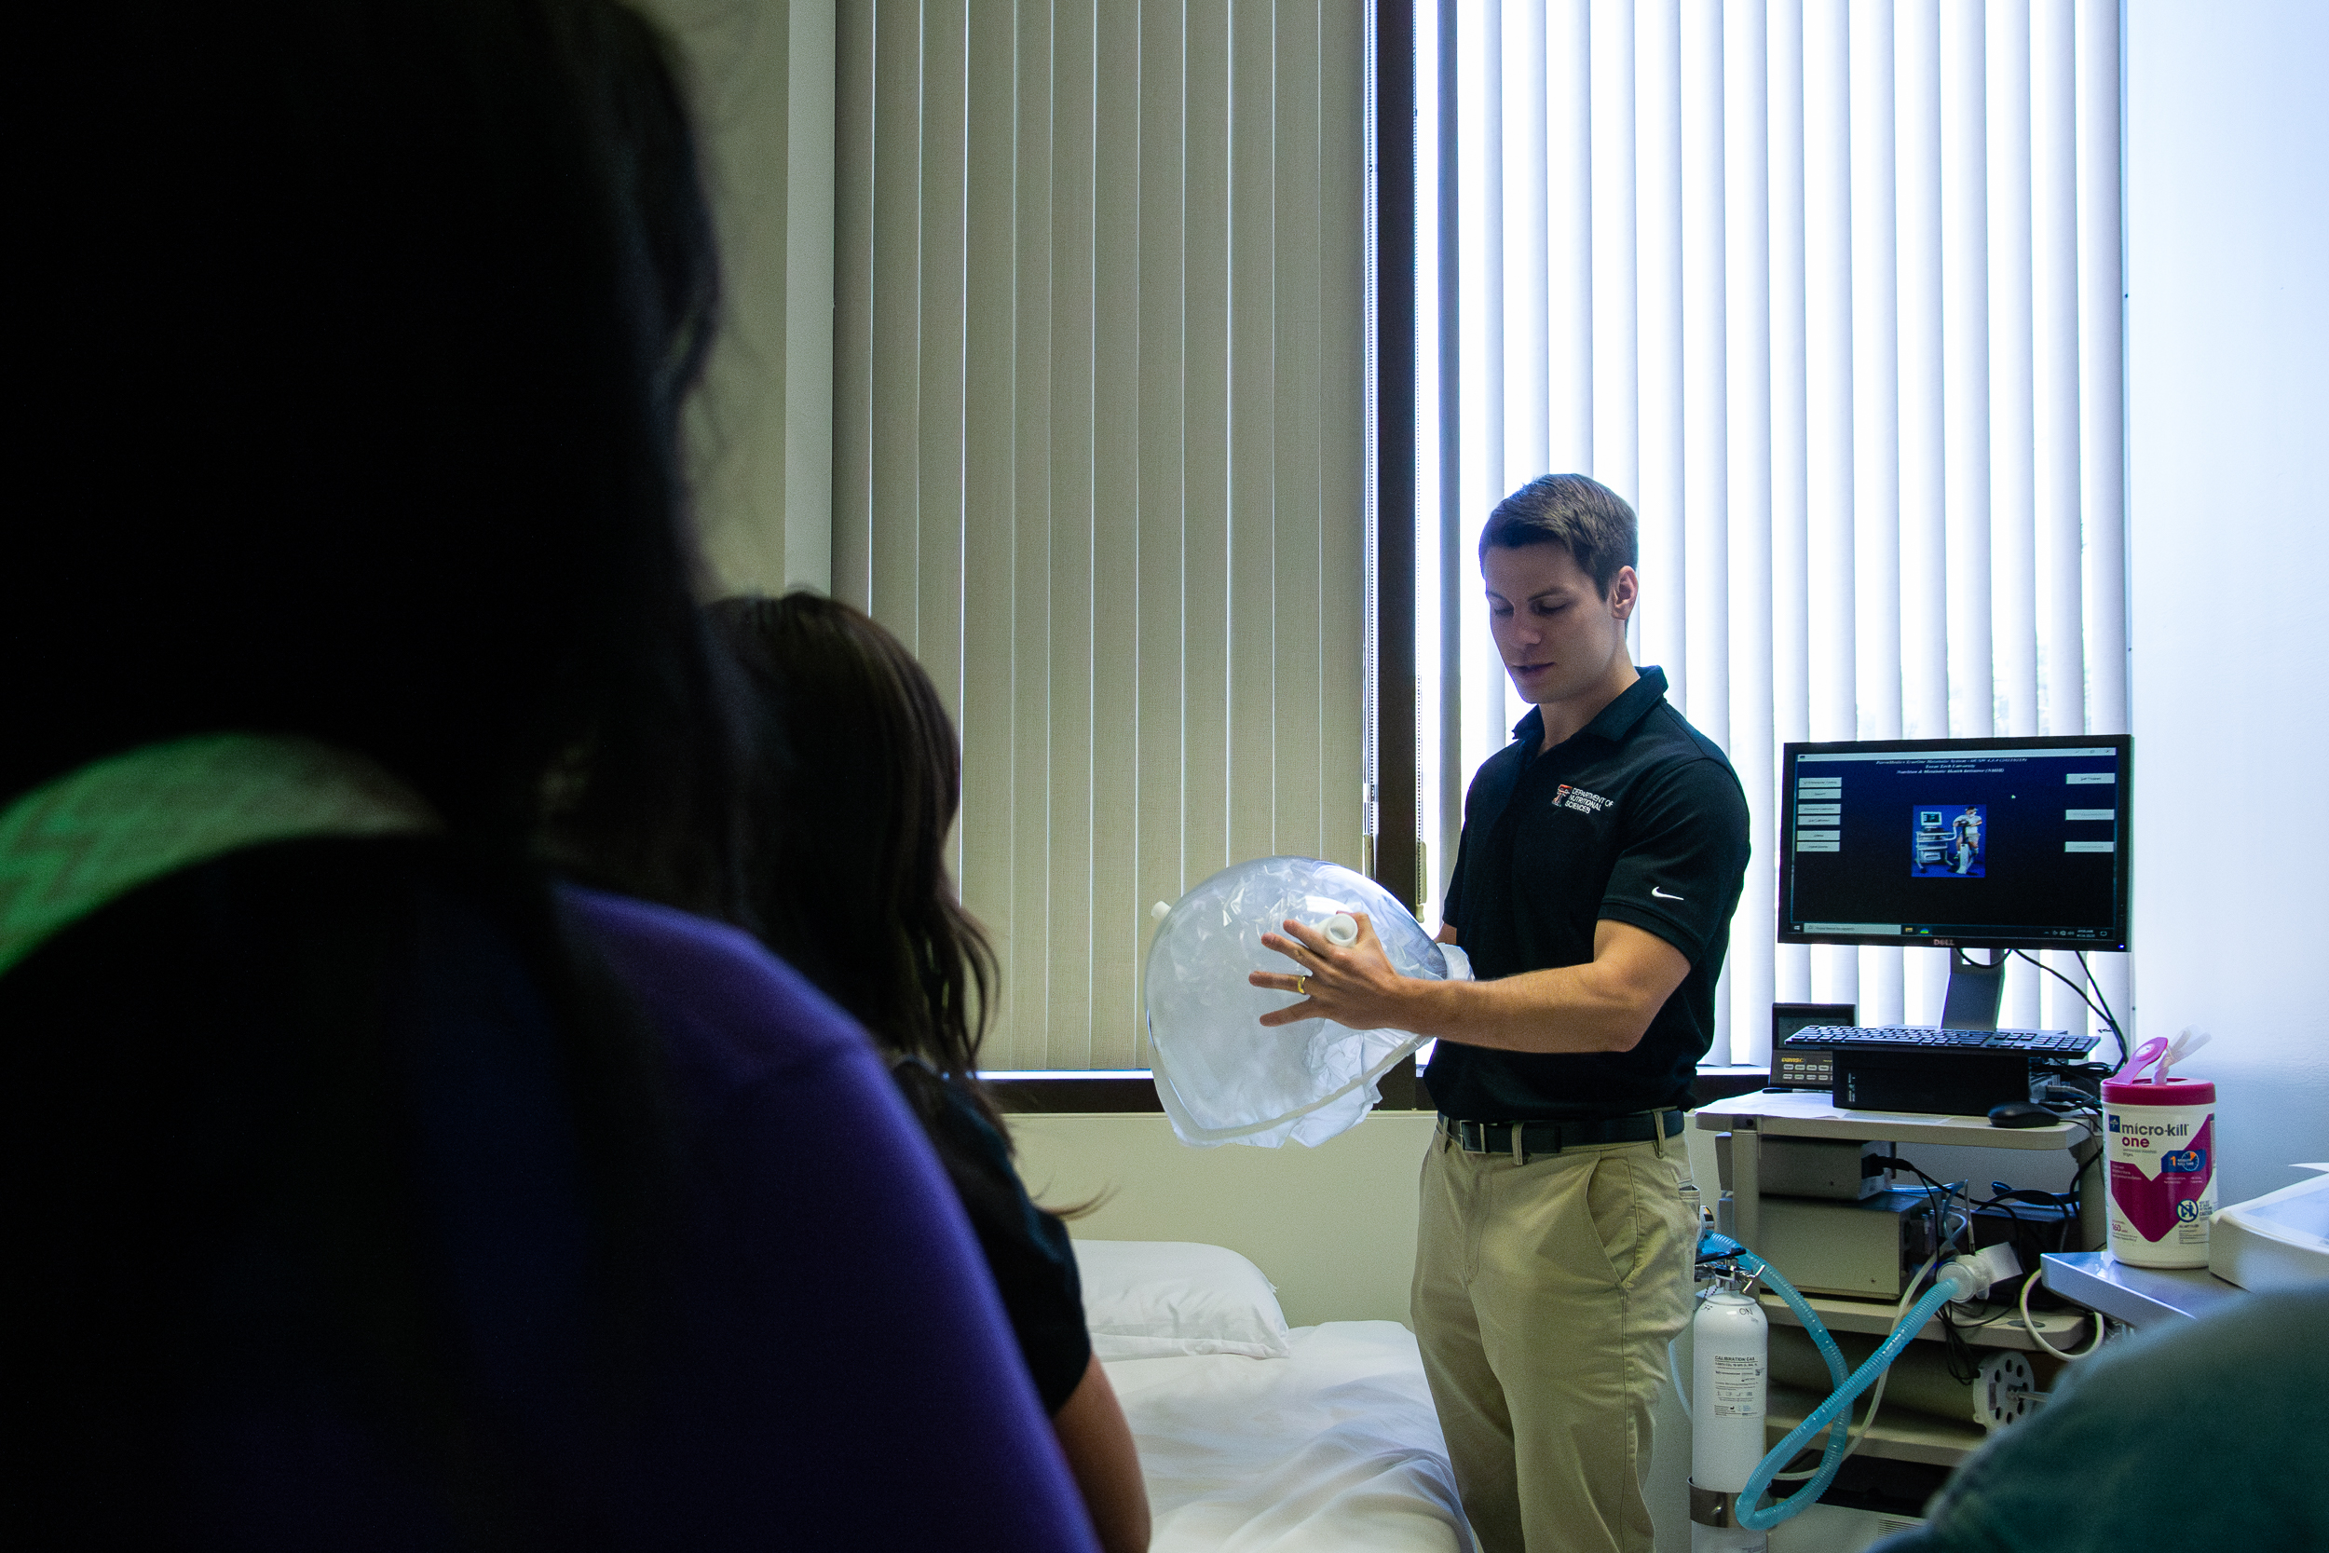
Buckner Family Pathways Program Talkington Nutrition Experience

Master's Theses and Doctoral Dissertations
- Zobayda Farzana Haque
  - Degree: Ph.D.
  - Thesis Title: Branched-chain amino acids (BCAAs) can be a potential predictive and/or diagnostic biomarker for Alzheimer's Disease (AD)
  - Dissertation Committee: Dr. Andrew Shin (Committee Chair), Drs. Vijay Hegde, Shannon Galyean, Murali Vijayan, and Puliyar Mohankumar

- Amnah Ali
  - Degree: Ph.D.
  - Dissertation Title: The Effect of E4ORF1 Adeno-Viral Protein on Weight Reduction and Fat Loss: A Potential Novel Approach to Obesity and Blood Glucose Regulation
  - Dissertation Committee: Dr. Vijay Hegde (Committee Chair), Drs. Nikhil Dhurandhar, Andrew Shin, Marleigh Hefner, Danielle Levitt and Alhaddad Ahmad

Student Achievements
- Most Arifa Sultana received the Graduate Student Research Support (GSRS) Award from the Graduate School to complete research (thesis/dissertation or non-thesis based)
with an award amount of $1500
- Fereshteh Dehghani was awarded a 2nd place in the poster competition at the 11th annual meeting of the Center of Excellence in Obesity and Cardiometabolic Research

Funding
- Title: Preclinical Therapeutic Validation of Insparin
  - Funding Agency: Insparin Therapeutics
  - Total Amount: $300,000
  - Principal Investigator: Dr. Nikhil V Dhurandhar; Co-Principal Investigator: Dr. Vijay Hegde

- Title: The Gut Microbiome, Inflammation, and Insulin Resistance: Exploring Biological Pathways Linking Social Determinants of Health and Metabolic Risk
  - Funding Agency: Institute for One Health Innovation (IOHI) Seed Funding Program FY2
  - Total Amount: $7,478
  - Principal Investigator: Dr. Jeni Page; Co-Investigator: Dr. Mostafa Abdelrahman, Dr. Surya R Niraula, Dr. Bibha Gautam, Dr. Mary Rogge

- Title: Comparison between the health effects of an AI-driven model with those of human professional guidelines for the treatment of obesity.
  - Funding Agency: General Funding-Spring, Internal grant
  - Total Amount: $7,500
  - Principal Investigator: Dr. Surya R Niraula; Co-Investigator: Dr. Shannon Galyean, Dr. Shariful Islam

Patents received
- Dhurandhar, N., Hegde, V., "A therapeutic treatment for Alzheimer's Disease," United States Regular Patent US 12,514,901 B2. (Issued January 2026).

Presentations, Publications, and Invited Lectures and Boards

SFASU Allied Health Conference (February, 2026)

- Raul Palacios, AI & Nutrition: What We Learned in 2025
Nutrition & Dietetics Educators Group Annual Conference (March, 2026)
- Raul Palacios, Invited Speaker: "Confessions of a Cyborg: What I Learned From a Year of Teaching With AI"

Keystone Symposia (March, 2026)

- Dehghani F, Fotros D, Scott G, Shin AC. A BCAA-Synthesizing Bacterium Exacerbates Food-Reward Responses Under a High-Fat Diet. Keystone Symposia, Breckenridge, CO (oral presentation).
The American Society of ExtraCorporeal Technology (AMSECT) International Conference (March, 2026).

- Mina Esmaeili. Comparing the Effects of Pulsatile and Non-Pulsatile Flow on the Vasoactive-Inotropic Score (VIS) and Clinical Outcomes in Patients Following Coronary Artery Bypass Grafting Surgery (Poster)

Texas Academy of Nutrition and Dietetics Annual Conference (April, 2026)

- Raul Palacios, Invited Speaker: "AI 2.0 Clinical Applications
- Kylee Stuve, Raul Palacios - GLP-1 Post Discontinuation Guidelines Review
- Jeweljana Helm, Raul Palacios- Comparative Review of DPD Program Undergraduate Curricula

Human Molecular Aging Center (HMAC) Symposium(April, 2026)

- Marjan Ramezan, Sex differences in hypothalamic glucose metabolism in Alzheimer’s Disease (short talk)

Undergraduate Research Conference, TTU (April, 2026)

- Arnav Gaitonde, Seyed Ali Abba Hashemi, Marleigh Hefner. Waist-to-Arm Ratio Versus BMI as Predictors of Cardiometabolic Risk in US Adults. First place in the URC poster competition awards
- Barton S, Dehghani F, Shin AC. Link Between Branched-Chain Amino Acids and Sweet Reward: Gene Analysis in the Brain
- Scott G, Dehghani F, Fotros D, Shin AC. Can dietary BCAA manipulation alter reward-related genes in the amygdala?
- Saleth Orozco, Most Arifa Sultana, Marleigh Hefner, Vijay Hegde. Exploring the neuroprotective effects of nanoparticle encapsulated Malvidin chloride in ameliorating Alzheimer’s disease pathology
- Asseel Ojjeh, Tanvi Kale, Nikhil V. Dhurandhar, Vijay Hegde. A 70 amino acid peptide of Insparin upregulates distal insulin signaling

Fourth International Conference on Applications of Mathematics to Nonlinear Sciences (AMNS-2026) in Kathmandu, Nepal (May, 2026)

- Surya Raj Niraula, Seyed Ali Abbas-Hashemi, Abu Ansar Md Rizwan, Marleigh Hefner, Shannon Galyean. The Effects of Vegetarian Diets on Blood Pressure: A Systematic Review and Meta-Analysis of Randomized Clinical Trials (RCTs). Invited speaker and session chair.

Journal Articles
- Grant M. Tinsley, Marleigh Hefner, Philip Sapp, Jeremy Townsend, Christian Rodriguez, and Christine Florez. Sex differences in nutrient gaps among active adults. Journal of Nutritional Science, 2026.
- Antonio F. Pagán, Hannah Yoo, Marleigh Hefner, Yazmine P. Huizar, Sharmin Akter, Chelsi Webster, Martin Binks. Development of the Health Coaching Quality Index: A Proposed Method for Evaluating Health Coaching Intervention. International Journal of Behavioral Medicine, 2026.
- Ashti Morovati, Yasmine Moussa, Nishan Sudheera Kalupahana, Yujiao Zu, Heejin Jun, Mohamed Fokar, Naima Moustaid-Moussa. Neuroinflammation in Alzheimer’s Disease: The Role of Obesity, Gut Microbiota, and Therapeutic Potential of Omega-3 Fatty Acids and Neural Stem Cells, The Journal of Nutrition, 2026.
- Niraula SR, Basnet L, Guragain P, Bhattari DA, Ghimire A. Social-contextual factors associated with problematic alcohol drinking in the Eastern Hills of Nepal. The American Journal of Drug and Alcohol Abuse, 2026.
- Niraula SR, Niraula TP, Rizwan AAM, Kafle RC. Health management services and patient satisfaction – institutional and patient perspective: a qualitative study in Eastern Nepal. BMC Health Serv Res, 2026.
- Ozioma PU, Kudchadkar GM, Ranjbar S, Hefner M, Kale T, Hia RA, Zaroudi M, Niraula S, Dhurandhar NV. The Role of High-Protein Instant Ramen Noodles in Inducing and Maintaining Satiety: Acute, Randomized, Crossover Study. Nutrition & Diabetes, 2026.
- Acharya A, Yadav AK, Yadav BK, & Niraula SR. Evaluation of Sleep Quality and Its Determinants Among Undergraduate Medical Students Across Different Phases of Medical Training. Journal of College of Medical Sciences-Nepal, 2026.
- Kunwor S, Lama S, Niraula SR, Pokharel R, Pradhan N, Thapa K, Nepal S. Resilience and Mental Wellbeing among Older Adults in Dharan Nepal: An Observational Study. J Nepal Med Assoc 2026.
- Della Guardia L, Shin AC. Adipose tissue catecholamine resistance: a metabolic safeguard that challenges weight control. Metabolism: Clinical and Experimental, 2026.
- Ramezan M, Demetriou A, Burke SN, Nalvarte I, Shin AC. Sex differences in brain glucose metabolism and Alzheimer’s disease risk and progression. Alzheimer’s & Dementia, 2026.
- Dhurandhar EJ, Maki KC, Dhurandhar NV, Kyle TK, Yurkow S, Hawkins MAW, Agley J, Ho EH, Cheskin LJ, Sørensen TIA, Wang XR, Gorman B, Allison DB. Development and rigorous multistep validation of a psychometric tool to measure food noise Appetite, 2026.
- Nateqi M, Hegde V, Dhurandhar NV. Commentary: E4orf1 as a key modulator in oncogenesis and of metabolism in Adenovirus infection. Frontiers in Virology, 2026.
- Hefner M, Hia RA, Nguyen T, Nateqi M, Dhurandhar NV, Hegde V. Reproducibility and Sex Differences in a STZ–High Fat Diet Model of MASLD and Early Hepatocarcinogenesis. International Journal of Molecular Sciences, 2026.Hubert PA, Coleman C, Grosicki GJ, Kiel J, Shepherd M, Lofton HF, Heymsfield SB, Thomas G, Dhurandhar NV, Jonnalagadda. Mind the Plateau: A Mathematical Modeling Analysis of Long-term GLP-1 Receptor Agonist Treatment. Journal of the Academy of Nutrition and Dietetics. 226;126(8): 156366.
- Hawkins MAW, Jimenez-Garcia JA, Dhurandhar EJ, Maki KC, Dhurandhar NV, Kyle TK, Yurkowo S, Agley J, Cheskin LJ, Sorensen T, Binks M, Wang XR, Gorman B, Chao AM, Allison DB, Ho EH. New Horizons for the Ro Allison Indiana Dhurandhar Food Noise Inventory: Response to a Letter to the Editor. Obesity(Silver Spring),2026

Invited Lectures, Presentations, and Workshops

- Dr. Nikhil V Dhurandhar
  - American Pistachios Growers: Role of pistachios in nutrition and health. Palm Springs, CA.
  - “Fat Loss, Not Just Weight Loss”. Grand Rounds, Internal Medicine. University of Austin Medical School, Austin, TX.Is Medication the Missing Piece? Rethinking Obesity Management. Invited presentation. Texas Tech University Heallth Sciences, Center, El Paso, TX.

- Dr. Andrew Shin
  - Speaker, Graduate Nutrition Organization (GNO), TTU, Lubbock, Texas, USA
  - Keynote Speaker, Human Molecular Aging Center Symposium, TTU, Lubbock, Texas, USA. Correcting Alzheimer’s trajectory through metabolic intervention
  - Speaker, Addictive Disorders & Recovery Studies, TTU, Lubbock, Texas, USA, Panel for grant writing
- Raul Palacious
- Cardiovascular Health-Well Dietetics Practice Group Invited Speaker
- Maryland Academy of Nutrition & Dietetics Annual Conference Invited Speaker: "Learn about AI, To Get Back To People"
- FSMEC Invited Keynote Speaker: "Confessions of a Cyborg"
Nutrition Educators of Health Professionals Dietetics Practice Groups Invited Speaker - "Catching up to AI in 2026"

Awards, Miscellaneous Board and Other Appointments
- Dr. Nikhil V Dhurandhar received the Distinguished Fellow of the American Society for Nutrition - the highest honor bestowed by the American Society for Nutrition.
- Dr. Andrew C. Shin has been appointed on Medical Advisory Board, Diabetes Action Research and Education Foundation
- Dr. Andrew C. Shin has been appointed as Chair, Neuroscience Section, The Obesity Society (TOS)
- Dr. Andrew C. Shin has been appointed as an Associate Editor, Journal of Alzheimer's Disease
- Raul Palacios has been awarded with Young Dietitian of the Year Award - Texas Academy of Nutrition & Dietetics
- Raul Palacios has been awarded with Outstanding Dietetics Educator - DPD Director - Nutrition & Dietetics Educators Practice Group

In the Media
Professors
- Dr. Nikhil V Dhurandhar
- Obesity is linked to 1 in 10 deaths from infection worldwide — and scientists are still learning why; Obesity may make people more likely to die from severe infections, study finds | Live Science

- Dr. Sergej Ostojic
- Dietary Reference Index for creatine at Nutraingredients, a leading, authoritative online news source for the functional food, supplement, and nutrition industries, covering Asia, Europe, and the USA; Establishing creatine reference intakes for adults

Activities that GNO hosted during Spring 2026
- Spring Kickoff (Welcoming back students and faculty)
- GNO community event at "Give kids a smile" at the Science Spectrum
- Guest Lecture by Dr. Sergej M. Ostojic – Beyond Muscle: Exploring the Expanding Biology of Creatine
- The Great Nutrition Debate: Translating Nutrition Science into Cardiometabolic Health – Mechanisms, Interventions, and Impact
- Career Development Seminar with Dr. Temitope Ibiyemi
- Raising Cane’s Fundraiser Event
- End-of-Semester Potluck & Fun Fest (A fun gathering of food and community)
- GNO Officer Transition & Appreciation Ceremony
- TTU Arbor Day

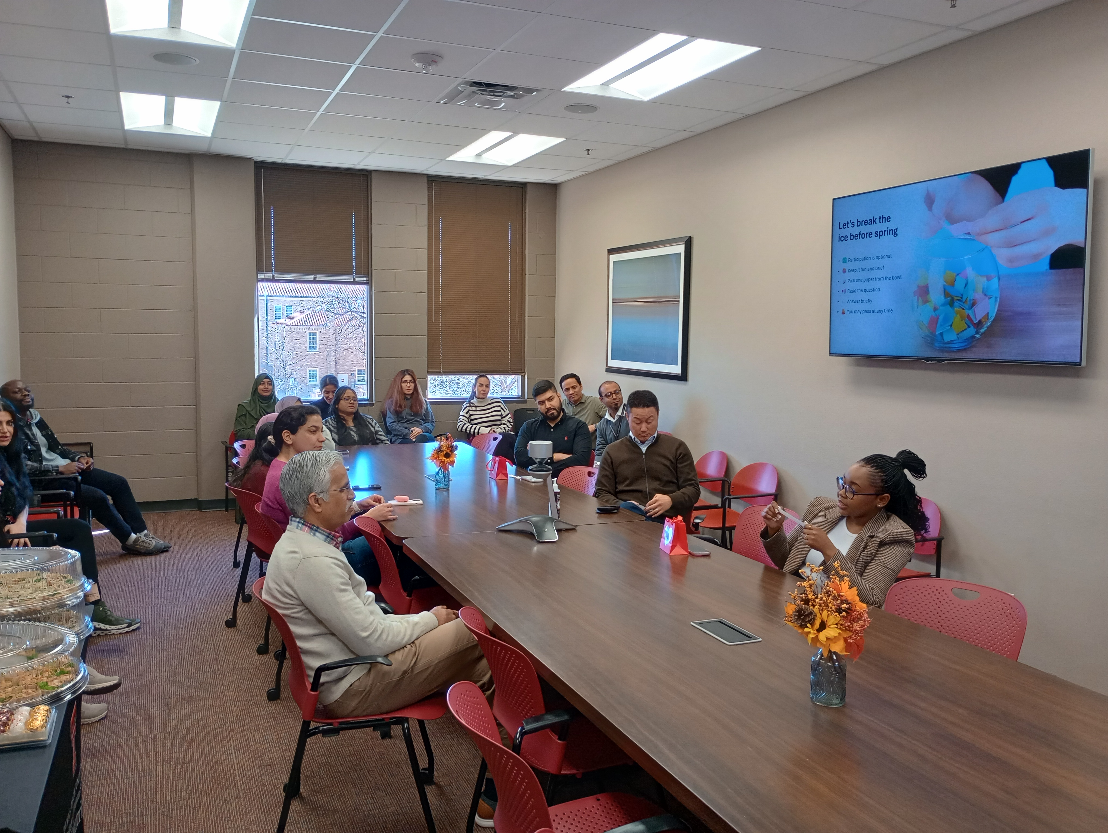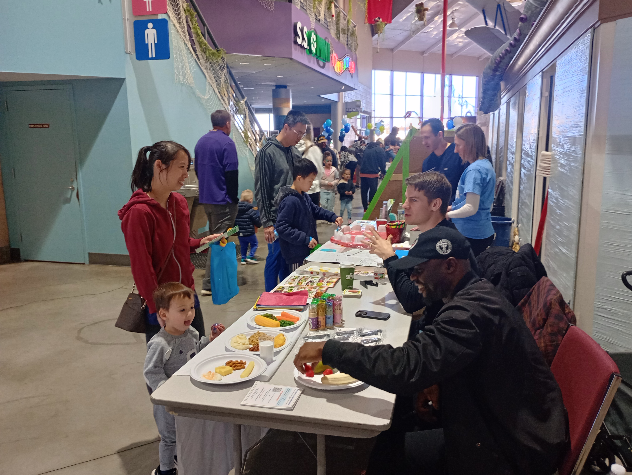
Spring Kickoff Give kids a smile

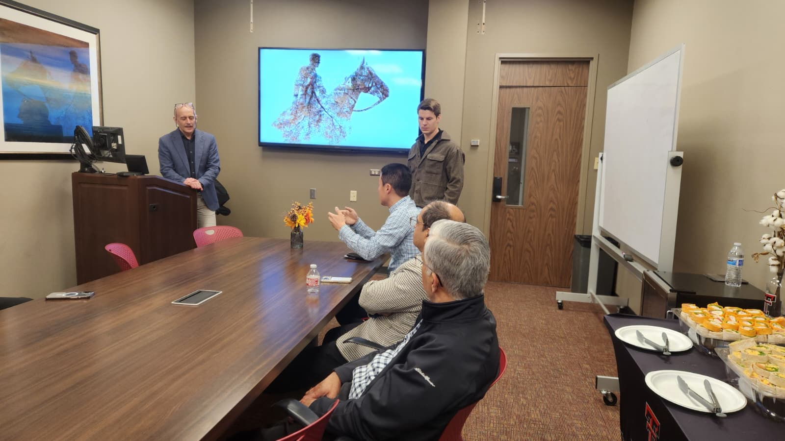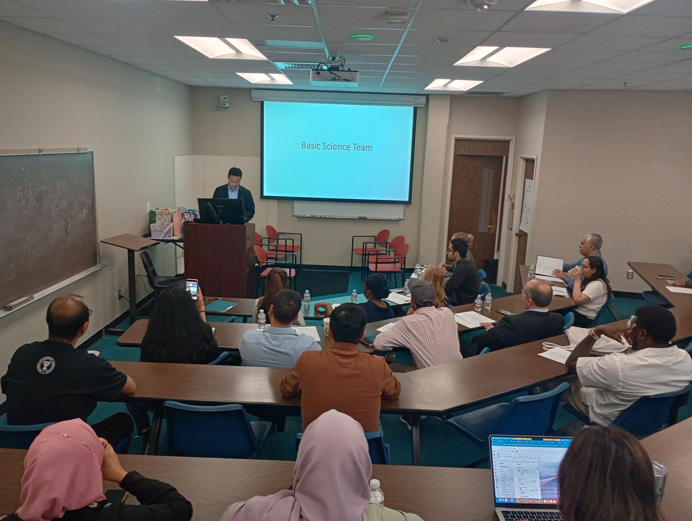
Guest Lecture by Dr. Sergej M. Ostojic The Great Nutrition Debate

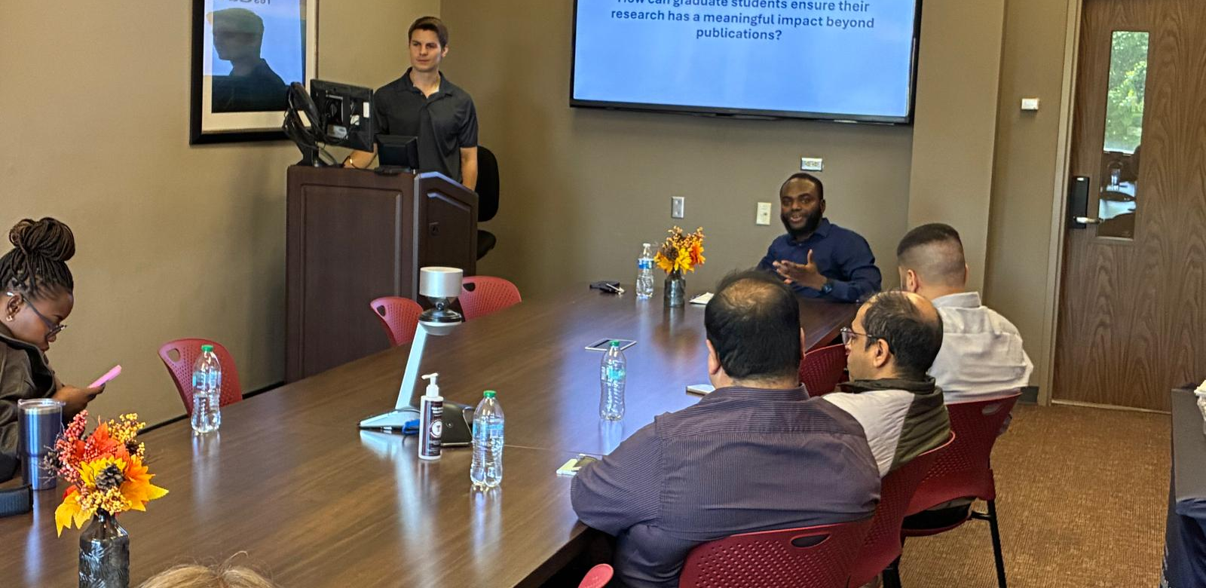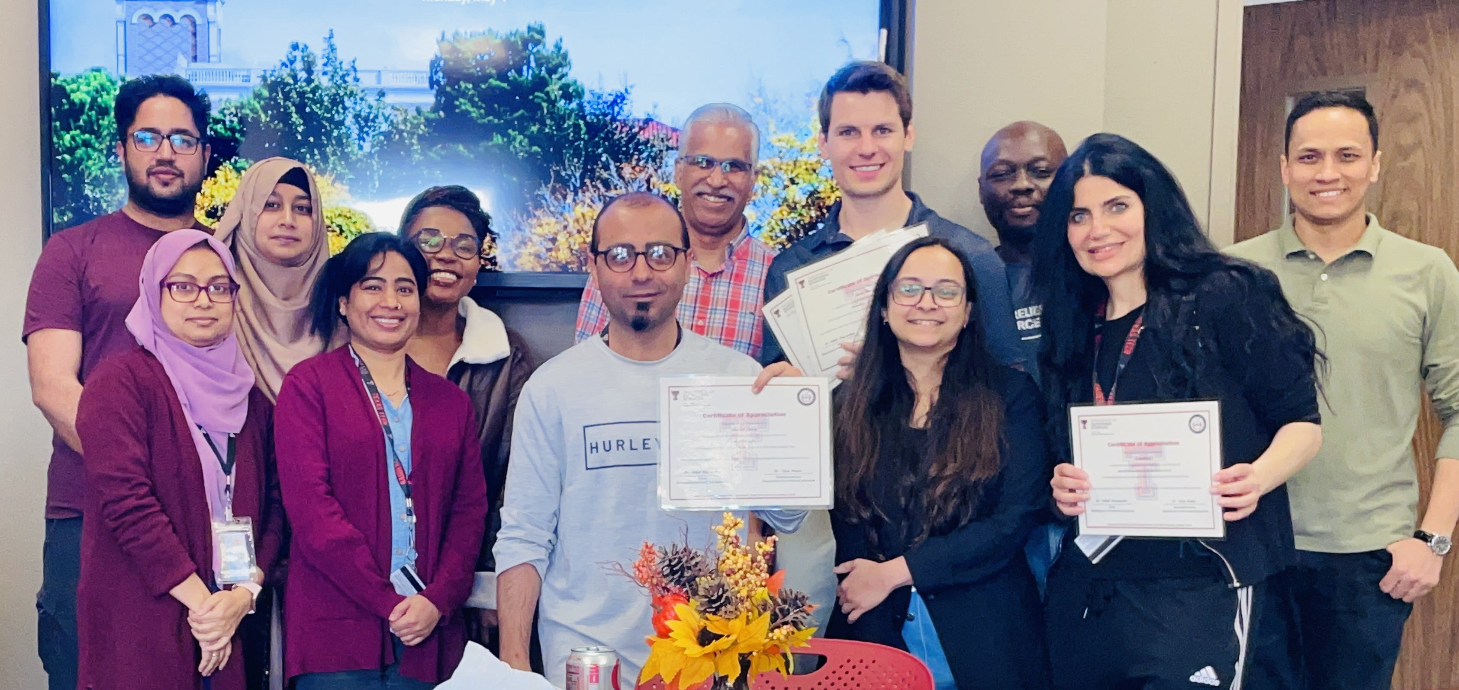
Career Development Seminar GNO Officer Transition & Appreciation Ceremony

Home Page Content
- Department Announcements
  - Learn about spring graduates, new appointments, and lab updates!

- Student Achievements
  - See what kind of awards NS Department students are receiving.

- Faculty Awards
  - Get the scoop on the latest faculty member awards!

- Funding
  - Check out our funded projects.

- Abstracts, Publications, and Invited Lectures and Miscellaneous
  - Discover the revolutionary research and efforts being done by students and faculty!

- In the Media
  - Catch up on all our media-worthy news items.

- Contact Us
  - Share your comments and suggestions. Email the editor Tanvi Kale (takale@ttu.edu) whenever you receive awards or funding; appear in the media, or have lab updates, publications, presentations, or other achievements you wish to share. We look forward to hearing from you! Add my email and name

- Follow Us
  - Like and follow us on Facebook, Instagram, and Twitter to keep up with the latest NS news!
  - Facebook: Texas Tech University Department of Nutritional Sciences (@TTUNSc) https://www.facebook.com/TTUNSc/
  - Instagram: TTU Nutritional Sciences (@ttunutr) https://www.instagram.com/ttunutr/

  - Twitter: TTU Nutritional Sciences (@TTUNSc) https://twitter.com/TTUNSc

