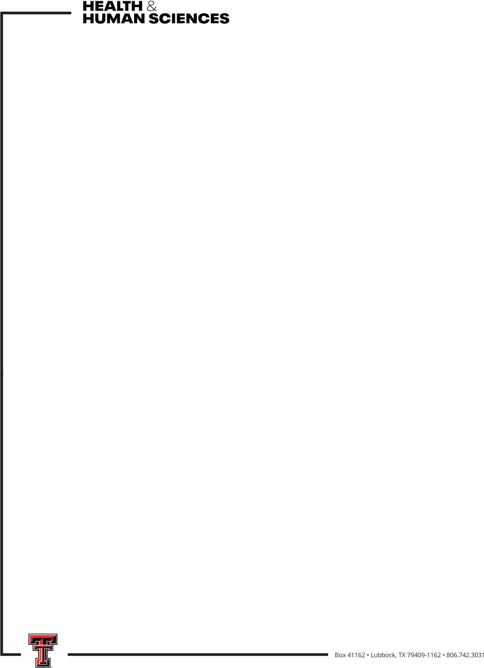

2026-2027 CHHS Cancer Research Seed Grant
The Cancer Research Seed grant is to support CHHS faculty to conduct projects related to any aspect of cancer and/or cancer treatment (i.e., physiological or behavioral). Faculty are encouraged to consider a project with collaborators from various disciplines, including colleagues from outside of TTU and from the TTUHSC. Projects should have the potential for high scientific reward and result in the submission of a federal grant proposal.

Who is eligible?
- Full-time CHHS tenure-track faculty

What is the grant amount and what can it be used for?
One grant of $15,000 will be awarded and can be used for materials and supplies necessary to conduct the research (including the cost of human subject participation, hourly graduate or undergraduate assistant support, etc.). Faculty salary, graduate assistantships, and travel are not allowed.

What is required in the proposal?

The proposal is limited to 3 pages and includes:
- Description of the research project, including methodology
- Potential impact on the field of cancer research/treatment
- Detailed timeline for project completion
- Detailed budget and budget justification
- Identification of federal grant to be applied for based on the proposed project

How will proposals be reviewed?
Proposals will be evaluated based on
- Submitting a complete application, including federal grant
- Clarity of research project
- Scientific merit/potential impact
- Feasibility/detailed timeline of the project
- Appropriate budget and budget justification

Who will review the proposals?

Members of the CHHS Research Committee will review proposals and make recommendations to the Associate Dean for Research. Members of the Research Committee are eligible to apply and will not review their own proposals.

When is the proposal due?
October 23, 2026 by 5pm
When does the grant money need to be spent/encumbered?
December 31, 2027
When is a report of grant activity due?
January 31, 2028

