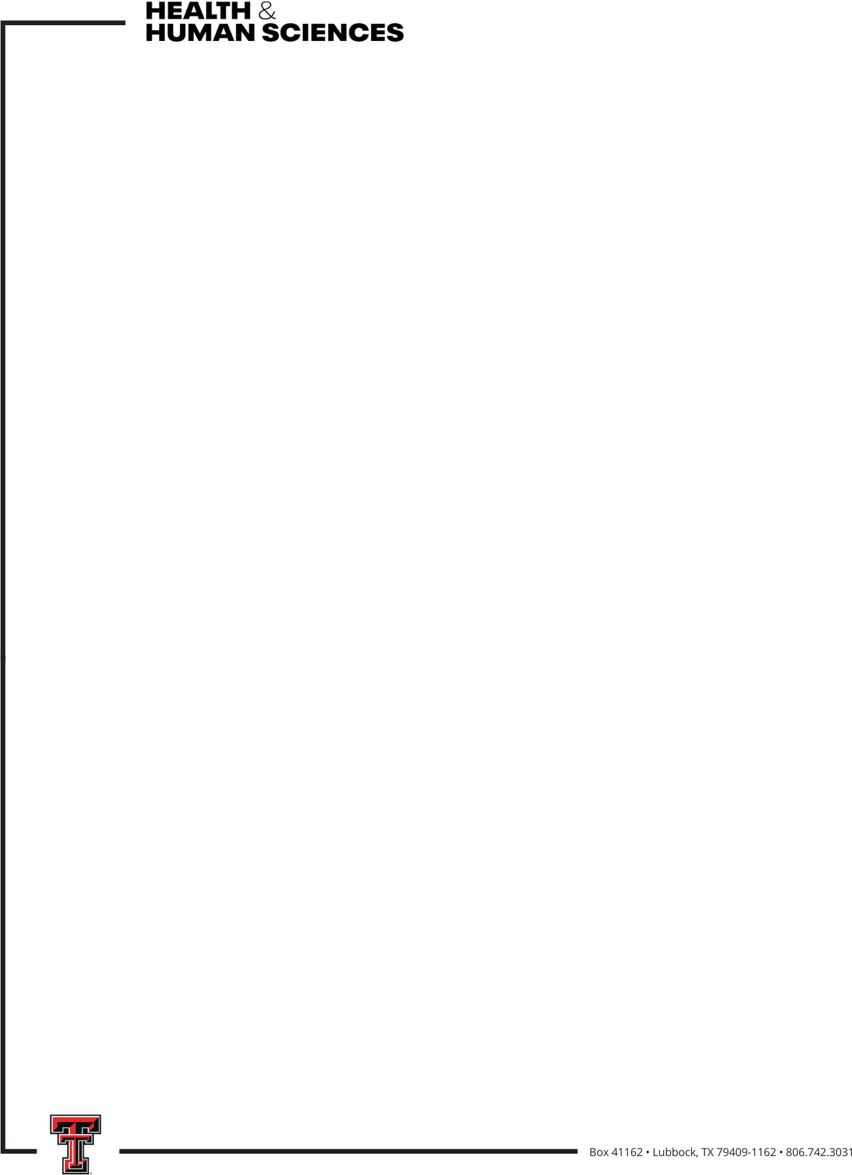

2026-2027 CHHS Cross-College Collaboration Grant
The CHHS Cross-College Collaboration Grant is to support faculty to collaborate with faculty in another college on a pilot research project. The collaboration may be a partnership with a new faculty member or a new project with an existing collaborator.

Who is eligible?
- Full-time CHHS faculty (professors of practice and tenure-track faculty) without current start-up and faculty who do not hold endowed professorships/endowed chair positions. The Co-PI must be a faculty member in another TTU college.

What is the grant amount and what can it be used for?
Two grants of $10,000 each will be awarded and can be used for materials and supplies necessary to conduct the research (including the cost of human subject participation, hourly graduate or undergraduate assistant support, etc.). Faculty salary, graduate assistantships, and travel are not allowed.

What is required in the proposal?
The proposal is limited to 3 pages and includes:
- Description of the research, including methodology and potential impact
- Detailed timeline for project completion
- Detailed budget and budget justification
- Description of the roles of the mentor and mentee
- External grant to be applied for based on the results of the project

How will proposals be reviewed?
Proposals will be evaluated based on
- Submitting a complete application, including external grant
- Clarity of research project
- Scientific merit/potential impact
- Feasibility/detailed timeline of the project
- Appropriate budget and budget justification

Who will review proposals?Who will review proposals?

Members of the CHHS Research Committee will review proposals and make recommendations to the Associate Dean for Research. Members of the Research Committee are eligible to apply and will not review their own proposals.

When is the proposal due?
January 29, 2027 by 5pm
When does the grant money need to be spent/encumbered?
March 31, 2028
When is a report of grant activity due?
April 30, 2028

