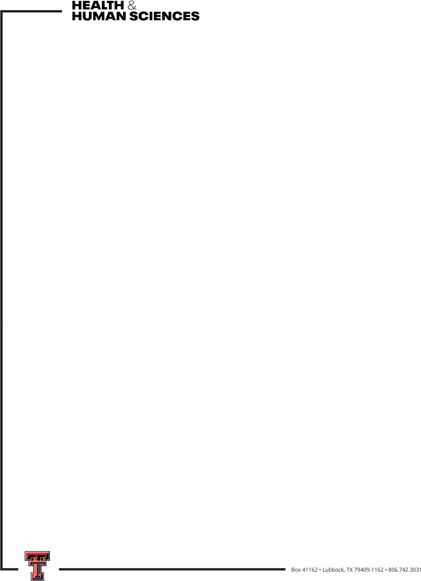

2026-2027 CHHS Health and Wellness Research Grant
The Health and Wellness Grant is for CHHS faculty to conduct pilot projects related to any aspect of health and wellness (e.g., psychological well-being, relationships, environments, nutrition, tourism, etc.). Recipients of this grant will be expected to submit an external grant proposal using preliminary data generated by this seed funding as the foundation of their submission.

Who is eligible?
- Full-time CHHS faculty (professors of practice and tenure-track faculty)
- Priority will be given to proposals with faculty from 2 or more units in CHHS

What is the grant amount and what can it be used for?
Two grants of $20,000 each will be awarded and can be used for materials and supplies necessary to conduct the research (including the cost of human subject participation, hourly graduate or undergraduate assistant support, etc.). Faculty salary, graduate assistantships, and travel are not allowed.

What is required in the proposal?
The proposal is limited to 3 pages and includes:
- Description of the research, including methodology and potential impact
- Detailed timeline for project completion
- Detailed budget and budget justification
- External grant to be applied for based on the results of the project

How will proposals be reviewed?
Proposals will be evaluated based on
- Submitting a complete application, including external grant
- Clarity of research project
- Scientific merit/potential impact
- Feasibility/detailed timeline of the project
- Appropriate budget and budget justification
- Interdisciplinary: faculty from 2 or more units

Who will review proposals?

Members of the CHHS Research Committee will review proposals and make recommendations to the Associate Dean for Research. Members of the Research Committee are eligible to apply and will not review their own proposals.

When is the proposal due?
October 23, 2026 by 5pm
When does the grant money need to be spent/encumbered?
December 31, 2027
When is a report of grant activity due?
January 31, 2028

