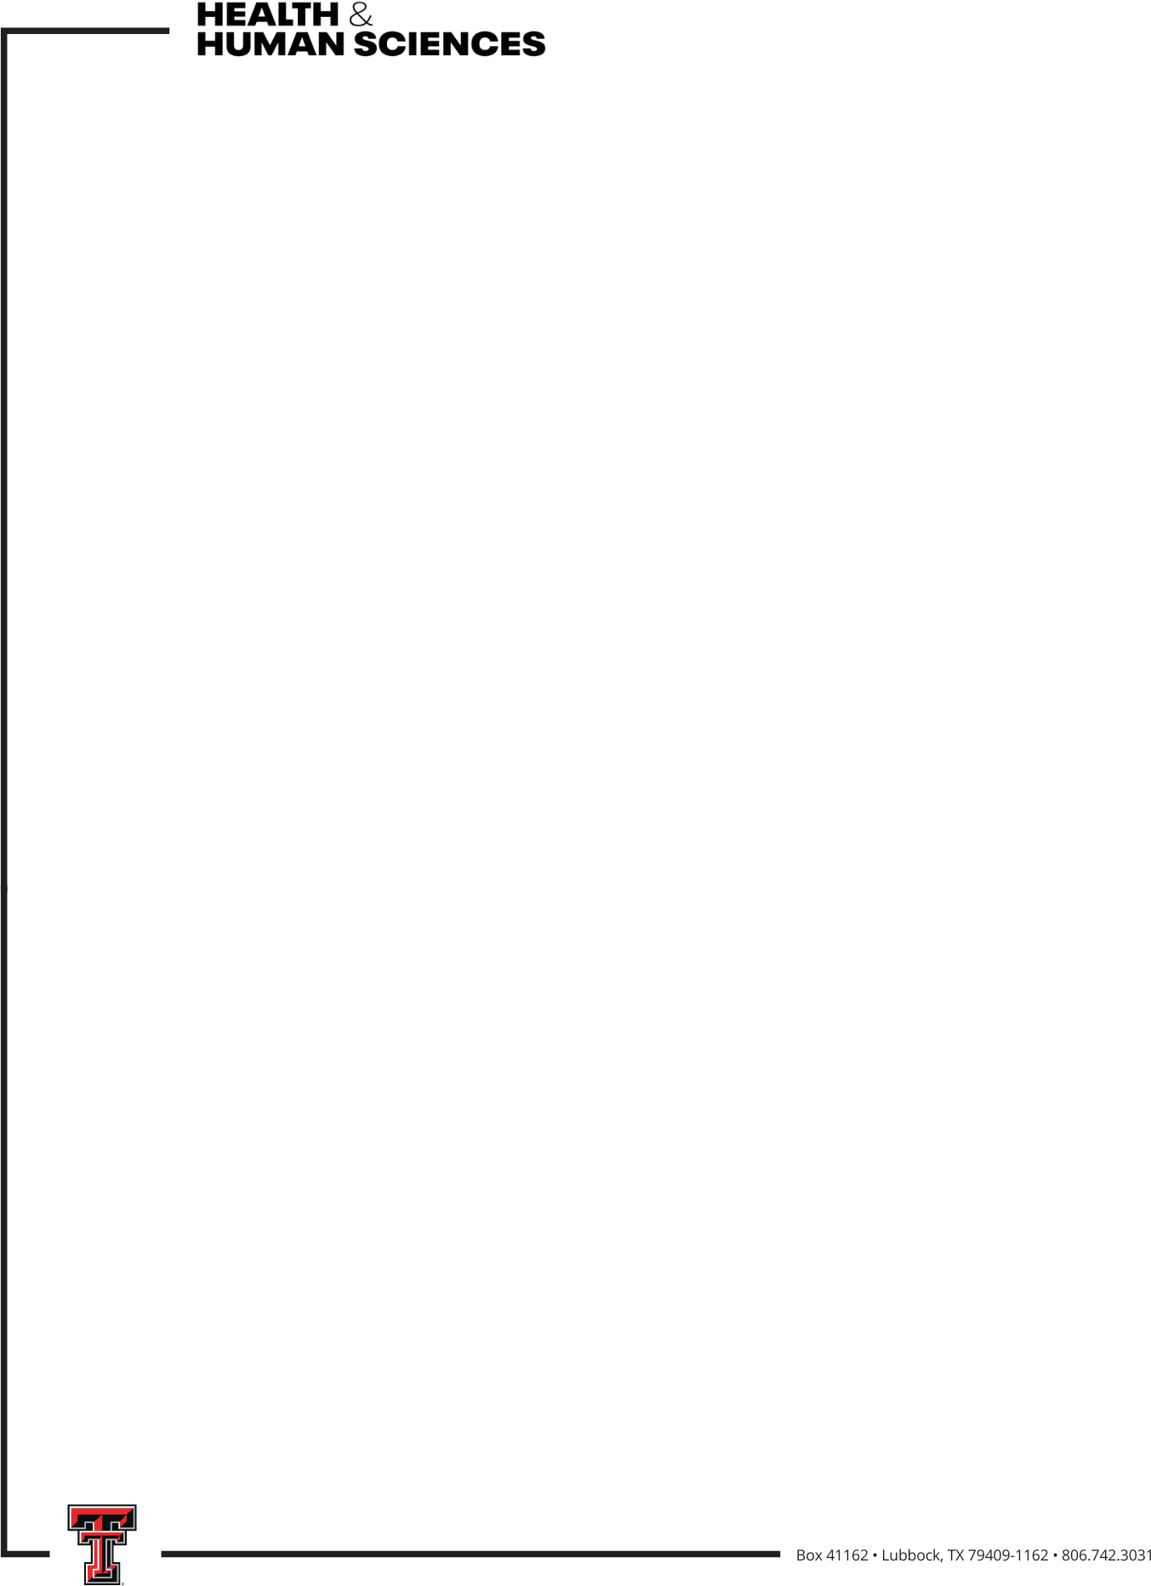

2026- 2027 CHHS Mid-Career Faculty Grant
The Mid-Career Faculty Grant is to support tenure-track Associate Professors to support their work toward career progression to Professor.

Who is eligible?
- Tenure-track CHHS associate professors without endowed professorships/endowed chair positions and who have not previously received this award

What is the grant amount and what can it be used for?
Seven awards of $10,000 each will be made (1 in each of the 7 units in the college), depending on the quality and number of proposals. Funds may be used for course buyouts, summer pay, travel, and other research expenses (e.g., human subject payments, animal costs, etc.). Work related to this award will occur between Summer 2027 and Fall 2028.

What is required in the proposal?
The proposal is limited to 3 pages and includes
- Detailed description of proposed work/focus of your research
- Explanation of how this work will promote career progression
- Detailed timeline for completion of proposed project(s)
- Detailed budget and budget justification
How will the proposal be reviewed?
Proposals will be evaluated based on
- Submitting a complete application
- Clarity of proposed work
- Evidence of how the proposed work will promote career progression to full professor
- Feasibility/detailed timeline of the project
- Appropriate budget and budget justification

Who will review the proposal?

The Associate Dean for Academics and Faculty and the Associate Dean for Research will review proposals.

When is the proposal due?
March 5, 2027 by 5pm
When does the grant money need to be spent/encumbered?
December 31, 2028
When is the report of grant activity due?
January 31, 2029

