

ICASALS Vision
Arid Land Studies and
International Development

The International Center for Arid and Semiarid Lands Studies (ICASALS) was founded in 1966 at Texas Tech University to foster interdisciplinary research and education concerned with improving the quality of life in arid and semiarid regions of the world. At the present time, ICASALS activities are focused on water resources and water related topics. These are important issues not only to the region where Texas Tech is located, but also in the western Great Plains and many other places in the U.S. and the world.
ICASALS has carried out projects in arid and semiarid lands for over 40 years. Most of these projects were undertaken outside the U.S., involving water resources and water related issues such as water supply and conservation, ground water management, irrigation, farming, urban and rural development, and the use of alternative energy sources. A characteristic common to all projects has been the need for the participation of specialists with different expertise to create solutions for complex problems.

Cover image by Eleanor Brown.

(ICASALS)
The economic development of arid and semiarid lands is closely related to the availability of water resources. Drylands are a special type of sparsely populated areas that are generally dependent on government programs and subsidies. Therefore, it is critical that any proposed development program for these areas be designed by specialists with a broad understanding of arid and semiarid lands to minimize the chance of failure that would represent an additional burden to government resources.

Significance and Location
More than 50 percent of the State of Texas, approximately one-third of the United States, and one-third of the earth’s land surface are classified as arid or semiarid. Being situated in a semiarid region of the United States, adjacent to arid regions and an international border, Texas Tech University is ideally suited for arid and semiarid research activities. ICASALS provides the unique ties that bind nations and people in the arid and semiarid areas of the world.

NON-PROFIT ORG
U. S. POSTAGE
LUBBOCK, TX
PERMIT #764

Texas Tech University
International Cultural Center
Box 45004
Lubbock, TX 79409-5004

CALL FOR ENTRIES

The International Cultural Center
of Texas Tech University’s
Office of International Affairs announces
a Call for Entries for the 15th annual
juried exhibition

HIGH AND DRY:
A photographic exhibition of peoples
& places of the world’s dry lands.

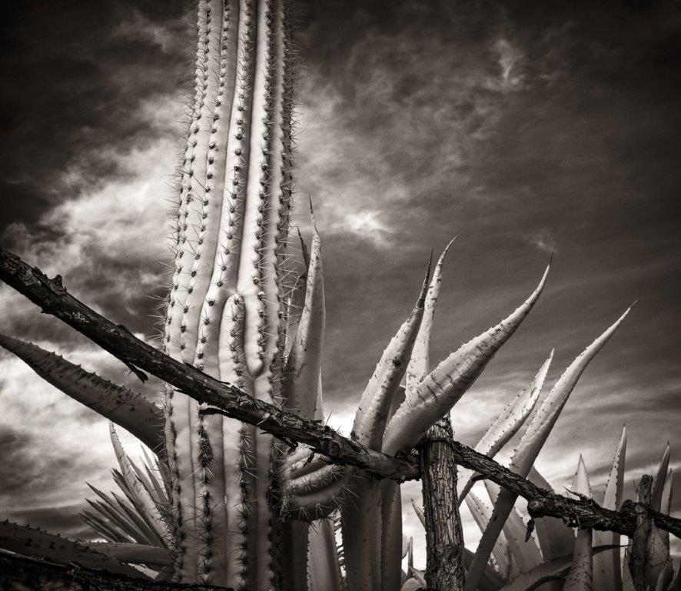
Photo by Eleanor Brown, High and Dry, 2014

Juror: Miguel Gandert

Over $1,000 in cash prizes

Miguel Gandert, Juror
Miguel Gandert, one of America’s leading documentary photographers, has been photographing the social rituals, people, and landscapes of his native New Mexico for four decades. His photographs have been exhibited widely in museums and galleries throughout the world, including the Whitney Museum of American Art and the Smithsonian Institution’s National Museum of American History. His series Nuevo Mexico Profundo: Rituals of an Indo-Hispano Homeland was the subject of a book and a one-person exhibition for the National Hispanic Culture Center of New Mexico, and his work was selected for the 1993 Whitney Museum Biennial.
Gandert's books of photographs include In the Country of Empty Crosses: The Story of a Hispano Protestant Family in Catholic New Mexico (2012) by Arturo Madrid; The Plazas of New Mexico (2011); Nuevo México Profundo: Rituals of an Indo-Hispano Homeland (2000); Hermanitos Comanchitos: Indo-Hispano Rituals of Captivity and Redemption (2003); The Pilgrimage to Chimayo: Contemporary Portrait of a Living Tradition (1996), and Upper Rio Grande Hispano Farms Study (1996).
A native New Mexican and descendant of Spanish settlers, Gandert’s common ancestry with his subjects has produced an insider’s view of contemporary Hispanic culture which maintains deep roots with the past. He is a Distinguished Professor of Communication and Journalism at the University of New Mexico and the Director of UNM's Interdisciplinary Film and Digital Media Program.

CALENDAR OF EVENTS
Oct 02 (Friday) Entries due at the I.C.C.
Oct 23 (Friday) Notification sent to entrants
Nov 13 (Friday) Matted prints due in the I.C.C.
Nov 20 (Friday) Exhibit goes up
Dec 04 (Friday) Reception for exhibitors
Jan 15 (Friday) Exhibit comes down

CALENDAR OF EVENTS
Oct 05 (Monday) Entries due at the I.C.C.
Oct 26 (Monday) Notice sent to photographers
Nov 16 (Monday) Matted prints due to the ICC
Nov 23 (Monday) Exhibit goes up
Dec 04 (Friday) Reception
Jan 20 (Wed) Exhibit comes down

SUBJECT MATTER

Images must be from an arid or a semiarid region. That region will be specified on your exhibit label should your work be selected (i.e., Palo Duro Canyon; Santa Fe, NM; etc). As long as the work reflects some aspect of the arid/semiarid theme (be it people, animals, or landscapes), the choice of subject is up to the photographer. Entries deemed inappropriate for display at the International Cultural Center, a facility open to all age groups, will not be accepted. Entries must be submitted on a CD.

HOW TO ENTER DIGITAL FILES ON CD
1. Enclose one check to cover the entry fee of $6.00 per digital image, limit 5. If CD contains more than 5 images, only the first 5 will be considered. Checks payable to Texas Tech University.

2. Files should be saved in JPEG format on high quality setting (not maximum).

3. Label each file with consecutive numbers followed by your name and title of the image; i.e. (1) Doe, Jane - Afghan Warrior (2) Doe, Jane - Desert Willow.

4. Fill out Entry Form and be sure the List of Entries is legible. Make sure that numbers and titles on the form match those on the CD. Payment, CD, and entry form must be received by October 5, 2015.

5. CDs will not be returned unless specifically requested. A CD envelope with return postage must be included for returns.

ELIGIBILITY

The exhibition is open to amateur and professional photographers. Photographs submitted must not have been previously exhibited in Lubbock. Entrants warrant that they have copyright to all submitted work. If the print delivered does not accurately represent the digital file, we reserve the right to refuse the image.

AWARD
First Place $600; Second Place $300; Third Place $150

FEES
Photographers may submit up to 5 CD images at $6 each for a non-refundable fee of up to $30.

LIABILITY
The I.C.C. will exercise due care in CDs and prints, but will not be responsible for loss, damage, or replacement during selection, exhibit, or shipping.

REPRODUCTION
The I.C.C. will have the right to display, project and reproduce work accepted for this exhibition for publicity and promotional purposes only. Individual photographers retain copyrights to their individual works.

SPECIFICATIONS
Color and black & white photographs are eligible. Final matted size of submissions must be 16” X 20” with at least 2” borders surrounding the photograph on all sides. (Due to gallery limitations, three-dimensional works cannot be accepted).

ENTRY FORM INSTRUCTIONS

1. List the title of each work as it appears on the entry form
and the CD. Print your name and address on the entry form.
Notification will be mailed to you immediately following the
juror’s decision. It will be your official notification of the
juror’s selection and her decision is final. Any work which,
upon receipt, is deemed to have been misrepresented by the
digital image, or to be of poor technical quality, may be
omitted by the juror or the I.C.C.

2. If your work is accepted, please send one exhibition
quality matted print for each accepted image. Prints must
be mounted in pure white matte board with outside
dimensions of 16”X20”, with at least 2” of border showing
on all sides of the print. Include a check payable to
Texas Tech University for return postage at the
conclusion of exhibit unless you plan to pick up your work.
Prints will be returned in the container in which they were
received. Prints WITHOUT postage will not be returned.

3. Send prints to:
JANE BELL
TEXAS TECH UNIVERSITY
INTERNATIONAL CULTURAL CENTER
601 INDIANA AVE
BOX 45004
LUBBOCK TX 79409-5004

Please fill out this form. Mail along with your CD, an entry fee and your SASE (only for specified CD return) to:

JANE BELL
TEXAS TECH UNIVERSITY
INTERNATIONAL CULTURAL CENTER
601 INDIANA AVE
BOX 45004
LUBBOCK TX 79409-5004

Questions: Jane Bell at (806) 742-3667
Email: jane.bell@ttu.edu
Or
Christi Felton at (806) 742-3667
Email: christi.felton@ttu.edu

ENTRY FORM

Name: __________________________________

Address: __________________________________

City: __________________________________

State/Zip: __________________________________

Home Phone: __________________________________

Work Phone: __________________________________

Email Address: __________________________________

Local participants who would like to pick up their entry after the show please answer (circle one):

Use SASE to return Please call or e-mail for pick up

Sponsored by The CH Foundation and the
Office of International Affairs

LIST OF ENTRIES
(Exhibit labels will be made from this information)

Photo Title

1. ______________________________________________________

2. ______________________________________________________

3. ______________________________________________________

4. ______________________________________________________

5. ______________________________________________________

Region where photo was taken

Photo #1:________________________________________________

Photo #2:________________________________________________

Photo #3:________________________________________________

Photo #4:________________________________________________

Photo #5:__________________________________________________

