ONENOTE

IT Learning Technologies ShortCourse Handout

Jacob Crowder

Contents

Introduction 4
Course Objectives 5
Creating a Notebook 6
OneNote Interface 7
Definitions 9
Pages 10
Paragraph Handle 10
Entering Information on Pages or Subpages 10
Applying Tags to Notes 11
Follow-along Activity 13
Adding Sections 13
Adding Pages 13
Type a Note and Format Text 14
Insert a Table 14
Modifying a Table 15
Adding a Subpage 16
Adding Content to a Subpage 17
Creating Tags 18
Inserting Tags in a Subpage 18
Inserting a File and a Link 19
Deleting a Page and Inserting Pictures 20
Inserting a Video 21
Using Pen Mode and Converting Handwriting 22
Formatting a List and Inserting an Internet Screen Clipping 23
Inserting an Outlook Meeting 24
Saving a Notebook 26
Sending a Copy (of a Page) of Your Notes to a Different Location 26
Deleting Sections 26
Add Writing Space to a Page 27
Using Shared Notebooks 27
Sharing a OneNote Notebook with Others 28
Editing Permissions After Sharing a Link 29
Deleting a Notebook 29
Inserting a Document or File as a Printout 30
Repositioning and Resizing a File Printout Picture on the Page 30
Showing Authors in a Share Notebook 31
Reviewing Recent Notes in a Notebook 31
Performing a Simple Calculation in Your Notes 32
Examples of Simple Calculations 32
Supported Arithmetic Operators and Math Functions 33
Using the Translator 33
Applying a Password to a Section 33
Ways to Use OneNote at Work 35
Getting Things Done! 35
Shared Notebooks 35
Online Resources 35
Where to Get Help 35

Microsoft OneNote
Copyright 2026 Technology Support, Texas Tech University. ALL RIGHTS RESERVED. Members of Texas Tech University or Texas Tech Health Sciences Center may print and use this material for personal use only. No part of this material may be reproduced in any form without written permission from Maggie Corrigan, ShortCourse Program Manager.

Introduction
Microsoft Office OneNote is a note-taking software that was introduced in Microsoft Office 2003. OneNote is an electronic version of a paper notebook where you can write down notes, ideas, and reminders, whether you are taking notes in a classroom or in a meeting.
With OneNote you can gather and organize text, images, digital handwriting, audio and video recordings, and more - all in one digital notebook on your computer. Images (screen captures, embedded document scans or even photographs) can be searched for embedded text content.

With OneNote you have the ability to write anywhere, assign "tags" to notes, copy and drag from any application, webpage, and PDF into a OneNote page, and have it enter the link where it came from directly below it, create Outlook tasks or appointments, even contacts directly from the notes. You can record audio and/or video directly into a note page, you can password protect sections, you can draw, highlight, and email.

OneNote is commonly used on laptops or desktop PCs, but it is particularly well-suited for use on pen-enabled Tablets, in environments where pen, audio or video notes are more appropriate than an intensive use of keyboards. OneNote is an ideal tool for research, meetings, and lectures.

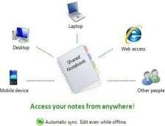

Course Objectives

After completing this ShortCourse, you should be able to:
- Perform basic editing techniques;
- Insert images, web Links and other media into your notes;
- Create and delete sections and pages;
- Integrate your notes with other applications;
- Flag notes for follow up;
- Search your Notes;
- Create Shared notebooks;
- Save and Share files in the Cloud;
- Send notes as email messages;
- Create screen clippings;
- Perform simple calculations;
- Translate text with Translator;
- Import documents as images;
- Password-protect your notes.

Creating a Notebook

  - Start the OneNote program (Search Bar -> OneNote (App)).
  - Click “File”, “New”, then “Browse”. Navigate to the file location where you want to store your Notebook.
  - In the Notebook Name box, enter a name for your new notebook, School for example.
  - Click the Create button.

  - Click the Hamburger icon to see all your existing notebooks.

  - Click the Hamburger icon again to hide the Notebook Pane.

  - Right-click on the notebook's name (on the Notebook pane, on the left) and select “Properties” to modify settings about the notebook, such as the “Display Name” or “Color”.
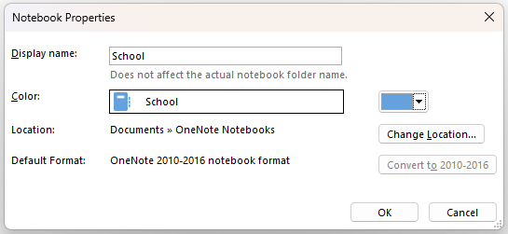

OneNote Interface
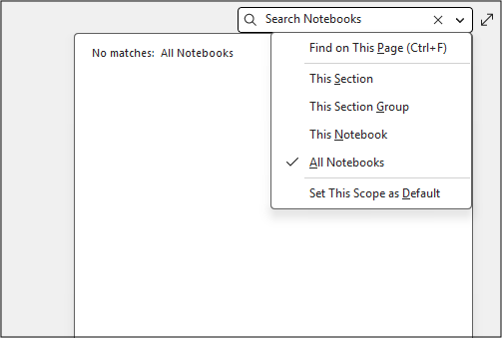
  - Search Box – Located on the right side of the screen. By default, the search box can only search page names and section names. To search within the contents of a page, you must have the page open and selected. You can designate which notebook you want to search from (or all notebooks).

  - Full Screen – to the right of the search box, there is a full screen icon. Clicking this icon will expand the current page to fit the screen, and minimize all other open tabs/boxes.

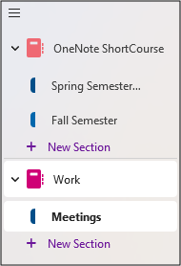
  - Navigation Pane – The leftmost panel on the screen. Lists the names of all open notebooks, which can be expanded to show the sections within them.

  - Quick Notes – Quick Notes are effectively ‘Sticky Notes’ in OneNote. Short notes that you can take that automatically save in a specific location within OneNote. Create Quick Notes even without having OneNote open by pressing Windows + Alt + N on your keyboard, type your note in the window that appears, then close it. The quick note will save automatically to your Quick Notes notebook. To access this notebook, open the Navigation Pane, and click “Quick Notes” on the bottom.

Definitions
  - Notebook title- The name of the notebook that you are currently working in appears here.
  - Section – A section is equivalent to a chapter or unit of a book. Each section contains individual pages; pages are where information is stored. Sections can be grouped
together into Section Groups for organization. Sections can also be color coded by right clicking the section and clicking “Section Color”.
  - Section tabs- A vertical row of section tabs on the left of the notes page provides easy access to each section in the current notebook. You can drag section tabs up or down to the locations you prefer and right-click a tab to display formatting and organization options. OneNote data is stored in files called sections, which have a .one extension.
  - Pages Pane- A pane on the left side of the screen, in-between the Navigation Pane and the Currently Open Page. This pane vertically lists every page within the currently open section. Navigating from one page to another is as simple as clicking on a page within the Pages Pane.
  - Add Page-This button quickly creates new pages below whatever active page you’re on.
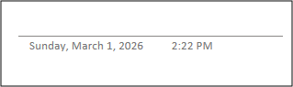
  - Page title-In this text box, you can type or write a title for the current page. OneNote automatically duplicates the titles of your pages in their respective page tabs.
  - Notes container-The boxes that contain typed or handwritten notes are called note containers. Aside from typed or handwritten text, note containers can also contain images, tables, graphics, and other objects. You can format, move, resize, and even merge notes containers on the pages in your notebook.

  - Subpages – Any page can be designated as a subpage of another page, referred to as the parent page. To do this, click and hold the page, and drag to the right, or, select the page, right click it, and click ‘Make subpage”.
  - Tags – Tags are visual/organizational icons you can apply to content within a page. These can be used to visually organize content or can be used for actions such as reminders or to-do lists.

Pages

  - Pages in OneNote are where you capture your notes within the individual sections you have created.
  - Page tabs are arranged vertically along the left side of a page, inside of the Pages Pane.
  - To move between pages, click the appropriate page.
  - New page tabs are added after the active page.
  - To delete a page, right-click the appropriate page tab and then click “Delete Page.”

Paragraph Handle
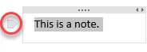
    - After you type some text, an icon appears to the left of each paragraph of text as you move the pointer over the note container on the current page.
    - Use paragraph handles to drag text paragraphs to new locations on the page, or right-click a paragraph handle to view additional information and formatting options.
    - To copy or cut text from one page to another page, right-click the note container, click copy or cut on the shortcut menu, and then paste the notes to the page you want.

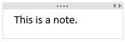
Entering Information on Pages or Subpages
    - Place the cursor at any position on a new or existing page. Begin entering data and a data "container" will appear to record the work.

    - If you use a tablet or touchscreen computer, OneNote will place handwritten or drawn material inside a container. If the tablet or multi-touch screen is pressure sensitive, OneNote will increase the width or density of the pen strokes, reflecting the pressure.
    - Each page can contain multiple containers. Containers can overlap, be arranged to the front or back, and be moved anywhere on a page.
    - Access bullet lists, number lists, and text styles from the "HOME" tab. This permits basic note formatting within the OneNote page.
    - Insert Tables, Files, Pictures, and Links from the Insert tab.
    - Insert “Printouts” from Word, Excel, and PowerPoint documents using the “File
Printout” buttons on the Insert tab. Other files can be inserted as attachments, which inserts a button to open the file within its’ applicable application, but does not insert data directly from the file itself.
    - “Outlook Tasks” will connect to your Outlook calendar and allow you to enter the date, time, and details for a meeting or appointment item.
    - You can also add audio and online videos.
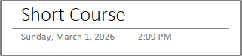
    - The Date and Timestamp displayed on a page shows the date and time when you first created the page (this cannot be edited).

Applying Tags to Notes
      - Tags provide an option for locating information. For example, you might tag notes that are to-do items, contacts, or websites to visit. And then, OneNote tags can be searched and sorted.
      - You can tag anything from a single line of text to an entire paragraph.
      - Place the cursor at the beginning of the line of text you want to tag. Click Home, click the Tag  icon, then choose the icon of the tag you want to apply.
      - To remove a single tag, backspace to delete the tag or click anywhere within the tagged text, then reselect the same tag from the Tag This Note list.

      - You can also click anywhere in the line of text that is tagged and press CTRL+0 to remove a tag.
      - To remove multiple tags, select all the text containing the tags you want to remove, and then press CTRL+0.

Follow-along Activity

Adding Sections
- Right-click New Section 1, choose “Rename Section,” and type Classes. Press the Enter key.
- To create more sections, click the Add Section tab at the bottom left of the page, and create sections for Student Events, and Science Fair.
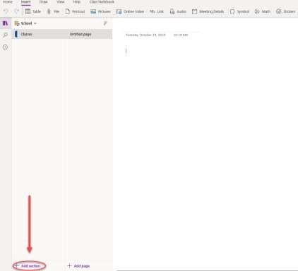
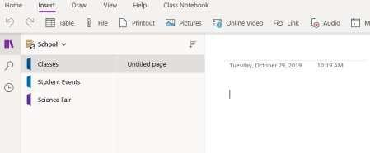

Adding Pages
  - In your School notebook, click the Classes section in the top left corner of the screen in the Navigation Pane.
  - To rename the page, at the blinking cursor, type: Class Schedule and press Enter.
  - To create a new page, in the Pages Pane, click Add Page, and at the blinking cursor, type: English and press Enter.
  - Repeat Step 3 to create the following four additional pages: U.S. History, Algebra, Chemistry, and Computer Science.

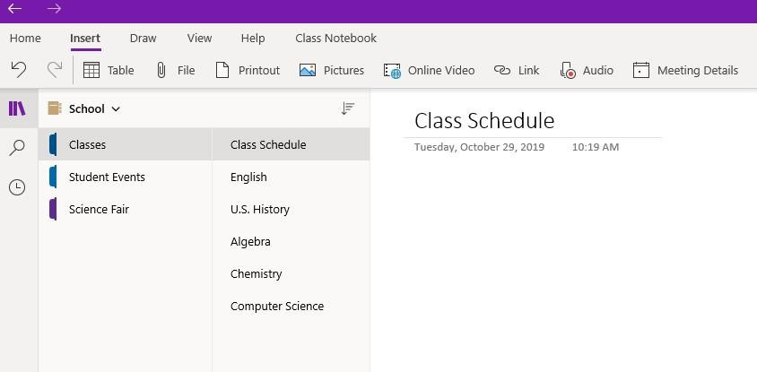

Type a Note and Format Text
Notes in OneNote are contained in containers. After a page is named, a note container with a blinking cursor appears automatically below the title. You can start a new note by clicking anywhere on a page and typing. The basic tools for formatting text in OneNote are similar to those found in other Microsoft applications.
- In your School notebook, click the Classes section. In the Pages Pane, click the “Class Schedule” page.
- In the note container, at the blinking cursor, type: First Semester:
- Select the text “First Semester:” by clicking and dragging over it.
- On the Home tab, click the Font Size drop-down arrow and select 14. Click Bold. Click the Font Color dropdown arrow and select Dark Blue. Deselect the text (click away from the container).

Insert a Table
- In your School notebook, in the Classes section, on the Class Schedule page, click to the right of the note container.
- On the Insert tab, click the Table button. In the Insert Table box, select 2x2 Table.
- In the first cell of the first row of the table, type: Period. Press the Tab key. Then type:
Subject. Press the Tab key.

- In the first cell of the second row, type: 1. Press Tab. type: English. Press Tab.
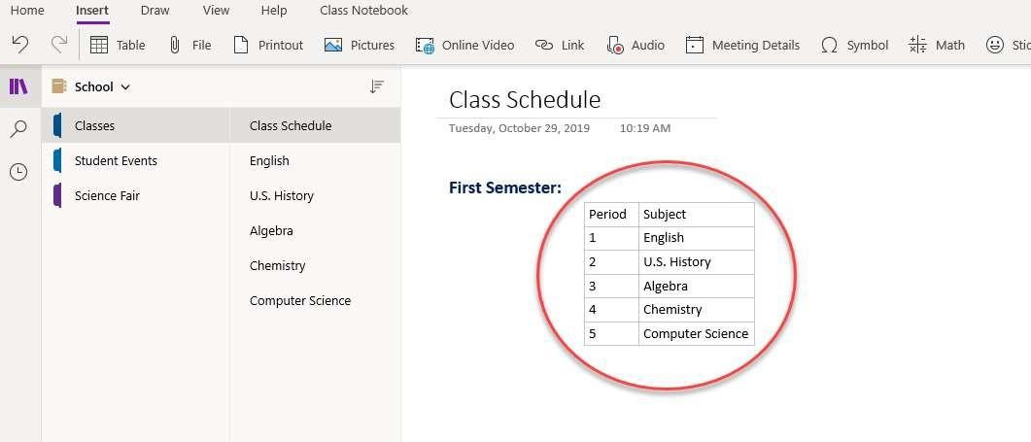
- Repeat Step 4 to add the following rows to the table:

Modifying a Table
- Position the cursor anywhere in the second column of the table you just created.
- On the Table tab, click the Insert Right button.
- Click in the top row of the new column and type: Teacher. Press the down arrow.
- In the second row of the new column, type: Smith. Press the down arrow.
- Repeat Step 4 to add the following information to the table:
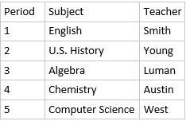
- Select all the cells in the first column of the table. On the Home tab, click the
Paragraph Formatting arrow button. Select the center alignment option.
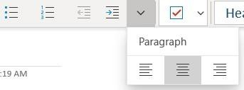

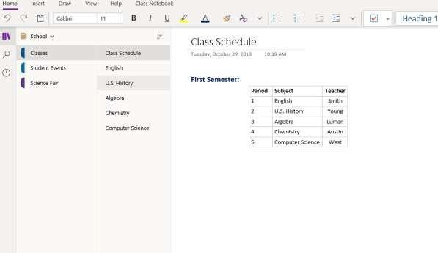
- Select all the cells in the first row of the table. On the Home tab, click Bold. Deselect the cells.

Adding a Subpage
- In your School notebook, on the Classes section, click the English page. Click “Add page” in the bottom of the page area to add a new page below English. Right-click the new “Untitled Page” and select “Make Subpage.”
- Click the new subpage and type “Day 1” on the title line of the notes page (above the date and time stamp). This will also rename the subpage name on the page tab.
- You can now hide/unhide the subpage by clicking the English page tab.

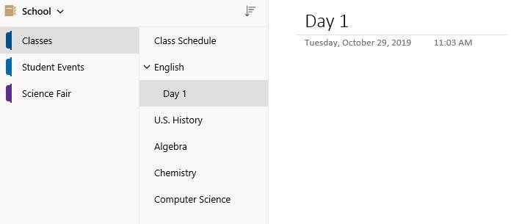

Adding Content to a Subpage
- In your School notebook, on the Classes tab, on the Day 1 subpage, type “Homework:” below the “Day 1” title. Select the text by clicking and dragging over “Homework.” After selecting the text, the short cut menu appears. Use this menu to change the font to 14, Dark Blue, and Bold (right-click over the note container if the menu disappears).
- To the right of your new “Homework” heading, create a new heading that reads “Today’s Topics:”. The font for this heading should also be 14, Dark Blue, and Bold.
- Below the “Homework:” heading, add a new heading titled, “Most Important Facts Covered Today:”.

Make the font 14, Dark Blue, and Bold.

Creating Tags
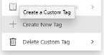
- Select the Home tab then select the Tag icon.
- Choose the Customize Tags option towards the end of the menu. Select New Tag…
- In the Display Name text box, type Pin. Open the Symbol drop-down menu and search for the pin icon 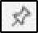 . Click Ok to finalize your selections. Click OK again to create the tag.
- Go through these same steps to create a new tag named Homework using the house icon  from the Symbols drop-down.
- To view the two new tags you’ve created, click the Tag icon on the Home tab, and they
should be the first two listed in the Tags drop-down.

Inserting Tags in a Subpage
- Return to the Day 1 subpage (School>Classes>English>Day 1). Click to the right of the colon next to Homework and hit enter.
- When your cursor is on the next line, go to the list of tags and choose the Homework tag (little house). Use the down arrow to go to the next line below this tag and add another Homework tag, so that you have two houses listed under the Homework heading.
- Repeat the above steps to add three Star tags under Most Important Facts Covered Today, and two pin tags under Today’s Topics. Your notes should look like the below example.

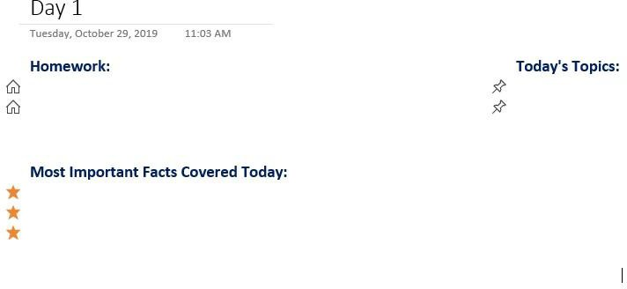

- Under Today’s Topics: click to the right of the first pin, and type: Shakespeare. Click to the right of the second pin and type: Sonnets. Change the font for both items to Calibri, 12, Black, un-bolded.
- Under Most Important Facts Covered Today, click to the right of the first bullet, and type (in Calibri, 12, Black, un-bolded):
  - William Shakespeare was an English poet and playwright who lived from 1564 to 1616.
- Repeat Step 2 to add the following text next to the second and third bullets (in Calibri, 12, Black, un-bolded):
  - Shakespeare wrote 154 sonnets.
  - A Shakespearean sonnet is a poem made up of 14 lines that rhyme in a fixed pattern.

Inserting a File and a Link
- In your School notebook, on the Classes tab, on the Day 1 subpage, under Homework: click to the right of the first bullet, and type: Read Shakespeare’s Sonnet 18. Change the font to Calibri, 12, Black, un-bolded.
- Click to the right of the second bullet, type: Research Shakespeare’s life. Change the font to Calibri, 12, Black, un-bolded.
- Click to the right of the note container for Most Important Facts Covered Today:

and on the Insert tab, click the File button.
- In the Choose a file or a set of files to insert dialog box, navigate to S:\Microsoft Office\OneNote\OneNote Exercise.
- Select the Sonnet 18 Word document. Click Insert. When asked “How do you want to insert this file?” choose Insert as Attachment.
- Double-click the Sonnet 18 icon to open the file. And then, close the Word document.
- Click below the second Homework entry, and then on the Insert tab, click the Link
button.
- In the Link dialog box, in the Text to display box, type: Folger Shakespeare Library, and in the Address box, type: https://www.folger.edu. Click Insert.
- Click the link. The Web site opens in your default Web browser. Close the browser window.
- To edit a Link (URL), right click the Link and then click Link > Edit Link on the shortcut menu.

Deleting a Page and Inserting Pictures
  - In your School notebook, on the Science Fair tab, click the Add Page tab to create a second Untitled page.
  - To name the page, type: Botanic Garden and press Enter.
  - In the Page Tabs, right-click on the first Untitled page. In the drop-down menu, select
Delete Page.
  - On the Botanic Garden page, the cursor should be blinking in a note container below the title. On the Insert tab, click the Pictures button then choose From File. Navigate to S:\Microsoft Office\OneNote\OneNote Exercise. Select the Butterfly image file. Click Open.
  - Repeat the step above to insert the Wild Flowers picture below the butterfly image. image files.
  - Click one of the images to select it. When the four-headed arrow appears, drag the image to the desired position. Adjust the positions of all two images as desired. You can also resize image as you see fit.

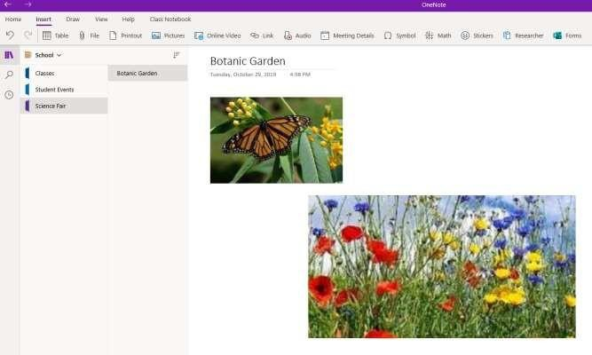

Inserting a Video
  - In your School notebook, on the Science Fair tab, on the Botanic Garden page, click in an open spot.
  - On the Insert tab, click the File button. Navigate to S:\Microsoft Office\OneNote\OneNote Exercise. Double-click the Wildlife sample video file. When asked “How do you want to insert this file?” choose Insert as Attachment.
  - Double-click the Wildlife video icon.
  - The video will open and play in a new window.
  - Close the video.

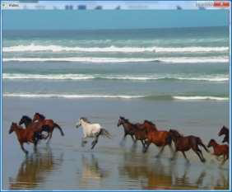

Using Pen Mode and Converting Handwriting
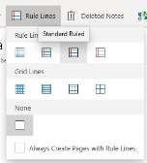
Using a tablet, you can create your own drawings and handwritten notes in OneNote. If you don’t have a tablet, you can draw or write by clicking and moving the mouse or by clicking and moving your finger on the trackpad. A powerful feature of OneNote is the ability to
convert handwritten text into type.
- In your School notebook, on the classes tab, on the Algebra page, on the View tab, click Rule Lines, and then select Standard Ruled.
- On the Draw tab, choose the first pen, which is the Black Pen (0.5 mm). To modify the pen weight and color, click a second time on the pen when the
arrow shows up in the bottom right corner , and select your preferences.
- Using the page rules as a guide, use your tablet pen to write: Goal: $1,000. If you do not have a tablet and pen, you can write by clicking and moving the mouse or by clicking and moving your finger on the trackpad.
- On the Draw tab, click the Select button  . Click and drag around Goal: $1,000 to select the entire handwritten item.
- On the Draw tab, click the Ink to Text button.

- Click the Select Objects or Type Text button 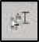 and correct any errors in the conversion.
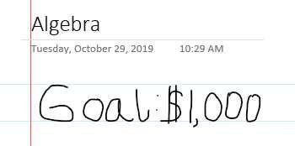
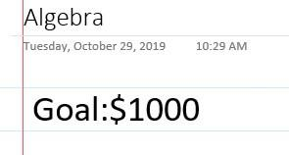

Formatting a List and Inserting an Internet Screen Clipping
Inserting a screen clipping involves taking a picture of all or part of your computer screen and choosing a OneNote page on which to place the image.
  - In your School notebook, click the Student Events tab. At the blinking cursor, type the page title: Opinion Article and press Enter.
  - In the note container that appears, type: Find a local news story. Press Enter. Type: Interview students and teachers to get their opinions about the story. Press Enter. Type: Write the article.
  - Select the text you just entered. On the Home tab, click the Numbering dropdown arrow 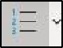. From the Numbering Library menu that appears, select the first format.
  - Open a Web browser window and go to http://www.ttu.edu news. Find a news story that
interests you.
  - Keeping the Web browser window open, search and open Snipping Tool in your desktop’s search bar.
Click New and select the area you want the snipping tool to copy.
  - Once the area has been “snipped,” write click the pictures and copy.
  - Return to OneNote. And then click below the text container containing the numbered list.
  - Right-click and select Paste or CTRL+V.
  - Click your news story to move it around the note page or to resize it.



Inserting an Outlook Meeting
OneNote integrates closely with Microsoft Outlook. OneNote can track meetings and appointments that are set up in your Outlook calendar.
  - Create a Microsoft Outlook appointment
  - In OneNote, on the Home tab click the Meeting Details button. When the Meeting Details menu opens. Click the down-arrow to the right of Today’s Meetings, and select the day that has the meeting you are wanting to choose.
  - When meetings for that date open, choose one. The meetings details will be pasted into your note.

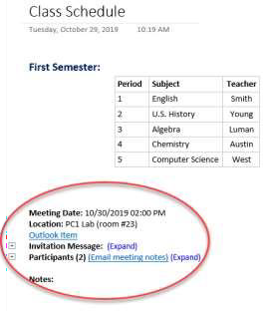

Saving a Notebook
  - There is no Save button on the toolbar.

  - OneNote automatically and continuously saves your work while you take notes, whenever you switch to another page or section, and whenever you close sections and notebooks.

Sending a Copy (of a Page) of Your Notes to a Different Location
    - Click the Share button in the top right corner. Click Email Copy of Page. This will open a new email and copy the page of your notes to that email. You only have to type in the recipient and send.

Deleting Sections
  - Sections are saved as separate files. Therefore, after you have added a section, you cannot select the “undo” option. You must delete the section to remove it.
  - Right click the section you want to delete. Select Delete Section. When asked “Are you sure you want to move this section to deleted notes?” Click Yes. Your section will be deleted.
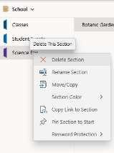

Add Writing Space to a Page

    - On the Draw tab, click the Insert Space button.

    - On the page, click where you want to insert more space, and then drag the pointer in the direction indicated by the arrow to add as much space as you want.

    - Drag to add space at the edges of a page or between lines of text.
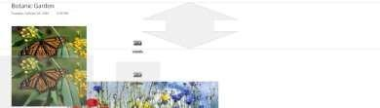

Using Shared Notebooks
  - Multiple people can edit it at the same time.
  - Changes are merged automatically.
  - You can use a shared notebook for notes about a team project, so that everyone can work on it at once.
  - Shared notebooks are great for storing:
- Meeting notes
- Project vision and brainstorming ideas
- Any supporting materials collected by group members
- List of teamwork items that people can mark off.
  - A notebook can be shared simply by storing it in a shared location, such as a shared folder on your own computer, a file share on a server, or SharePoint site.

Sharing a OneNote Notebook with Others
  - You can invite people to see your notebook with an email message generated by OneNote. Only people who are invited will be able to open your notebook.
- Click Share in the top right corner of the page, then click Share Entire Notebook.
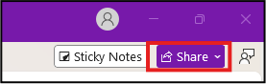

- In the first text box, type the names or email addresses of people you'd like to share your notebook with.
- Add a personal note, if you'd like, and choose Share. The people you've selected will get an email invitation to open your notebook.
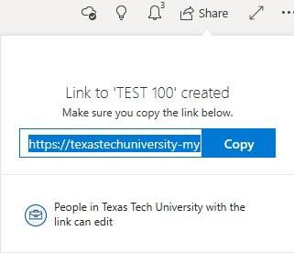
  - You can also generate a link to your notebook so others can view or edit it. If someone forwards the link to another person, they will also be able to see your notebook.
- Go to Share and click Copy Link to Notebook.
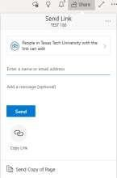
When prompted, click the Copy button, then send the link through your desired medium.

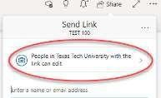
Editing Permissions After Sharing a Link
  - To edit what permissions your recipients will have, click Share. Select the box that reads “People in Texas Tech University with the link can edit.”

  - From this menu, you can specify who is able to view the link
(Anyone, individuals within TTU, or specific people.)
  - Check mark Allow Editing if you want the people you share with to be able to edit the notebook.
  - Once you have chosen your settings, click Apply.

Deleting a Notebook
  - If you're planning to delete a notebook that you have shared with others, be sure to give advance notice to everyone who has permission to view or edit the shared notebook or they may lose important information.
  - As with standard notebooks that are stored on your local hard drive, shared notebooks stored in a network location cannot be recovered once they have been deleted.
  - Because OneNote is automatically linked to your TTU OneDrive, you must delete your OneNote notebook through your OneDrive site.
  - Go to the OneDrive where the Notebook is stored, Right-click the folder that matches the name of the shared notebook you want to remove, and then click Delete

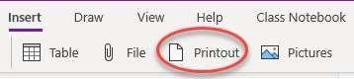

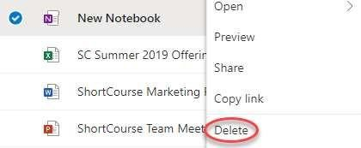

Inserting a Document or File as a Printout
  - When you want to insert information from other files on your computer without attaching or linking to the files, you can insert a picture or "printout" of the information by using the OneNote print driver.
  - Instead of literally printing the file onto paper, the print driver sends the printout to your notebook electronically. You can position the printout anywhere on a page.
  - You can also annotate the printout pictures with additional notes by typing or writing over them.
  - On the Insert tab, click Printout.
  - Navigate to the location of the file that you want to insert, select it, and click Open (to
select multiple files, hold down the CTRL key while you select the files.)
  - Depending on the type of file you are inserting, OneNote will attempt to launch the source program for the file and then print its contents directly to the current notebook page as a picture

Repositioning and Resizing a File Printout Picture on the Page
  - By default, each page of an inserted document or file is placed in your notes as a separate picture. You can move inserted printout pictures wherever you want them.

  - Select the picture by moving the pointer over it and then clicking anywhere on the printout. You can now resize the printout as you would any normal picture.
  - To reposition, click and drag the picture to any new location.

Showing Authors in a Share Notebook
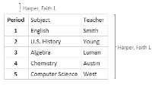
- When several people work in a shared notebook, OneNote will tag changes with author’s name and highlight any new content when opened.
- To show author initials, click History > Hide Authors. The Hide Authors button is a toggle that you click to turn on or off. Click it again if you no longer want to see author initials.
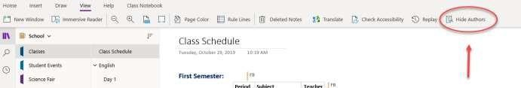

Reviewing Recent Notes in a Notebook
  - The Recent Edits tool in OneNote helps you keep track of notes and changes you or others have made in a notebook. You can use the tool to see a list of pages that have most recently been edited.
  - Click the History tab, then click Recent Edits. A drop-down menu will appear, asking you to select a time frame. Select whichever time frame you would like, and a pane will open on the right side of the screen, including a list of all edits that happened in the notebook within that time frame.
  - When you are done, click the X on the top right of the pane to close the Recent Edits.
  - In the Recent Notes list that appears, your pages will be listed based on what was most recently edited.

Performing a Simple Calculation in Your Notes
  - On any page in your notes, place the cursor where you want the result of a calculation to appear.
  - Type out the mathematical expression that you want OneNote to calculate.
  - For example, type 47+120+768= to calculate the sum of the numbers 47, 120, and 768, or SQRT(4)= to calculate the square root of 4.
    - Do not use spaces in the expression.
    - Type the numbers, operators, and functions as one single, continuous string of text.
    - Function names are not case-sensitive.
- For example, typing SQRT(4)= will yield the same answer as sqrt(4)= or Sqrt(4)=.
    - Immediately after the expression, type an equal sign (=) and then press SPACEBAR. OneNote calculates and places the answer after the equal sign.
Tip: To create a new line after the answer, press ENTER (instead of SPACEBAR) after the equals sign.
Note: When the answer appears after the equals sign, you can delete the expression that precedes it. The answer will remain in place. This is useful when you want only the final figure to appear in your notes.

Examples of Simple Calculations
Below are a few examples of mathematical expressions that OneNote can calculate.
- Type $670/12= and then press SPACEBAR to calculate the average monthly sales of a product that creates a total of $670,000 per year in revenue.
- Type 14*$39.99= and then press SPACEBAR to calculate the cost of 14 loads of materials at $39.99 a load.
- Type sin(30)= and then press SPACEBAR to calculate the sine of a 30-degree angle.
- Type (6+7)/(4*sqrt(3))= and then press the SPACEBAR to calculate the answer to this more complex mathematical equation : (6+7) divided by (4 times the square root of 3).

Supported Arithmetic Operators and Math Functions
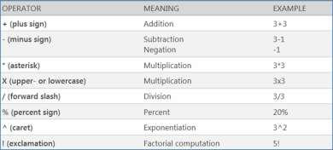
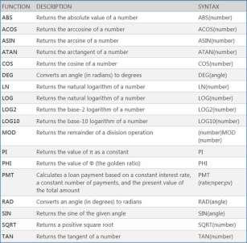

Using the Translator
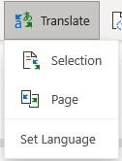
  - Select a line of text. Click Review, then Translate.
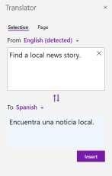
  - Choose either Translate Selected Text or Translate Page.
  - The Translator menu will open and will allow you to
choose the “From” and “To” languages.
  - If the translation looks correct, select Insert.

Applying a Password to a Section
  - Right-click the tab of the section you want the password to apply to.

Click Password Protect This Section.
  - In the Password Protection task pane, click Set Password.
  - In the Password Protection dialog box, type the password you want in the Enter password
box.
  - Confirm the password by typing it in the Confirm password box, and then click OK.

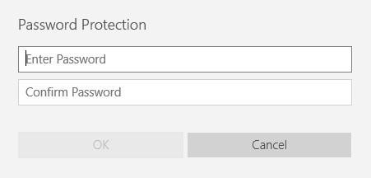

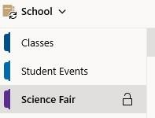
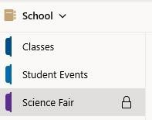
  - You will know what sections have passwords because they will have a lock next to the section names. The lock will be open or closed depending on if that section is locked or unlocked at that moment. Click the lock icon to lock and unlock that section.

  - To delete the password, right click on the section (when the lock is unlocked), select Password Protection, and choose Remove. OneNote will make you enter the password before you can remove it.

Ways to Use OneNote at Work

Getting Things Done!
OneNote is very much an empty notebook with which you can implement GTD at work. Use folders, sections, and subsections like you would use physical folders. Instead of printing out that email or webpage, simply hit “Send to OneNote” on the Outlook menu. You can then file the “printout” where you need to.

Shared Notebooks
Put the OneNote notebook file in a place where it can be accessed by the people who need it and setup it up to share. Use OneNote to manage projects among many people, or simply as a place to throw ideas around. If there is sensitive material, you can password-protect sections so that only certain people can see them. Take better notes in meetings
Bring your laptop to meetings and have OneNote open and ready to take notes. Use the tagging feature to flag important tasks or questions as they arise. Then, if you have a shared notebook with someone, share your notes so you can see if you were thinking the same things in the meeting.

Online Resources
    - FREE Online Video Training Library www.cbt.ttu.edu and http://library.ttu.edu/lynda
    - TTU Safari e-Books at http://library.ttu.edu . More than 6000 Safari eBooks to access for four simultaneous users. Please use the log-out link when you are done using the database. Here are some recommended eBooks:

Where to Get Help
If you need help from me, please e-mail Jacob.Crowder@ttu.edu

Credit:
This document was adapted partly from Microsoft Office “Getting to know OneNote” and Getting Started with OneNote (included with the program), OneNote Help, and Microsoft Office System Inside Out book. Also, some of the exercises in this document were adapted

Into to OneNote ShortCourse Updated: 3/1/2026

from FREE OneNote Tutorial Exercises @
http://highered.mheducation.com/sites/007661395x/student_view0/onenote_2010_tutorial .html accessed on June 1, 2014.

Please e-mail your comments or suggestions to: Jacob.Crowder@ttu.edu

