Beef Carcass Data Collection
Standard Operating Procedure

HARVEST DATA:
The following actions will be conducted on the harvest floor. Five person crew needed.

- Eartag identification – (1 person) Individual animal eartag identification will be manually verified and recorded in the kill order number. If animals are tagged with electronic identification (EID) only, the number will be scanned with an EID reader. If the tag does not read, the last 6 digits of the number will be manually recorded.

- Individual identification of the carcass in kill order – (1 person) Because of the differences that exist among plants, the following procedure will generally be followed but may be slightly modified to accommodate a specific situation. After the cattle have been individually identified, a tag will be placed on the ventral side of the leading carcass half that corresponds to the sequence of animal harvest (i.e. first animal harvested = 1, second animal harvested = 2, etc.). This tag will be used to identify the carcass for all remaining data collection activities. Within each study, identification will begin at 1 and end near 2,400.

- Liver Abscesses / abnormalities – (1 person) Liver abscesses will be manually scored and recorded according to the Eli Lilly (Elanco) Liver Check System ( = no abscesses, A- = 1 or 2 small abscesses, A = 2 to 4 small active abscesses, A+ = 1 or more large active abscesses, A+ Adhesion = liver adhered to GI tract, A+ Open = open liver abscess). Other liver abnormalities that will be recorded include: Cirrhosis, Flukes, and Telang. Additionally, if a liver is condemned for contamination, the liver will be recorded as Contamination.

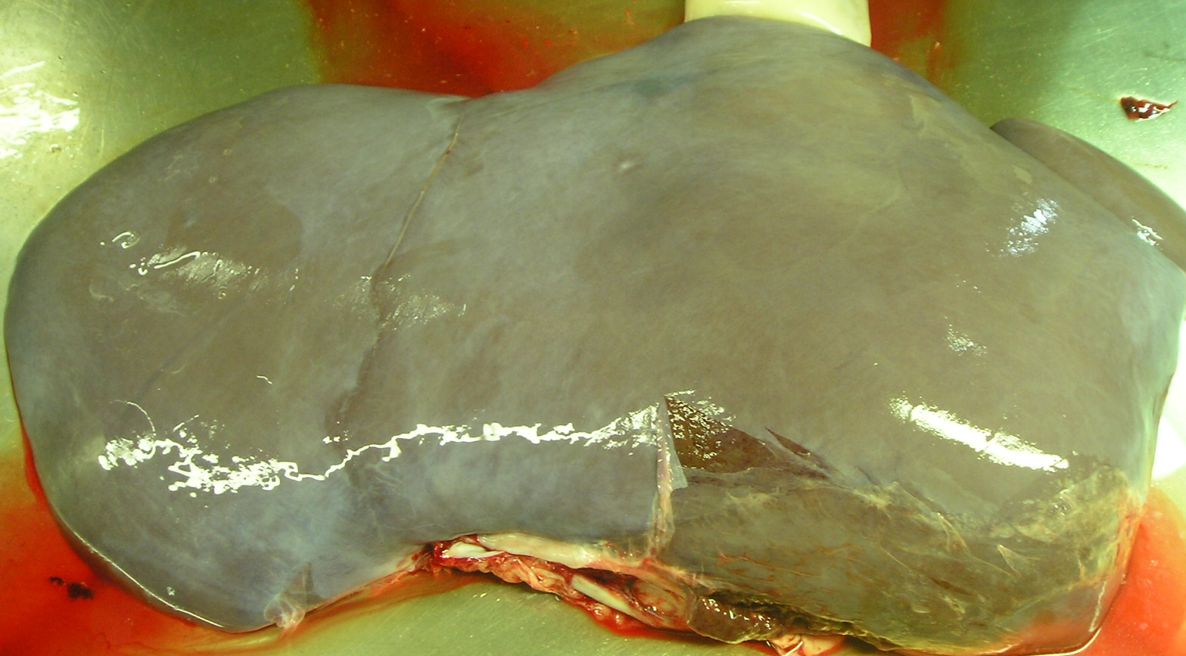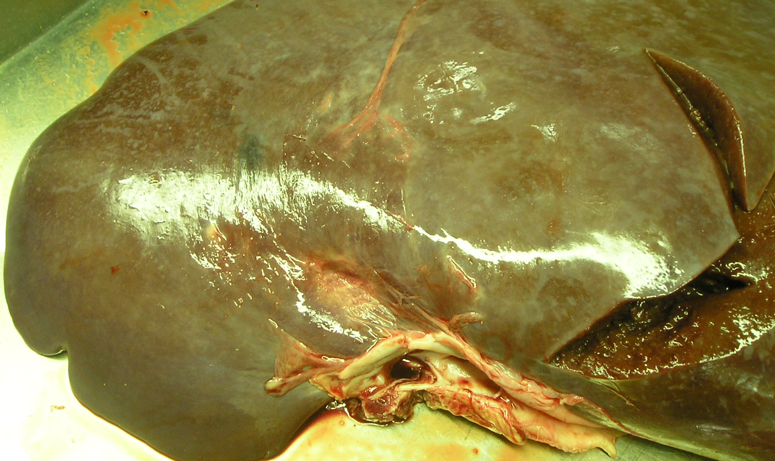
GOOD LIVER
A -

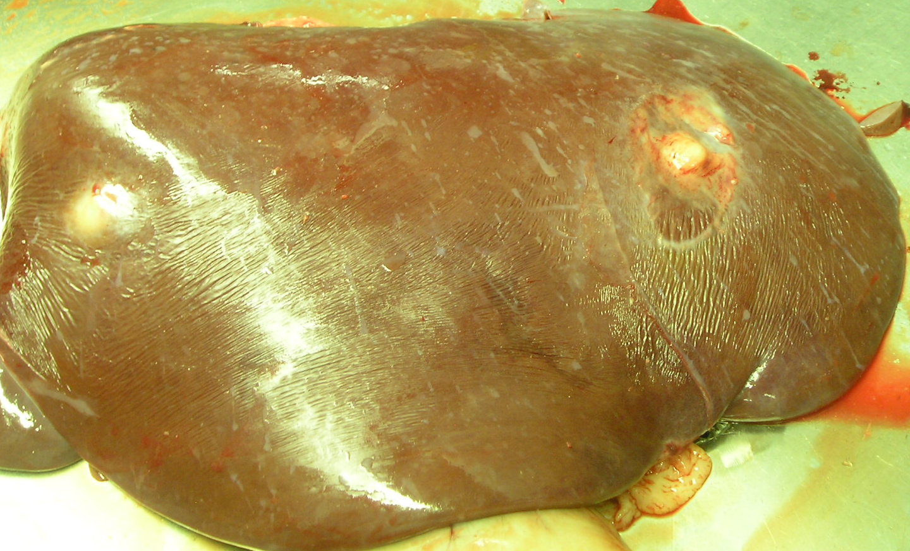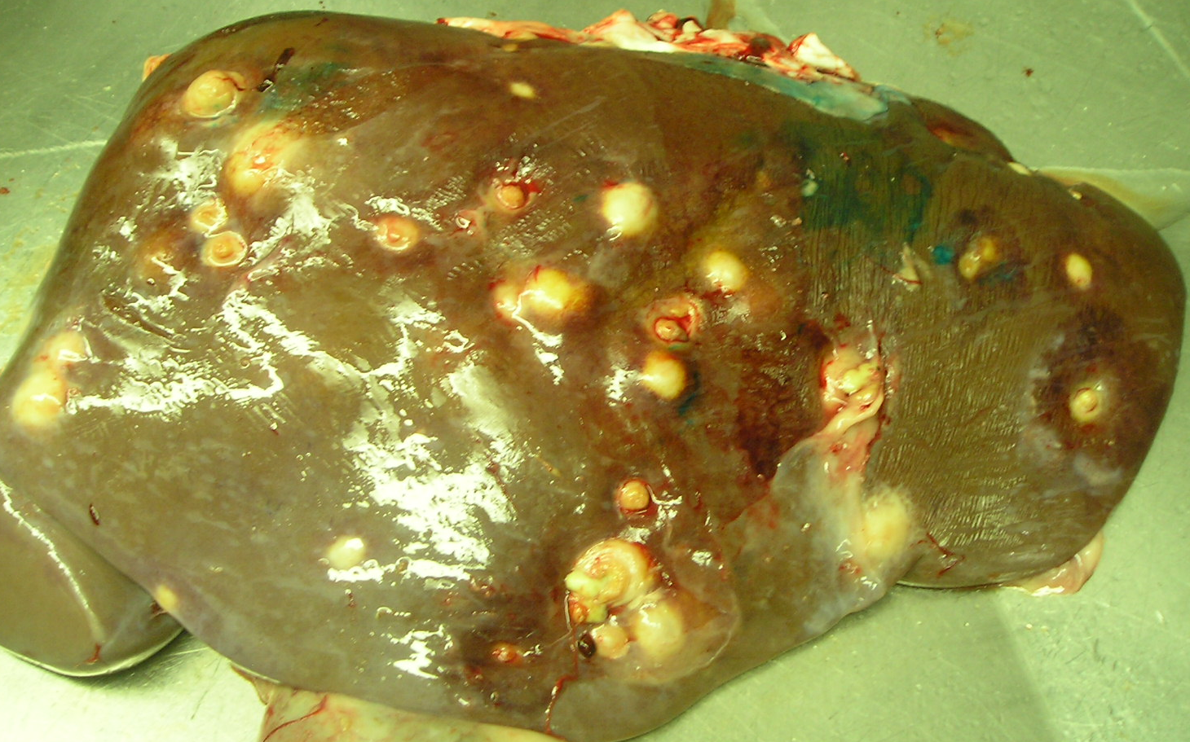
A
A +

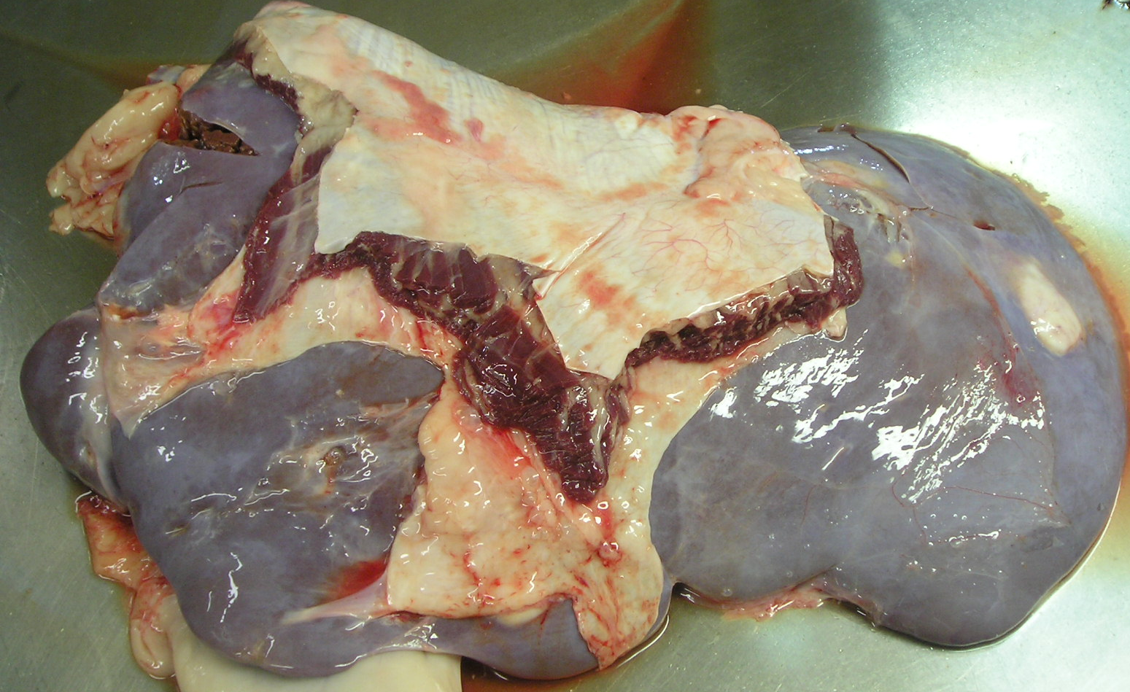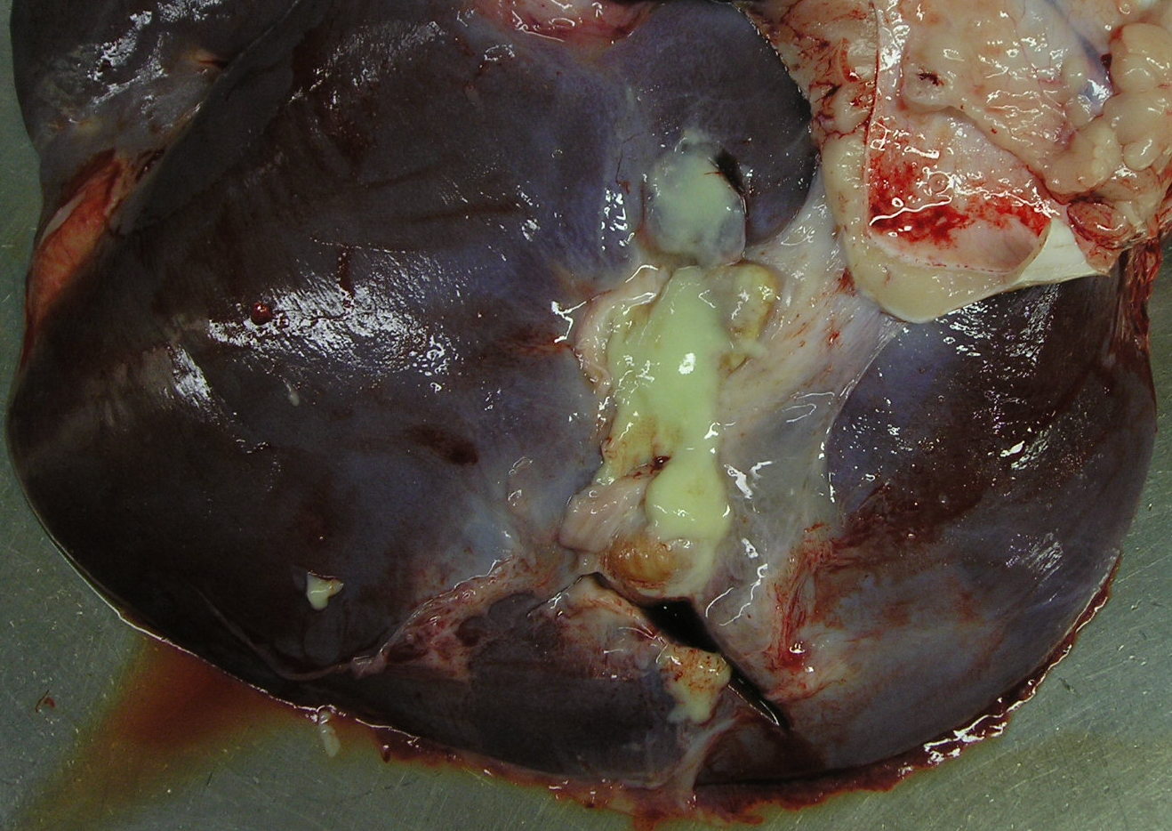
A + ADHESION
A + OPEN ABSCESS

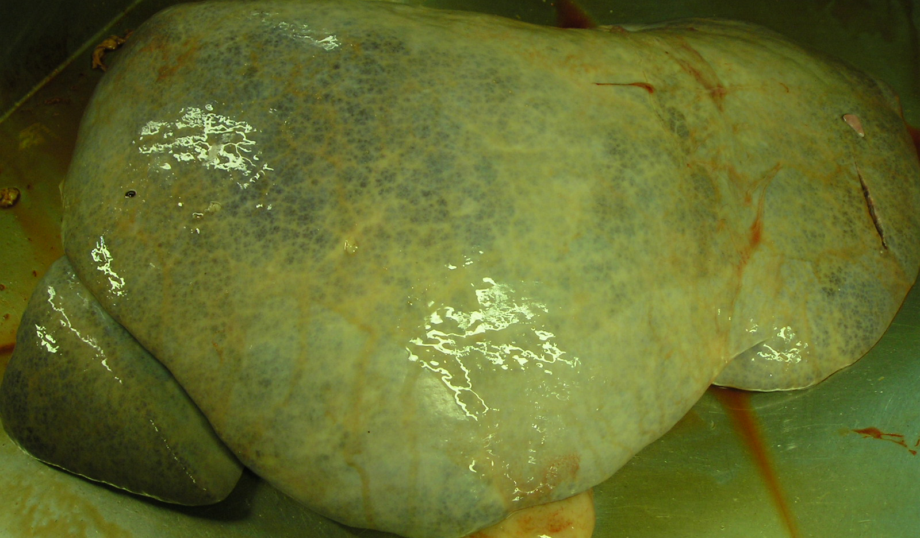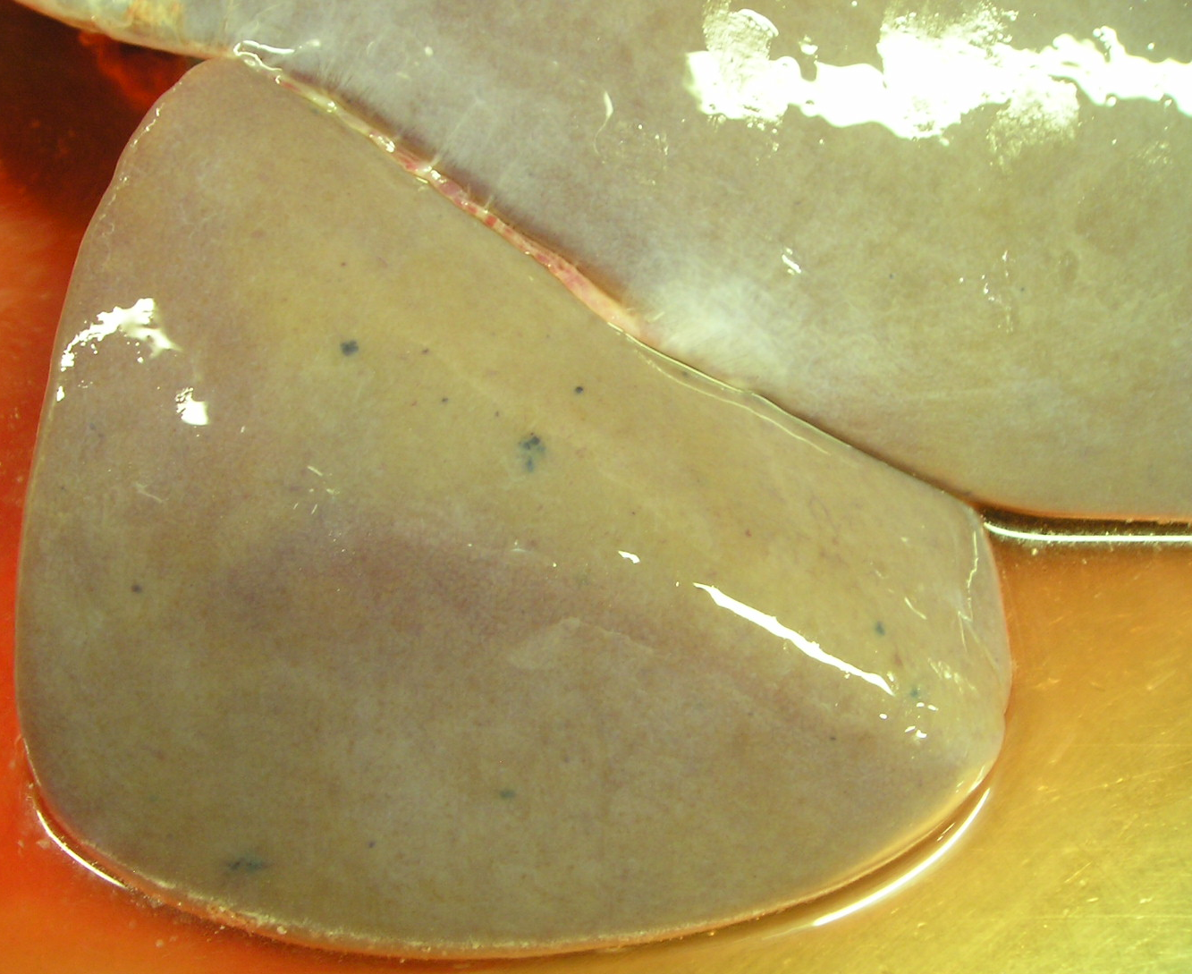
CIRRHOSIS
TELANGIECTASIS

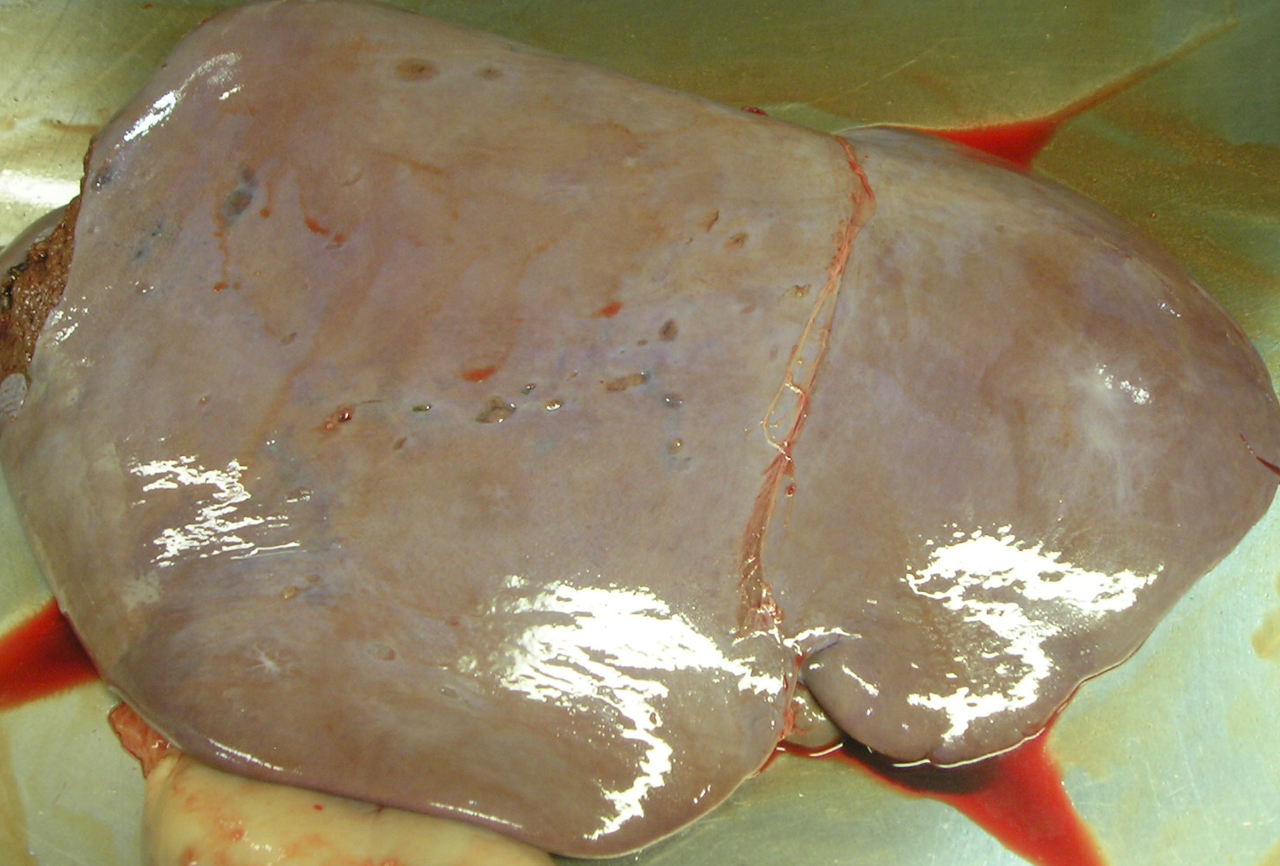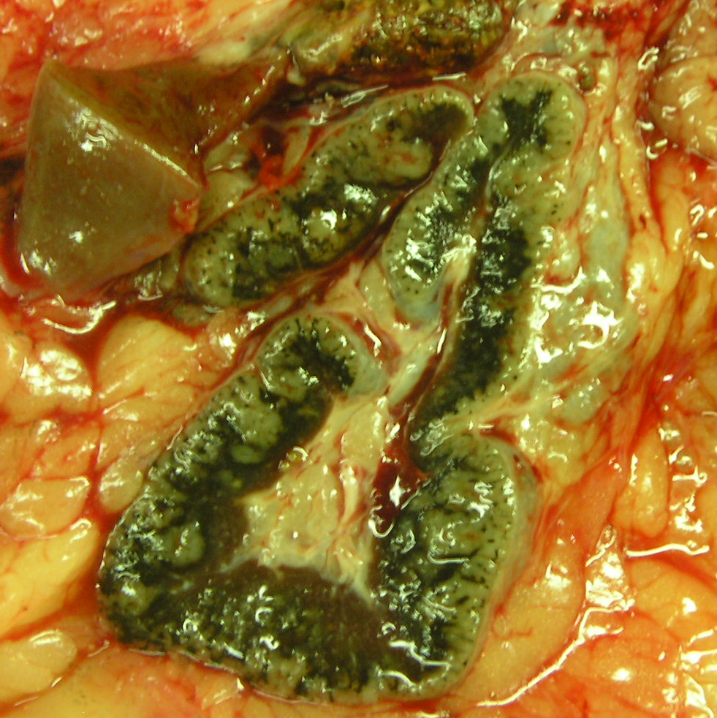
LIVER FLUKES
LIVER FLUKES BLACK LYMPH NODE

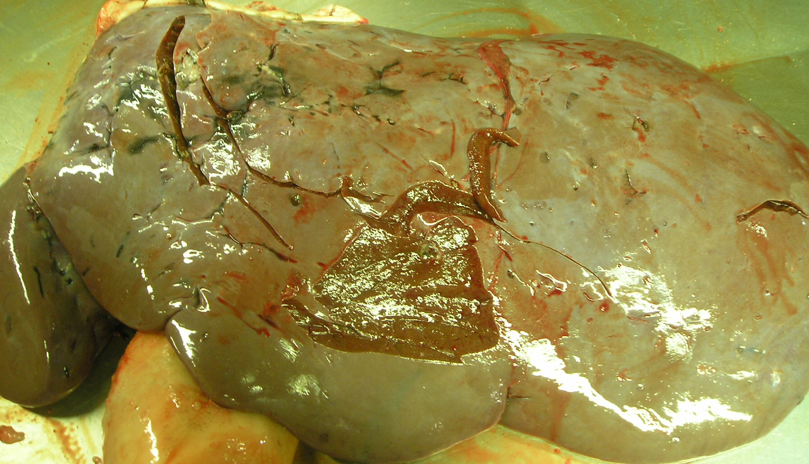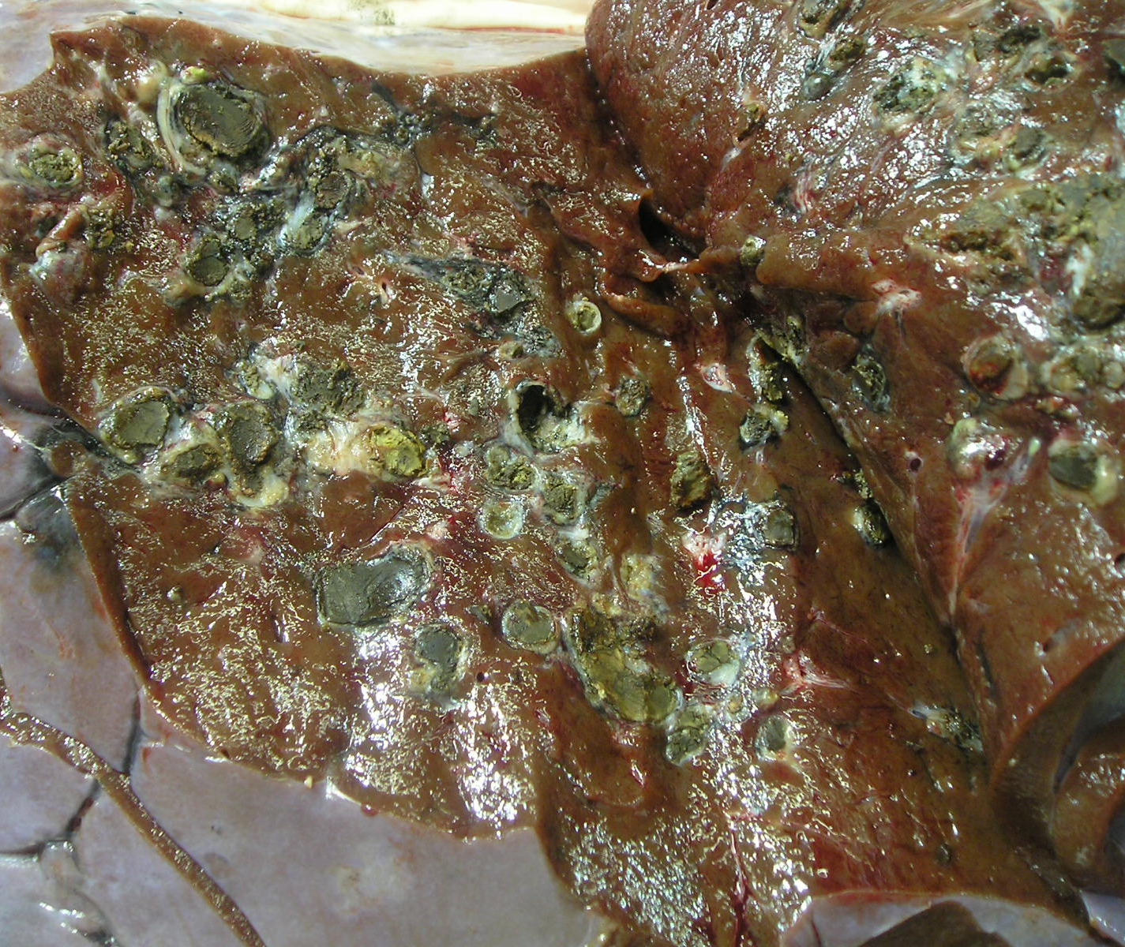
SEVERE LIVER FLUKES
SEVERE LIVER FLUKES
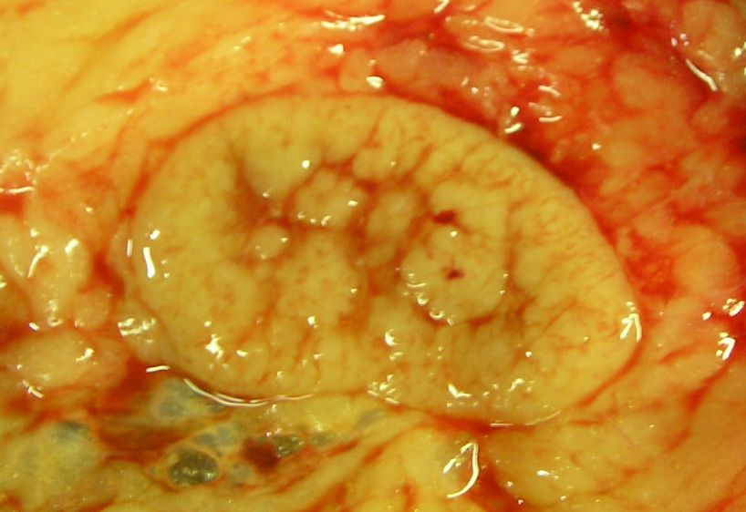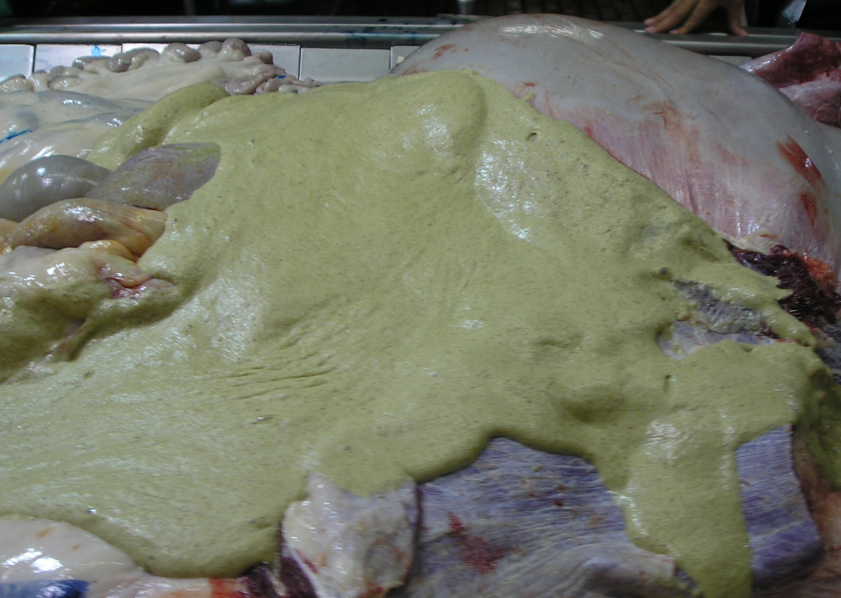
GOOD LYMPH NODE
CONTAMINATION

- Hot carcass weight – (1 person) Each carcass will be weighed and recorded to the nearest full pound. This weight is critical and will be taken just prior to washing the carcass. This weight will be manually verified and recorded from the plant scale or the carcass weight tag and verified against the packer final kill sheets.

- Tag switching – (1 person) The carcass identification tag was initially placed on the ventral side of the carcass for identification of GI contents to assist with liver scoring. The tag will be moved to the dorsal side of the carcass when moved into the hot box for ease of identification when collecting cooler data. (Monitor for railouts)

GRADING COOLER DATA:
The following actions will be conducted in the grading cooler. Eleven person crew needed.

- Ribeye area – (2 persons) If the plant utilizes a vision camera system, the ribeye area will be recorded from the vision camera. Otherwise, a reverse image of the ribeye from the leading carcass side will be collected using blotting paper (LS-601-4657, Life Science Products, Inc., Frederick, CO). The harvest sequence identification number will be recorded on the individual 4” X 8” sheet of blotting paper. This paper is then placed on the ribeye (the exposed transverse section of the longissimus dorsi between the 12th and 13th ribs) and rubbed slightly to produce a mirror image of the ribeye. The paper is then removed from the ribeye by another person a few feet further down the chain. The blotted image is allowed to dry, outlined, and this blotted image measured in a uniform manner (USDA dot grid, planimeter, scanning program, CAD program) to determine the cross sectional area of the longissimus dorsi to the nearest tenth of a square inch and recorded. If the plant uses a camera for grading purposes, be sure to obtain a printout of the camera data.

- Estimate of the percentage of kidney pelvic and heart fat – (2 persons to estimate KPH and fat thickness; 1 evaluator, 1 recorder) The estimate is recorded as the percentage of the hot carcass weight yielded as kidney area fat, pelvic area fat, and heart area fat, as estimated on each carcass by a qualified individual and recorded as: (4.0% = +1, 3.5% = 0, 3.0% = -1, 2.5% = -2, 2.0% = -3, 1.5% = -4, 1.0% = -5, 0.5% = -6). This evaluation may be conducted on either the hot or cold carcass depending upon the conditions within the plant. If the plant removes the KPH fat on the harvest floor and identifies the percentage removed on their weight tag, this percentage may be utilized and recorded as the percentage of KPH fat. Otherwise, if KPH is removed on the harvest floor and no estimation is present on the carcass tag or anywhere else, evaluate the KPH fat that is present on the harvest floor before it is removed.

- Fat thickness – (2 persons to estimate fat thickness and KPH; 1 evaluator, 1 recorder) If the plant utilizes a vision camera system, the fat thickness will also be recorded from the vision camera in addition to manually collected data. Otherwise, fat thickness will be measured with a PYG (Preliminary Yield Grade) ruler and adjusted as indicated in the USDA Beef Grading Standards. This measurement is evaluated as the thickness of external fat over the ribeye muscle when measured perpendicular to the outside at a point 3/4ths of the length of the ribeye from its chine bone end and between the 12th and 13th ribs. This evaluation may be adjusted as necessary, to reflect the average amount of subcutaneous fat on the carcass. This measurement will be taken and adjusted by a qualified individual. The actual measurement will be recorded followed by the adjusted measurement (i.e., 2.3/2.5 with 2.3 being the actual measurement and 2.5 the adjusted measurement). The adjusted value will be used in reporting fat thickness and in calculating the final yield grade.

- Maturity Score – (2 persons; 1 evaluator, 1 recorder) All carcasses will be evaluated for both lean and skeletal maturity by a qualified individual using the current USDA Beef Carcass Grading Standards. Carcass maturity will be recorded to the nearest 10th of a score (i.e. A40, B60, etc.).

- Marbling Score – (2 persons in conjunction with color score; 1 evaluator, 1 recorder) Marbling score will be evaluated on both carcass sides by a qualified individual using current USDA Beef Carcass Grading Standards and the score of the highest side will be recorded to the nearest 10th of a score (i.e. Sm20, Mt50, etc.)

- Color Score – (2 persons in conjunction with marbling score; 1 evaluator, 1 recorder) If L*, a*, b* data are available from a vision camera system, those data will also be collected. Otherwise, visual lean color score will be evaluated by a qualified individual and scored to the whole number according to the following scale published by Herschler et al. 1995. (1 = light pink, 2 = pink, 3 = dark pink, 4 = light cherry red, 5 = cherry red, 6 = dark red, 7 = very dark red {1/3 dark cutter}, 8 = maroon {2/3 dark cutter}, 9 = dark maroon {full dark cutter}).

3 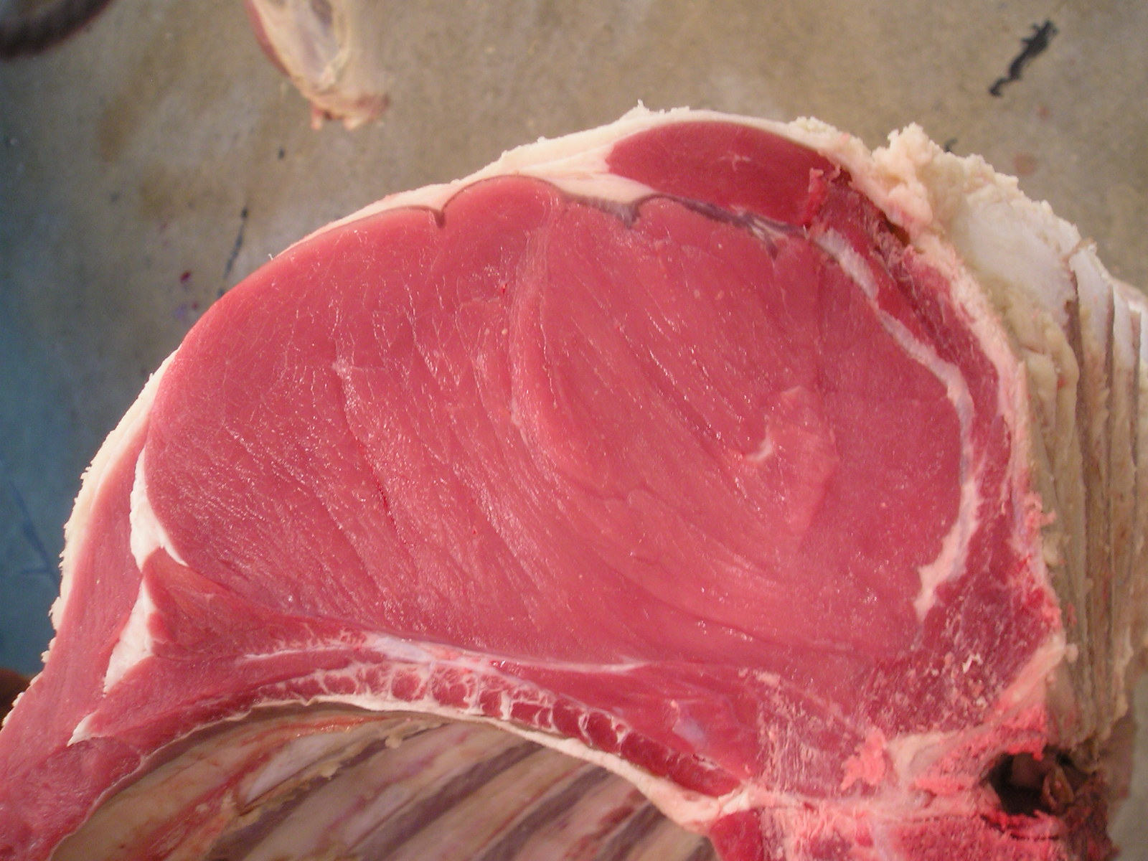
4 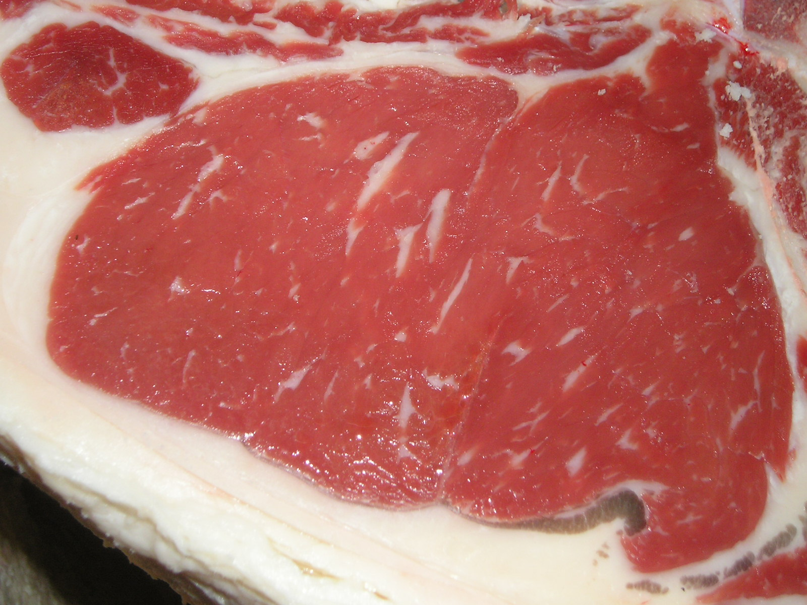
5 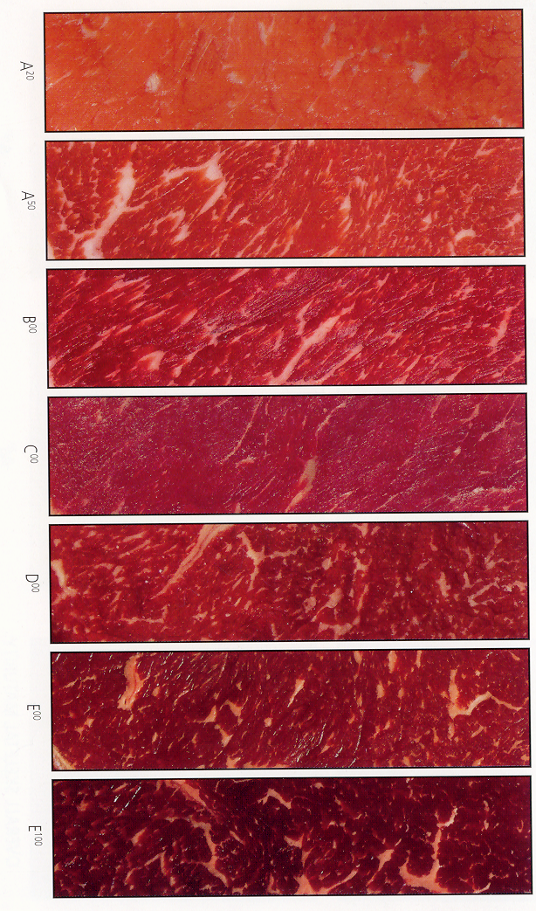
6
7
8
9

- Stamped USDA Quality and Yield grades – (1 person to record QG, YG, and carcass discounts) Actual USDA quality and yield grade stamps will be manually verified and recorded for each carcass. Cattle that are upgraded (regrades) will also be noted.

- Carcass discounts – (1 person to record QG, YG, and carcass discounts) Carcass discounts will be manually verified and recorded. Discounts include: Blood splash (Capillary hemorrhaging evident in the ribeye muscle), Dark Cutter (Evidence of abnormally dark lean color that is “sticky” to the touch), 30+ (Carcasses that exhibited 3 or more permanent incisors at harvest), Callous (Evidence of fatty degeneration from a prior injury), Bruise (Evidence of primal trim from removal of bruised tissue will be recorded by severity and primal), or Bullock (Evidence of large pizzle eye, large jump muscle, and prominent crest).

- Final Calculated Yield Grade – The final yield grade of each carcass will be calculated using the USDA Yield Grade equation: 2.5 + (2.5 x inches of backfat thickness) + (0.0038 x pounds of hot carcass weight) + (0.2 x percentage of kidney, pelvic, heart fat) – (0.32 x square inches of ribeye area).

- Final Calculated Quality Grade – The final quality grade of each carcass will be determined from the marbling score, skeletal, and lean maturity scores following USDA Beef Carcass Grading Standards.

