Pd-Ce NANOPARTICLES 2 nm USING CMC AND NaBH₄
Synthesis of PdCeCMC (i.e. 15 mg Na₂PdCl₄ dissolved in 15 ml H₂O and 21.7 mg Ce(NO₃)₃.6H₂O were separately dissolve in 15 ml H₂O respectively) was repeated using CMC (150 mg Sodium carboxyl methyl cellulose Mw = 90k dissolve in 10 ml H₂O) and sodium borohydride solutions 0.5 M (220 mg NaBH₄ in 10.6 ml distilled water). 10.6 ml NaBH₄ solution was added into the Pd-Fe-CMC mixture drop-wise at 500 rpm.
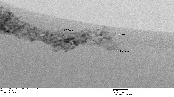
Fig. 1 TEM image of 2 nm

Pd NANOPARTICLES 2-3 nm USING ETHYLENE GLYCOL WAS ACHIEVED (POLYOL METHOD)
The polyol method is developed with 135.6 mg Pd(OAc)₂ dissolved in 25 ml ethylene glycol (EG) at 90ºC for 30 minutes with a stirring rate of 60 rpm under nitrogen environment. The experiment was also done at a reduced temperature of 40ºC for 5 -10 minutes at 60 rpm.
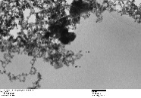
Fig. 2 TEM image of 2-3 nm

Pd-Fe NANOPARTICLES USING CMC AND NaBH₄ (3:1 molar ratio)
Synthesis of PdFeCMC 3:1 molar concentration (i.e. 15 mg Na₂PdCl₄ dissolved in 15 ml H₂O and 5 mg FeSO₄.7H₂O were separately dissolve in 15 ml H₂O respectively) was repeated using CMC (150 mg Sodium carboxyl methyl cellulose Mw = 90k dissolve in 10 ml H₂O) and sodium borohydride solutions 0.05 M (9.4 mg NaBH₄ in 5 ml distilled water). 3.6 ml NaBH₄ solution into the Pd-Fe-CMC mixture drop-wise at 500 rpm.
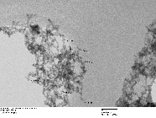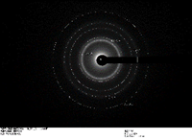
Fig. 3 TEM image of 2-3 nm

Pd-La NANOPARTICLES USING CMC AND NaBH₄ (1:1 molar ratio)
Synthesis of PdLaCMC 1:1 molar concentration (i.e. 15 mg Na₂PdCl₄ dissolved in 15 ml H₂O (0.003M) and 21.7 mg La(NO₃)₂.6H₂O were separately dissolve in 15 ml H₂O (0.003 M) respectively) was repeated using CMC (150 mg Sodium carboxyl methyl cellulose Mw = 90k dissolve in 10 ml H₂O) and sodium borohydride solutions 0.5 M (220 mg NaBH₄ in 11.6 ml distilled water). 11.6 ml NaBH₄ solution into the Pd-Fe-CMC mixture drop-wise at 500 rpm. pH = 9.
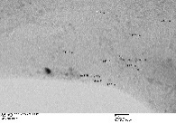
Fig. 4 TEM image of 2-6 nm

Pd-La NANOPARTICLES USING CMC AND NaBH₄ (3:1 molar ratio)
Synthesis of PdLaCMC 1:1 molar concentration (i.e. 37 mg Pd(NO₃)₂.H₂O dissolved in 15 ml H₂O (0.009M) and 21.7 mg La(NO₃)₂.6H₂O were separately dissolve in 15 ml H₂O (0.003 M) respectively) was repeated using CMC (150 mg Sodium carboxyl methyl cellulose Mw = 90k dissolve in 10 ml H₂O) and sodium borohydride solutions 0.5 M (220 mg NaBH₄ in 11.6 ml distilled water). 11.6 ml NaBH₄ solution into the Pd-Fe-CMC mixture drop-wise at 500 rpm. pH = 9.
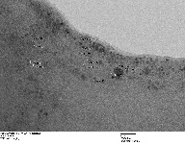
Fig. 5 TEM image of 2 nm

Pd-Ce NANOPARTICLES USING CMC AND NaBH₄ (3:1 molar ratio)
Synthesis of PdLaCMC 1:1 molar concentration (i.e. 37 mg Pd(NO₃)₂.H₂O dissolved in 15 ml H₂O (0.009M) and 21.7 mg Ce(NO₃)₃.6H₂O were separately dissolve in 15 ml H₂O (0.003 M) respectively) was repeated using CMC (150 mg Sodium carboxyl methyl cellulose Mw = 90k dissolve in 10 ml H₂O) and sodium borohydride solutions 0.5 M (220 mg NaBH₄ in 11.6 ml distilled water). 11.6 ml NaBH₄ solution into the Pd-Fe-CMC mixture drop-wise at 500 rpm.
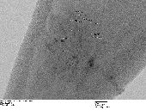
Fig. 6 TEM image of 2 nm

Pd-Ce NANOPARTICLES USING CMC AND NaBH₄ (1:1 molar ratio)
Synthesis of PdLaCMC 1:1 molar concentration (i.e. 15 mg Na₂PdCl₄ dissolved in 15 ml H₂O (0.003M) and 21.7 mg Ce(NO₃)₃.6H₂O were separately dissolve in 15 ml H₂O (0.003 M) respectively) was repeated using CMC (150 mg Sodium carboxyl methyl cellulose Mw = 90k dissolve in 10 ml H₂O) and sodium borohydride solutions 0.5 M (220 mg NaBH₄ in 11.6 ml distilled water). 11.6 ml NaBH₄ solution into the Pd-Fe-CMC mixture drop-wise at 500 rpm. pH = 9.
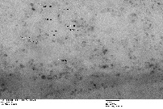
Fig. 7 TEM image of 2-3 nm

