- PdAu nanoparticles (1:5 molar ratio) preparation using Sodium carboxyl methyl cellulose as stabilizing & NaBH₄ reducing agent
Materials:
13.23 mg Na₂PdCl₄ (Sigma-Aldrich)
1.89 g NaBH₄ (Sigma-Aldrich)
88.61 mg HAuCl₄.3H₂O (Sigma-Aldrich)
150 mg Sodium carboxyl methyl cellulose (Average Mw = 90,000 g/mole) Sigma-Aldrich
100 ml size three neck flask
Nitrogen gas, high purity
Measuring cylinders
50 ml Erlenmeyer’s
Proper size pipettes, pipettors, pipette tips, stir plates, stoppers
Nanoparticle preparation:
- 13.23 mg Na₂PdCl₄ was transferred into 100 ml size three neck flask and dissolved in 15 ml of heavy water (D₂O) for 30 minutes.
- 150 mg of sodium carboxyl methyl cellulose was dissolved in 10 ml nitrogen-bubbled heavy water and added to the solution mentioned in step 1. The mixture was stirred for 1 hour.
- 88.61 mg HAuCl4 was dissolved in 15 ml D₂O and stirred for 2 hours. The gold salt solution was added to Pd-CMC mixture in step 2 and stirred for 3 hours.
- 1.89 g NaBH₄ was added to 10 ml nitrogen-bubbled heavy water (5.0 M NaBH₄ solution) was used to reduce Pd-CMC-Au mixture in step 3.
- The color of the solution changed from pale yellow to dark brown pH = 9. The Pd-Au nanoparticles was washed thoroughly with 50 ml water and purified using centrifuge.
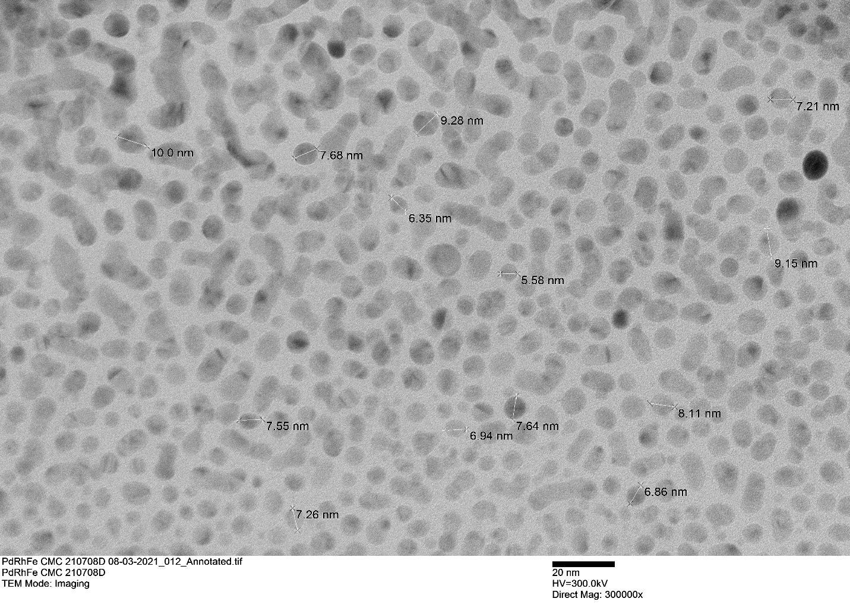
Figure 1. TEM image of PdRhFe nanoparticles

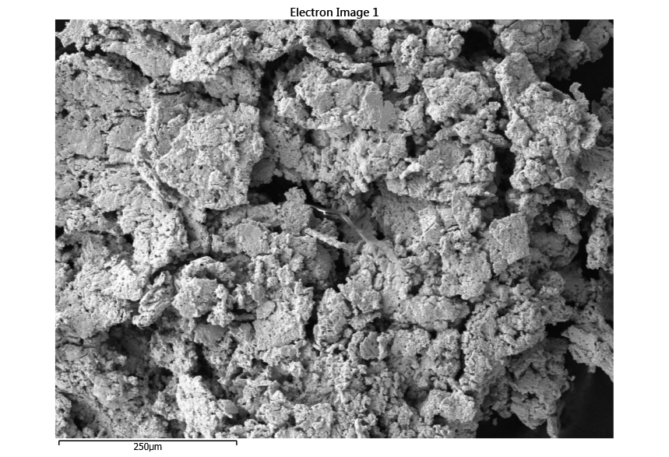
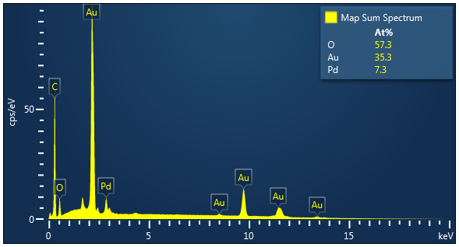
Fig. 2. EDS images Pd-Au (1:5 molar ratio)

- PdAu nanoparticles (5:1 molar ratio) preparation using Sodium carboxyl methyl cellulose as stabilizing & NaBH₄ reducing agent
Materials:
66.19 mg Na₂PdCl₄ (Sigma-Aldrich)
378 mg NaBH₄ (Sigma-Aldrich)
15 mg HAuCl₄.3H₂O (Sigma-Aldrich)
150 mg Sodium carboxyl methyl cellulose (Average Mw = 90,000 g/mole) Sigma-Aldrich
100 ml size three neck flask
Nitrogen gas, high purity
Measuring cylinders
50 ml Erlenmeyer’s
Proper size pipettes, pipettors, pipette tips, stir plates, stoppers
Nanoparticle preparation:
- 66.19 mg Na₂PdCl₄ was transferred into 100 ml size three neck flask and dissolved in 15 ml of heavy water (D₂O) for 30 minutes.
- 150 mg of sodium carboxyl methyl cellulose was dissolved in 10 ml nitrogen-bubbled heavy water and added to the solution mentioned in step 1. The mixture was stirred for 1 hour.
- 15 mg HAuCl4 was dissolved in 15 ml D₂O and stirred for 2 hours. The gold salt solution was added to Pd-CMC mixture in step 2 and stirred for 3 hours.
- 378 mg NaBH₄ was added to 10 ml nitrogen-bubbled heavy water (1.0 M NaBH₄ solution) was used to reduce Pd-CMC-Au mixture in step 3.
- The color of the solution changed from pale yellow to dark brown pH = 9. The Pd-Au nanoparticles was washed thoroughly with 50 ml water and purified using centrifuge.

Pd NANOPARTICLES USING ETHYLENE GLYCOL WAS ACHIEVED (POLYOL METHOD)
The synthesis was done with 90.4 mg Pd(OAc)₂ dissolved in 25 ml ethylene glycol (EG) at 125ºC for 1 hour with a stirring rate of 60 rpm under nitrogen environment. See TEM image below Fig. 3
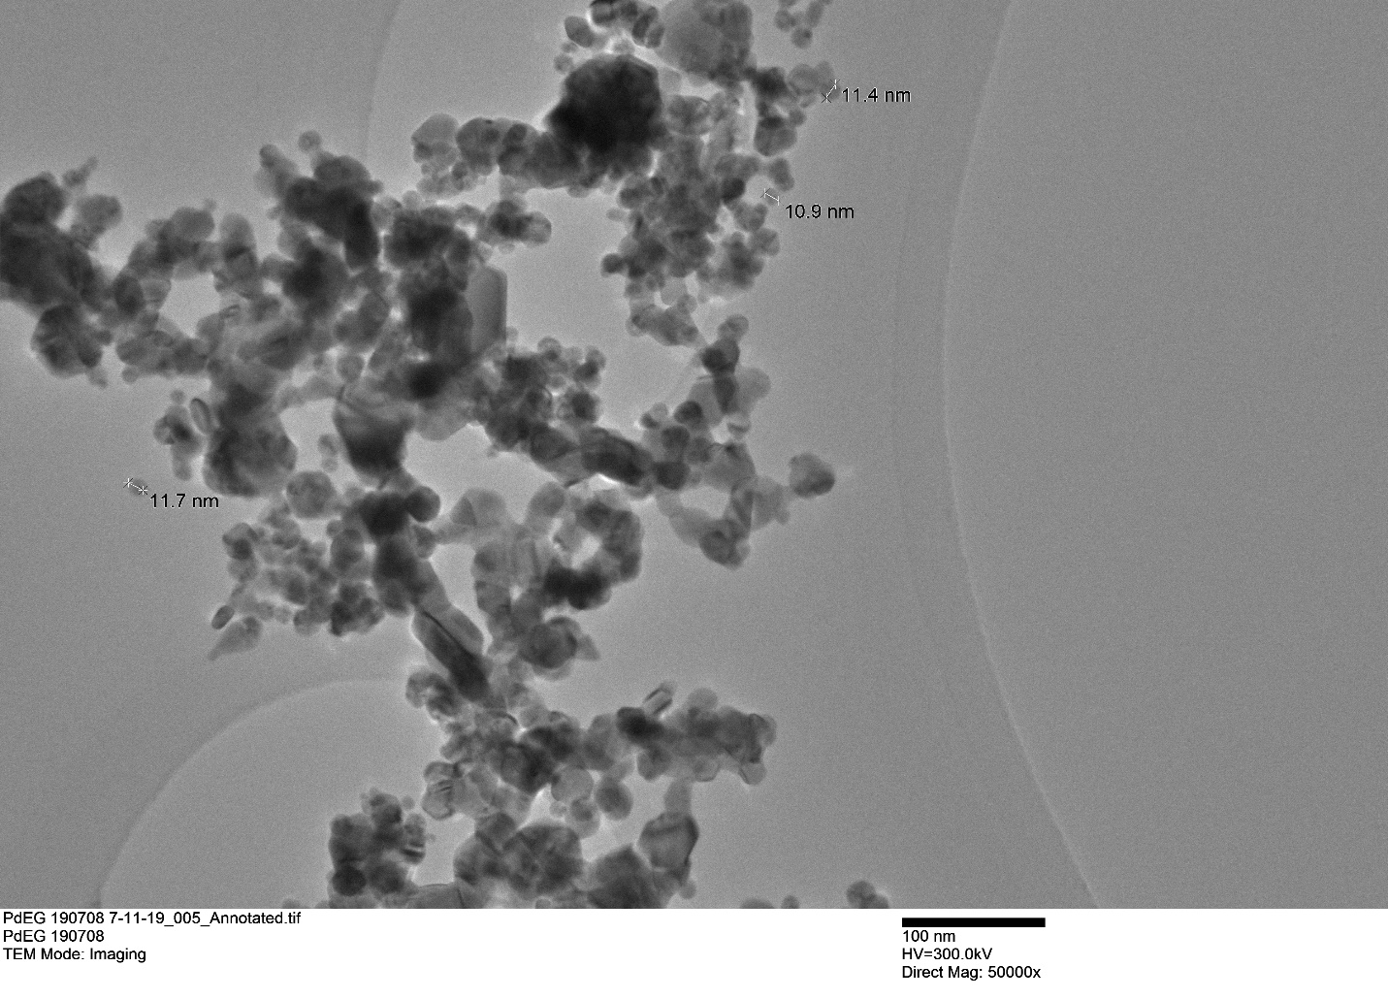
Figure 3. TEM image of palladium nanoparticles synthesized with ethylene glycol

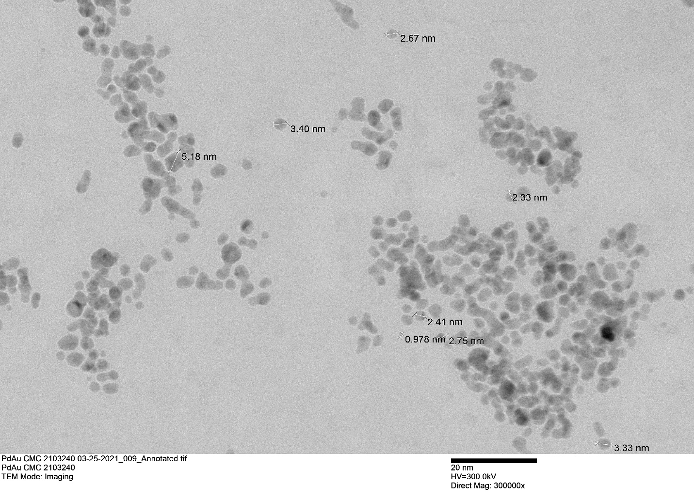
Fig. 4. TEM Image Pd-Au nanoparticles (5:1 molar ratio)
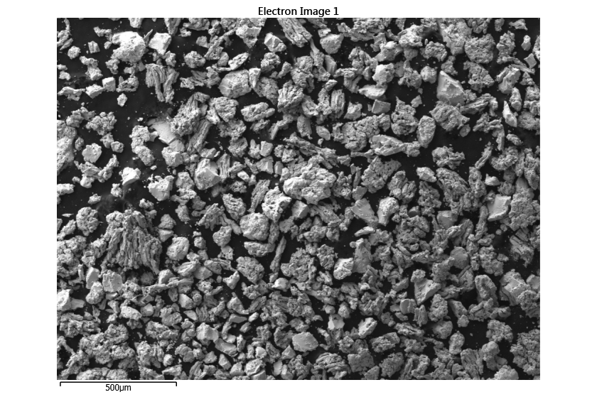
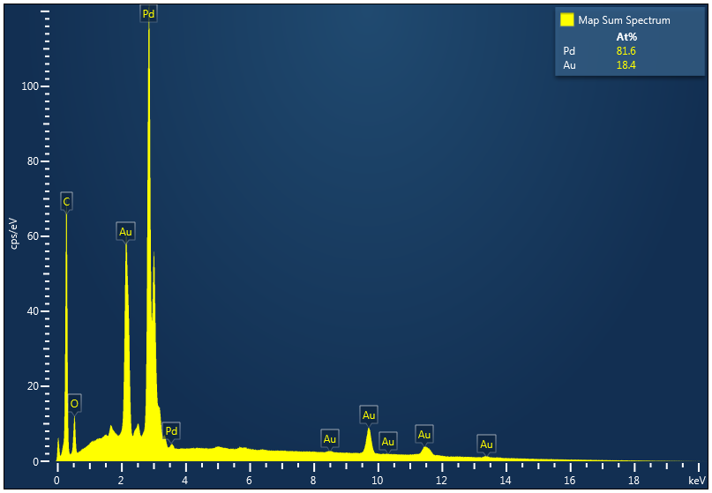Fig. 5. EDS images Pd-Au (5:1 molar ratio)

- PdRh nanoparticles preparation using Sodium carboxyl methyl cellulose as stabilizing agent and NaBH₄ as reducing agent
Materials:
40 mg Na₂PdCl₄ (Sigma-Aldrich)
15 mg RhCl₃ (VWR)
378 mg NaBH₄ (Sigma-Aldrich)
150 mg Sodium carboxyl methyl cellulose (Average Mw = 90,000 g/mole) Sigma-Aldrich
50 ml size three neck flask
Nitrogen gas, high purity
Measuring cylinders
50 ml Erlenmeyer’s
Proper size pipettes, pipettors, pipette tips, stir plates, stoppers, thermometer
Nanoparticle preparation:
- Distilled water was bubbled under nitrogen for 30 minutes.
- Transfer 40 mg Na₂PdCl₄ into 50 ml size three neck and 15 ml distilled water was added. Then stirred for 15 minutes. 15 mg of RhCl₃ salt was dissolved in 50 ml of distilled water. 15 ml of the Rhodium salt solution (stock solution) was added to the Pd-CMC mixture.
- 150 mg Sodium carboxyl methyl cellulose dissolved in 10 ml of water was added as a stabilizing agent and allow to stir for 1 hour.
- 378 mg NaBH₄ was dissolved in 10 ml of distilled water and added to the mixture in step 3 at 25ºC. The color changed from pale yellow to dark brown when the NaBH₄ solution (reducing agent) was added dropwise. pH = 9. The Pd-Au nanoparticles was washed thoroughly with 50 ml water and purified using centrifuge.

Palladium nanoparticles synthesis with (−)-Epigallocatechin gallate: 21.5 mg Na₂PdCl₄ was transferred into 50 ml size three neck flask and 16 mg (−)-Epigallocatechin gallate (EGCG) was added and stirred in a nitrogen environment. A dark-brown coloration was observed when 40 ml of D₂O was introduced to the mixture and stirred 500 rpm for 24 hours at room temperature.
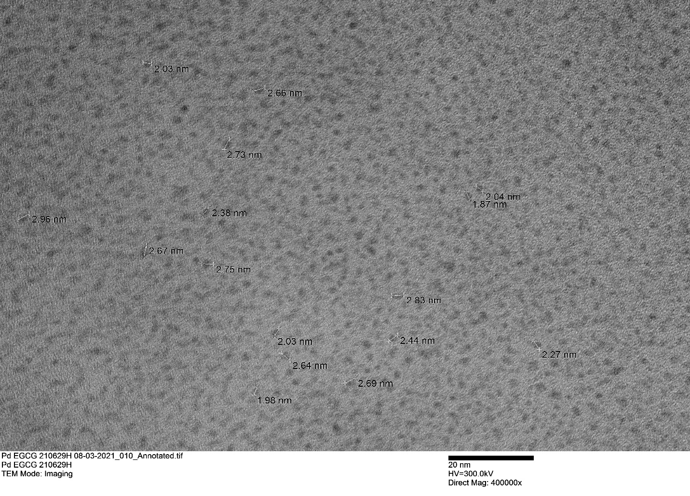
Figure 6. TEM images of palladium nanoparticles synthesized with (−)-Epigallocatechin gallate (EGCG)

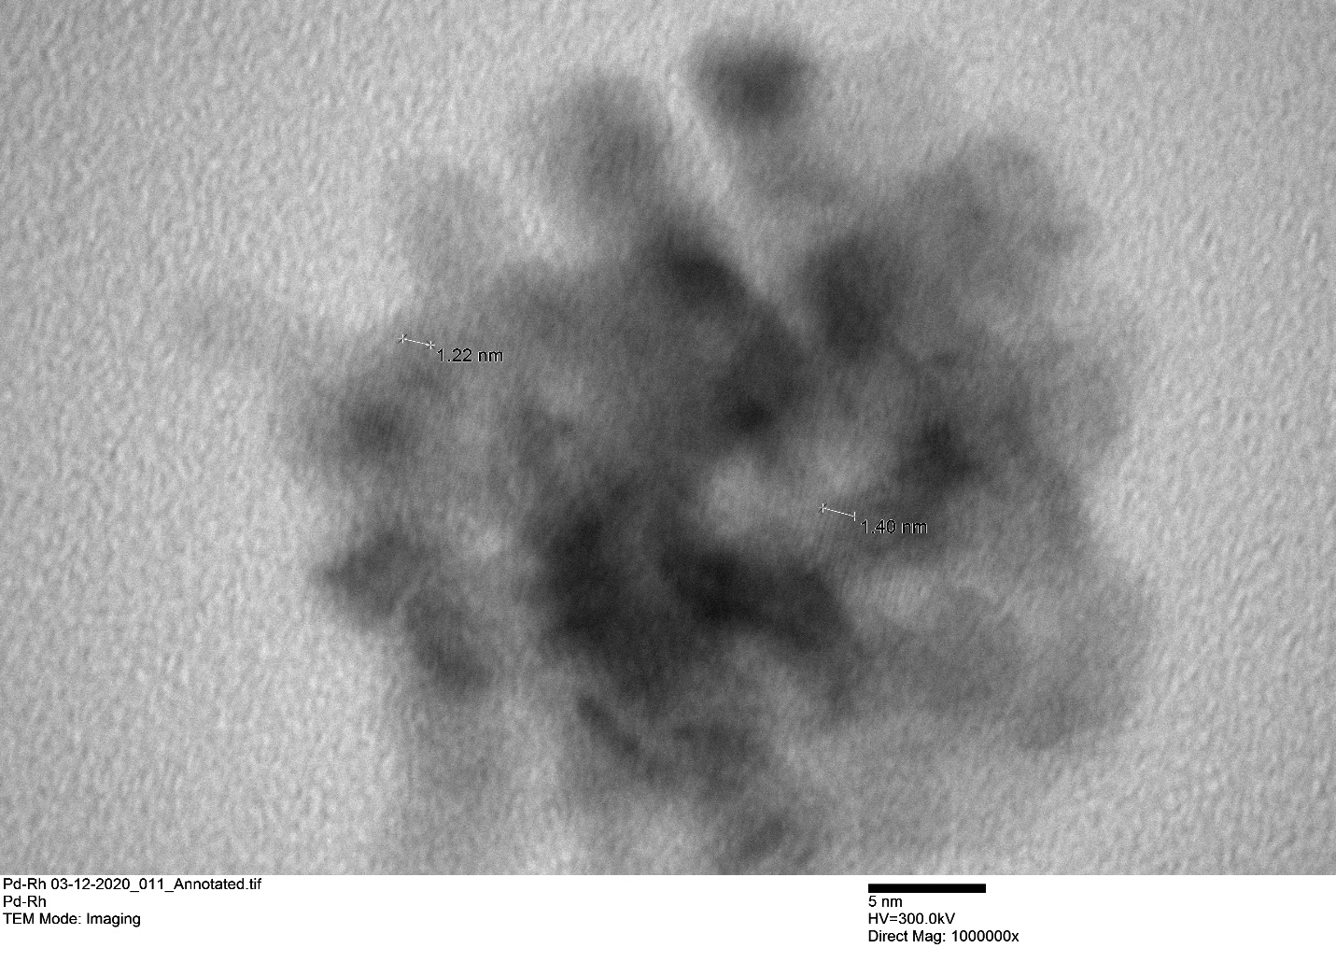
Fig. 7. TEM image Pd-Rh nanoparticles
Fig. 8. SAED Diffraction pattern Pd-Rh nanoparticles
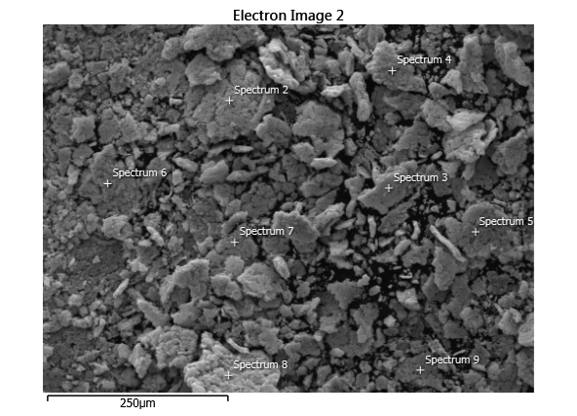
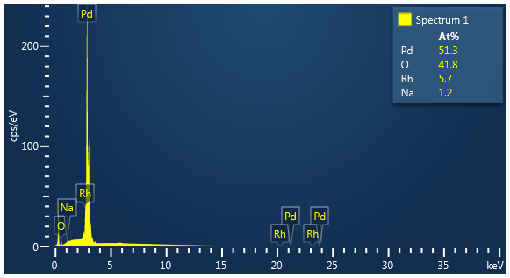
Fig. 9. EDS images Pd-Rh nanoparticles

