TechBuy Guidelines for Entering Requisitions for Guest Lodging
The following guidelines are intended to provide assistance for individuals entering requisitions for. The Procurement Services Department has made every effort to ensure that the guidelines are in compliance with TTU operating policies. However, in the event of conflict between these guidelines and operating policies, the operating policies shall prevail.

- The Guest Lodging program allows TTTU/TTU System departments to reserve and pay for individual hotel rooms at a contract rate at selected Lubbock area hotels for guests on official business, such as guest speakers or prospective employees. It may also be used for TTU/TTUS employees who are not headquartered in Lubbock but who are here on campus for meetings. (Please see the Notes section for guidance on what expenses may be included on the requisition.)
- First contact the participating hotel, make a reservation, and obtain a confirmation number. The following is a list of the hotels currently included in the program, along with some of the amenities offered:
Hotel Name | Phone # | Rate + City Tax | Amenities
Arbor Inn & Suites | 722-2726 | $95.23 | ext cont breakfast, ask for Rob when making res.
Ashmore Inn and Suites | 785-0060 | $82.39 | free internet, deluxe continental breakfast
Baymont Inn & Suites | 792-5181 | $80.25 | free internet, ext cont breakfast, shuttle service
Embassy Suites | 771-7000 | $95.23 | free internet, airport shuttle, breakfast
Hawthorn Suites | 792-3600 | $95.23 | free internet, hot breakfast, shuttle service
Homewood Suites | 771-7000 | $95.23 | free internet, airport shuttle, breakfast, dinner M-Th
Hyatt Place Lubbock | 741-0200 | $95.23 | free internet, free parking, full hot breakfast
La Quinta Inn & Suites Lubbock North | 749-1600 | $95.23 | free internet, ext cont breakfast, shuttle service
La Quinta Inn Lubbock West Med Center | 792-0178 | $89.88 | free internet, extended continental breakfast
Lubbock Courtyard by Marriott | 795-1633 | $95.23 | free internet
Lubbock Fairfield Inn | 795-1288 | $95.23 | continental breakfast
Lubbock Hampton Inn | 795-1080 | $95.23 | free internet, hot breakfast buffet
MCM Elegante Hotel and Suites | 763-1200 | $95.23 | free internet, shuttle service, restaurant
Overton Hotel | 776-7000 | $95.23 | free internet, shuttle service
Staybridge Suites | 765-8900 | $95.23 | hot breakfast buffet
Woodrow House Bed & Breakfast | 793-3330 | $95.23 | full breakfast

- Once you have the confirmation number, enter a TechBuy requisition using the Guest Lodging form.
  - For Supplier, select the correct hotel from the drop-down list.
  - For Quantity, enter the number of nights of lodging. Example for two nights:
  - For Authorized Charges, enter the rate per night of lodging plus 7% for city occupancy taxes.
  - For Packaging, always enter “1”.
  - In Product Description, enter “Guest Lodging for (name of guest)”.
f. Under Additional Information, list the name and arrival and departure date for each guest that you are including on the requisition. Please be sure you list the departure date correctly, as the hotels confirm this with the reservation.

- In the Incidental Expenses field, if the hotel has a restaurant, you may request that the hotel allow meals for guests in addition to the lodging charges using local funds only. For information on adding the amount for meals,see #5 below. (Please see the Notes section for guidance on what meal expenses may be included on the requisition.)
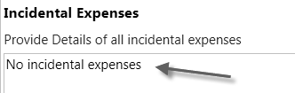
- In Purpose/Benefit Statement, provide a statement detailing the purpose for the guest’s visit to TTU/TTUS and the benefit. For example, if the visitor is a guest lecturer, include information about the event and who will be attending. If you are using a sponsored programs FOP, be sure to include a statement about how the visit benefits the project.
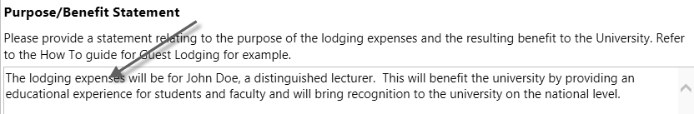
- When you have completed this form, click on Go in the upper right corner, and this will create a cart. You can edit the cart just like other TechBuy carts: changing/splitting the FOAPs, adding Internal and External Notes and Attachments, etc. Use the following account codes, depending on the type of guest or incidental expenses you are authorizing:
Guest Type | Expense | Funds | Acct Code
Prospective employee | Lodging | Not permitted on 13, 14, 16C or 16D. Other funds should be verified. | 7B5005
Guests (such as speakers or participants) | Lodging | Local funds only | 7B7006
Guests (such as speakers or participants) | Individual meals | Local funds only | 7B7007

- To add meals for TTU guests: (Please see the Notes section for guidance on what meal expenses may be included on the requisition.)
  - Click on the “Add non-catalog item for this supplier” option.
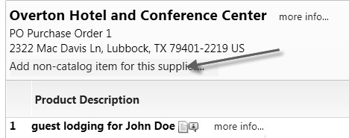

  - In the dialog box, enter a description, such as “meals for speaker” or “breakfast for speaker.”
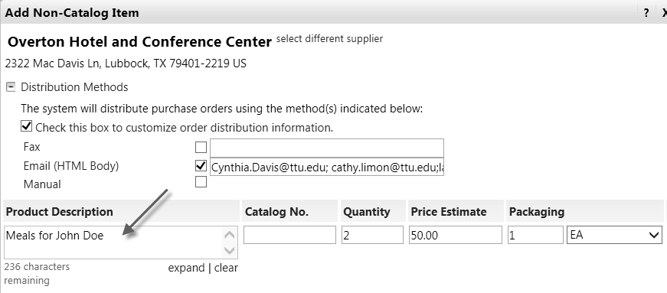
  - Enter the quantity of days your guest is staying and the amount you want to pay for the meals.
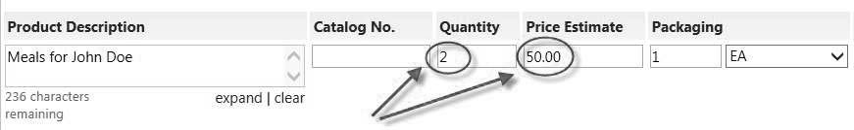
  - The packaging should always be “1” and then click on Save and Close.
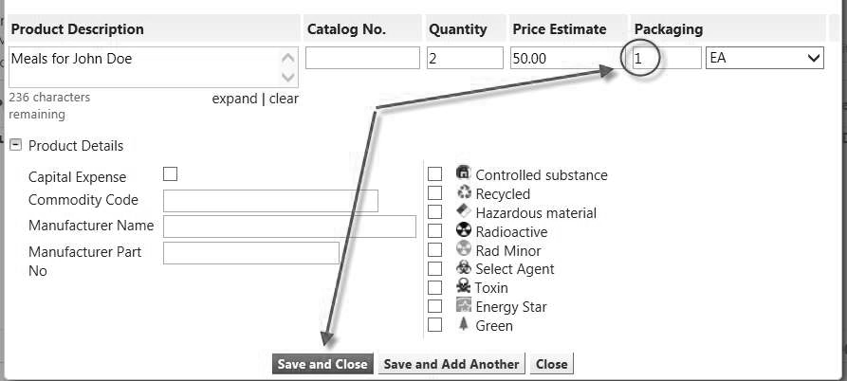
- The hotel will not charge the guest for any charges associated with the purchase order that are allowable and included on the purchase order. However, the hotel will require the guest to provide a credit card for any incidental expenses not covered by the PO, such as movies, personal long-distance phone calls, etc.
- The hotel will email invoices to Procurement Services, where they will be scanned and attached to the purchase order. The receiving policy for the guest lodging POs will be the same as the standard TTU/TTUS receiving policy. (See the How To Guide for “Receiving in TechBuy” at http://www.depts.ttu.edu/procurement/purchasingContracting/howToGuides/documents/Receiving.pdf)

Notes:
- If you complete a PO for guest lodging, the room will be considered “guaranteed” by participating hotels and will be held for the guest. However, if the guest does not need the room, you are responsible for canceling the reservation at least 24 hours in advance or your department will be charged for both the room and for city and state taxes.

- If you do not complete a requisition in time for a PO to be processed and sent to the hotel in advance of the guest’s arrival, the room will not be guaranteed and the reservation will not be held by the hotel.
- If you have checked with all the participating hotels listed and there are no rooms available, you can call other hotels here in Lubbock and see if they have a room available and will accept a purchase order. If they will accept a TTU purchase order, you will need to do the following:
  - Ask the hotel for their fax number and a contact name, to make sure that we send the PO to the correct place. You may also request they fill out the new vendor forms, if needed. Vendor Services: vendor.services@ttu.edu is also available to assist.
  - Use a non-catalog form, and be sure you select the correct hotel in the supplier search field.
  - Enter the same information that is required on the Guest Lodging form—the number of nights lodging, the lodging rate, the name of the guest, the arrival and departure date, and the purpose/benefit statement.

The following expenses and restrictions apply:
- TTU Guests (such as speakers or participants)—Local funds only
- Lodging—TTU guests are not limited to the GSA/State lodging rates. However, departments should try to conserve TTU funds whenever possible by using contract rates when available. Travel exception forms will not be required when the contract rate is not available.
- Meals—Meals should be reasonable for one person and tips are limited to 20%. No alcohol is allowed. Exceptions to this will require that a completed Travel Exception Form be attached. The form can be downloaded at http://www.depts.ttu.edu/afism/AFISMFormRepository/ProcurementDept/TravelandPay/Travel%20Exception% 20Form.pdf
- TTU/TTUS Employees (employees headquartered outside of Lubbock and visiting campus for official business) Travel rules apply to all payments and reimbursements for travel expenses for TTU employees
- Lodging—Employees are limited to the GSA/State lodging rates. If the contract rate is not available, a completed Travel Exception Form must be attached to the requisition. (If using state-appropriated funds, the overage must be placed on local funds.) The Travel Exception Form can be downloaded at http://www.depts.ttu.edu/afism/AFISMFormRepository/ProcurementDept/TravelandPay/Travel%20Exception% 20Form.pdf
- Meals—Meals cannot be added to the requisition. They may be reimbursed through the online travel system.
- Prospective Employees Travel rules apply to all payments and reimbursements for travel expenses for prospective employees
- Lodging—Employees are limited to the GSA/State lodging rates. If the contract rate is not available, a completed Travel Exception Form must be attached to the requisition. (If using state-appropriated funds, the overage must be placed on local funds.) The Travel Exception Form can be downloaded at http://www.depts.ttu.edu/afism/AFISMFormRepository/ProcurementDept/TravelandPay/Travel%20Exception% 20Form.pdf
- Meals—Meals cannot be added to the requisition. They may be reimbursed through the online travel system.

