Academic Engagement Ad Hoc Committee Meeting
3/22/2016
MINUTES
Present: Jaclyn Canas (Arts & Sciences), Sarah Dodd (Human Sciences), Claudia Cogliser (Graduate School), Kelley Coleman (International Affairs), Pat DeLucia (VPR), Jerod Foster (Media & Communications), Jacqueline Henninger (Visual & Performing Arts), Scott Longing (CASNR), Steven Maxner (Vietnam Center), Craig Morton (OPA), Nicky Ladkin (Museum), Otto Ratheal (eLearning), Venki Uddameri (Engineering)
Absent: Dustin Benham (Law), Gary Elbow (Honors College), Paul Frazier (Diversity, Equity, and Community Engagement), Robin Lock (Education), Laura Heinz (Libraries), Justin Louder (eLearning), Andrew Vernooy (Architecture).
The meeting was called to order at 2:30 p.m. Dr. Green provided the welcome followed by introductions. Craig Morton from the Office of Planning and Assessment (OPA) then presented a dashboard summarizing institution wide engagement data as reported by Texas Tech faculty and staff in the 2015 Raiders Engaged survey (see attached). The dashboard highlighted type and number of projects conducted, type and number of populations served, geographic locations of activities, and total number of faculty and staff hours spent on outreach and engagement activities across the institution. OPA also created individual dashboards broken out by college and school, and each committee member received a copy containing the data for their respective area. Craig noted that data reported by administrative units was pooled together. Several representatives in the room expressed an interest in receiving their specific administrative unit’s data. Some committee members were also interested in receiving further break-down of college level data by departments. Craig noted that OPA could provide data broken out by reporting departments as well as administrative units.
Birgit noted that the break-down by unit or departments would be helpful in identifying those areas whose activities are currently missing in Raiders Engaged. Steve Maxner also pointed out that the breakdown could be useful for the next survey. Sara Dodd asked about the availability of funding breakdowns. Craig noted that the full report of the results from the 2015 Raiders Engaged administration will be published in April and will include more detailed information regarding sources of funding for engagement activities.
Birgit mentioned that the goal for future administrations of Raiders Engaged will be to gain more accurate funding information through authenticated sources such as Cayuse (for grant funded projects) and Indigo (for non-credit programs and registration fees). Craig added that the 2016 Raiders Engaged survey will open for input in mid-summer.
The discussion continued to focus on the annual assessment of outreach and engagement. Birgit reviewed the various Forms of Engagement and associated definitions currently outlined in Raiders Engaged. She asked for feedback from the committee as to whether these accurately reflect the types of engagement activities that are currently taking place at Texas Tech, and whether the definitions combined with the examples of activities given in Raiders Engaged are adequate to help respondents identify and categorize their engagement activities.
Steve Maxner pointed out that the Vietnam Center hosts several academic conferences that attract participants from around the world. Birgit noted that conferences would fall under the category of “Engaged Instruction: Noncredit Classes and Programs” even if the event attracts participants from within the field of academia. Jacqueline Henninger mentioned that the School of Visual and Performing Arts recently hosted an event in collaboration with the National Saxophone Association which includes both school teachers and saxophone professionals. She also mentioned some projects involving collaborations with local schools to prepare music ensembles. Birgit clarified that any projects involving collaborations with outside entities such as schools, universities and community colleges would qualify as engagement regionally or nationally.
Further, Claudia Cogliser talked about The Rawls College of Business’ Career Management Center which initiates relationships between employers and students through career fairs and alumni center talk sessions. She asked for clarification whether these types of activities qualify as engagement specially because there is a reciprocal and ongoing relationship between the employers and the School of Business. Birgit clarified that as long as the relationship is mutually beneficial and tied to the educational mission of the college or department, those would qualify. The committee ultimately agreed that “Economic Development” was not adequately represented in the current list of categories. Birgit noted that she would add this category and provide an updated version of the classifications.
Next Birgit sought feedback on the formal definition of Outreach and Engagement. Texas Tech currently uses the Carnegie Foundation’s definition. Upon review, the committee agreed that the Carnegie definition is appropriate and adequate for use by Texas Tech and recommended that the institution keep using it (see attached).
Lastly, Birgit informed the committee about an upcoming internal proposal submission process for the Community Engagement Scholarship Awards Program sponsored by the Association of Public and Land Grant Universities. She encouraged all committee members to share the RFP with colleagues and submit projects as these internal submissions would increase awareness about current engagement projects. She also mentioned that her office would provide assistance in the submission process.
The meeting adjourned at 3:30 p.m. Additional discussions were tabled until the next committee meeting which is scheduled for April 26th, from 2:30-3:30 p.m. Dr. Green invited committee members to, in the meantime, share any additional thoughts related to the discussions via e-mail.
04/25/16

Attachments:
2015 Raiders Engaged Institutional Summary Dashboard
Forms of Engagement (2015 Raiders Engaged version)
Carnegie Foundation Engagement Definition (currently used by TTU)

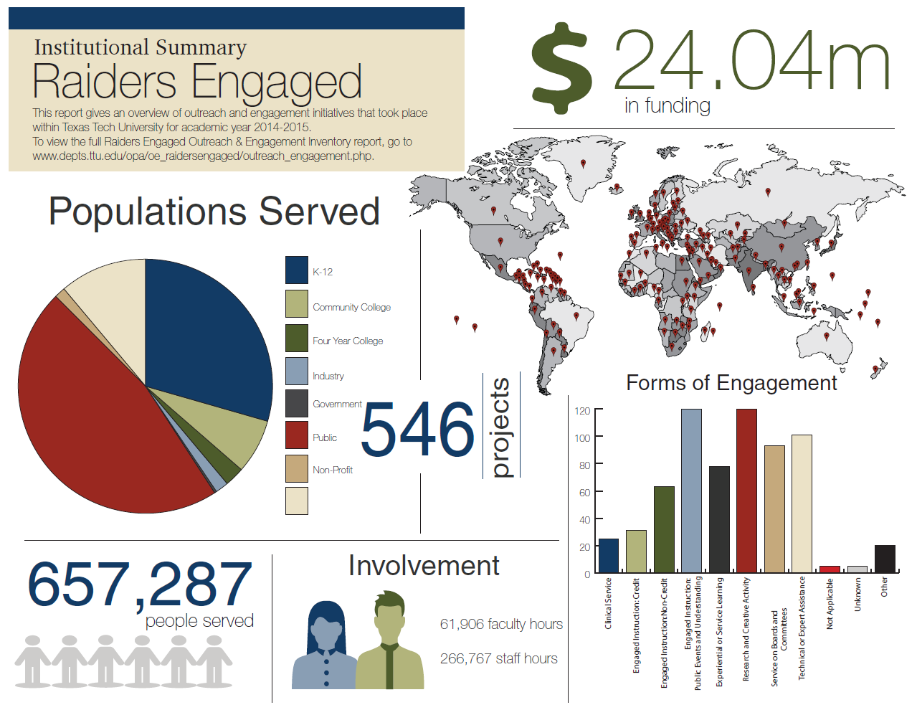
Appendix II – Institutional Summary

2015 Raiders Engaged “Forms of Engagement”
Categories and Definitions
Clinical Service | All client and patient (human and animal) care provided by university faculty or staff through unit-sponsored group practice or as part of clinical instruction, and by medical or graduate students as part of their professional education and practice. | Examples: Symptom screening of children exposed to domestic violence; tax or legal clinics for indigent populations; family counseling services.
Engaged Instruction: Credit Courses and Programs | Courses and instructional programs that offer academic credit hours to non-traditional students - those specifically designed and marketed to serve those who are neither traditional campus degree seekers nor campus staff. Such courses and programs are often scheduled at times outside of the university’s traditional operating hours or delivered via non-traditional means (online, skype, off-campus). | Examples: A weekend MBA program; an off-campus Master's program in Education offered in a rural area; an online certificate program in human resource management.
Engaged Instruction: Noncredit Classes and Programs | Classes and instructional programs designed and marketed specifically to non-traditional learners -those who are neither degree seekers nor on-campus faculty, staff, or students. These programs typically provide certificates of completion or continuing education units to professionals, career seekers, or lifelong learners, but do not provide academic credit. | Examples: A short-course for engineers on the use of new composite materials; a summer math camp for high school students; a personal enrichment program for older adults; a summer institute for bank executives; a conference on solar technologies (note: this does not include conferences that are purely designed for academic audiences); a seminar for counseling professionals.
Engaged Instruction: Public Events and Understanding | Academic or administrative resources designed for the general public that include either managed learning environments (e.g., museums, libraries, gardens, galleries, exhibits, expositions, demonstrations, fairs); or educational materials and products accessible through print, radio, television, or web media (e.g., pamphlets, web sites, software, CD’s). The learning experience is often short-term and directed or paced by the learner. | Examples: Exhibits, interactive displays, demonstrations, presentations, archival documents that draw on scholarly knowledge but are designed for and accessible by the general public. Pamphlets, booklets, self-paced online course modules or CD-ROMs on contents of interest to the general public (i.e. gardening, shelter construction, organizational skills, travel, etc.), software, or textbooks for lay audiences; Dissemination of knowledge through media such as speaker’s bureaus, TV appearances, newspaper interviews, radio broadcasts, web pages, and podcasts, if scholarly and readily available to the public; popular writings in newsletters, popular press, or practitioner-oriented publications.*
Experiential or Service Learning* | Classes and curricular programs that enable students to learn with and from community partners in a community setting while linking their academic study with civic needs. Includes any class with a service learning component in which students are asked to reflect on their community practice or make connections between academic content and the community setting. Activities provide students with academic credit and are conducted under the guidance and supervision of a faculty member. Also includes study abroad programs with service learning components. Other forms of experiential learning include career-oriented practicums or internships whether at a local, national, or international location. | Examples: A student-led after-school health and exercise program for children; a study abroad trip to Mexico involving drinking-well construction in Mexico; a reading program for pre-school children at a local library; a student internship at a wind power production plant.
Research and Creative Activity | Research: Applied or community-based research specifically targeted at a community-defined problem and intended to have a direct impact on a specific community while creating new knowledge for the community and the discipline (for potentially broader societal applications). Also includes capacity-building, evaluation and impact assessments, as well as technology transfer. May be funded through grants or contracts from government agencies, businesses, community-based organizations, nonprofit agencies, or foundations.  Creative Activity: Original creations of literary, fine, performing, or applied arts and other expressions of creative disciplines or fields at the university that are made available to or generated in collaboration with external, public audiences. | Examples: A U.S. Beef Processing Study for Food Industry Specialists; a community garden project in a “food-arm” neighborhood; an after-school mentoring program for educationally disadvantaged students.  Examples: community performances; after school enrichment programs in theatre, dance, music, or the arts; film and video productions.
Service on Boards and Committees | Contributions of scholarly or professional expertise by faculty or staff to non-university audiences on an ad hoc or ongoing basis via local, national, or international boards or committees. | Examples: Service on Child Protective Services Board; Participation in ad hoc committee on addressing gang violence in certain parts of the city.
Technical or Expert Assistance | Activities in which faculty or staff respond to requests from individuals, programs, or agencies and organizations external to the university by sharing their knowledge, expertise, and skills in order to help those entities achieve their goals. There is direct interaction with the external constituency (as opposed to responding by delivering a pamphlet or reference to a Web site or the like). | Examples: Providing expertise to address or improve the effectiveness and efficiency of an organization or to improve knowledge and skills; providing expert testimony and other forms of legal advice; consulting work for the benefit of the constituent; assisting agencies or businesses with analyzing production processes.

DEFINTION OF ENGAGEMENT (CURRENTLY USED BY TTU)

Community Engagement describes the collaboration between institutions of higher education and their larger communities (local, regional/state, national, global) for the mutually beneficial exchange of knowledge and resources in a context of partnership and reciprocity.
The purpose of community engagement is the partnership of college and university knowledge and resources with those of the public and private sectors to enrich scholarship, research, and creative activity; enhance curriculum, teaching and learning; prepare educated, engaged citizens; strengthen democratic values and civic responsibility; address critical societal issues; and contribute to the public good.
http://classifications.carnegiefoundation.org/descriptions/community_engagement.php

