ETD Accessibility Resource Series


Lists

To pass the thesis/dissertation accessibility check, all lists in your final PDF document must be formatted using Word’s built in list features (i.e. bullets or numbers). Properly formatted lists allow screen readers to recognize a list and alert readers that they have entered a list. They will announce the type of list (ordered/unordered), the number of items and when the list starts and ends. This ensures documents are accessible to all users.

For a video which explains how to add lists to your document, follow this link.

To create lists in Microsoft Word:
- Select your list
- In the Home tab, select the Bullets/Numbers command in the Paragraph group
- For more options click the drop-down menu (down arrow) on the Bullets/Numbers command

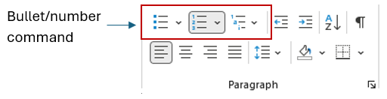

Tips:
- If you split a list, right click on the part of the list that is split and choose either Restart at 1 to start numbering from 1, or Continue Numbering to continue the previous list
- To change the distance between the bullet/number and the tab, click and drag the hanging indent marker (the little upwards arrow) on the ruler
- For multi-level lists, use the tab key to move the level of each line item down in your list or shift + tab to move the level of the line item up in your list. You can also use one of the built-in styles in the Multi-Level List command (next to the Numbers command)
For more information including trainings and resources, visit Texas Tech's Digital Accessibility Website.

